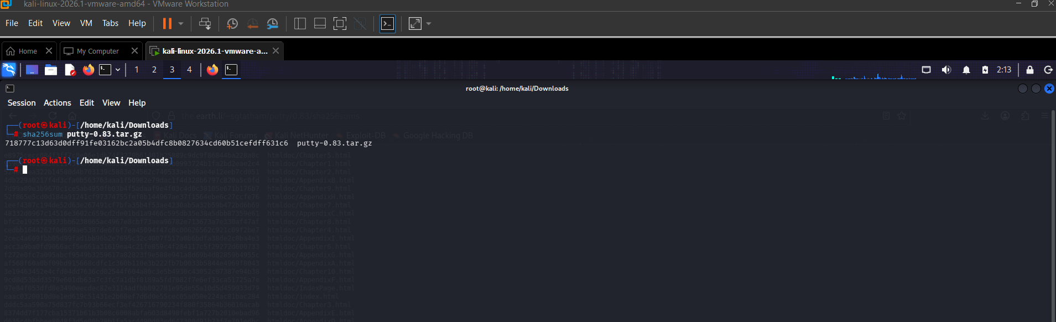

SHA256: 718777c13d63d0dff91fe03162bc2a05b4dfc8b0827634cd60b51cefdff631c6
SAME MATCH WITH THE OFFICIAL PROVIDED
