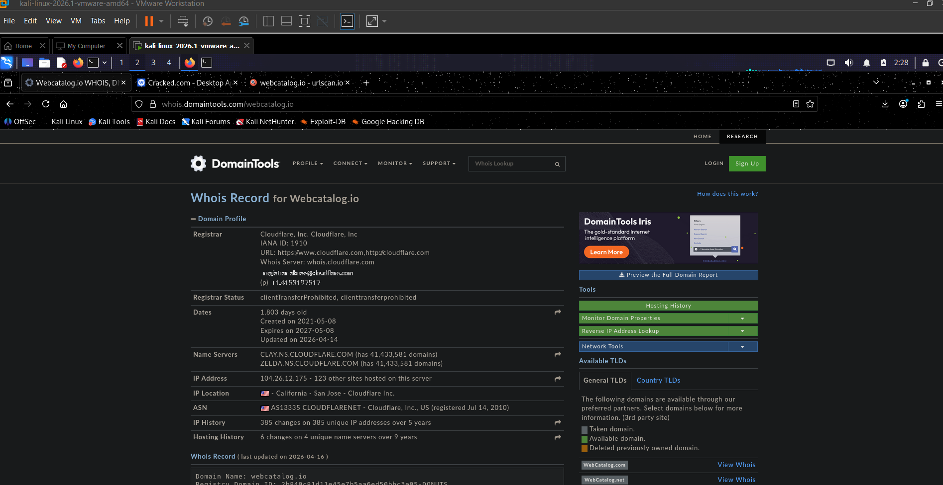

URL: webcatalog.io

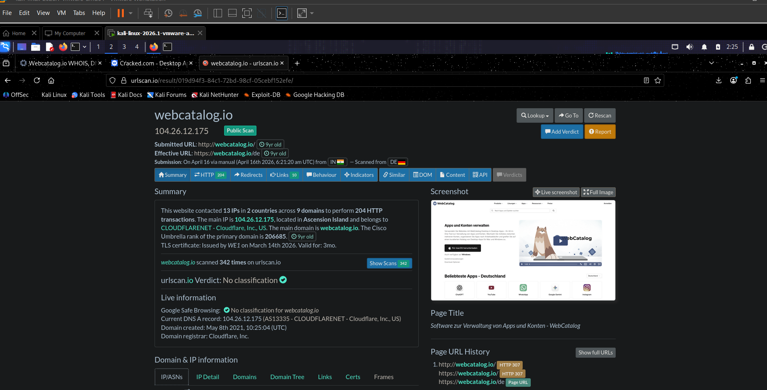
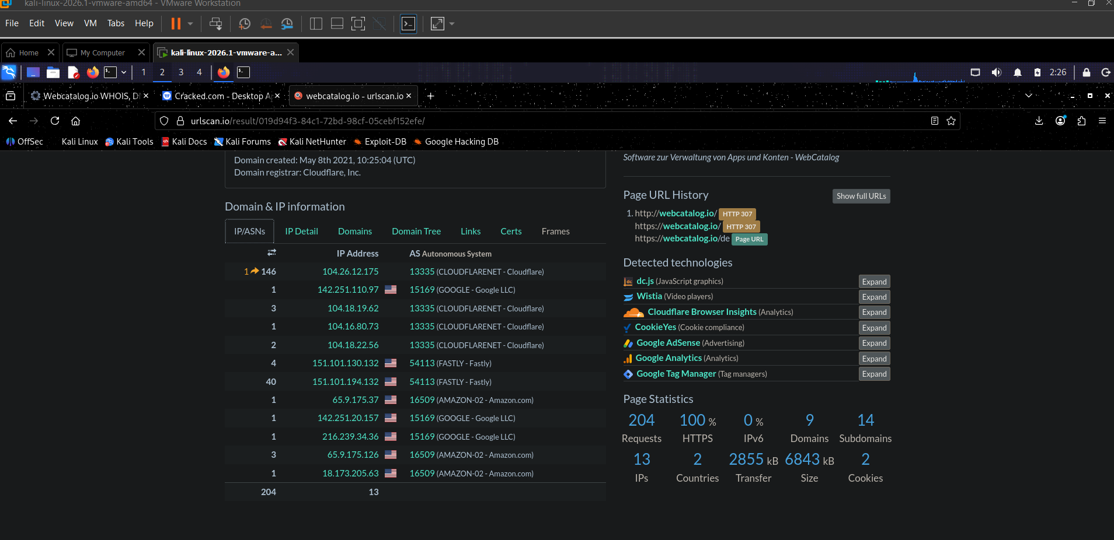

Domain created 2021, registered via Cloudflare, no malicious flags on URLScan,
Google Safe Browsing clean. Risk level: Low. Safe to visit.

