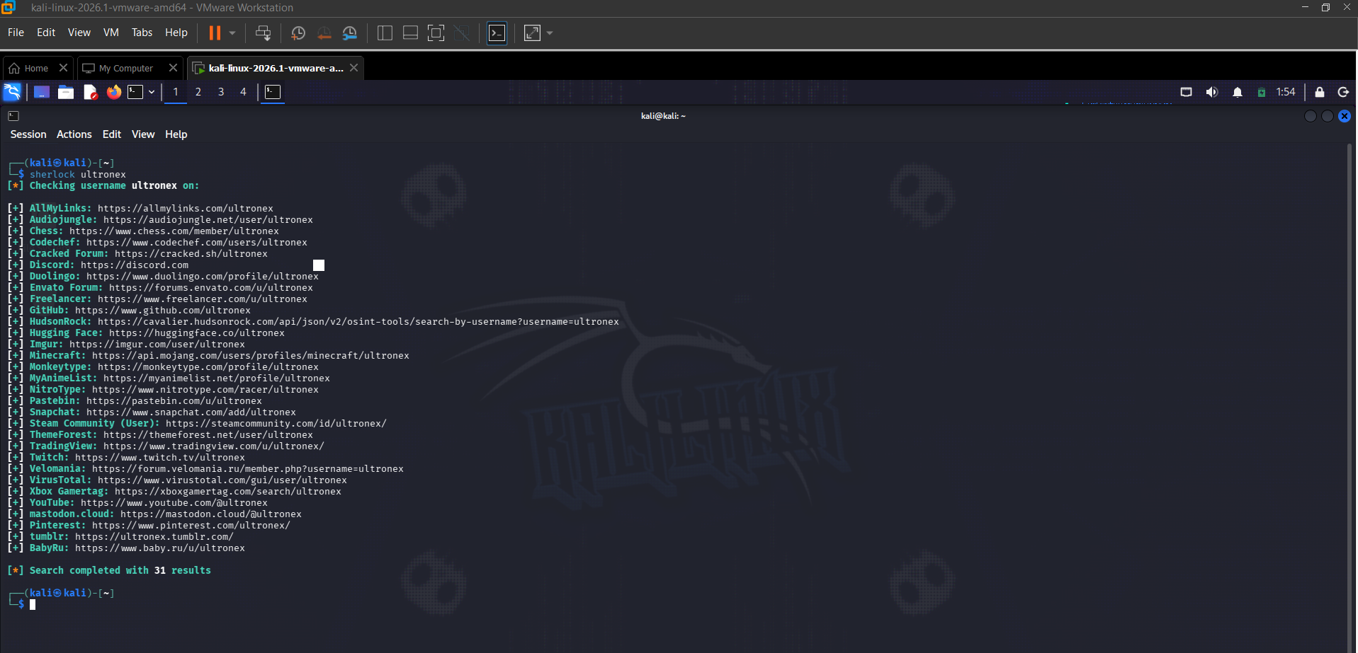

Sherlock identified 31 accounts linked to the username
"ultronex" across platforms including GitHub, Steam, Pastebin,
Snapchat, YouTube, and surprisingly BabyRu and Cracked Forum.
The Pastebin and HudsonRock results are most concerning - as it showed my pc was compromised in 2022 with all my data along with ids and passwords of gmail and rest acc.

