**자료구조**

**실습 보고서**

[제 04주] 위상 정렬

제출일 : 2015.10.06

201402432 / 조디모데

1.프로그램설명서

AppController

_appView

_graph

_topologicalSort

+run

+showMessage

+inputAndMakeGraph

+showGraph

+showSortedList()

MessageID

***Notice_StartProgram***,

***Notice_EndProgram***,

***Notice_ShowGraph***,

***Error_FailInputGraph***,

***Error_WrongEdge***,

***Notice_ShowDistance***,

***Notice_ShowSortedList***

Main

+main

AdjacencyListDirectedGraph

NumOfVertices

_adjacency

_numOfvertices

_numOfEdges

+deseVertexExist

+doesEdgeExist

+numOfVertices

+numOfEdges

+addEdge

+showGraph

+adjacentVerticesIterator

AppView

_sc

+inputNumber

+outputMessage

+inputEdge

DirectedEdge

+smaeEdgeAs

TopologicalSort

_predecessorCount

_zeroCountVertices

_sortedList

_graph

+sortedList

+perform

+pushVerticesWithNoPredecessors

+createAndSetPredecessortCount

+showZeroCountVertices

+showPredecessortCount

Edge

_tailVertex

_headVertex

+setTailVertex

+tailVertex

+setHeadVertex

+headVertex

+smaeEdgeAs

Node

_element

_next

+set_next

+get_next

+set_element

+get_next

**자료 구조 : Topological Sort, Stack, ArrayList, LinkedList**

2. Test Data

3.실행 결과 분석

1.입력과출력

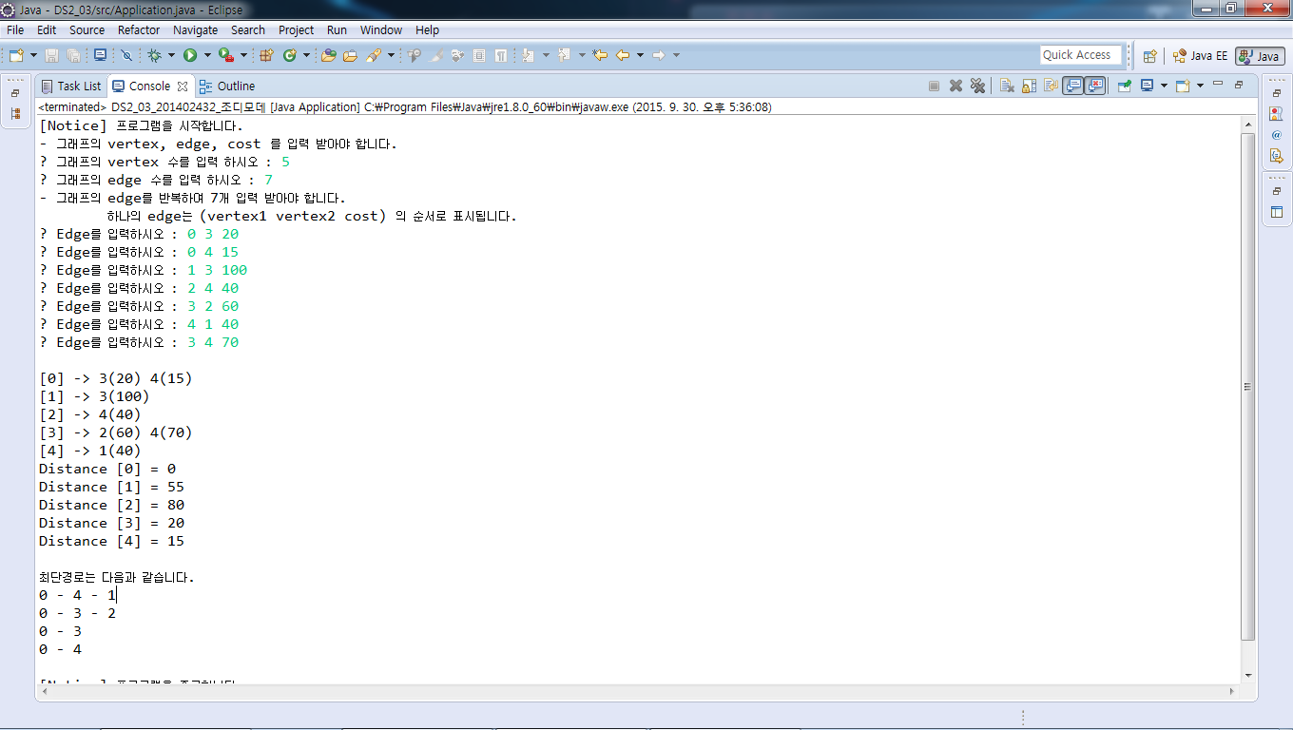

2.결과분석

직접 찾아본 최단 경로와 프로그램의 결과값이 일치하였다.

3.소스 코드

<main>

**public** **class** DS2_03_201402432_조디모데 {

**public** **static** **void** main(String[] args) {

// **TODO** Auto-generated method stub

Application appController = **new** Application() ;

appController.run();

}

}

<AdjacencyMatrixGraph>

**import** java.util.Arrays;

**public** **class** AdjacencyMatrixGraph {

**private** **final** **int** MAX_COST = 9999;

**private** **int**[][] _adjacency ;

**private** **int** _numOfVertices;

**private** **int** _numOfEdges;

**public** AdjacencyMatrixGraph(**int** givenNumOfVertices){

**this**._numOfVertices = givenNumOfVertices ;

**this**._numOfEdges = 0 ;

**this**._adjacency = **new** **int**[**this**._numOfVertices][**this**._numOfVertices] ;

**for**(**int** i=0 ; i<**this**._adjacency.length ; i++)

Arrays.*fill*(**this**._adjacency[i], MAX_COST) ;

}

**public** **boolean** doesVertexExist(**int** aVertex){

**if**(aVertex>-1 && aVertex<**this**._numOfVertices)

**return** **true** ;

**return** **false** ;

}

**public** **boolean** doesEdgeExist(Edge anEdge){

**if**( **this**._adjacency[anEdge.headVertex()][anEdge.tailVertex()]!=MAX_COST)

**return** **true** ;

**return** **false** ;

}

**public** **int** numOfVertices(){

**return** **this**._numOfVertices ;

}

**public** **int** numOfEdges(){

**return** **this**._numOfEdges ;

}

**public** **boolean** addEdge(Edge anEdge){

**if**(!**this**.doesVertexExist(anEdge.headVertex()))

**return** **false** ;

**if**(!**this**.doesVertexExist(anEdge.tailVertex()))

**return** **false** ;

**if**(**this**.doesEdgeExist(anEdge))

**return** **false** ;

**this**._adjacency[anEdge.headVertex()][anEdge.tailVertex()] = anEdge.cost() ;

**return** **true** ;

}

**public** **void** showGraph(){

**int** i = 0 ;

System.***out***.println();

**while**(i<**this**._adjacency.length ){

System.***out***.print("["+i+"] -> ");

**for**(**int** j=0 ; j<**this**._adjacency[i].length ; j++ )

**if**(**this**._adjacency[i][j]!=**this**.maxCost())

System.***out***.print(j+"("+**this**._adjacency[i][j]+") ") ;

System.***out***.println();

i++ ;

}

}

**protected** **int** maxCost(){

**return** MAX_COST ;

}

**public** **int** costOfEdge(**int** aFromVertex, **int** aToVertex){

**return** **this**._adjacency[aFromVertex][aToVertex] ;

}

**public** AdjacentVerticesIterator adjacentVerticesIterator(**int** givenVertex){

**return** **new** AdjacentVerticesIterator(givenVertex) ;

}

**public** **class** AdjacentVerticesIterator{

**private** **int** _nextPosition ;

**private** **int** _vertex ;

**private** AdjacentVerticesIterator(**int** givenVertex){

**this**._nextPosition = 0 ;

**this**._vertex = givenVertex ;

}

**public** **boolean** hasNext(){

**while**(_adjacency[**this**._vertex][**this**._nextPosition] == MAX_COST

&& **this**._nextPosition != numOfVertices()) ;

**this**._nextPosition++ ;

**return** (**this**._nextPosition < numOfVertices()) ;

}

**public** DirectedEdge next(){

DirectedEdge anEdge =

**new** DirectedEdge (_vertex, **this**._nextPosition, _adjacency[**this**._vertex][**this**._nextPosition]) ;

**this**._nextPosition++ ;

**return** anEdge ;

}

} // Inner class

} // class

<Application>

import java.util.ArrayList;

import java.util.Iterator;

public class Application {

private AppView _appView ;

private AdjacencyMatrixGraph _graph ;

private DijkstraShortestPaths _dijkstrashortestPaths;

public Application(){

this._appView = new AppView() ;

}

public void run(){

this.showMessage(MessageID.Notice_StartProgram);

if ( this.inputAndMakeGraph() ) {

this.showGraph() ;

this._dijkstrashortestPaths = new DijkstraShortestPaths(this._graph);

this._dijkstrashortestPaths.perform();

this.showDijkstraShortestDistance();

this.showDijkstraShortestPath();

}

else {

this._appView.outputMessage(MessageID.Error_FailInputGraph);

}

this.showMessage(MessageID.Notice_EndProgram);

}

private boolean inputAndMakeGraph(){

// 그래프 정보를 입력받음, 마지막에 입력된 그래프를 출력하여 보여줌

int countEdges ;

int numOfVertices ;

int numOfEdges ;

this._appView.outputMessage("- 그래프의 vertex, edge, cost 를 입력 받아야 합니다.\n") ;

this._appView.outputMessage("? 그래프의 vertex 수를 입력 하시오 : ") ;

numOfVertices = this._appView.inputNumber() ;

this._appView.outputMessage("? 그래프의 edge 수를 입력 하시오 : ") ;

numOfEdges = this._appView.inputNumber() ;

this._graph = new AdjacencyMatrixGraph(numOfVertices) ;

countEdges = 0 ;

this._appView.outputMessage("- 그래프의 edge를 반복하여 " + numOfEdges + "개 입력 받아야 합니다.\n");

this._appView.outputMessage(" 하나의 edge는 (vertex1 vertex2 cost) 의 순서로 표시됩니다.\n");

this._appView.outputMessage("? Edge를 입력하시오 : ") ;

while(true){

DirectedEdge anEdge = new DirectedEdge(this._appView.inputNumber(),

this._appView.inputNumber(), this._appView.inputNumber() );

if(anEdge.cost() > 0 && this._graph.addEdge(anEdge)){

countEdges ++ ;

}

else

this._appView.outputMessage(MessageID.Error_WrongEdge) ;

if(countEdges == numOfEdges)

break ;

this._appView.outputMessage("? Edge를 입력하시오 : ");

}

return (countEdges == numOfEdges) ;

}

private void showDijkstraShortestDistance() {

int i = 0 ;

this._appView.outputMessage(MessageID.Notice_ShowDistance);

DijkstraShortestPaths.ShortestPathsIterator dijkstraShortestPathsIterator

= this._dijkstrashortestPaths.shortestPathsIterator() ;

while(dijkstraShortestPathsIterator.hasNext()){

this._appView.outputShortestDistance(i, dijkstraShortestPathsIterator.next());

i++ ;

}

this._appView.outputMessage("\n") ;

}

private void showDijkstraShortestPath() {

this._appView.outputMessage(MessageID.Notice_ShowPath);

for(int i=1 ; i<this._graph.numOfVertices() ; i++){

ArrayList<Integer> resultShortestPath = this._dijkstrashortestPaths.findPath(0, i, null) ;

Iterator<Integer> arrayListIterator = resultShortestPath.iterator() ;

this._appView.outputPrintPathFirst(arrayListIterator.next()) ;

while(arrayListIterator.hasNext()){

this._appView.outputPrintPath(arrayListIterator.next()) ;

}

this._appView.outputMessage("\n") ;

}

this._appView.outputMessage("\n") ;

}

public void showGraph(){

// Graph의 showGraph() 함수 호출

this._graph.showGraph() ;

}

private void showMessage(MessageID aMessageID) {

this._appView.outputMessage(aMessageID);

}

} // class End

<AppView>

**import** java.util.Scanner;

**public** **class** AppView {

**private** Scanner _sc ;

AppView(){

**this**._sc = **new** Scanner(System.***in***) ;

}

**public** **int** inputNumber() {

**return** **this**._sc.nextInt() ;

}

**public** **void** outputMessage(String MessageID){

System.***out***.print(MessageID);

}

**public** **void** outputMessage(MessageID MessageID) {

**switch**(MessageID) {

**case** ***Notice_StartProgram*** :

**this**.outputMessage("[Notice] 프로그램을 시작합니다. \n");

**break** ;

**case** ***Notice_EndProgram*** :

**this**.outputMessage("[Notice] 프로그램을 종료합니다. \n");

**break** ;

**case** ***Error_WrongEdge*** :

**this**.outputMessage("[Error] 입력 오류입니다. \n");

**break** ;

**case** ***Notice_ShowPath*** :

**this**.outputMessage("최단경로는 다음과 같습니다.\n");

**break** ;

**default**:

**break**;

}

}

**public** Edge inputEdge(**int** v1, **int** v2, **int** cost){

**return** **new** DirectedEdge(v1, v2, cost) ;

}

**public** **void** outputShortestDistance(**int** tailVertex, **int** i) {

**this**.outputMessage("Distance ["+tailVertex+"] = " + i + "\n" );

}

**public** **void** outputPrintPathFirst(Integer next) {

System.***out***.print(next);

}

**public** **void** outputPrintPath(Integer next) {

System.***out***.print(" - "+next);

}

}

<DijkstraShortestPaths>

import java.util.ArrayList;

import java.util.Arrays;

public class DijkstraShortestPaths {

private int _numOfVertices ;

private int[] _distance;

private AdjacencyMatrixGraph _graph ;

private int[] _path ;

public DijkstraShortestPaths(AdjacencyMatrixGraph givenGraph ){

this._graph = givenGraph ;

this._numOfVertices = this._graph.numOfVertices() ;

this._distance = new int[this._numOfVertices] ;

this._path = new int[this._numOfVertices] ;

}

public void perform(){

int i, u, w ;

boolean[] found = new boolean[this._numOfVertices] ;

Arrays.fill(found, false) ;

for (i= 0; i< this._numOfVertices; i++) {

this._distance[i] = this._graph.costOfEdge(0, i) ;

}

found[0] = true ;

this._distance[0] = 0 ;

for (i=0; i< this._numOfVertices-2; i++) {

u = this.choos(found) ;

found[u] = true;

for (w = 0; w < this._numOfVertices; w++) {

if ( !found[w] ) {

if(this._graph.costOfEdge(u, w)!=this._graph.maxCost())

if ( this._distance[w] > this._distance[u] + this._graph.costOfEdge(u, w) ){

this._distance[w] = this._distance[u] + this._graph.costOfEdge(u, w);

this._path[w] = u ;

}

}

}

}

}

public ArrayList<Integer> findPath(int start, int end, ArrayList<Integer> pathList){

if(pathList == null){

pathList = new ArrayList<Integer> (this._numOfVertices) ;

pathList.add(start) ;

}

if(_path[end] != start)

pathList = findPath(start, _path[end], pathList) ;

pathList.add(end) ;

return pathList ;

}

private int choos(boolean[] givenFound){

int min = 0;

int[] tmp = this._distance.clone() ;

for(int i=0 ; i<this._distance.length ; i++)

if(givenFound[i]==true)

tmp[i] = this._graph.maxCost() ;

Arrays.sort(tmp);

while(true){

if(this._distance[min]==tmp[0])

break ;

min++ ;

}

return min ;

}

public ShortestPathsIterator shortestPathsIterator(){

return new ShortestPathsIterator() ;

}

public class ShortestPathsIterator{

private int _next ;

private ShortestPathsIterator(){

this._next = 0 ;

}

public boolean hasNext(){

return (this._next != _numOfVertices) ;

}

public int next(){

int next = _distance[this._next] ;

_next ++ ;

return next ;

}

}

}

<DirectedEdge>

**public** **class** DirectedEdge **extends** Edge {

**public** DirectedEdge(**int** givenHeadVertex, **int** givenTailVertex,

**int** givenCost){

**super**( givenHeadVertex, givenTailVertex, givenCost);

}

@Override

**public** **boolean** sameEdgeAs(Edge anEdge) {

**if**(**this**.tailVertex() == anEdge.tailVertex() && anEdge.headVertex() == **this**.headVertex())

**return** **true** ;

**else**

**return** **false** ;

}

}

<Edge>

**public** **abstract** **class** Edge {

**private** **int** _tailVertex ;

**private** **int** _headVertex ;

**private** **int** _cost ;

**public** Edge(**int** givenHeadVertex, **int** givenTailVertex, **int** givenCost){

**this**._headVertex = givenHeadVertex ;

**this**._tailVertex = givenTailVertex ;

**this**._cost = givenCost ;

}

**public** **void** setTailVertex(**int** aTailVertex){

**this**._tailVertex = aTailVertex ;

}

**public** **int** tailVertex(){

**return** **this**._tailVertex ;

}

**public** **void** setHeadVertex(**int** aHeadVertex){

**this**._headVertex = aHeadVertex ;

}

**public** **int** headVertex(){

**return** **this**._headVertex ;

}

**public** **void** setCost(**int** aCost){

**this**._cost = aCost ;

}

**public** **int** cost(){

**return** **this**._cost ;

}

**public** **abstract** **boolean** sameEdgeAs(Edge anEdge) ;

}

<MessageID>

**public** **enum** MessageID {

// Message IDs for Notices:

***Notice_StartProgram***,

***Notice_EndProgram***,

***Notice_ShowGraph***,

// MessageIDs for Errors:

***Error_FailInputGraph***,

***Error_WrongEdge***,

***Notice_ShowDistance***,

***Notice_ShowPath***,

}