**자료구조**

**실습 보고서**

[제 06주] 정렬 – 성능비교

제출일 : 2015.11.03

201402432 / 조디모데

1.프로그램설명서

**자료 구조 : Insertion, Heap, Bubble, Quick**

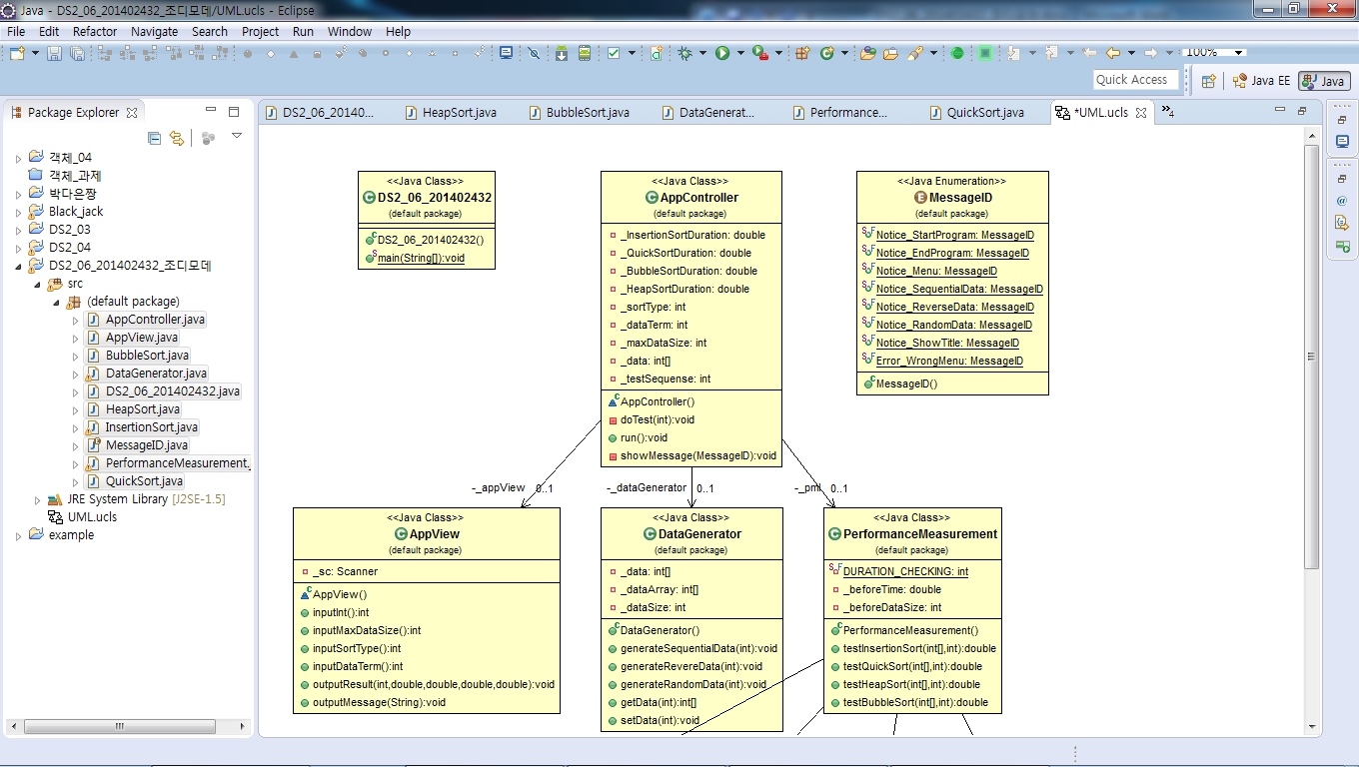

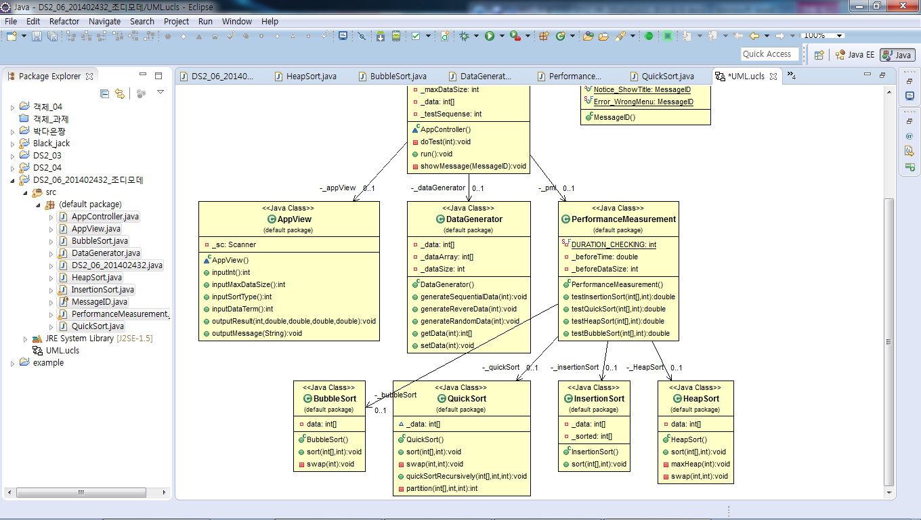

2.실행 결과 분석

1.입력과출력

Random

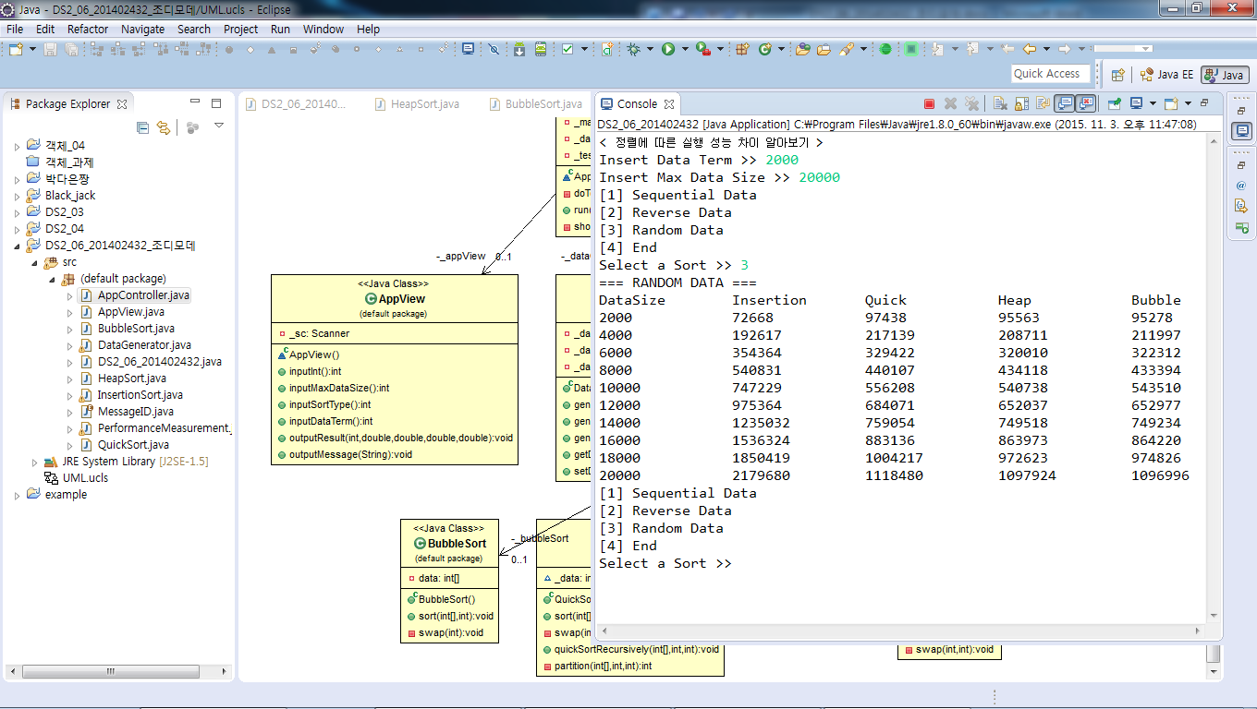

Reverse

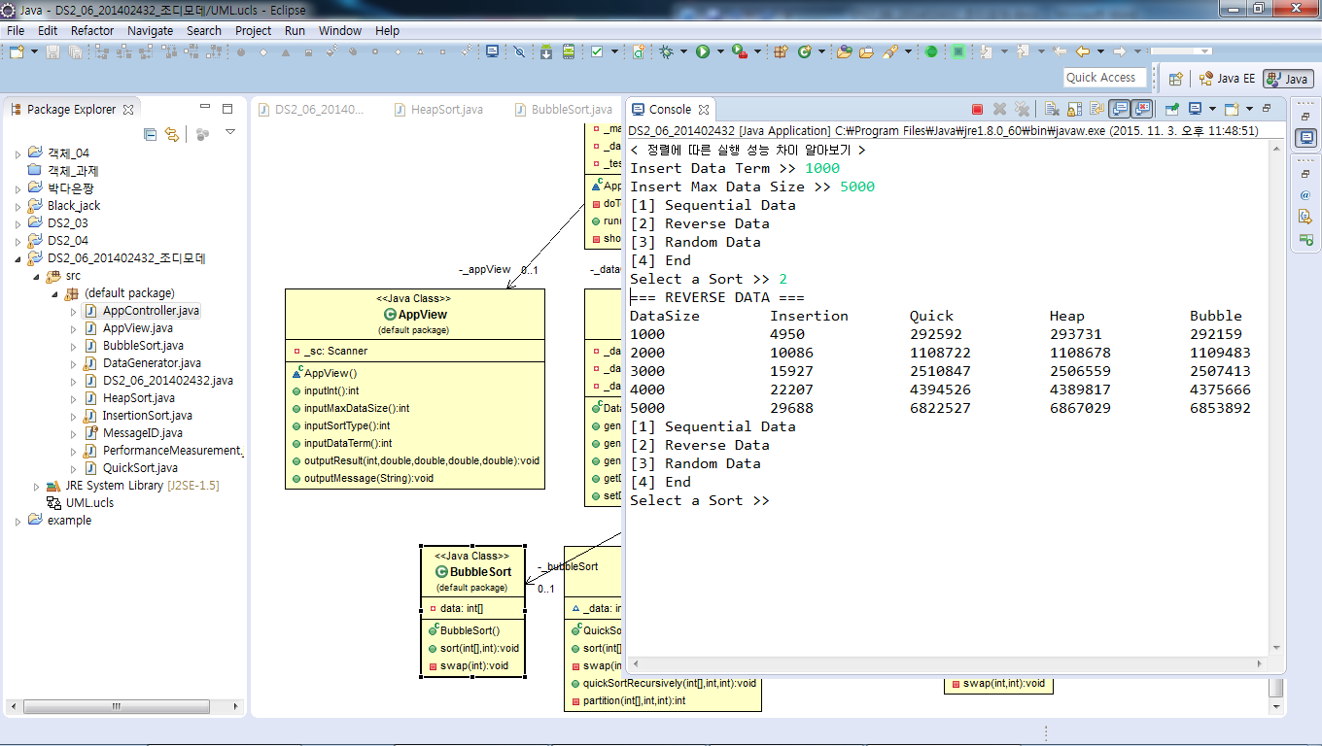

Sequence

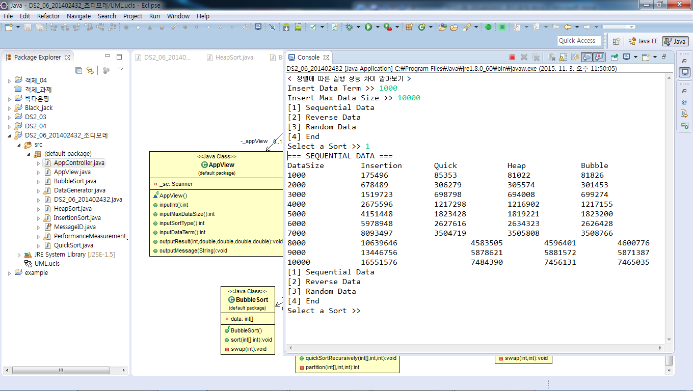

3.소스 코드

<main>

**public** **class** DS2_06_201402432 {

**public** **static** **void** main(String[] args) {

AppController appController = **new** AppController() ;

appController.run() ;

}

}

<performanceMeasurement>

**import java.util.* ;**

**public class PerformanceMeasurement {**

**private static final int DURATION_CHECKING = 5000;**

**private InsertionSort _insertionSort;**

**private QuickSort _quickSort;**

**private HeapSort _HeapSort;**

**private BubbleSort _bubbleSort;**

**private double _beforeTime;**

**private int _beforeDataSize;**

**public PerformanceMeasurement(){**

**this._insertionSort = new InsertionSort() ;**

**this._quickSort = new QuickSort() ;**

**this._HeapSort = new HeapSort() ;**

**this._bubbleSort = new BubbleSort() ;**

**this._beforeTime = -1 ;**

**this._beforeDataSize = -1 ;**

**}**

**public double testInsertionSort(int[] data, int dataSize){**

**double insertTime = 0 ;**

**long start, end ;**

**start = System.nanoTime() ;**

**this._insertionSort.sort(data, dataSize) ;**

**end = System.nanoTime() ;**

**insertTime = (double) (end - start) ;**

**return insertTime ;**

**}**

**public double testQuickSort(int [] data, int dataSize){**

**double insertTime = 0 ;**

**long start, end ;**

**start = System.nanoTime() ;**

**this._quickSort.sort(data, dataSize) ;**

**end = System.nanoTime() ;**

**insertTime = (double) (end - start) ;**

**return insertTime ;**

**}**

**public double testHeapSort(int [] data, int dataSize){**

**double insertTime = 0 ;**

**long start, end ;**

**start = System.nanoTime() ;**

**this._HeapSort.sort(data, dataSize) ;**

**end = System.nanoTime() ;**

**insertTime = (double) (end - start) ;**

**return insertTime ;**

**}**

**public double testBubbleSort(int [] data, int dataSize){**

**double insertTime = 0 ;**

**long start, end ;**

**start = System.nanoTime() ;**

**this._bubbleSort.sort(data, dataSize) ;**

**end = System.nanoTime() ;**

**insertTime = (double) (end - start) ;**

**return insertTime ;**

**}**

**}**

<Application>

public class AppController {

private AppView _appView ;

private DataGenerator _dataGenerator ;

private PerformanceMeasurement _pml ;

private double _InsertionSortDuration ;

private double _QuickSortDuration ;

private double _BubbleSortDuration ;

private double _HeapSortDuration ;

private int _sortType ;

private int _dataTerm ;

private int _maxDataSize ;

private int[] _data ;

private int _testSequense ;

AppController(){

this._appView = new AppView() ;

this._dataGenerator = new DataGenerator() ;

this._pml = new PerformanceMeasurement() ;

this._testSequense = 50 ;

}

private void doTest(int dataSize){

this._InsertionSortDuration = 0 ;

this._QuickSortDuration = 0 ;

this._BubbleSortDuration = 0 ;

this._HeapSortDuration = 0 ;

this._data = this._dataGenerator.getData(dataSize) ;

for(int index = 0 ; index < this._testSequense ; index++){

this._InsertionSortDuration += this._pml.testInsertionSort(this._data, dataSize);

this._QuickSortDuration += this._pml.testQuickSort(this._data, dataSize);

this._BubbleSortDuration += this._pml.testQuickSort(this._data, dataSize);

this._HeapSortDuration += this._pml.testQuickSort(this._data, dataSize);

}

this._InsertionSortDuration = this._InsertionSortDuration / this._testSequense ;

this._QuickSortDuration = this._QuickSortDuration / this._testSequense ;

this._BubbleSortDuration = this._BubbleSortDuration / this._testSequense ;

this._HeapSortDuration = this._HeapSortDuration / this._testSequense ;

}

public void run(){

this.showMessage(MessageID.Notice_StartProgram);

this._sortType = 0 ;

this._dataTerm = this._appView.inputDataTerm() ;

this._maxDataSize = this._appView.inputMaxDataSize();

this._dataGenerator.setData(this._maxDataSize) ;

while(this._sortType != 4){

this.showMessage(MessageID.Notice_Menu);

this._sortType = this._appView.inputSortType() ;

if(this._sortType == 1){

this._dataGenerator.generateSequentialData(this._maxDataSize) ;

this.showMessage(MessageID.Notice_SequentialData);

}

else if (this._sortType == 2){

this._dataGenerator.generateRevereData(this._maxDataSize) ;

this.showMessage(MessageID.Notice_ReverseData);

}

else if (this._sortType == 3){

this._dataGenerator.generateRandomData(this._maxDataSize) ;

this.showMessage(MessageID.Notice_RandomData);

}

else if (this._sortType == 4){

break ;

}

else {

this.showMessage(MessageID.Error_WrongMenu);

continue ;

}

this.showMessage(MessageID.Notice_ShowTitle) ;

// 메모리 생성 및 테스트의 안정성을 위하여 가장 첫 성능 측정을 미리 한번 진행한다.

this.doTest(this._dataTerm);

// 실제 테스트 진행

for(int dataSize = this._dataTerm ; dataSize<=this._maxDataSize ; dataSize += this._dataTerm){

this.doTest(dataSize);

this._appView.outputResult(dataSize, this._InsertionSortDuration,this._QuickSortDuration,

this._HeapSortDuration,this._BubbleSortDuration);

System.out.println();

}

}

this.showMessage(MessageID.Notice_EndProgram) ;

}

private void showMessage(MessageID MessageID) {

switch(MessageID) {

case Notice_StartProgram:

this._appView.outputMessage("< 정렬에 따른 실행 성능 차이 알아보기 >\n");

break;

case Notice_EndProgram:

this._appView.outputMessage("< 성능 측정을 종료합니다 >\n");

break;

case Notice_Menu :

this._appView.outputMessage( "[1] Sequential Data\n"

+ "[2] Reverse Data\n"

+ "[3] Random Data\n"

+ "[4] End\n") ;

break;

case Notice_SequentialData :

this._appView.outputMessage("=== SEQUENTIAL DATA ===\n");

break;

case Notice_ReverseData :

this._appView.outputMessage("=== REVERSE DATA ===\n");

break;

case Notice_RandomData :

this._appView.outputMessage("=== RANDOM DATA ===\n");

break;

case Notice_ShowTitle :

this._appView.outputMessage("DataSize\tInsertion\tQuick\t\tHeap\t\tBubble\n");

break;

case Error_WrongMenu:

this._appView.outputMessage("<<ERROR: 잘못된메뉴입니다.>>\n");

break;

}

}

}<AppView>

**import** java.util.Scanner;

**public** **class** AppView {

**private** Scanner _sc ;

AppView(){

**this**._sc = **new** Scanner(System.***in***) ;

}

**public** **int** inputInt(){

**return** **this**._sc.nextInt() ;

}

**public** **int** inputMaxDataSize(){

**this**.outputMessage("Insert Max Data Size >> ");

**return** **this**._sc.nextInt() ;

}

**public** **int** inputSortType() {

**this**.outputMessage("Select a Sort >> ");

**return** **this**._sc.nextInt() ;

}

**public** **int** inputDataTerm() {

**this**.outputMessage("Insert Data Term >> ");

**return** **this**._sc.nextInt() ;

}

**public** **void** outputResult(**int** dataSize, **double** InsertionSortDuration,

**double** QuickSortDuration, **double** HeapSortDuration,

**double** BubbleSortDuration) {

String str = dataSize+"\t\t"+(**int**)InsertionSortDuration+"\t\t"+(**int**)QuickSortDuration

+"\t\t"+(**int**)HeapSortDuration+"\t\t"+(**int**)BubbleSortDuration ;

**this**.outputMessage(str) ;

}

**public** **void** outputMessage (String aMessageString) {

System.***out***.print(aMessageString);

}

}

<performance> **import** java.util.* ;

**public** **class** PerformanceMeasurement {

**private** **static** **final** **int** ***DURATION_CHECKING*** = 5000;

**private** InsertionSort _insertionSort;

**private** QuickSort _quickSort;

**private** HeapSort _HeapSort;

**private** BubbleSort _bubbleSort;

**private** **double** _beforeTime;

**private** **int** _beforeDataSize;

**public** PerformanceMeasurement(){

**this**._insertionSort = **new** InsertionSort() ;

**this**._quickSort = **new** QuickSort() ;

**this**._HeapSort = **new** HeapSort() ;

**this**._bubbleSort = **new** BubbleSort() ;

**this**._beforeTime = -1 ;

**this**._beforeDataSize = -1 ;

}

**public** **double** testInsertionSort(**int**[] data, **int** dataSize){

**double** insertTime = 0 ;

**long** start, end ;

start = System.*nanoTime*() ;

**this**._insertionSort.sort(data, dataSize) ;

end = System.*nanoTime*() ;

insertTime = (**double**) (end - start) ;

**return** insertTime ;

}

**public** **double** testQuickSort(**int** [] data, **int** dataSize){

**double** insertTime = 0 ;

**long** start, end ;

start = System.*nanoTime*() ;

**this**._quickSort.sort(data, dataSize) ;

end = System.*nanoTime*() ;

insertTime = (**double**) (end - start) ;

**return** insertTime ;

}

**public** **double** testHeapSort(**int** [] data, **int** dataSize){

**double** insertTime = 0 ;

**long** start, end ;

start = System.*nanoTime*() ;

**this**._HeapSort.sort(data, dataSize) ;

end = System.*nanoTime*() ;

insertTime = (**double**) (end - start) ;

**return** insertTime ;

}

**public** **double** testBubbleSort(**int** [] data, **int** dataSize){

**double** insertTime = 0 ;

**long** start, end ;

start = System.*nanoTime*() ;

**this**._bubbleSort.sort(data, dataSize) ;

end = System.*nanoTime*() ;

insertTime = (**double**) (end - start) ;

**return** insertTime ;

}

}

<quick Sort> **public** **class** QuickSort{

**int**[] _data ;

**public** **void** sort(**int**[] data, **int** dataSize){

**this**._data = data.clone() ;

**int** minLoc = 0 ;

// 최소값을 원소 구간의 맨 끝으로 옮긴다.

swap(minLoc, dataSize-1) ;

// 정렬을 시작한다.

quickSortRecursively(**this**._data, 0,dataSize-2) ;

}

**private** **void** swap(**int** positionA, **int** positionB){

**int** temp = **this**._data[positionA] ;

**this**._data[positionA] = **this**._data[positionB] ;

**this**._data[positionB] = temp ;

}

**public** **void** quickSortRecursively(**int**[] data, **int** left, **int** right){

**if** (left < right) /* 구간의크기가2 이상이면*/{

**int** mid = partition(**this**._data, left, right) ; // DIVIDE

quickSortRecursively(data, left, mid-1) ;// CONQUER

quickSortRecursively(data, mid+1, right) ; // CONQUER

}

}

**private** **int** partition(**int** data[], **int** left, **int** right){

**int** pivot = left ;

**int** pivotScore = data[pivot] ;

right++ ;

**do**{

**do**{

left++ ;

}**while**(data[left] > pivotScore);

**do**{

right--;

}**while**(data[right] < pivotScore);

**if**(left<right)

**this**.swap(left, right);

}**while**(left<right);

**this**.swap(pivot, right);

**return** right ;

}

}

}

<InsertionSort>

**import** java.util.Arrays;

**public** **class** InsertionSort {

**private** **int**[] _data ;

**private** **int**[] _sorted ;

**public** InsertionSort(){

}

**public** **void** sort(**int**[] data, **int** dataSize) {

**int** tmp ;

**this**._data = Arrays.*copyOf*(data, dataSize) ;

**this**._data[0] = -1 ;

**for**(**int** i=1 ; i<dataSize ; i++){

**for**(**int** j=1 ; j<i ; j++)

**if**(**this**._data[i]<**this**._data[j]){

tmp = **this**._data[j] ;

**this**._data[j] = **this**._data[i] ;

**this**._data[i] = tmp ;

**break** ;

}

}

}

} // class

<Heapsort> **public** **class** HeapSort {

**private** **int**[] data ;

**public** HeapSort(){

}

**public** **void** sort(**int**[] data, **int** dataSize) {

**this**.data = data.clone() ;

**for**(**int** i=0 ; i<**this**.data.length ; i++)

**this**.maxHeap(i) ;

}

**private** **void** maxHeap(**int** i) {

**int** l = i*2+1 ;

**int** r = i*2+2 ;

**int** largest ;

**if**( (l <= **this**.data.length-1) && (**this**.data[l]>**this**.data[i]))

largest = l ;

**else**

largest = i ;

**if**(r <= **this**.data.length-1 && **this**.data[l] > **this**.data[i])

largest = r ;

**if**(largest != i){

swap(i, largest) ;

maxHeap(largest) ;

}

}

**private** **void** swap(**int** i, **int** largest) {

**int** tmp = **this**.data[i] ;

**this**.data[i] = **this**.data[largest] ;

**this**.data[largest] = tmp ;

}

}

<DataGenerator>

import java.util.* ;

import java.util.Arrays;

public class DataGenerator {

private int[] _data ;

private int[] _dataArray;

private int _dataSize ;

public DataGenerator(){

this._dataSize = -1 ;

}

public void generateSequentialData(int size) {

this._dataArray = Arrays.copyOf(this._data, size) ;

Arrays.sort(this._dataArray) ;

}

public void generateRevereData(int size) {

this._dataArray = Arrays.copyOf(this._data, size) ;

Arrays.sort(this._dataArray) ;

int tmp[] = this._dataArray.clone() ;

for(int i=0 ; i<size ; i++)

this._dataArray[i] = tmp[size-i-1] ;

this._dataArray[0] = -1 ;

}

public void generateRandomData(int size) {

// 이미 랜덤으로 저장된 Data입니다.

this._dataArray = Arrays.copyOf(this._data,size) ;

}

public int[] getData(int size) {

int[] copyArray = Arrays.copyOf(this._dataArray, size) ;

return copyArray ;

}

public void setData(int size) {

Random r = new Random() ;

this._dataSize = size ;

this._data = new int[size] ;

this._data[0] = -1 ;

for(int i=1 ; i<size ; i++)

this._data[i] = r.nextInt(1000)+1 ;

}

}

<BubbleSort>

**import** java.util.Arrays;

**public** **class** BubbleSort {

**private** **int**[] data ;

**public** BubbleSort(){

}

**public** **void** sort(**int**[] data, **int** dataSize) {

**this**.data = Arrays.*copyOf*(data, dataSize) ;

**for**(**int** i = 0 ; i<dataSize ; i++)

**for**(**int** j = 0 ; j<dataSize-i-1 ; j++)

**if**(**this**.data[j]>**this**.data[j+1])

swap(j) ;

}

**private** **void** swap(**int** n){

**int** tmp ;

tmp = **this**.data[n] ;

**this**.data[n] = **this**.data[n+1] ;

**this**.data[n+1] = tmp ;

}

}