**자료구조**

**실습 보고서**

[제 12주] 사전 – 성능분석

제출일 : 2015.12.1

201402432 / 조디모데

1.프로그램설명서

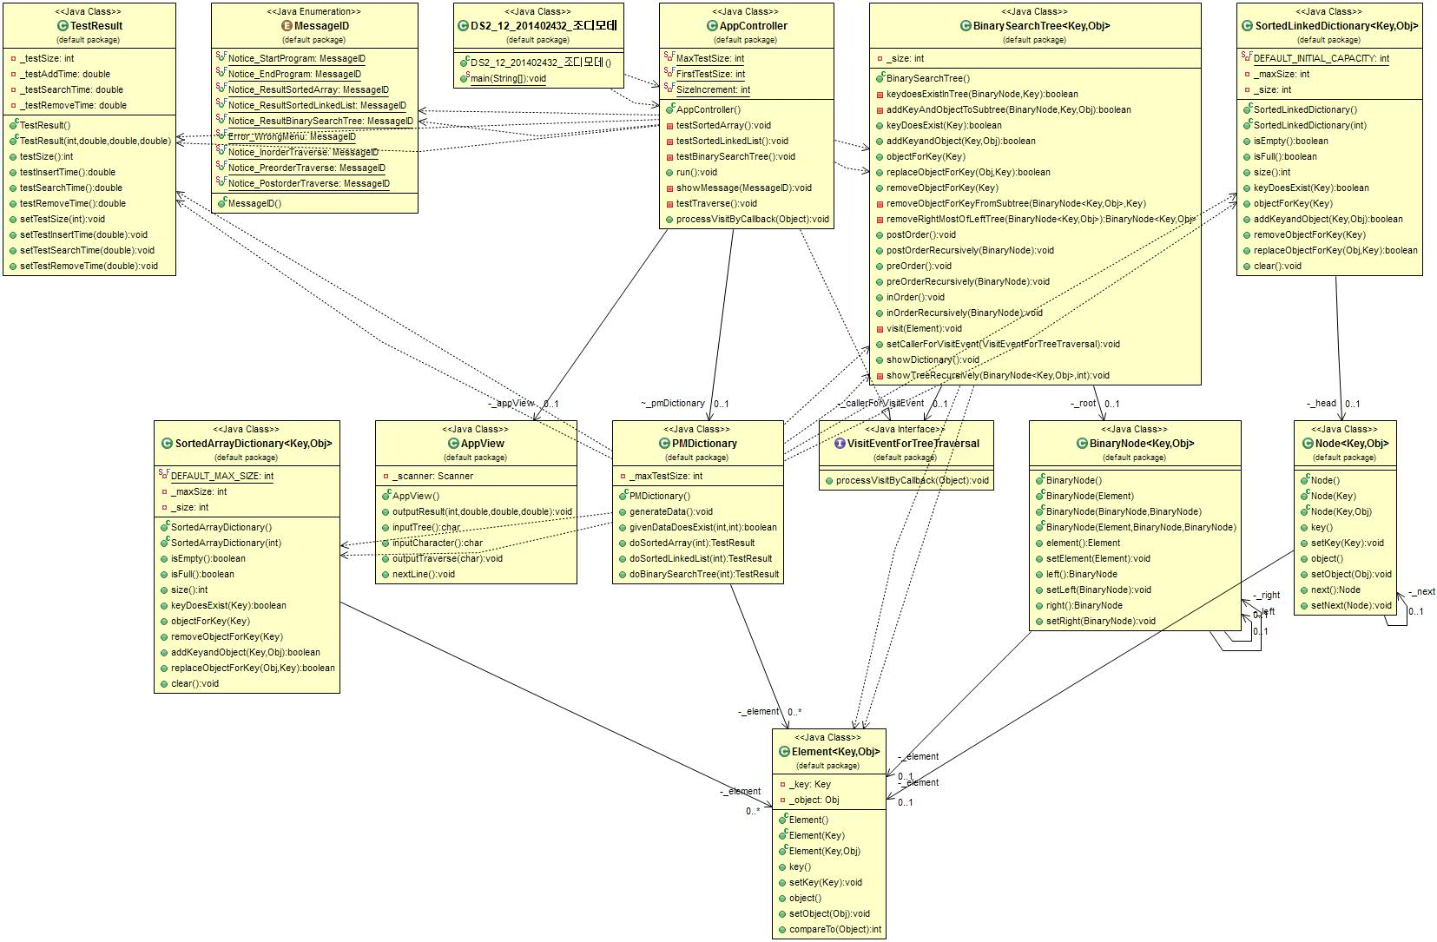

**자료 구조 & 알고리즘 : ArryList, LinkedList, BinarySearchTree, Hash**

2.실행 결과 분석

1.입력과출력

* 프로그램 실행 화면

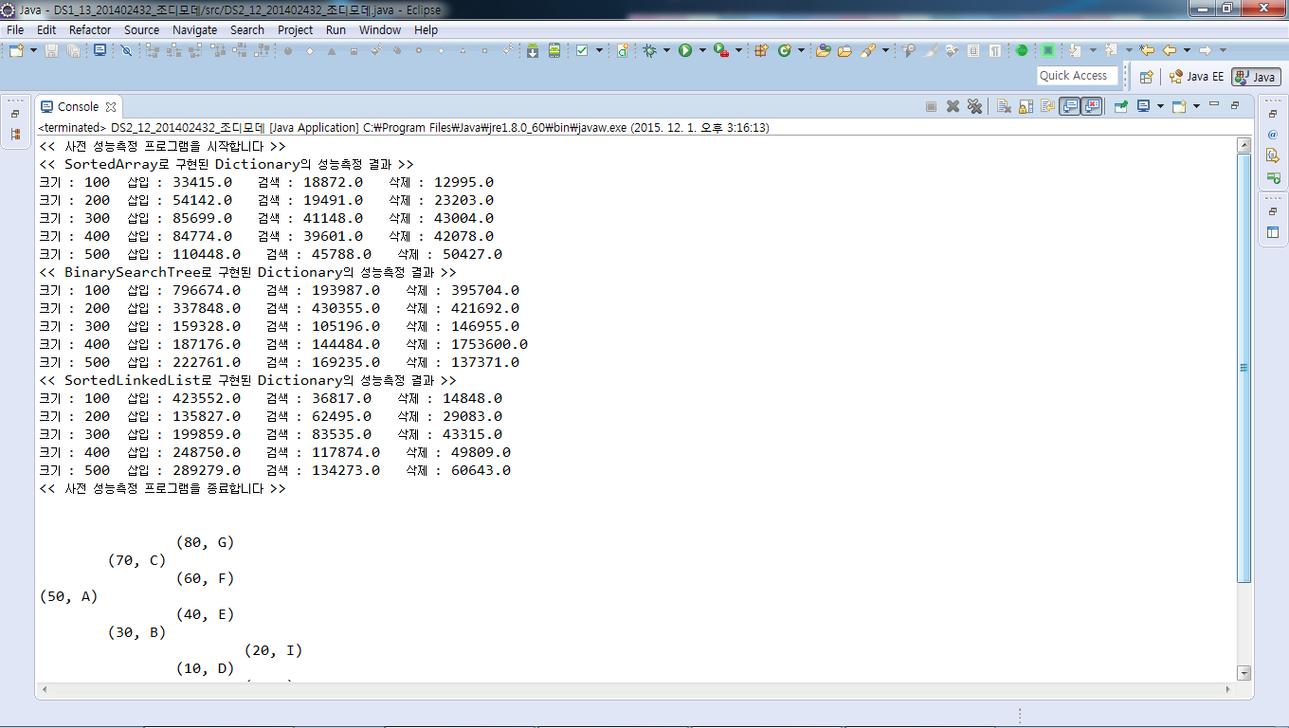

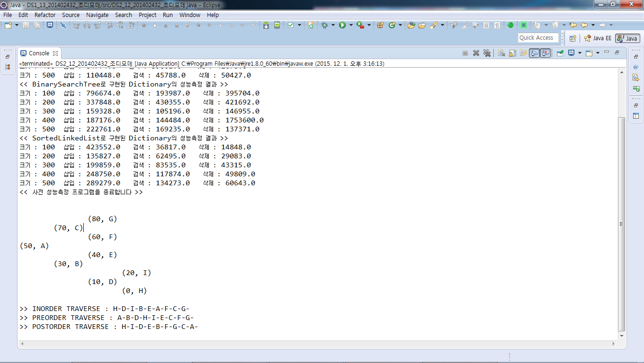

3.소스 코드

<main>

**public** **class** DS2_12_201402432_조디모데 {

**public** **static** **void** main(String[] args) {

// **TODO** Auto-generated method stub

AppController appController = **new** AppController() ;

appController.run();

}

}

<AppControllor>

**public** **class** AppController **implements** VisitEventForTreeTraversal {

**private** AppView _appView;

PMDictionary _pmDictionary;

**private** **static** **final** **int** ***MaxTestSize*** = 500;

**private** **static** **final** **int** ***FirstTestSize*** = 100;

**private** **static** **final** **int** ***SizeIncrement*** = 100;

**public** AppController() {

**this**._appView = **new** AppView();

}

**private** **void** testSortedArray() {

**this**.showMessage(MessageID.***Notice_ResultSortedArray***);

**for** (**int** testSize = ***FirstTestSize***; testSize <= ***MaxTestSize***; testSize += ***SizeIncrement***) {

TestResult testResult = **this**._pmDictionary.doSortedArray(testSize);

**this**._appView.outputResult(testResult.testSize(),

testResult.testInsertTime(), testResult.testSearchTime(),

testResult.testRemoveTime());

}

}

**private** **void** testSortedLinkedList() {

**this**.showMessage(MessageID.***Notice_ResultSortedLinkedList***);

**for** (**int** testSize = ***FirstTestSize***; testSize <= ***MaxTestSize***; testSize += ***SizeIncrement***) {

TestResult testResult = **this**._pmDictionary

.doSortedLinkedList(testSize);

**this**._appView.outputResult(testResult.testSize(),

testResult.testInsertTime(), testResult.testSearchTime(),

testResult.testRemoveTime());

}

}

**private** **void** testBinarySearchTree() {

**this**.showMessage(MessageID.***Notice_ResultBinarySearchTree***);

**for** (**int** testSize = ***FirstTestSize***; testSize <= ***MaxTestSize***; testSize += ***SizeIncrement***) {

TestResult testResult = **this**._pmDictionary

.doBinarySearchTree(testSize);

**this**._appView.outputResult(testResult.testSize(),

testResult.testInsertTime(), testResult.testSearchTime(),

testResult.testRemoveTime());

}

}

**public** **void** run() {

**this**.showMessage(MessageID.***Notice_StartProgram***);

**this**._pmDictionary = **new** PMDictionary();

**this**._pmDictionary.generateData();

**this**.testSortedArray();

**this**.testBinarySearchTree();

**this**.testSortedLinkedList();

**this**.showMessage(MessageID.***Notice_EndProgram***);

System.***out***.println();

**this**.testTraverse();

}

**private** **void** showMessage(MessageID aMessageID) {

**switch** (aMessageID) {

**case** ***Notice_ResultSortedArray***:

System.***out***.println("<< SortedArray로 구현된 Dictionary의 성능측정 결과 >>");

**break**;

**case** ***Notice_StartProgram***:

System.***out***.println("<< 사전 성능측정 프로그램을 시작합니다 >>");

**break**;

**case** ***Notice_EndProgram***:

System.***out***.println("<< 사전 성능측정 프로그램을 종료합니다 >>");

**break**;

**case** ***Notice_ResultSortedLinkedList***:

System.***out***

.println("<< SortedLinkedList로 구현된 Dictionary의 성능측정 결과 >>");

**break**;

**case** ***Notice_ResultBinarySearchTree***:

System.***out***

.println("<< BinarySearchTree로 구현된 Dictionary의 성능측정 결과 >>");

**break**;

**case** ***Notice_InorderTraverse***:

System.***out***.print(">> INORDER TRAVERSE : ");

**break**;

**case** ***Notice_PreorderTraverse***:

System.***out***.print(">> PREORDER TRAVERSE : ");

**break**;

**case** ***Notice_PostorderTraverse***:

System.***out***.print(">> POSTORDER TRAVERSE : ");

**break**;

**default**:

**break**;

}

}

**private** **void** testTraverse() {

BinarySearchTree<Integer, Character> binaryTree = **new** BinarySearchTree<Integer, Character>();

**char** value = 'A';

**int**[] input = **new** **int**[] { 50, 30, 70, 10, 40, 60, 80, 0, 20 };

**for** (**int** i = 0; i < input.length; i++)

binaryTree.addKeyandObject(input[i], value++);

**this**._appView.nextLine();

binaryTree.showDictionary();

binaryTree.setCallerForVisitEvent(**this**);

**this**._appView.nextLine();

**this**.showMessage(MessageID.***Notice_InorderTraverse***);

binaryTree.inOrder();

**this**._appView.nextLine();

**this**.showMessage(MessageID.***Notice_PreorderTraverse***);

binaryTree.preOrder();

**this**._appView.nextLine();

**this**.showMessage(MessageID.***Notice_PostorderTraverse***);

binaryTree.postOrder();

**this**._appView.nextLine();

}

@Override

**public** **void** processVisitByCallback(Object anObj) {

**this**._appView.outputTraverse((Character) anObj);

}

}

<AppView>

**import** java.util.*;

**public** **class** AppView {

**private** Scanner _scanner;

**public** AppView() {

**this**._scanner = **new** Scanner(System.***in***);

}

**public** **void** outputResult(**int** aTestSize, **double** aTestInsertTime,

**double** aTestSearchTime, **double** aTestRemoveTime) {

System.***out***.println("크기 : " + aTestSize + " 삽입 : " + aTestInsertTime

+ " 검색 : " + aTestSearchTime + " 삭제 : " + aTestRemoveTime);

}

**public** **char** inputTree() {

**return** **this**._scanner.nextLine().charAt(0);

}

**public** **char** inputCharacter() {

**return** **this**._scanner.nextLine().charAt(0);

}

**public** **void** outputTraverse(**char** anObj) {

System.***out***.println(anObj);

}

**public** **void** nextLine() {

System.***out***.println();

}

}

<PMDictionary>

**import** java.util.Random;

**public** **class** PMDictionary {

**private** **int** _maxTestSize;

**private** Element<Integer, Integer>[] _element;

**public** PMDictionary() {

**this**._maxTestSize = 500;

**this**._element = **new** Element[**this**._maxTestSize];

}

**public** **void** generateData() {

Random random = **new** Random();

**int** currentSize = 0;

**while** (currentSize < **this**._maxTestSize) {

**int** newData = random.nextInt(**this**._maxTestSize);

**if** (!**this**.givenDataDoesExist(newData, currentSize)) {

Element<Integer, Integer> newElement = **new** Element<Integer, Integer>(

newData, currentSize);

**this**._element[currentSize] = newElement;

currentSize++;

}

}

}

**public** **boolean** givenDataDoesExist(**int** newData, **int** currentDataSize) {

**for** (**int** i = 0; i < currentDataSize; i++)

**if** (**this**._element[i].key() == newData)

**return** **true**;

**return** **false**;

}

**public** TestResult doSortedArray(**int** testSize) {

SortedArrayDictionary<Integer, Integer> dic = **new** SortedArrayDictionary<Integer, Integer>();

**long** timeForAdd, timeForSearch, timeForRemove;

**long** start, stop;

timeForAdd = 0;

**for** (**int** testCount = 0; testCount < testSize; testCount++) {

start = System.*nanoTime*();

dic.addKeyandObject(**this**._element[testCount].key(),

**this**._element[testCount].object());

stop = System.*nanoTime*();

timeForAdd += (stop - start);

}

timeForSearch = 0;

**for** (**int** testCount = 0; testCount < testSize; testCount++) {

Integer searchObj;

start = System.*nanoTime*();

searchObj = dic.objectForKey(**this**._element[testCount].key());

stop = System.*nanoTime*();

timeForSearch += (stop - start);

}

timeForRemove = 0;

**for** (**int** testCount = 0; testCount < testSize; testCount++) {

Integer removedObj;

start = System.*nanoTime*();

removedObj = dic.removeObjectForKey(**this**._element[testCount].key());

stop = System.*nanoTime*();

timeForRemove += (stop - start);

}

**return** **new** TestResult(testSize, timeForAdd, timeForSearch,

timeForRemove);

}

**public** TestResult doSortedLinkedList(**int** testSize) {

SortedLinkedDictionary<Integer, Integer> dic = **new** SortedLinkedDictionary<Integer, Integer>();

**long** timeForAdd, timeForSearch, timeForRemove;

**long** start, stop;

timeForAdd = 0;

**for** (**int** testCount = 0; testCount < testSize; testCount++) {

start = System.*nanoTime*();

dic.addKeyandObject(**this**._element[testCount].key(),

**this**._element[testCount].object());

stop = System.*nanoTime*();

timeForAdd += (stop - start);

}

timeForSearch = 0;

**for** (**int** testCount = 0; testCount < testSize; testCount++) {

Integer searchObj;

start = System.*nanoTime*();

searchObj = dic.objectForKey(**this**._element[testCount].key());

stop = System.*nanoTime*();

timeForSearch += (stop - start);

}

timeForRemove = 0;

**for** (**int** testCount = 0; testCount < testSize; testCount++) {

Integer removedObj;

start = System.*nanoTime*();

removedObj = dic.removeObjectForKey(**this**._element[testCount].key());

stop = System.*nanoTime*();

timeForRemove += (stop - start);

}

**return** **new** TestResult(testSize, timeForAdd, timeForSearch,

timeForRemove);

}

**public** TestResult doBinarySearchTree(**int** testSize) {

BinarySearchTree<Integer, Integer> dic = **new** BinarySearchTree<Integer, Integer>();

**double** timeForAdd, timeForSearch, timeForRemove;

**long** start, stop;

timeForAdd = 0;

**for** (**int** testCount = 0; testCount < testSize; testCount++) {

start = System.*nanoTime*();

dic.addKeyandObject(**this**._element[testCount].key(),

**this**._element[testCount].object());

stop = System.*nanoTime*();

timeForAdd += (**double**) (stop - start);

}

timeForSearch = 0;

**for** (**int** testCount = 0; testCount < testSize; testCount++) {

Integer searchObj;

start = System.*nanoTime*();

searchObj = dic.objectForKey(**this**._element[testCount].key());

stop = System.*nanoTime*();

timeForSearch += (**double**) (stop - start);

}

timeForRemove = 0;

**for** (**int** testCount = 0; testCount < testSize; testCount++) {

Integer removedObj;

start = System.*nanoTime*();

removedObj = dic.removeObjectForKey(**this**._element[testCount].key());

stop = System.*nanoTime*();

timeForRemove += (**double**) (stop - start);

}

**return** **new** TestResult(testSize, timeForAdd, timeForSearch,

timeForRemove);

}

}

<MessageID>

**public** **enum** MessageID {

***Notice_StartProgram***,

***Notice_EndProgram***,

***Notice_ResultSortedArray***,

***Notice_ResultSortedLinkedList***,

***Notice_ResultBinarySearchTree***,

***Error_WrongMenu***,

***Notice_InorderTraverse***,

***Notice_PreorderTraverse***,

***Notice_PostorderTraverse***,

}

<SortedLinkedDictionary>

**public** **class** SortedLinkedDictionary<Key **extends** Comparable, Obj> {

**private** **static** **final** **int** ***DEFAULT_INITIAL_CAPACITY*** = 20;

**private** **int** _maxSize;

**private** **int** _size;

**private** Node<Key, Obj> _head;

**public** SortedLinkedDictionary() {

**this**._maxSize = **this**.***DEFAULT_INITIAL_CAPACITY***;

**this**._size = 0;

**this**._head = **null**;

}

**public** SortedLinkedDictionary(**int** aMaxsize) {

**this**._maxSize = aMaxsize;

**this**._size = 0;

**this**._head = **null**;

}

**public** **boolean** isEmpty() {

**return** **this**._size == 0;

}

**public** **boolean** isFull() {

**return** **this**._maxSize == **this**._size;

}

**public** **int** size() {

**return** **this**._size;

}

**public** **boolean** keyDoesExist(Key aKey) {

Node exNode = **this**._head;

**while** (exNode != **null**) {

**if** (exNode.key() == aKey)

**return** **true**;

exNode = exNode.next();

}

**return** **false**;

}

**public** Obj objectForKey(Key aKey) {

Node exNode = **this**._head;

Obj findObj = **this**._head.object();

**while** (exNode != **null**) {

**if** (exNode.key() == aKey)

**return** findObj;

exNode = exNode.next();

}

**return** **null**;

}

**public** **boolean** addKeyandObject(Key aKey, Obj anObject) {

**if** (!**this**.keyDoesExist(aKey)) {

Node newNode = **new** Node(aKey, anObject);

Node previousNode = **null**;

Node currentNode = **this**._head;

**if** (!isEmpty()) {

**while** (currentNode != **null**) {

**if** (currentNode.key().compareTo(aKey) > 0) {

previousNode.setNext(newNode);

newNode.setNext(currentNode);

**return** **true**;

}

previousNode = currentNode;

currentNode = currentNode.next();

}

} **else** {

**this**._head = newNode;

**return** **true**;

}

}

**return** **false**;

}

**public** Obj removeObjectForKey(Key aKey) {

**if** (**this**.isEmpty())

**return** **null**;

**else** {

Node previousNode = **null**;

Node currentNode = **this**._head;

Obj removeObj = **this**._head.object();

**while** (currentNode != **null**) {

**if** (currentNode.key() == aKey) {

removeObj = (Obj) currentNode.object();

previousNode.setNext(currentNode);

**return** removeObj;

}

previousNode = currentNode;

currentNode = currentNode.next();

}

**return** **null**;

}

}

**public** **boolean** replaceObjectForKey(Obj newObject, Key aKey) {

**if** (!**this**.keyDoesExist(aKey))

**return** **false**;

**else** {

Node exNode = **this**._head;

**while** (exNode != **null**) {

**if** (exNode.key() == aKey) {

exNode.setObject(newObject);

**return** **true**;

}

exNode = exNode.next();

}

**return** **false**;

}

}

**public** **void** clear() {

**this**._size = 0;

**this**._head = **null**;

}

}

<BinaryNode>

**public** **class** BinaryNode<Key **extends** Comparable, Obj> {

**private** Element<Key, Obj> _element;

**private** BinaryNode<Key, Obj> _left;

**private** BinaryNode<Key, Obj> _right;

**public** BinaryNode() {

**this**._element = **null**;

**this**._left = **null**;

**this**._right = **null**;

}

**public** BinaryNode(Element anElement) {

**this**._element = anElement;

**this**._left = **null**;

**this**._right = **null**;

}

**public** BinaryNode(BinaryNode aLeft, BinaryNode aRight) {

**this**._element = **null**;

**this**._left = aLeft;

**this**._right = aRight;

}

**public** BinaryNode(Element anElement, BinaryNode aLeft, BinaryNode aRight) {

**this**._element = anElement;

**this**._left = aLeft;

**this**._right = aRight;

}

**public** Element element() {

**return** **this**._element;

}

**public** **void** setElement(Element anElement) {

**this**._element = anElement;

}

**public** BinaryNode left() {

**return** **this**._left;

}

**public** **void** setLeft(BinaryNode aLeft) {

**this**._left = aLeft;

}

**public** BinaryNode right() {

**return** **this**._right;

}

**public** **void** setRight(BinaryNode aRight) {

**this**._right = aRight;

}

<BinarySearchTree>

**public** **class** BinarySearchTree<Key **extends** Comparable, Obj> {

**private** BinaryNode<Key, Obj> _root;

**private** **int** _size;

**private** VisitEventForTreeTraversal _callerForVisitEvent;

**public** BinarySearchTree() {

**this**._root = **null**;

**this**._size = 0;

}

**private** **boolean** keydoesExistInTree(BinaryNode currentRoot, Key aKey) {

**if** (currentRoot == **null**)

**return** **false**;

**else** {

**if** (currentRoot.element().key() == aKey)

**return** **true**;

**else** **if** (currentRoot.element().key().compareTo(aKey) > 0)

**return** keydoesExistInTree(currentRoot.left(), aKey);

**else**

**return** keydoesExistInTree(currentRoot.right(), aKey);

}

}

**private** **boolean** addKeyAndObjectToSubtree(BinaryNode currentRoot, Key aKey,

Obj anObject) {

BinaryNode newNode = **null**;

**if** (currentRoot.element().key().compareTo(aKey) == 0)

**return** **false**;

**else** **if** (currentRoot.element().key().compareTo(aKey) > 0) {

**if** (currentRoot.left() == **null**) {

newNode = **new** BinaryNode(**new** Element(aKey, anObject), **null**,

**null**);

currentRoot.setLeft(newNode);

**this**._size++;

**return** **true**;

} **else**

**return** addKeyAndObjectToSubtree(currentRoot.left(), aKey,

anObject);

} **else** {

**if** (currentRoot.right() == **null**) {

newNode = **new** BinaryNode(**new** Element(aKey, anObject), **null**,

**null**);

currentRoot.setRight(newNode);

**this**._size++;

**return** **true**;

} **else**

**return** addKeyAndObjectToSubtree(currentRoot.right(), aKey,

anObject);

}

}

**public** **boolean** keyDoesExist(Key aKey) {

**return** **this**.keydoesExistInTree(**this**._root, aKey);

}

**public** **boolean** addKeyandObject(Key aKey, Obj anObject) {

**if** (**this**._root == **null**) {

**this**._root = **new** BinaryNode(**new** Element(aKey, anObject), **null**, **null**);

**this**._size++;

**return** **true**;

} **else**

**return** addKeyAndObjectToSubtree(**this**._root, aKey, anObject);

}

**public** Obj objectForKey(Key aKey) {

**boolean** found = **false**;

BinaryNode currentRoot = **this**._root;

**while** ((!found) && (currentRoot != **null**)) {

**if** (currentRoot.element().key().compareTo(aKey) == 0)

found = **true**;

**else** **if** (currentRoot.element().key().compareTo(aKey) > 0)

currentRoot = currentRoot.left();

**else**

currentRoot = currentRoot.right();

}

**if** (found)

**return** (Obj) currentRoot.element().object();

**else**

**return** **null**;

}

**public** **boolean** replaceObjectForKey(Obj newObject, Key aKey) {

**boolean** found = **false**;

BinaryNode currentRoot = **this**._root;

**while** ((!found) && (currentRoot != **null**)) {

**if** (currentRoot.element().key().compareTo(aKey) > 0)

currentRoot = currentRoot.left();

**else** **if** (currentRoot.element().key().compareTo(aKey) < 0)

currentRoot = currentRoot.right();

**else**

found = **true**;

}

**if** (found) {

currentRoot.element().setObject(newObject);

**return** **true**;

} **else**

**return** **false**;

}

**public** Obj removeObjectForKey(Key aKey) {

Obj removedObject = **null**;

**if** (**this**._root == **null**)

**return** **null**;

**else** **if** (**this**._root.element().key().compareTo(aKey) == 0) {

removedObject = (Obj) **this**._root.element().object();

**if** ((**this**._root.left() == **null**) && (**this**._root.right() == **null**))

**this**._root = **null**;

**else** **if** (**this**._root.left() == **null**)

**this**._root = **this**._root.right();

**else** **if** (**this**._root.right() == **null**)

**this**._root = **this**._root.left();

**else** {

BinaryNode<Key, Obj> newRoot = removeRightMostOfLeftTree(**this**._root);

newRoot.setLeft(**this**._root.left());

newRoot.setRight(**this**._root.right());

**this**._root = newRoot;

}

**this**._size--;

**return** removedObject;

} **else** {

**return** removeObjectForKeyFromSubtree(**this**._root, aKey);

}

}

**private** Obj removeObjectForKeyFromSubtree(BinaryNode<Key, Obj> currentRoot,

Key aKey) {

**if** (currentRoot.element().key().compareTo(aKey) > 0) {

BinaryNode<Key, Obj> child = currentRoot.left();

**if** (child == **null**)

**return** **null**;

**else** {

**if** (child.element().key().compareTo(aKey) == 0) {

Obj removedObject = (Obj) child.element().object();

**if** (child.left() == **null** && child.right() == **null**)

currentRoot.setLeft(**null**);

**else** **if** (child.left() == **null**)

currentRoot.setLeft(child.right());

**else** **if** (child.right() == **null**)

currentRoot.setLeft(child.left());

**else** {

BinaryNode<Key, Obj> newChild = removeRightMostOfLeftTree(child);

newChild.setLeft(child.left());

newChild.setRight(child.right());

currentRoot.setLeft(newChild);

}

**this**._size--;

**return** removedObject;

} **else** {

**return** removeObjectForKeyFromSubtree(child, aKey);

}

}

} **else** {

BinaryNode<Key, Obj> child = currentRoot.right();

**if** (child == **null**)

**return** **null**;

**else** {

**if** (child.element().key().compareTo(aKey) == 0) {

Obj removedObject = (Obj) child.element().object();

**if** (child.left() == **null** && child.right() == **null**)

currentRoot.setRight(**null**);

**else** **if** (child.left() == **null**)

currentRoot.setRight(child.left());

**else** **if** (child.right() == **null**)

currentRoot.setRight(child.left());

**else** {

BinaryNode<Key, Obj> newChild = removeRightMostOfLeftTree(child);

newChild.setLeft(child.left());

newChild.setRight(child.right());

currentRoot.setLeft(newChild);

}

**this**._size--;

**return** removedObject;

} **else**

**return** removeObjectForKeyFromSubtree(child, aKey);

}

}

}

**private** BinaryNode<Key, Obj> removeRightMostOfLeftTree(

BinaryNode<Key, Obj> currentRoot) {

BinaryNode<Key, Obj> leftOfCurrentRoot = currentRoot.left();

**if** (leftOfCurrentRoot == **null**)

**return** **null**;

**if** (leftOfCurrentRoot.right() == **null**) {

currentRoot.setLeft(leftOfCurrentRoot.left());

**return** leftOfCurrentRoot;

} **else** {

BinaryNode<Key, Obj> parentOfRightMost = leftOfCurrentRoot;

BinaryNode<Key, Obj> rightMost = leftOfCurrentRoot.right();

**while** (rightMost.right() != **null**) {

parentOfRightMost = rightMost;

rightMost = rightMost.right();

}

parentOfRightMost.setRight(rightMost.left());

rightMost.setLeft(**null**);

**return** rightMost;

}

}

**public** **void** postOrder() {

**this**.postOrderRecursively(**this**._root);

}

**public** **void** postOrderRecursively(BinaryNode aRoot) {

**if** (aRoot != **null**) {

**this**.postOrderRecursively(aRoot.left());

**this**.postOrderRecursively(aRoot.right());

**this**.visit(aRoot.element());

} **else**

**return**;

}

**public** **void** preOrder() {

**this**.preOrderRecursively(**this**._root);

}

**public** **void** preOrderRecursively(BinaryNode aRoot) {

**if** (aRoot != **null**) {

**this**.visit(aRoot.element());

**this**.preOrderRecursively(aRoot.left());

**this**.preOrderRecursively(aRoot.right());

}

}

**public** **void** inOrder() {

**this**.inOrderRecursively(**this**._root);

}

**public** **void** inOrderRecursively(BinaryNode aRoot) {

**if** (aRoot != **null**) {

**this**.inOrderRecursively(aRoot.left());

**this**.visit(aRoot.element());

**this**.inOrderRecursively(aRoot.right());

} **else**

**return**;

}

**private** **void** visit(Element anElement) {

System.***out***.print((Character) anElement.object() + "-");

}

**public** **void** setCallerForVisitEvent(VisitEventForTreeTraversal aCaller) {

**this**._callerForVisitEvent = aCaller;

}

**public** **void** showDictionary() {

**this**.showTreeRecursively(**this**._root, 1);

}

**private** **void** showTreeRecursively(BinaryNode<Key, Obj> currentNode, **int** depth) {

**if** (currentNode != **null**) {

showTreeRecursively(currentNode.right(), depth + 1);

**for** (**int** i = 0; i < depth - 1; i++)

System.***out***.print("\t");

System.***out***.println("(" + currentNode.element().key() + ", "

+ (Character) currentNode.element().object() + ")");

showTreeRecursively(currentNode.left(), depth + 1);

}

}

}

<Element>

**public** **class** Element<Key **extends** Comparable, Obj> **implements** Comparable {

**private** Key _key;

**private** Obj _object;

**public** Element() {

**this**._key = **null**;

**this**._object = **null**;

}

**public** Element(Key aKey) {

**this**._key = aKey;

**this**._object = **null**;

}

**public** Element(Key aKey, Obj anObject) {

**this**._key = aKey;

**this**._object = anObject;

}

**public** Key key() {

**return** **this**._key;

}

**public** **void** setKey(Key aKey) {

**this**._key = aKey;

}

**public** Obj object() {

**return** **this**._object;

}

**public** **void** setObject(Obj anObject) {

**this**._object = anObject;

}

@Override

**public** **int** compareTo(Object arg0) {

**return** **this**._key.compareTo(arg0);

}

}

<Node>

**public** **class** Node<Key **extends** Comparable, Obj> {

**private** Element<Key, Obj> _element;

**private** Node<Key, Obj> _next;

**public** Node() {

**this**._element = **null**;

**this**._next = **null**;

}

**public** Node(Key aKey) {

**this**._element = **new** Element(aKey);

**this**._next = **null**;

}

**public** Node(Key aKey, Obj anObject) {

**this**._element = **new** Element(aKey);

**this**._element.setObject(anObject);

**this**._next = **null**;

}

**public** Key key() {

**return** **this**._element.key();

}

**public** **void** setKey(Key aKey) {

**this**._element.setKey(aKey);

}

**public** Obj object() {

**return** **this**._element.object();

}

**public** **void** setObject(Obj anObject) {

**this**._element.setObject(anObject);

}

**public** Node next() {

**return** **this**._next;

}

**public** **void** setNext(Node aNode) {

**this**._next = aNode;

}

}

<SortedArrayDictionary>

**public** **class** SortedArrayDictionary<Key **extends** Comparable, Obj> {

**private** **static** **final** **int** ***DEFAULT_MAX_SIZE*** = 20;

**private** **int** _maxSize;

**private** **int** _size;

**private** Element<Key, Obj>[] _element;

**public** SortedArrayDictionary() {

**this**._maxSize = **this**.***DEFAULT_MAX_SIZE***;

**this**._size = 0;

**this**._element = **new** Element[**this**._maxSize];

}

**public** SortedArrayDictionary(**int** aMaxSize) {

**this**._maxSize = aMaxSize;

**this**._size = 0;

**this**._element = **new** Element[**this**._maxSize];

}

**public** **boolean** isEmpty() {

**return** **this**._size == 0;

}

**public** **boolean** isFull() {

**return** **this**._size == **this**._maxSize;

}

**public** **int** size() {

**return** **this**._size;

}

**public** **boolean** keyDoesExist(Key aKey) {

**if** (**this**.isEmpty())

**return** **false**;

**else** {

**for** (**int** i = 0; i < **this**._size; i++)

**if** (**this**._element[i].key() == aKey)

**return** **true**;

}

**return** **false**;

}

**public** Obj objectForKey(Key aKey) {

**for** (**int** i = 0; i < **this**._size; i++)

**if** (**this**._element[i].key() == aKey)

**return** **this**._element[i].object();

**return** **null**;

}

**public** Obj removeObjectForKey(Key aKey) {

Element removedElement = **null**;

**for** (**int** i = 0; i < **this**._size; i++)

**if** (**this**._element[i].key() == aKey) {

removedElement.setObject(**this**._element[i].object());

**for** (**int** j = i; j < **this**._size; j++)

**this**._element[j] = **this**._element[j + 1];

**this**._element[**this**._size - 1] = **null**;

**this**._size--;

**break**;

}

**return** (Obj) removedElement;

}

**public** **boolean** addKeyandObject(Key aKey, Obj anObject) {

**if** (!**this**.keyDoesExist(aKey)) {

**for** (**int** i = 0; i < **this**._size; i++) {

**if** (**this**._element[i].compareTo(aKey) > 0) {

**for** (**int** j = **this**._size; j > i; j--) {

**this**._element[j] = **this**._element[j - 1];

}

**this**._element[i].setObject(anObject);

**return** **true**;

}

}

}

**return** **false**;

}

**public** **boolean** replaceObjectForKey(Obj newObject, Key aKey) {

**for** (**int** i = 0; i < **this**._size; i++)

**if** (**this**._element[i].key() == aKey) {

**this**._element[i].setObject(newObject);

**return** **true**;

}

**return** **false**;

}

**public** **void** clear() {

**this**._size = 0;

**this**._element = **null**;

}

}

<TestResult>

**public** **class** TestResult {

**private** **int** _testSize;

**private** **double** _testAddTime;

**private** **double** _testSearchTime;

**private** **double** _testRemoveTime;

**public** TestResult() {

**this**._testAddTime = 0;

**this**._testRemoveTime = 0;

**this**._testSearchTime = 0;

**this**._testSize = 0;

}

**public** TestResult(**int** testSize, **double** insertTime, **double** searchTime,

**double** removeTime) {

**this**._testSize = testSize;

**this**._testAddTime = insertTime;

**this**._testRemoveTime = removeTime;

**this**._testSearchTime = searchTime;

}

**public** **int** testSize() {

**return** **this**._testSize;

}

**public** **double** testInsertTime() {

**return** **this**._testAddTime;

}

**public** **double** testSearchTime() {

**return** **this**._testSearchTime;

}

**public** **double** testRemoveTime() {

**return** **this**._testRemoveTime;

}

**public** **void** setTestSize(**int** aTestSize) {

**this**._testSize = aTestSize;

}

**public** **void** setTestInsertTime(**double** aTestInsertTime) {

**this**._testAddTime = aTestInsertTime;

}

**public** **void** setTestSearchTime(**double** aTestSearchTime) {

**this**._testSearchTime = aTestSearchTime;

}

**public** **void** setTestRemoveTime(**double** aTestRemoveTime) {

**this**._testRemoveTime = aTestRemoveTime;

}

}

<VisitEventForTreeTraversal>

**public** **interface** VisitEventForTreeTraversal {

**public** **void** processVisitByCallback(Object anObj);

}