# PROJECT REPORT

**INTRODUCTION**

* 1. **Overview**

Vehicle Management System is proposed with the intention of upgrading the current stand-alone system to a web based or online system.It is proposed to smoothen the management process of the vehicle in order to handle the registration and scrapping it.

**1.2 Purpose**

* To register and keep the information about all vehicle.
* Report from the database records inorder to get the whole view about the vehicle amount.
* It helps the staffs to store and manage data efficiently and is more organized manner.

**2.PROBLEM DEFINITION&DESIGN THINKING**

**2.1 Empathy map**

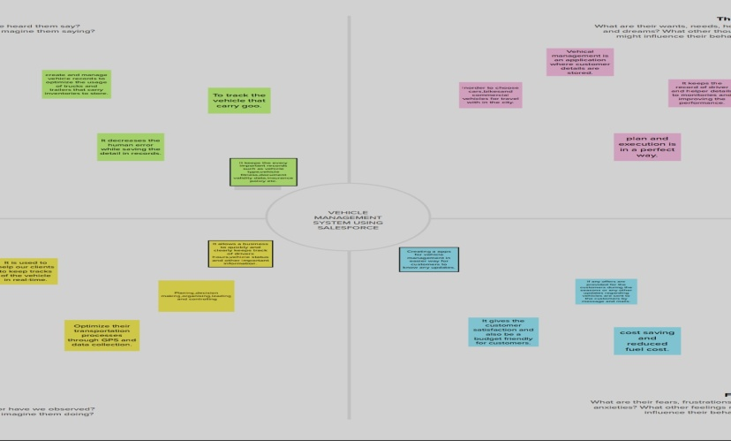

**2.2 Ideation &Brainstorming map**

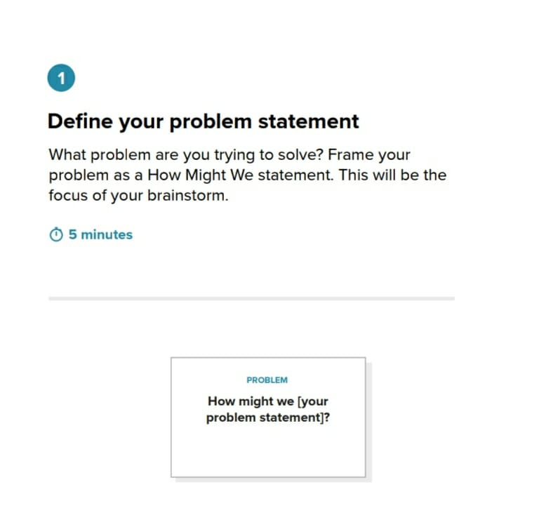

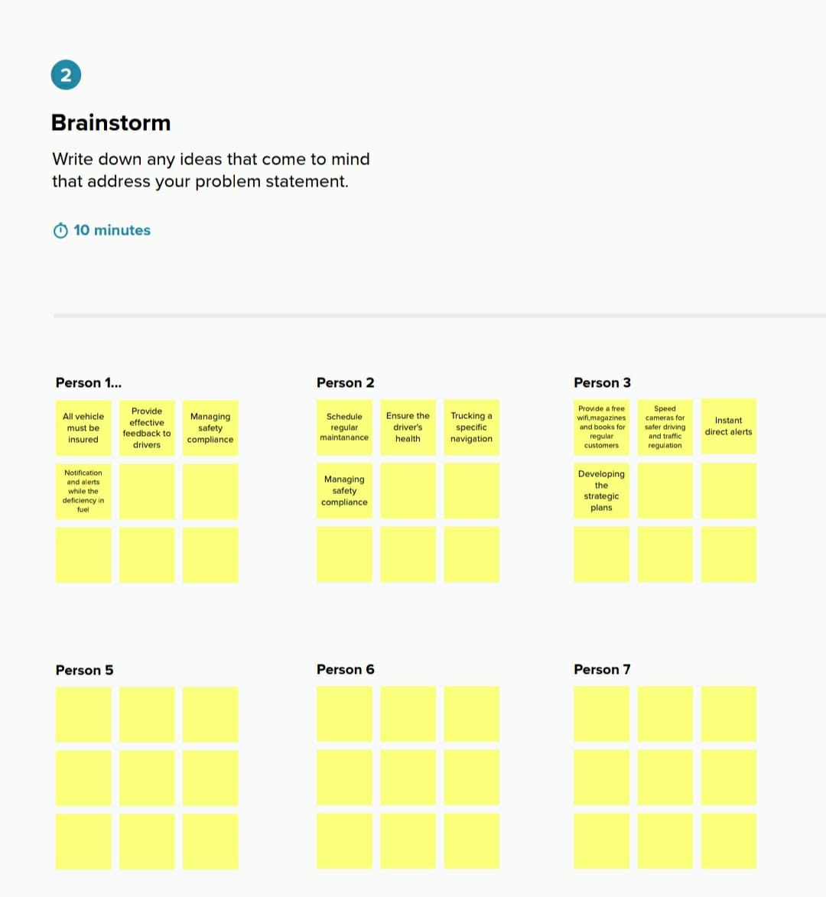

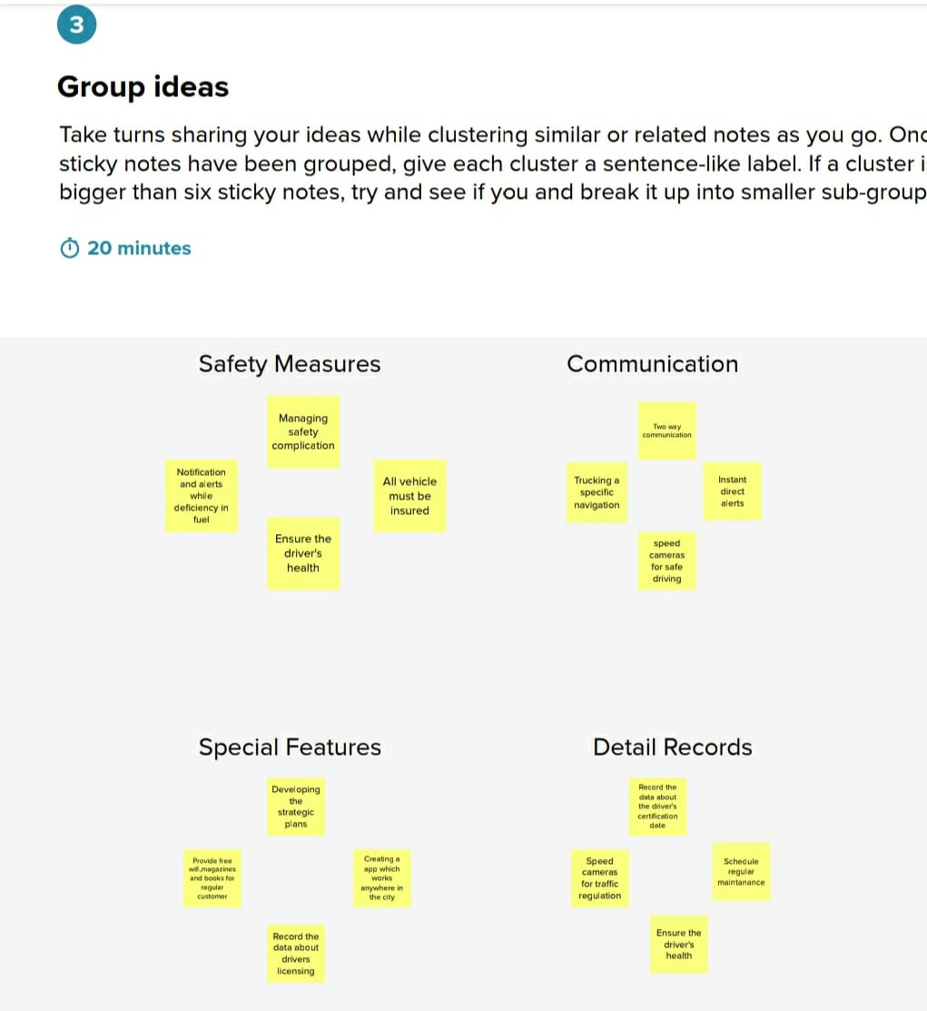

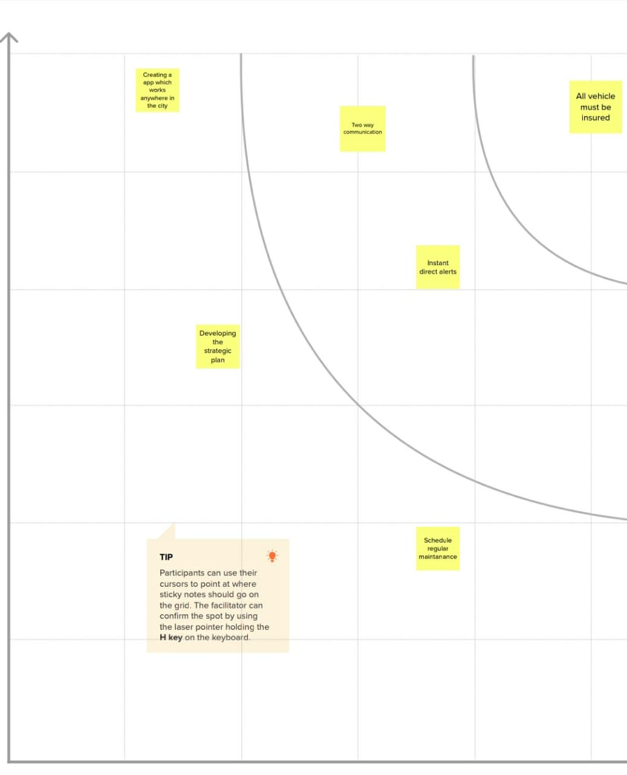

3.RESULT [3.1 DATA MODEL]

|  |  |
| --- | --- |
| Object name | Fields in the object |
| Vehicle | |  |  |  | | --- | --- | --- | | S.No | Field Names | Data Types | | 1 . | Customer Name | Text | | 2. | Customer Mobile No | Numbers | | 3. | Vehicle Type   * 2wheelers * 4wheelers | Picklist | | 4. | 2WHEELERS   * HERO * HONDA * BAJAJ * ROYAL ENFIELD * TVS * KINETIC * OLA * JAWA * SD * BATTERY | Picklist | | 5. | 4WHEELERS   * RENAULT * SKODA * HONDA * HYUNDAI * SUZUKI * MAHINDRA * VOLKSWAGEN * BENZ * AUDI * VOLVO | Picklist | | 6. | Vehicle Name | Text | | 7. | Vehicle No | Text | | 8. | Chassic No | Text | | 9. | Colour | Text | | 10. | Body Type | Text | | 11. | Vehicle Includes   * Fire Extenuation * First Aid Kit * Multi Charger Kit * Stepney * Stereo * Tool Kit * Tracking Device * Tyre Jack | MultiPicklist | | 12. | Condition   * **Good** * **Medium** * **Least** | Picklist | | 13. | Mileage | Text | | 14. | Seats | Numbers | | 15. | Start Date | Date/Time | | 16. | End Date | Date/Time | | 17. | Opportunity | Lookup  (opportunities) | |
| **Drivers** | |  |  |  | | --- | --- | --- | | S.No | Field Name | Data Type | | 1. | Driver Name | Text | | 2. | Licence No | Text | | 3. | Mobile No | Number | | 4. | Fair Per Hour | Text | | 5. | Vehicle | Lookup  (opportunities) | |

3.2 Activity & Screenshot

* First ,we can ceate a developer account in salesforce.

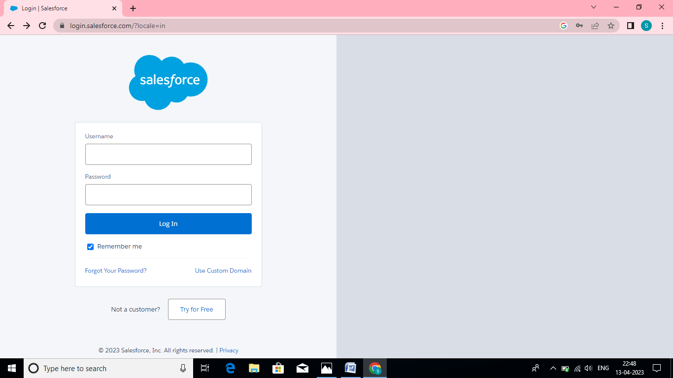

* **Next we need to create an objects that relates to our topic,and type their details of the objects.**

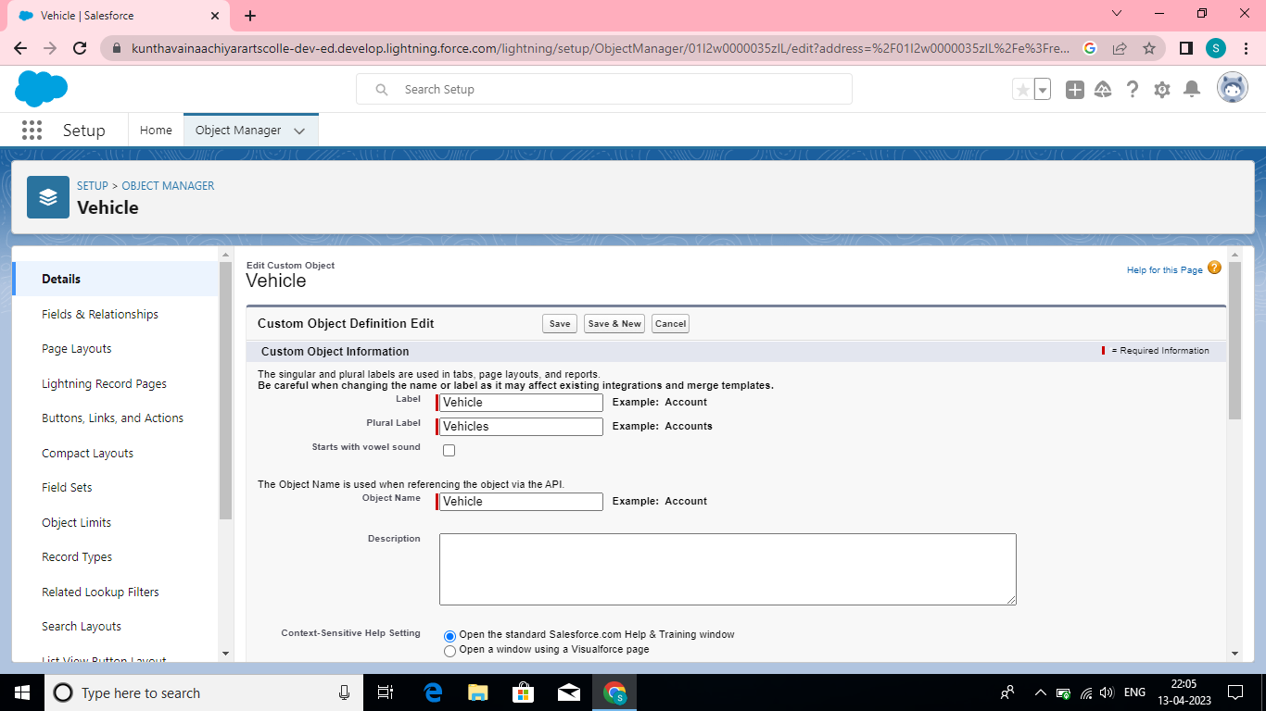

* **Then we have to create a field and relationship for the created object.nextly we need to create a user and profile for vehicle manager.**

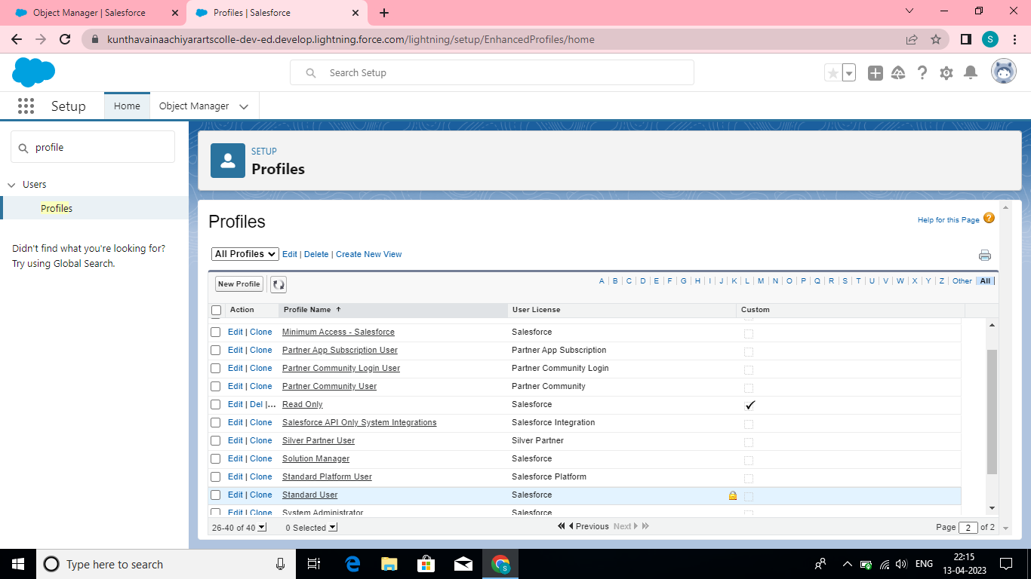

* **The next step is to create a reports for a objects that we have created and also create a dashboard too.**

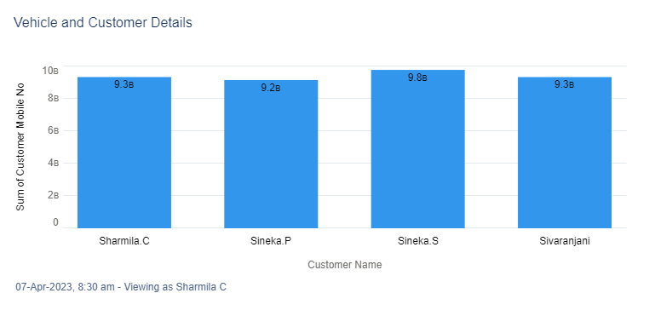

Dashboard for vehicle object

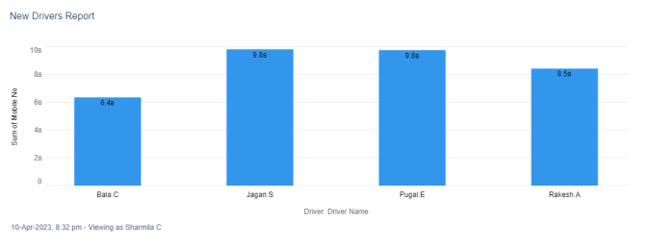

#### Dashboard for driver object

**4. TRAILHEAD PROFILE PUBLIC URL**

**Team lead-** https://trailblazer.me/id/s2020batch2

**Team Member 1-** <https://trailblazer.me/id/s2020batch>

**Team Member 2-** http://trailblazer.me/id/s2020batch8

**Team Member 3-** https://trailblazer.me/id/s2020batch7

**5.ADVANTAGES**

* **It improves productivity by saving delivery time due to use of advance route information,traffic alerts etc.**
* **It helps to reduce cost of fuel.**
* **It ensure safety of vehicles,drivers and goods.**
* **It provides real time location of fleets and serves the customers in better way.**
* **It helps in saving of maintenance cost by maintaining fleet effectively.**

**DISADVANTAGES**

* **Gps device used in fleet management is power hungry which drains battery faster.**
* **It requires skilled resources to maintain such system.**
* **Active tracking based fleet management requires monthly subscription charges and data usage charges**
* **It is difficult to manage ana maintain fleet management system due to use of multiple technologies such as cloud servers,cellular wireless system,fleet management software etc.**

**6.APPLICATIONS**

* **Complete database of customers**
* **SMS alerts for service reminder**
* **Promote service center**
* **Maitain service records**
* **Customize the report according to business**
* **Develope operational expenditure model**
* **GPS tracking**

**7.CONCLUSION**

**I have come to the conclusion that change is good because it mean that transport can evolve ant the technology can improve over time.Newer technology is improving our lives by making transport easir to access. Transport has become faster and there are move advantages to travelling in a car .Also the safety of the traveler should be ensured.**

**8.FUTURE SCOPE**

* **We can give more advance software for Vehicle Management System including more facilities.**
* **We will host the platform on online server to make it accessible worldwide.**
* **Integrate multiple drivers to pickup the customers.**
* **Create a vehicle and driver database structure to reduce the overload of the database queries.**
* **Implement the backup mechanism foe taking backup of codebase and database on regular basis on different servers.**