Mr. OO Matlala
u21740012@tuks.co.za

AI -Powered Insider Threat Detection System
COS720 Project


Generative AI declaration form for assignment submission

Q1. Student Information
Name & Surname | Oarabile Matlala
Student Number | u21740012
Course Code | COS720
Assignment Title | COS720 Computer Information & Security I Project Specification 2026

Q2. AI Declaration [tick one box]
- I used Generative Artificial Intelligence in the current assignment
- I did not use any Gen AI for the current assignment

Ensure you are permitted to use generative AI by reading the instructions for your assignment or assessment, or by consulting your study guide. Failure to follow the instructions regarding using generative AI for your assignment constitutes academic dishonesty. Examples of generative AI include ChatGPT, Google's Gemini, Microsoft's Copilot, Claude, and Meta's Llama 3 AI integrated into WhatsApp and Facebook. If you selected option 1 in Q1, please continue to complete the rest of the form:

Q3. Prompts used
Please paste all the prompts you created for the assignment and indicate which aspect(s) of the assignment the specific prompt was used for.
AI Tool | Prompt | Aspect of Assignment
Chatgpt | Recommend a simple tech stack with easy frontend development for an AI powered detection web application that analyses csv. Preferred language is python | For helping decide on a tech stack
Claude | Why is this code giving an error | Debugging errors
Chagpt | How can I word this sentence/paragraph better | Language correction suggestions
Chatgpt | Recomment referencing tool between EndNote and LaTex | Deciding on a reference and citation tool
Claude | Explain F1-score vs accuracy | Help me understand metrics for AI evaluation

Q4. Type of usage
Briefly describe the features for which you used the Gen AI. You may say “Not Applicable” where needed:
Feature used | Description
Brainstorming and idea generation | Helped me decide between different tech stacks to use for implementing my prototype
Language editing suggestions | Helped with correcting and strengthening my language for an academically acceptable paper
Feedback and revision suggestions | Not Applicable
Explaining complex concepts | Used to explain AI performance metrics
Writing coach | Helped with structuring report in an academically acceptable manner
Other (please specify): | Helped with errors, testing and debugging code

Q5. Ethical use
Write a brief paragraph explaining how you ensured the usage of Gen AI was aligned with the ethical and responsibility requirements of the University of Pretoria (link). Consider examples such as repurposing and reintegrating ideas generated by Gen AI with your own thoughts, integrating Gen AI ideas with other literature, critically evaluating Gen AI outputs, maintaining transparency about Gen AI usage, enhancing your learning and ensuring comprehension despite using Gen AI, and personal development through using Gen AI as an assistant. If you directly used text or data generated by Gen AI, ensure it was cited appropriately.

Ethical use statement:
I believe my use of AI was ethical and responsible, I ensure that AI was used to support and strengthen my ideas and solutions rather than using generative solutions that were not my own. I used AI for assistance with technical and language errors, to ensure the quality of my work. I used AI to help understand and explain concepts that I struggled to grasp, I used it as a tool for learning rather than a replacement for learning.

Q6. Why did you use Gen AI?
I used Gen AI to strengthen the quality of my own work, fix errors and to better understand concepts related to my assignment

Signature:
Student Signature
Date | 17/05/2026

Note: The Department of Education Innovation would like to thank Prof. Celeste Combrinck and Ms. Nelé Loubser for their innovative ideas, which have been instrumental in creating our new form.

AI -Powered Insider Threat Detection System

1. RESEARCH OVERVIEW

1.1 What is an insider threat

The objective of this project is to develop a lightweight AI-powered prototype system that detects potential insider threats based on a user’s behaviour recorded on organisational logs. Firstly, one must define what an insider threat is. An insider threat can be defined as an individual that abuses their privileged access rights within a corporation to maliciously compromise the organizational assets [1]. There can also be different types of insider threats categorized as traitors, impersonators and unintentional perpetrators[1]. Traitors are legitimate users with malicious intent to abuse the privileged access. Masquerades are outsider adversaries who managed to obtain privileged access of a legitimate user. Unintentional perpetrators are legitimate users who unintentionally pose a threat to assets by making mistakes or negligence.[1]

1.2 Use of Artificial Intelligence for behavioural detection

The use of artificial intelligence is very important and critical to detecting insider threats as because insider threats have authorised access to organisational assets and thus do not trigger traditional security alarms meant mainly to deter outside threats[2]. This makes the most affective means of detection to be behavioural analysis to identify unusual behaviour, and this is where machine learning will be a very useful tool. Manual monitoring of users’ interactions and data can prove to be very difficult especially in large companies with far larger and complex data to keep track of, so automating monitoring and detection with ML is essential[2]. ML algorithms can learn patterns from historical organisational behavioural data and then classify future data as being normal or malicious. ML algorithms allow for a far more adaptive behavioural detection system that can detect different kinds of behavioural threats that would be difficult to detect manually or with predefined rules[1].

1.3 Traditional rule-based systems vs ML-based systems

Traditional rule-based systems are limited to very predefined rules limiting adaptability to more complex and varying behavioural threat patterns. This means they often fail to detect evolved threat behaviours that may arise[2]. With ML-based systems these limitations are almost non-existent because instead of relying on predefined rules, ml algorithms adapt historical data of passed normal and malicious behaviour and can interpret more complex behavioural patterns that traditional systems may fail to identify. ML-based systems can also adapt to different scenarios instead of manually defining rules for each. ML-based systems also help to mitigate false detections where rule-based systems tend to produce them.

Traditional rule-based systems a still be useful for defining more specific activity and behaviour while ML will.

1.4 Research Paper Summary: Digital Forensic Readiness to Mitigate Insider Threats in the SaaS Cloud Environment

This paper focuses on combating insider threats in Software as a Service(SaaS) platforms by using the principles of digital forensic readiness[3]. The paper sees how SaaS is highly vulnerable to threats of individuals who have legitimate access right and thus can bypass traditional detection systems. Traditional security is also usually reactive which can lead to investigation delays and insufficient evidence collection. The paper proposes a DFR-BUST framework that pushes for proactive forensic readiness. The framework has 5 components that work to integrate forensic readiness, SaaS Evidence Preparation (SEP) for identification of essential logs across SaaS systems, Detection Engine Process (DEP) for analysis of normalized data for early indicators of malicious activity, Evidence Archival and Preservation (EAP) for evidence storage and preserving integrity, Analyst and Forensic Review (AFR) to aid in investigative interpretation and Audit and Documentation Process (ADP) to maintain investigative integrity and admissibility[3]. The framework is tested on a simulated scenario-based proof of concept that follows four phases: Baseline behaviour, Emerging Deviation, Escalation and Exfiltration, Departure. ML is only implemented as a support mechanism for investigative reasoning rather than detecting malicious behaviour[3].

  - Research Gap

Unlike DFR-BUST this project implements ML into a standalone behavioural detection system[3]. This project will utilize large-scale behavioural record evaluation rather than being limited to a scenario-driven prototype.

2. DATA PREPARATION

2.1 Dataset Overview

This project uses the “Insider Threat Dataset for Behavioural Features & Threat Classification Dataset for Security Assessment” obtained from Kaggle as the primary and only dataset. The dataset contains organizational activity logs of users and each record is either labelled as normal or malicious. The activity recorded includes, printing activity, contract status, file burning activity, access frequency, weekend access and foreign travel. The dataset will be used for training and testing of the Inside threat detection prototype.

2.2 Data Cleaning and Preprocessing

Before training model on the dataset, steps had to be taken to preprocess and prepare the dataset for training.
Missing values within the feature trip_day_number were handled by replacing the missing value with 0 to ensure the machine learning model can process the data without errors

Categorical features like employee department, employee campus, employee position, employee origin country transformed into numerical representation for the model to be able to process them as numerical input.

The dataset was split into training and testing data. The split was 50/50 with the traing data being used to train the ML model and the testing data being used for model performance evaluation as well as testing the behavioural upload functionality of the system. The upload testing data was also further split based on the is_malicious feature to have uploads of predominantly malicious behavioural records, normal behavioural records and balanced mixed record of normal and malicious behaviour.

2.3 Selected Features and Justification

Below is a table of features selected and the justification for their selection:
Feature | Justification
entry_during_weekend | This indicates unusual access time behaviour
burned_from_other | This may indicate that data was transferred from outside sources
total_files_burned | Indicates possible data exfiltration attemps
num_entries | Very high volume of entries may indicate suspicious behaviour
num_printed_pages_off_hours | This indicates unusual printing activity outside working hours
late_exit_flag | This indicates unusual behaviour outside working hours
num_unique_campus | This indicates unusual behaviour of moving between multiple different campuses
employee_classification | Indicates access/privilege level
is_abroad | To track suspicious behaviour risk of foreign access
hostility_country_level | Indicates potential threat of access from high-risk countries

All these features selected are indicators of the access level employees have, where the employees’ access from and the environmental influences from where they access data, when they access data especially when outside of working hours and their access activities like entries, printing, or burning files. These can all form a key indicator of potential insider threat behaviour and can be used for explainability and forensic reasoning.

3. Machine Learning Model Selection and Implementation

For this project it was important that the best fit model would be selected for the behavioural detection system. The goal of the project is to implement a very accurate and precise Insider Threat Detection system so model performance was a key factor for model selection. It was also important to look at models used in the research papers studied for this project.

3.1 Candidate Models

The following machine learning models were tested and evaluated to determine if they were suitable for the Insider Threat Detection System:
- Decision Tree
- Random Forest
- Logistic Regression
- Gradient Boosting
- Linear Support Vector Machine
These models all presented different classification approaches, making them perfect for exploring the best algorithm amongst them.

3.2 Model Performance Comparisons

These tests were ran using compare_models.py. The results are as follows:
Model | Accuracy | Precision | Recall | F1
Random Forest | 97.17% | 76.45% | 68.62% | 72.32%
Gradient Boosting | 97.19% | 84.12% | 58.91 | 69.29%
Decision Tree | 96.09% | 63.52% | 64.23% | 63.87%
Linear SVM | 88.49% | 29.26% | 80.24% | 42.88%
Logistic Regression | 87.88% | 28.18% | 80.86% | 41.8%

3.3 Final Model Selection
The model selected for this project was the Random Forest model. When looking at the performance comparison Random Forest had the best overall performance metrics most suited for this project. Gradient Boosting had the highest precision score, however Random Forest had the best F1-score as it had a better balance between precision and recall, which is important for minimizing false negative and false positives.

This is selection is also supported in Manoharan et al. findings[2], which also saw Random Forest achieve the best overall performance amongst other machine learning models for insider threat detection using the CERT dataset[2].

4. Prototype

4.1 Implementation and Tech Stack
The prototype was implemented as a streamlit web-based application. Python and streamlit were selected to develop the application because the are powerful tools for developing and presenting data and AI/ML applications. Python is industry standard for AI/ML applications and Streamlit does an excellent job at developing a frontend for data representation without requiring the use of (html/css) allowing you to build the frontend purely with Python.

4.2 System Components

User Interface: The prototype provides a web-based dashboard, with clear features representations like an upload csv, running analysis of profiles and view of results.
Prediction Model: the system utilizes a trained Random Forest model to label uploaded csv records.
Model prediction service: a ready trained model will generate predictions of normal or malicious behaviour from the provided csv input records.
Explanation Service: The model will produce human-readable explanations based on behavioural indicators from the uploaded csv records.
Logging Service: the system will allow for analysis results and explanations to be stored in a prediction logs file.

4.3 Prototype Features

CSV Upload: User can upload behavioural csv records to be analysed for insider threat detection.
Batch Analysis: The system can analyse multiple records as a batch and provide a summary for the entire batch of records.
Selected Record Analysis: This system can analyse single records from a batch of records.
Confidence Score: System displays the confidence scores of classifications.
Explanation: The system provides human-readable explanations for model classification.
Prediction logging: The system allows for storing of results.
Model description: The system allows for viewing of the model details as well as it’s evaluation features and scales.

4.4 UML Diagrams
Use Case Diagram:
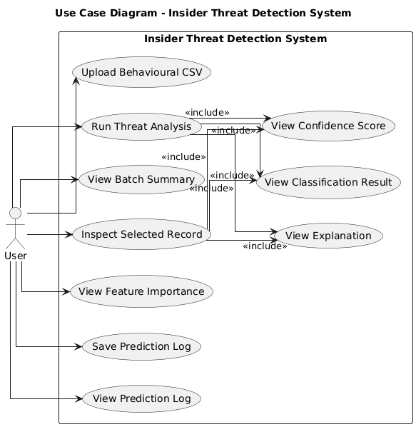

System Architecture:
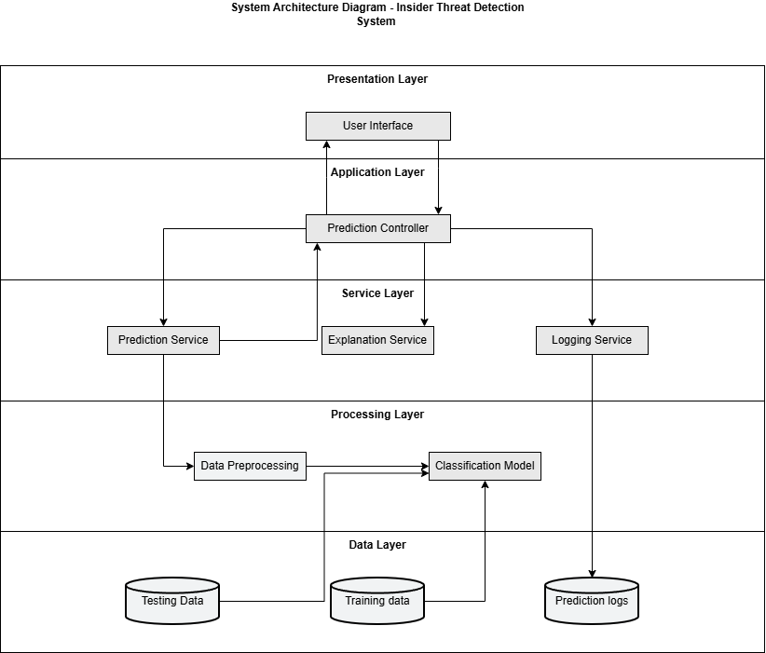

Activity Diagram:
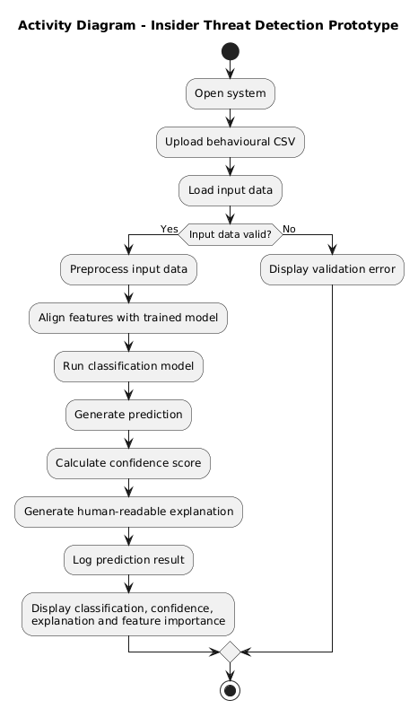

5. Evaluation and Results

This section will cover the performance evaluation of the Random Forest model use for the prototype Insider Threat Detection system. There are multiple measures of the model’s performance tested to ensure that the predictions are as accurate as possible with minimum false positives and false negatives.

5.1 Evaluation Metrics
The following metrics are used to evaluate the model’s performance:
- Accuracy: Measures the proportion of records that were correctly classified over the total number of records.
- Precision: Measures the number of records labelled as malicious were correctly classified.
- Recall: Measures the number of actual malicious records were successfully classified by the model
- F1-score: Measures the balance between precision and recall.
- Confusion Matrix: Shows the distribution of correct and incorrect predictions across all classes

5.2 Results

Random Forest performance table:
Metric | Score
Accuracy | 97.15%
Precision | 76.68%
Recall | 67.65%
F1-score | 71.88%

Random Forest confusion matrix:

 | Predicted Normal | Predicted Malicious
Actual Normal | 55,457 | 657
Actual Malicious | 1,033 | 2,160

5.3 Results Discussion

The model scores a high accuracy of 97.15%, indicating that most predicted classifications were correct. However, the dataset is imbalanced containing mostly normal behavioural records. This is why metrics like precision, recall and f1-score are important measures to see how well the model correctly identifies malicious records.

The model scores a precision of 76.68% which indicates that the model correctly classifies records as malicious 3 out of 4 times. This indicates a decently accurate classification of records as being malicious.

The model scores a recall of 67.65% which indicates that the model successfully identified 2 thirds of the malicious records successfully. This shows decent malicious detection capability but still means that a third of malicious behaviour may go undetected.

The model scores an overall f1-score of 71.88% indicating a high balanced performance between precision and recall.

The confusion matrix shows the number of records that are:
- True negatives: 55,457
- False positives: 657
- False negatives: 1,033
- True positives: 2,160

5.4 Strengths:

- The model scores high overall accuracy
- The model has very low false positive predictions, meaning falsely flagging normal records as malicious
- The model detects insider threat behaviour most of the time

5.5 Weaknesses:

- The model still misses several malicious records
- Malicious behaviour patterns of insider threats vary making it difficult for the model to generalize.
- Behavioural indicators alone may not be enough to determine malicious intent
- Dataset may not fully represent real world corporate environments

5.6 Possible Improvements

With the main weakness of the system being that several insider threat records are missed by the system several possible improvements could be made to minimize this.
- Adjust scaling thresholds to be more sensitive to malicious behaviour
- Add additional features as possible indicators
- Test other supervised machine learning models, such as XGBoost
- Using an even larger dataset with a larger number of malicious behavioural records and more representative of real-world corporate environments

6. Limitations and Ethical Concerns

6.1 Limitations

Overall, the system performs well at insider threat detection, however it still faces several limitations that must be considered.

Firstly, determining behavioural activity that could indicate malicious intent is very tricky within corporate environments especially since insider threats utilize privileged access. Corporate behavioural activity alone may not be enough to determine whether there is malicious intent and activity that may seem suspicious may have legitimate context, such as working overtime.

Secondly, there can be different types of insider threats as described in the overview with different origin such as an impersonator which is an outside individual that has managed to gain insider access privileges usually through theft of credentials.

Thirdly, the dataset used for this project may not fully represent real-world corporate environments. The performance of the model may differ when applied and used in a real-world environment. The dataset also contains very few malicious records compared to normal which affects the quality of its detection.

Another limitation of behavioural threat detection is behavioural indicators do not constitute direct forensic evidence of malicious activity. All the system can do is flag suspicious behaviour that may indicate potential insider threats. This means that effective evidence collection and investigation is still required to truly determine an insider threat.

Finally, the reality is false positives, and false negatives will likely always remain possible. This means the system could cause false accusations and could still miss insider threat behaviour. The system will likely require the combination of other security frameworks to cover its inaccuracies, such as human oversight, readiness and response frameworks.

6.2 Ethical Considerations

The nature of behavioural activity monitoring of employees will of course raise ethical concerns of privacy. The effectiveness of the model’s performance relies heavily on the data extensive data collected on employees’ activities. Excessive monitoring and collecting employee information may cause concerns for privacy, and responsible data usage. Employees may also be made aware of and consent to monitoring and data usage policies.

The system still runs the risk of false positives. This means that employees may be falsely accused of insider threat behaviour despite operating legitimately. This may cause unnecessary investigations and even unfair disciplinary action.

Machine learning systems are not perfect and can be wrong and biased. Their performance heavily relies on the quality of the data they are trained on. This is also means they can be manipulated and poisoned by the corrupted data which leads to unfair and false predications.

With these ethical concerns it is important that the proposed system is used as a supportive tool for identifying insider threats rather than an a fully trusted decision maker. As mentioned, it should be combined with human oversight as well as readiness and response frameworks to ensure a fair, insightful and evidence backed decision is made to determine an insider threat.

7. Bibliography

1. Liu, L., Detecting and Preventing Cyber Insider Threats: A Survey. IEEE COMMUNICATIONS SURVEYS & TUTORIALS, 2018. 20(2): p. 21.
2. Manoharan, P., Insider threat detection using supervised machine learning algorithms. Springer Science+Business Media, LLC, 2023: p. 17.
3. Shoderu, G.O., Digital Forensic Readiness to Mitigate Insider Threats in the SaaS Cloud Environment. The Indonesian Journal of Computer Science, 2025. 14(6): p. 14.

