
102003/CS500A • COMPUTER NETWORKS
COMPUTER NETWORKS
LAB CODEBOOK

Submitted in partial fulfillment of the requirements for the award of the degree of
Bachelor of Technology
in
Computer Science and Engineering
Name: _______________________________________
Roll No.: ______________ University Reg. No.: ___________________
Department of Computer Science and Engineering
Rajagiri School of Engineering & Technology (Autonomous)
(Parent University: APJ Abdul Kalam Technological University)
Rajagiri Valley, Kakkanad, Kochi – 682039
September 2026

INDEX / REVISED LAB CYCLE

Experiment pages begin at 1; cover and index are unnumbered. Dates follow the supplied reference record.
Sl. No. | Experiment name (revised lab cycle) | Date | Page No.
1 | Familiarization of (a) Linux network configuration files and commands; (b) shell scripting for IP, gateway, connectivity and routing | 18/07/2026 | 1
2 | Implement client–server communication using socket programming and TCP | 18/07/2026 | 5
3 | Implement client–server communication using socket programming and UDP | 15/07/2026 | 15
4 | Implement Stop-and-Wait, Go-Back-N and Selective Repeat ARQ | 05/08/2026 | 18
5 | Implement and simulate Distance Vector Routing | 19/08/2026 | 24
6 | Implement and simulate the Leaky Bucket algorithm | 02/09/2026 | 27
7 | Implement Simple Mail Transfer Protocol | 09/09/2026 | 33
8 | Implement File Transfer Protocol | 09/09/2026 | 37
9 | Introduction to Wireshark | 01/07/2026 | 40
10 | Familiarization with NS2 | 08/07/2026 | 41
11 | Study of Packet Tracer | 01/07/2026 | 42
Experiments 9–11 are familiarization records based on Familiarisation.docx; no screenshots are required for those three entries.

EXPERIMENT 01 / 18/07/2026
Familiarization: Linux networking and automatic network configuration

Aim: Inspect Linux network configuration and automate IPv4 address, default gateway, connectivity test and routing capture.
TITLE / Basics of network configuration files and networking commands in Linux
Inspect /etc/hosts (local name mappings), /etc/resolv.conf (DNS resolvers), and the network manager’s distribution-specific configuration. Use the commands below to inspect addresses, routes, listening sockets and reachability.
PROGRAM / Linux commands
ip addr show — list interfaces and IP addresses
ip route show — show the routing table and default gateway
ping -c 1 127.0.0.1 — test local connectivity
ss -tuln — show listening TCP/UDP sockets
cat /etc/hosts — read local hostname mappings
cat /etc/resolv.conf — read DNS resolver settings
SCREENSHOT OF OUTPUT
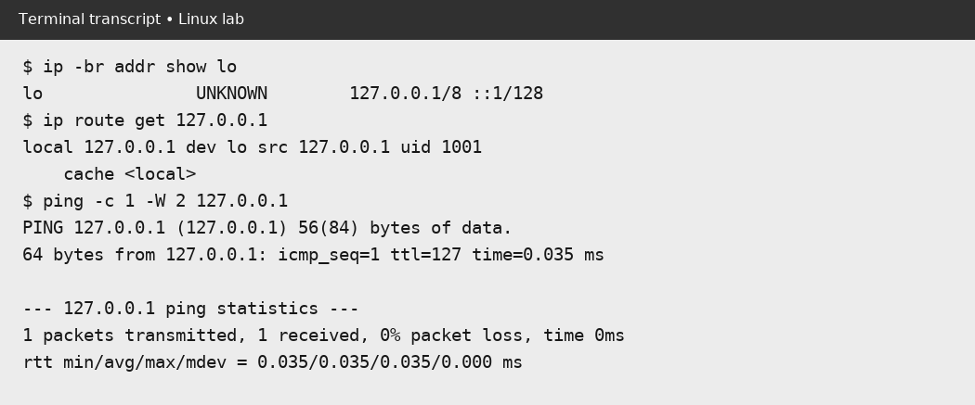
Rendered transcript of commands executed on the local loopback interface; not a claim of campus-network configuration.

EXPERIMENT 01 / 18/07/2026
Familiarization: Linux networking and automatic network configuration

This script was written for revised Day 1(b); no shell-script source was supplied in the original repository.
PROGRAM / network_setup.sh / PART 1 OF 2
#!/usr/bin/env bash
# Configure an IPv4 interface, set its default route, verify connectivity,
# and save the routing table. Run as root for changes; --dry-run is safe.
set -euo pipefail
usage() {
echo "Usage: $0 [--dry-run] INTERFACE ADDRESS/CIDR GATEWAY TEST_HOST [ROUTE_FILE]" >&2
exit 2
}
dry_run=0
if [[ ${1:-} == --dry-run ]]; then
dry_run=1
shift
fi
[[ $# -ge 4 && $# -le 5 ]] || usage
iface=$1
address=$2
gateway=$3
test_host=$4
route_file=${5:-routing_info.txt}
# Avoid passing arbitrary interface names or addresses to privileged commands.
[[ $iface =~ ^[a-zA-Z0-9_.:-]+$ ]] || usage
[[ $address =~ ^[0-9.]+/[0-9]+$ ]] || usage
[[ $gateway =~ ^[0-9.]+$ ]] || usage
[[ $test_host =~ ^[a-zA-Z0-9.:-]+$ ]] || usage
command -v ip >/dev/null && command -v ping >/dev/null || {
echo "Install iproute2 and iputils-ping first." >&2

EXPERIMENT 01 / 18/07/2026
Familiarization: Linux networking and automatic network configuration

PROGRAM / network_setup.sh / PART 2 OF 2
exit 1
}
if (( ! dry_run && EUID != 0 )); then
echo "Root privileges are required; rerun with sudo or use --dry-run." >&2
exit 1
fi
run() {
printf '+ '
printf '%q ' "$@"
printf '\n'
if (( ! dry_run )); then "$@"; fi
}
run ip addr replace "$address" dev "$iface"
run ip link set "$iface" up
run ip route replace default via "$gateway" dev "$iface"
if (( dry_run )); then
echo "DRY RUN: configuration and ping were not executed."
echo "DRY RUN: would ping $test_host and save 'ip route show' to $route_file."
exit 0
fi
# Save the route even if the connectivity test fails.
status=0
ping -c 2 -W 2 "$test_host" || status=$?
ip route show | tee "$route_file"
echo "Routing information saved to $route_file"
exit "$status"

EXPERIMENT 01 / 18/07/2026
Familiarization: Linux networking and automatic network configuration

SCREENSHOT OF OUTPUT / network_setup.sh --dry-run
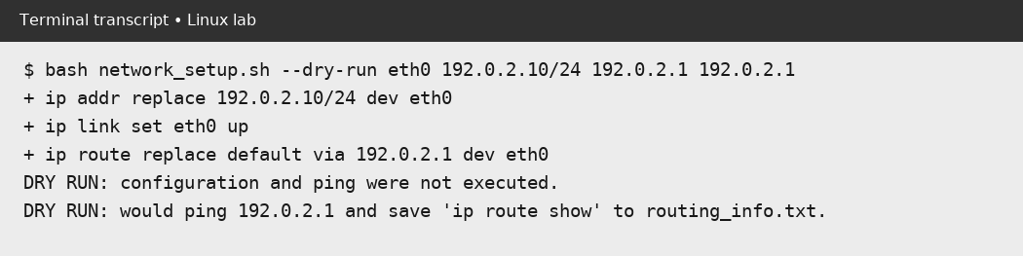
Dry-run evidence only: the script prints the three configuration commands but does not change an interface, run ping or write a route file. Run with sudo on a lab machine to perform and capture those steps.
RUN ON A LAB MACHINE
sudo bash network_setup.sh eth0 192.0.2.10/24 192.0.2.1 192.0.2.1 routes.txt
Use addresses and an interface supplied by your instructor. Changing the default route can disconnect a remote session.

EXPERIMENT 02 / 18/07/2026
Client–server communication using TCP socket programming

Aim: Exchange data between a TCP server and client, then explore chat and remote-calculator variants.
Note: Run each TCP server/client pair separately: all three server variants use port 5000. The calculator variant needs a JDK with JShell.
PROGRAM / TCPServer.java
import java.io.*;
import java.net.*;
public class TCPServer {
public static void main(String[] args) {
try {
ServerSocket serverSocket = new ServerSocket(5000);
System.out.println("Server is listening on port 5000...");
Socket socket = serverSocket.accept();
System.out.println("Client connected.");
BufferedReader in = new BufferedReader(new InputStreamReader(socket.getInputStream()));
PrintWriter out = new PrintWriter(socket.getOutputStream(), true);
String clientMessage = in.readLine();
System.out.println("Client says: " + clientMessage);
out.println("Hello from Server!");
socket.close();
serverSocket.close();
}
catch (IOException e) {
e.printStackTrace();
}
}
}

EXPERIMENT 02 / 18/07/2026
Client–server communication using TCP socket programming

PROGRAM / TCPClient.java
import java.io.*;
import java.net.*;
public class TCPClient {
public static void main(String[] args) {
try {
Socket socket = new Socket("localhost", 5000);
BufferedReader in = new BufferedReader(new InputStreamReader(socket.getInputStream()));
PrintWriter out = new PrintWriter(socket.getOutputStream(), true);
out.println("Hello from Client!");
String serverMessage = in.readLine();
System.out.println("Server says: " + serverMessage);
socket.close();
}
catch (IOException e) {
e.printStackTrace();
}
}
}

EXPERIMENT 02 / 18/07/2026
Client–server communication using TCP socket programming

PROGRAM / TCPServerChat.java
import java.io.*;
import java.net.*;
import java.util.Scanner;
public class TCPServerChat {
public static void main(String[] args) {
try {
ServerSocket serverSocket = new ServerSocket(5000);
System.out.println("Server is listening on port 5000...");
Socket socket = serverSocket.accept();
System.out.println("Client connected.");
BufferedReader in = new BufferedReader(new InputStreamReader(socket.getInputStream()));
PrintWriter out = new PrintWriter(socket.getOutputStream(), true);
Scanner scanner = new Scanner(System.in);
while (true) {
String clientMessage = in.readLine();
System.out.println("Client says: " + clientMessage);
System.out.print("Send to client: ");
String msg = scanner.nextLine();
out.println(msg);
if ("exit".equalsIgnoreCase(msg)) {
System.out.println("Server shutting down connection...");
break;
}
}
}
catch (IOException e) {
e.printStackTrace();
}
}
}

EXPERIMENT 02 / 18/07/2026
Client–server communication using TCP socket programming

PROGRAM / TCPClientChat.java
import java.io.*;
import java.net.*;
import java.util.Scanner;
public class TCPClientChat {
public static void main(String[] args) {
try {
Socket socket = new Socket("localhost", 5000);
BufferedReader in = new BufferedReader(new InputStreamReader(socket.getInputStream()));
PrintWriter out = new PrintWriter(socket.getOutputStream(), true);
Scanner scanner = new Scanner(System.in);
while (true) {
System.out.print("Send to Server: ");
String msg = scanner.nextLine();
out.println(msg);
String serverMessage = in.readLine();
System.out.println("Server says: " + serverMessage);
if ("exit".equalsIgnoreCase(msg)) {
System.out.println("Disconnecting from server...");
break;
}
}
}
catch (IOException e) {
e.printStackTrace();
}
}
}

EXPERIMENT 02 / 18/07/2026
Client–server communication using TCP socket programming

PROGRAM / TCPServerCalc.java / PART 1 OF 2
import java.io.*;
import java.net.*;
import jdk.jshell.JShell;
import jdk.jshell.SnippetEvent;
import java.util.List;
public class TCPServerCalc {
public static void main(String[] args) {
try {
JShell jshell = JShell.create();
ServerSocket serverSocket = new ServerSocket(5000);
System.out.println("Calculator is listening on port 5000...");
Socket socket = serverSocket.accept();
System.out.println("User connected.");
BufferedReader in = new BufferedReader(new InputStreamReader(socket.getInputStream()));
PrintWriter out = new PrintWriter(socket.getOutputStream(), true);
while (true) {
String clientMessage = in.readLine();
System.out.println("User says: " + clientMessage);
if ("exit".equalsIgnoreCase(clientMessage)) {
System.out.println("Calculator shutting down connection...");
break;
}

EXPERIMENT 02 / 18/07/2026
Client–server communication using TCP socket programming

PROGRAM / TCPServerCalc.java / PART 2 OF 2
List<SnippetEvent> events = jshell.eval(clientMessage);
if (!events.isEmpty()) {
SnippetEvent event = events.get(0);
// Check if the calculation was successful
if ("VALID".equals(event.status().name()) && event.value() != null) {
out.println("Result: " + event.value());
System.out.println("Result: " + event.value());
} else {
out.println("Error: Invalid syntax or incomplete expression.");
System.out.println("Error: Invalid syntax or incomplete expression.");
}
}
else {
out.println("Error: Could not parse input.");
}
}
}
catch (IOException e) {
e.printStackTrace();
}
}
}

EXPERIMENT 02 / 18/07/2026
Client–server communication using TCP socket programming

PROGRAM / TCPClientCalc.java
import java.io.*;
import java.net.*;
import java.util.Scanner;
public class TCPClientCalc {
public static void main(String[] args) {
try {
Socket socket = new Socket("localhost", 5000);
BufferedReader in = new BufferedReader(new InputStreamReader(socket.getInputStream()));
PrintWriter out = new PrintWriter(socket.getOutputStream(), true);
Scanner scanner = new Scanner(System.in);
while (true) {
System.out.print("Send to Calculator: ");
String msg = scanner.nextLine();
out.println(msg);
String serverMessage = in.readLine();
System.out.println(serverMessage);
if ("exit".equalsIgnoreCase(msg)) {
System.out.println("Disconnecting from Calculator...");
break;
}
}
}
catch (IOException e) {
e.printStackTrace();
}
}
}

EXPERIMENT 02 / 18/07/2026
Client–server communication using TCP socket programming

SCREENSHOT OF OUTPUT
TCP server
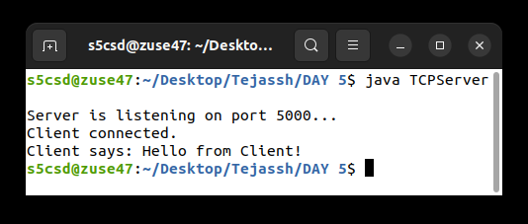
TCP client
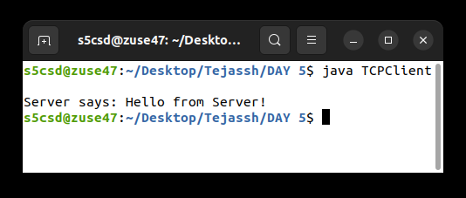
Evidence: cropped views of the original PNG terminal captures stored in this repository.

EXPERIMENT 02 / 18/07/2026
Client–server communication using TCP socket programming

SCREENSHOT OF OUTPUT
Chat server
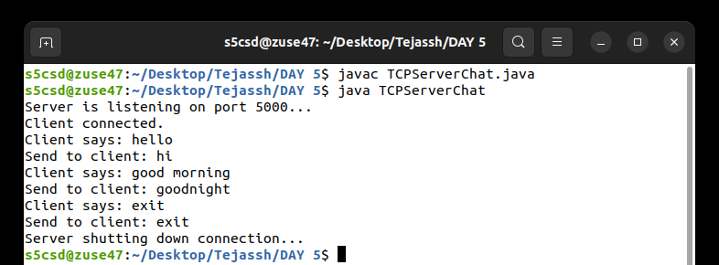
Chat client
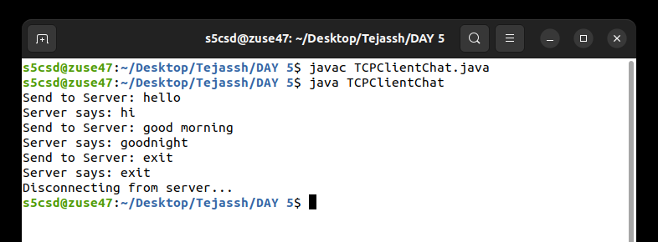
Evidence: cropped views of the original PNG terminal captures stored in this repository.

EXPERIMENT 02 / 18/07/2026
Client–server communication using TCP socket programming

SCREENSHOT OF OUTPUT
Calculator server
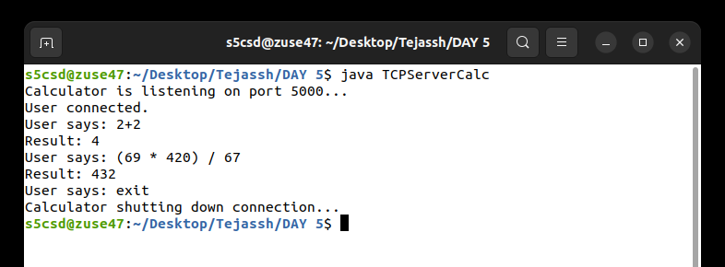
Calculator client
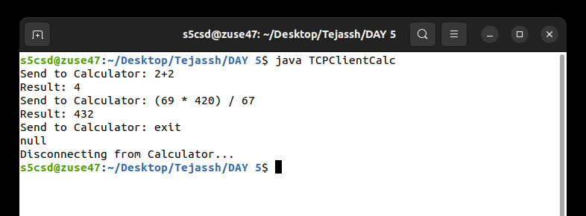
Evidence: cropped views of the original PNG terminal captures stored in this repository.

EXPERIMENT 03 / 15/07/2026
Client–server communication using UDP socket programming

Aim: Exchange a datagram and a response using UDP sockets.
PROGRAM / UDPServer.java
import java.net.*;
public class UDPServer {
public static void main(String[] args) {
try {
DatagramSocket serverSocket = new DatagramSocket(9876);
byte[] receiveData = new byte[1024];
System.out.println("Server is running and waiting for a message...");
DatagramPacket receivePacket = new DatagramPacket(receiveData, receiveData.length);
serverSocket.receive(receivePacket);
String clientMessage = new String(receivePacket.getData()).trim();
System.out.println("Client says: " + clientMessage);
InetAddress clientAddress = receivePacket.getAddress();
int clientPort = receivePacket.getPort();
String reply = "Hello from UDP Server!";
byte[] sendData = reply.getBytes();
DatagramPacket sendPacket = new DatagramPacket(sendData, sendData.length, clientAddress, clientPort);
serverSocket.send(sendPacket);
serverSocket.close();
}
catch (Exception e) {
e.printStackTrace();
}
}
}

EXPERIMENT 03 / 15/07/2026
Client–server communication using UDP socket programming

PROGRAM / UDPClient.java
import java.net.*;
public class UDPClient {
public static void main(String[] args) {
try {
DatagramSocket clientSocket = new DatagramSocket();
String message = "Hello from UDP Client!";
byte[] sendData = message.getBytes();
InetAddress serverAddress = InetAddress.getByName("localhost");
DatagramPacket sendPacket = new DatagramPacket(sendData, sendData.length,
serverAddress, 9876);
clientSocket.send(sendPacket);
byte[] receiveData = new byte[1024];
DatagramPacket receivePacket = new DatagramPacket(receiveData, receiveData.length);
clientSocket.receive(receivePacket);
String reply = new String(receivePacket.getData()).trim();
System.out.println("Server says: " + reply);
clientSocket.close();
}
catch (Exception e) {
e.printStackTrace();
}
}
}

EXPERIMENT 03 / 15/07/2026
Client–server communication using UDP socket programming

SCREENSHOT OF OUTPUT
UDP server
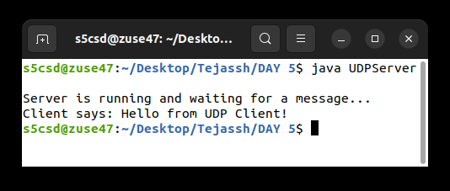
UDP client
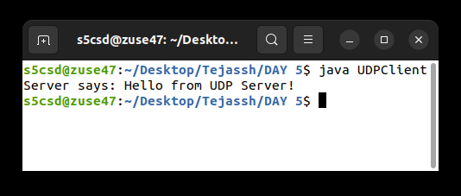
Evidence: cropped views of the original PNG terminal captures stored in this repository.

EXPERIMENT 04 / 05/08/2026
ARQ flow control: Stop-and-Wait, Go-Back-N and Selective Repeat

Aim: Observe retransmission after frame loss using three ARQ simulations.
PROGRAM / StopAndWait.java
import java.util.Scanner;
public class StopAndWait {
public static void main(String[] args) {
Scanner sc = new Scanner(System.in);
System.out.print("Enter number of frames: ");
int n = sc.nextInt();
System.out.print("Enter frame to lose (-1 for none): ");
int lost = sc.nextInt();
for (int i = 0; i < n; i++) {
while (true) {
System.out.println("Sending Frame " + i);
if (i == lost) {
System.out.println("Frame " + i + " lost.");
System.out.println("Timeout... Retransmitting Frame " + i);
lost = -1;
} else {
System.out.println("ACK received for Frame " + i);
break;
}
}
}
System.out.println("Transmission Complete.");
sc.close();
}
}

EXPERIMENT 04 / 05/08/2026
ARQ flow control: Stop-and-Wait, Go-Back-N and Selective Repeat

PROGRAM / GoBackN.java
import java.util.Scanner;
public class GoBackN {
public static void main(String[] args) {
Scanner sc = new Scanner(System.in);
System.out.print("Enter total frames: ");
int frames = sc.nextInt();
System.out.print("Enter window size: ");
int window = sc.nextInt();
System.out.print("Enter lost frame (-1 for none): ");
int lost = sc.nextInt();
int i = 0;
while (i < frames) {
int end = Math.min(i + window, frames);
System.out.println("\nSending Window:");
for (int j = i; j < end; j++) {
System.out.println("Frame " + j);
if (j == lost) {
System.out.println("Frame " + j + " lost.");
System.out.println("Go Back to Frame " + j);
i = j;
lost = -1;
break;
}
if (j == end - 1) {
i = end;
}
}
}
System.out.println("\nAll Frames Sent Successfully.");
sc.close();
}
}

EXPERIMENT 04 / 05/08/2026
ARQ flow control: Stop-and-Wait, Go-Back-N and Selective Repeat

PROGRAM / SelectiveRepeat.java
import java.util.Scanner;
public class SelectiveRepeat {
public static void main(String[] args) {
Scanner sc = new Scanner(System.in);
System.out.print("Enter total frames: ");
int frames = sc.nextInt();
System.out.print("Enter window size: ");
int window = sc.nextInt();
System.out.print("Enter lost frame (-1 for none): ");
int lost = sc.nextInt();
boolean[] ack = new boolean[frames];
for (int i = 0; i < frames; i += window) {
int end = Math.min(i + window, frames);
System.out.println("\nSending Window:");
for (int j = i; j < end; j++) {
if (j == lost) {
System.out.println("Frame " + j + " lost.");
} else {
System.out.println("Frame " + j + " acknowledged.");
ack[j] = true;
}
}
if (lost >= i && lost < end) {
System.out.println("Retransmitting Frame " + lost);
ack[lost] = true;
System.out.println("ACK received for Frame " + lost);
lost = -1;
}
}
System.out.println("\nAll Frames Successfully Received.");
sc.close();
}
}

EXPERIMENT 04 / 05/08/2026
ARQ flow control: Stop-and-Wait, Go-Back-N and Selective Repeat

SCREENSHOT OF OUTPUT
Stop-and-Wait ARQ
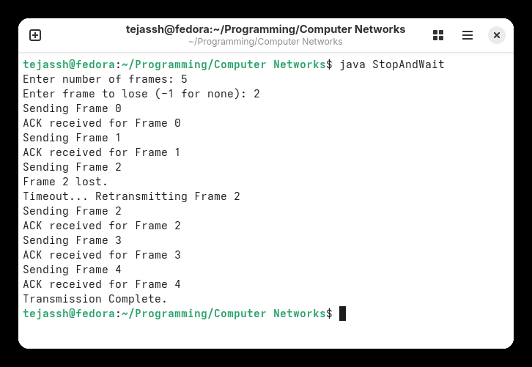
Evidence: cropped views of the original PNG terminal captures stored in this repository.

EXPERIMENT 04 / 05/08/2026
ARQ flow control: Stop-and-Wait, Go-Back-N and Selective Repeat

SCREENSHOT OF OUTPUT
Go-Back-N ARQ
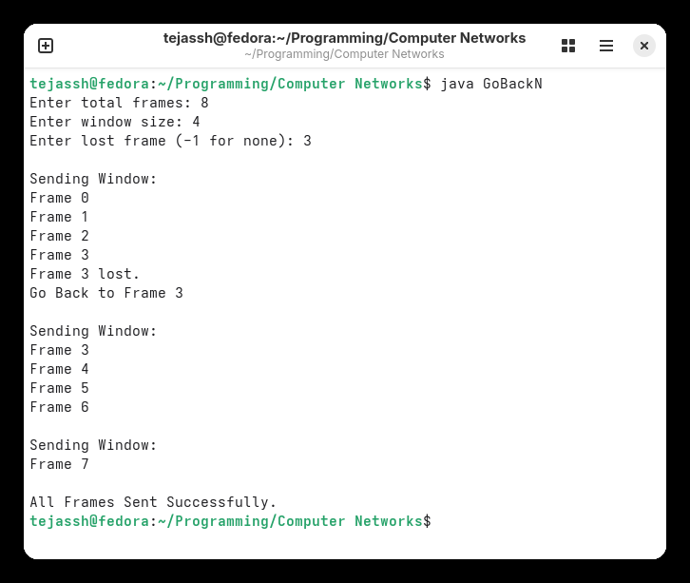
Evidence: cropped views of the original PNG terminal captures stored in this repository.

EXPERIMENT 04 / 05/08/2026
ARQ flow control: Stop-and-Wait, Go-Back-N and Selective Repeat

SCREENSHOT OF OUTPUT
Selective Repeat ARQ
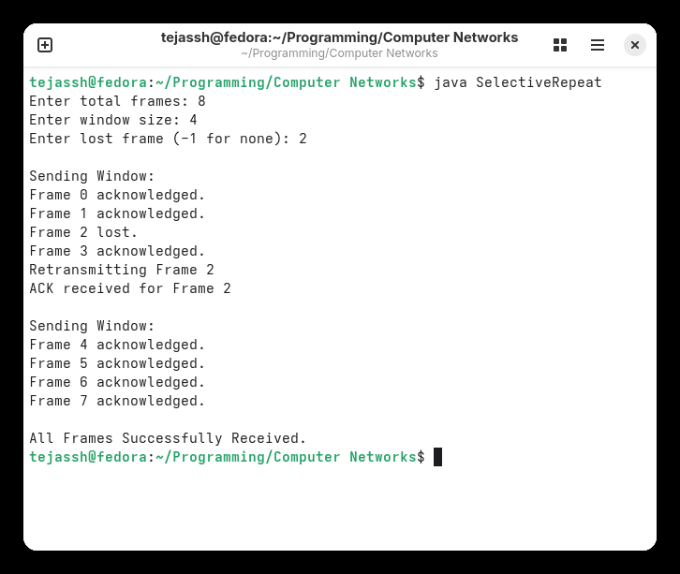
Evidence: cropped views of the original PNG terminal captures stored in this repository.

EXPERIMENT 05 / 19/08/2026
Implementation and simulation of Distance Vector Routing

Aim: Calculate routing costs and next hops from an input cost matrix.
Note: The supplied program performs in-place all-pairs cost relaxation (Floyd–Warshall style); it does not exchange vectors between routers.
PROGRAM / DistanceVector.java / PART 1 OF 2
import java.util.Scanner;
public class DistanceVector {
public static void main(String[] args) {
Scanner sc = new Scanner(System.in);
int routers;
System.out.print("Enter the number of routers: ");
routers = sc.nextInt();
int[][] cost = new int[routers][routers];
int[][] distance = new int[routers][routers];
int[][] nextHop = new int[routers][routers];
System.out.println("Enter the Cost Matrix (Use 999 for Infinity):");
for (int i = 0; i < routers; i++) {
for (int j = 0; j < routers; j++) {
cost[i][j] = sc.nextInt();
distance[i][j] = cost[i][j];
if (i == j)
nextHop[i][j] = i;
else
nextHop[i][j] = j;
}
}
// Distance Vector Algorithm

EXPERIMENT 05 / 19/08/2026
Implementation and simulation of Distance Vector Routing

PROGRAM / DistanceVector.java / PART 2 OF 2
for (int k = 0; k < routers; k++) {
for (int i = 0; i < routers; i++) {
for (int j = 0; j < routers; j++) {
if (distance[i][k] + distance[k][j] < distance[i][j]) {
distance[i][j] = distance[i][k] + distance[k][j];
nextHop[i][j] = nextHop[i][k];
}
}
}
}
// Display Routing Tables
for (int i = 0; i < routers; i++) {
System.out.println("\nRouting Table for Router " + i);
System.out.println("----------------------------------------");
System.out.println("Destination\tNext Hop\tCost");
for (int j = 0; j < routers; j++) {
System.out.println(j + "\t\t" + nextHop[i][j] + "\t\t" +
distance[i][j]);
}
}
sc.close();
}
}

EXPERIMENT 05 / 19/08/2026
Implementation and simulation of Distance Vector Routing

SCREENSHOT OF OUTPUT
DistanceVector — routing tables
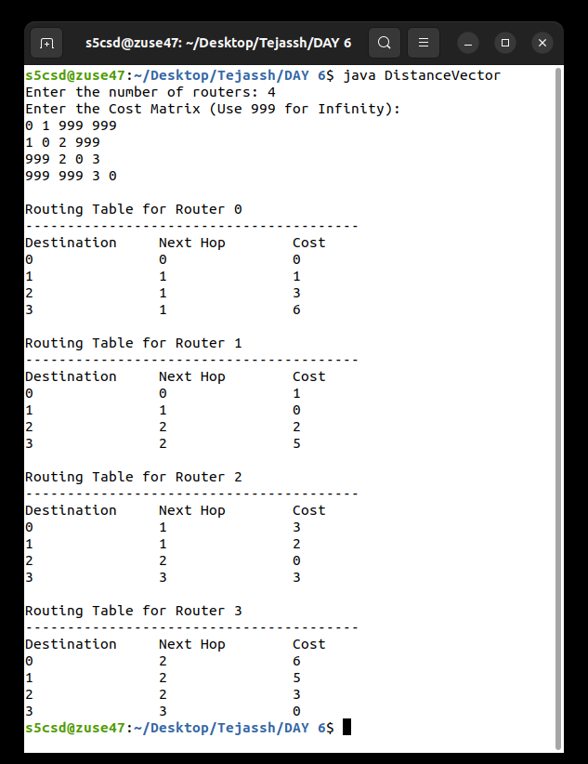
Evidence: cropped views of the original PNG terminal captures stored in this repository.

EXPERIMENT 06 / 02/09/2026
Implementation and simulation of the Leaky Bucket algorithm

Aim: Simulate a finite-capacity bucket with a fixed output rate and overflow queued for resend.
PROGRAM / LeakyBucket.java / PART 1 OF 2
import java.util.Scanner;
public class LeakyBucket {
public static void main(String[] args) {
Scanner sc = new Scanner(System.in);
int bucketSize, outputRate;
int stored = 0, resend = 0;
System.out.print("Bucket size: ");
bucketSize = sc.nextInt();
System.out.print("Output rate: ");
outputRate = sc.nextInt();
System.out.print("Number of packet batches: ");
int n = sc.nextInt();
for (int i = 1; i <= n; i++) {
System.out.print("Incoming packets: ");
int packets = sc.nextInt();
packets = packets + resend;
resend = 0;
int space = bucketSize - stored;
if (packets <= space) {
stored = stored + packets;
} else {
stored = bucketSize;
resend = packets - space;
System.out.println("Overflow packets: " + resend);
System.out.println("Overflow packets will be resent.");
}
int transmitted;
if (stored >= outputRate) {
transmitted = outputRate;

EXPERIMENT 06 / 02/09/2026
Implementation and simulation of the Leaky Bucket algorithm

PROGRAM / LeakyBucket.java / PART 2 OF 2
} else {
transmitted = stored;
}
stored = stored - transmitted;
System.out.println("Packets transmitted: " + transmitted);
System.out.println("Packets in bucket: " + stored);
if (resend > 0) {
System.out.println("Packets waiting for resend: " + resend);
}
System.out.println();
}
while (resend > 0) {
int space = bucketSize - stored;
if (resend <= space) {
stored = stored + resend;
resend = 0;
} else {
stored = bucketSize;
resend = resend - space;
}
int transmitted;
if (stored >= outputRate) {
transmitted = outputRate;
} else {
transmitted = stored;
}
stored = stored - transmitted;
System.out.println("Resent packets transmitted: " + transmitted);
}
sc.close();
}
}

EXPERIMENT 06 / 02/09/2026
Implementation and simulation of the Leaky Bucket algorithm

PROGRAM / LeakyBucketv2.java / PART 1 OF 2
import java.util.Scanner;
public class LeakyBucketv2 {
public static void main(String[] args) {
Scanner sc = new Scanner(System.in);
System.out.println("=== LEAKY BUCKET CONFIGURATION ===");
System.out.print("Enter Bucket Size: ");
int bucketSize = sc.nextInt();
System.out.print("Enter Output Rate: ");
int outputRate = sc.nextInt();
System.out.print("Enter Number of Packet Batches: ");
int n = sc.nextInt();
System.out.println("===================================\n");
int stored = 0, resend = 0;
for (int i = 1; i <= n; i++) {
System.out.println("--- BATCH " + i + " ---");
System.out.print("Incoming packets: ");
int packets = sc.nextInt();
packets = packets + resend;
resend = 0;
int space = bucketSize - stored;
if (packets <= space) {
stored = stored + packets;
} else {
stored = bucketSize;
resend = packets - space;
System.out.println("[ALERT] Overflow! " + resend + " packets overflowed and must be resent.");
}
int transmitted;
if (stored >= outputRate) {
transmitted = outputRate;
} else {
transmitted = stored;
}

EXPERIMENT 06 / 02/09/2026
Implementation and simulation of the Leaky Bucket algorithm

PROGRAM / LeakyBucketv2.java / PART 2 OF 2
stored = stored - transmitted;
System.out.println("-> Transmitted : " + transmitted + " packets");
System.out.println("-> Remaining in Bucket: " + stored + "/" + bucketSize);
if (resend > 0) {
System.out.println("-> Waiting for Resend : " + resend + " packets");
}
System.out.println();
}
if (resend > 0) {
System.out.println("=== PROCESSING OVERFLOWED PACKETS ===");
}
while (resend > 0) {
int space = bucketSize - stored;
if (resend <= space) {
stored = stored + resend;
resend = 0;
} else {
stored = bucketSize;
resend = resend - space;
}
int transmitted;
if (stored >= outputRate) {
transmitted = outputRate;
} else {
transmitted = stored;
}
stored = stored - transmitted;
System.out.println("-> Resent Transmitted : " + transmitted + " packets");
System.out.println("-> Remaining in Bucket: " + stored + "/" + bucketSize);
System.out.println();
}
System.out.println("=== PROCESS COMPLETED ===");
sc.close();
}
}

EXPERIMENT 06 / 02/09/2026
Implementation and simulation of the Leaky Bucket algorithm

SCREENSHOT OF OUTPUT
LeakyBucket
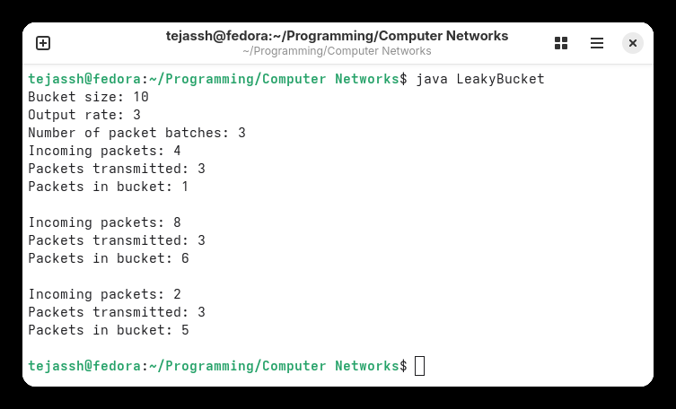
Evidence: cropped views of the original PNG terminal captures stored in this repository.

EXPERIMENT 06 / 02/09/2026
Implementation and simulation of the Leaky Bucket algorithm

SCREENSHOT OF OUTPUT
LeakyBucketv2
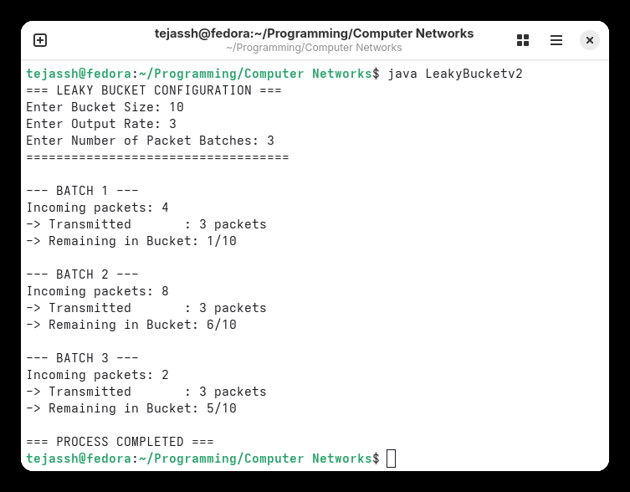
Evidence: cropped views of the original PNG terminal captures stored in this repository.

EXPERIMENT 07 / 09/09/2026
Implementation of Simple Mail Transfer Protocol (SMTP)

Aim: Exchange SMTP-style greetings, envelope, message data and termination over a local socket.
Note: This is a local SMTP-style teaching simulation on TCP port 2525, not a connection to a production mail server.
PROGRAM / SMTPServer.java / PART 1 OF 2
import java.io.*;
import java.net.*;
class SMTPServer {
public static void main(String args[]) {
try {
ServerSocket ss = new ServerSocket(2525);
System.out.println("SMTP Server started...");
Socket s = ss.accept();
BufferedReader in = new BufferedReader(
new InputStreamReader(s.getInputStream()));
PrintWriter out = new PrintWriter(
s.getOutputStream(), true);
out.println("220 SMTP Server Ready");
String msg;
while ((msg = in.readLine()) != null) {
System.out.println("Client: " + msg);
if (msg.startsWith("HELO")) {
out.println("250 Hello");
}
else if (msg.startsWith("MAIL FROM")) {
out.println("250 Sender OK");
}
else if (msg.startsWith("RCPT TO")) {

EXPERIMENT 07 / 09/09/2026
Implementation of Simple Mail Transfer Protocol (SMTP)

PROGRAM / SMTPServer.java / PART 2 OF 2
out.println("250 Receiver OK");
}
else if (msg.equals("DATA")) {
out.println("354 Start mail input");
while ((msg = in.readLine()) != null) {
if (msg.equals(".")) {
break;
}
System.out.println("Mail: " + msg);
}
out.println("250 Mail received");
}
else if (msg.equals("QUIT")) {
out.println("221 Bye");
break;
}
}
s.close();
ss.close();
}
catch (Exception e) {
System.out.println(e);
}
}
}

EXPERIMENT 07 / 09/09/2026
Implementation of Simple Mail Transfer Protocol (SMTP)

PROGRAM / SMTPClient.java
import java.io.*;
import java.net.*;
class SMTPClient {
public static void main(String args[]) {
try {
Socket s = new Socket("localhost", 2525);
BufferedReader in = new BufferedReader(
new InputStreamReader(s.getInputStream()));
PrintWriter out = new PrintWriter(
s.getOutputStream(), true);
System.out.println("Server: " + in.readLine());
out.println("HELO localhost");
System.out.println("Server: " + in.readLine());
out.println("MAIL FROM:<sender@example.com>");
System.out.println("Server: " + in.readLine());
out.println("RCPT TO:<receiver@example.com>");
System.out.println("Server: " + in.readLine());
out.println("DATA");
System.out.println("Server: " + in.readLine());
out.println("Subject: Test Mail");
out.println("From: sender@example.com");
out.println("To: receiver@example.com");
out.println();
out.println("This is a test email.");
out.println(".");
System.out.println("Server: " + in.readLine());
out.println("QUIT");
System.out.println("Server: " + in.readLine());
s.close();
}
catch (Exception e) {
System.out.println(e);
}
}
}

EXPERIMENT 07 / 09/09/2026
Implementation of Simple Mail Transfer Protocol (SMTP)

SCREENSHOT OF OUTPUT
SMTP server
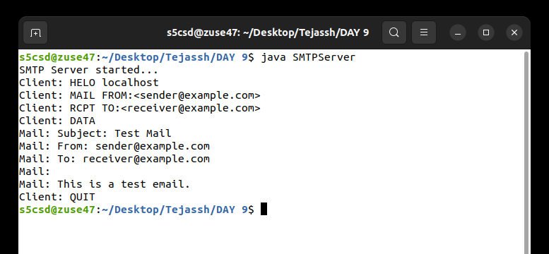
SMTP client
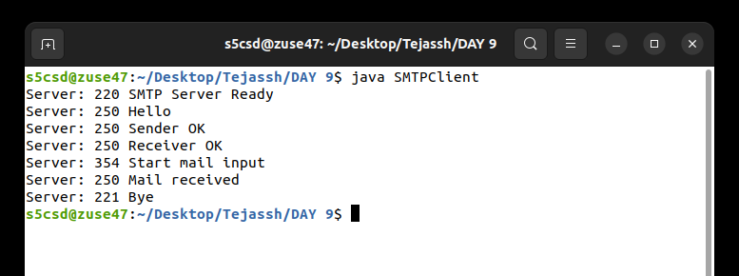
Evidence: cropped views of the original PNG terminal captures stored in this repository.

EXPERIMENT 08 / 09/09/2026
Implementation of File Transfer Protocol (FTP)

Aim: Transfer a text file from a client to a server over a local TCP connection.
Note: These sources demonstrate a custom file transfer over TCP port 5000; they do not implement the standard FTP protocol. The repository’s test.txt and received_test.txt both contain “Message transmitted through FTP!”.
PROGRAM / FTPServer.java
import java.io.*;
import java.net.*;
public class FTPServer {
public static void main(String[] args) throws Exception {
ServerSocket ss = new ServerSocket(5000);
System.out.println("Server started...");
System.out.println("Waiting for client...");
Socket s = ss.accept();
System.out.println("Client connected.");
DataInputStream dis = new DataInputStream(s.getInputStream());
String fileName = dis.readUTF();
System.out.println("Receiving file: " + fileName);
FileOutputStream fos = new FileOutputStream("received_" + fileName);
byte[] buffer = new byte[4096];
int bytesRead;
while ((bytesRead = dis.read(buffer)) != -1) {
fos.write(buffer, 0, bytesRead);
}
fos.close();
dis.close();
s.close();
ss.close();
System.out.println("File received successfully.");
}
}

EXPERIMENT 08 / 09/09/2026
Implementation of File Transfer Protocol (FTP)

PROGRAM / FTPClient.java
import java.io.*;
import java.net.*;
public class FTPClient {
public static void main(String[] args) throws Exception {
Socket s = new Socket("localhost", 5000);
DataOutputStream dos = new DataOutputStream(s.getOutputStream());
File file = new File("test.txt");
dos.writeUTF(file.getName());
FileInputStream fis = new FileInputStream(file);
byte[] buffer = new byte[4096];
int bytesRead;
while ((bytesRead = fis.read(buffer)) != -1) {
dos.write(buffer, 0, bytesRead);
}
fis.close();
dos.close();
s.close();
System.out.println("File sent successfully.");
}
}

EXPERIMENT 08 / 09/09/2026
Implementation of File Transfer Protocol (FTP)

SCREENSHOT OF OUTPUT
FTP server
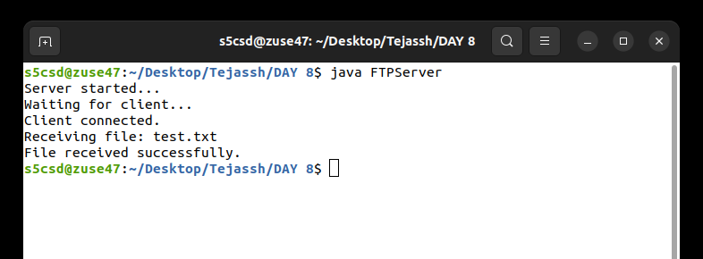
FTP client
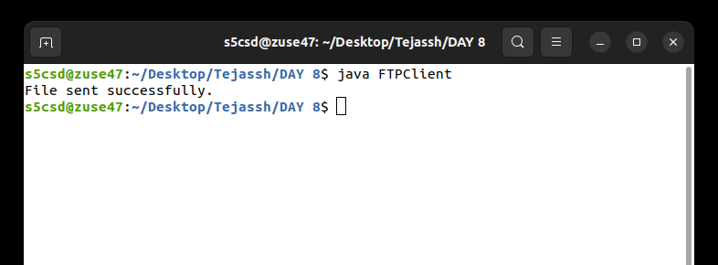
Evidence: cropped views of the original PNG terminal captures stored in this repository.

EXPERIMENT 09 / 01/07/2026
Introduction to the Wireshark tool

Aim: Learn to capture, filter and inspect network traffic with Wireshark.
TITLE / Introduction to the Wireshark tool
STUDY MATERIAL / Familiarisation.docx
Wireshark is a free, open-source network protocol analyzer used to capture and examine packets as data travels through a network.
KEY FEATURES
• Packet capture: records packets transmitted and received by a computer.
• Protocol analysis: examines TCP, UDP, HTTP, DNS and ICMP traffic.
• Packet details: shows source and destination IP addresses, ports, protocol and packet length.
• Display filters: isolates traffic of interest, such as tcp, udp or icmp.
• Troubleshooting: helps identify loss, retransmissions and connection failures.
FAMILIARIZATION ACTIVITY
Select a network interface, start a capture, apply a display filter and inspect a packet’s decoded fields.
RESULT / LEARNING OUTCOME
The Wireshark familiarization material describes capturing and analyzing packets with suitable filters to understand packet details and network protocols.

EXPERIMENT 10 / 08/07/2026
Familiarization with the NS2 simulator

Aim: Understand topology creation, Tcl scenarios, trace files and NAM in NS2.
TITLE / Familiarization with the NS2 simulator
STUDY MATERIAL / Familiarisation.docx
NS2 (Network Simulator 2) is a discrete-event simulator for designing and analyzing computer networks without a physical network.
KEY FEATURES
• Network simulation: models virtual nodes, links and connections.
• Protocol study: investigates TCP, UDP, routing and MAC protocols.
• Tcl scripts: define scenarios and schedule simulated events.
• NAM: animates packet transmission and other network activity.
• Trace files: record transmission, reception and loss; support analysis of throughput, delay, loss and packet delivery ratio.
FAMILIARIZATION ACTIVITY
Study a simple Tcl network scenario and inspect its trace file or NAM animation.
RESULT / LEARNING OUTCOME
The NS2 familiarization material describes a basic simulation and the use of topologies, packet traces and performance analysis.

EXPERIMENT 11 / 01/07/2026
Study of Packet Tracer

Aim: Learn to assemble, configure and test a small virtual network in Packet Tracer.
TITLE / Study of Packet Tracer
STUDY MATERIAL / Familiarisation.docx
Cisco Packet Tracer is a simulation tool for building virtual networks without physical equipment. It provides routers, switches, PCs and servers that can be interconnected and configured.
KEY FEATURES
• Network topology: place and connect virtual devices.
• Addressing and configuration: assign IP addresses and configure devices.
• Connectivity testing: use ping from a PC command prompt.
• Packet observation: watch data move through the virtual network.
FAMILIARIZATION ACTIVITY
Build a small two-PC network, assign addresses in one subnet and test connectivity with ping.
RESULT / LEARNING OUTCOME
The Packet Tracer familiarization material describes building a basic network, configuring devices and testing connectivity to understand addressing, topology and packet transmission.

