COS 226 – PRAC 5

GROUP MEMBERS
- Jamie King - 24916031
- Stephen Odhiambo – 25176502
- Nare Maela – 24607917

CampusGuard description:
CampusGuard is an application designed to manage incidents that may occur on a campus by dispatching teams to resolve them and changing building access levels to prevent the public from entering restricted areas.

UML Class Diagram
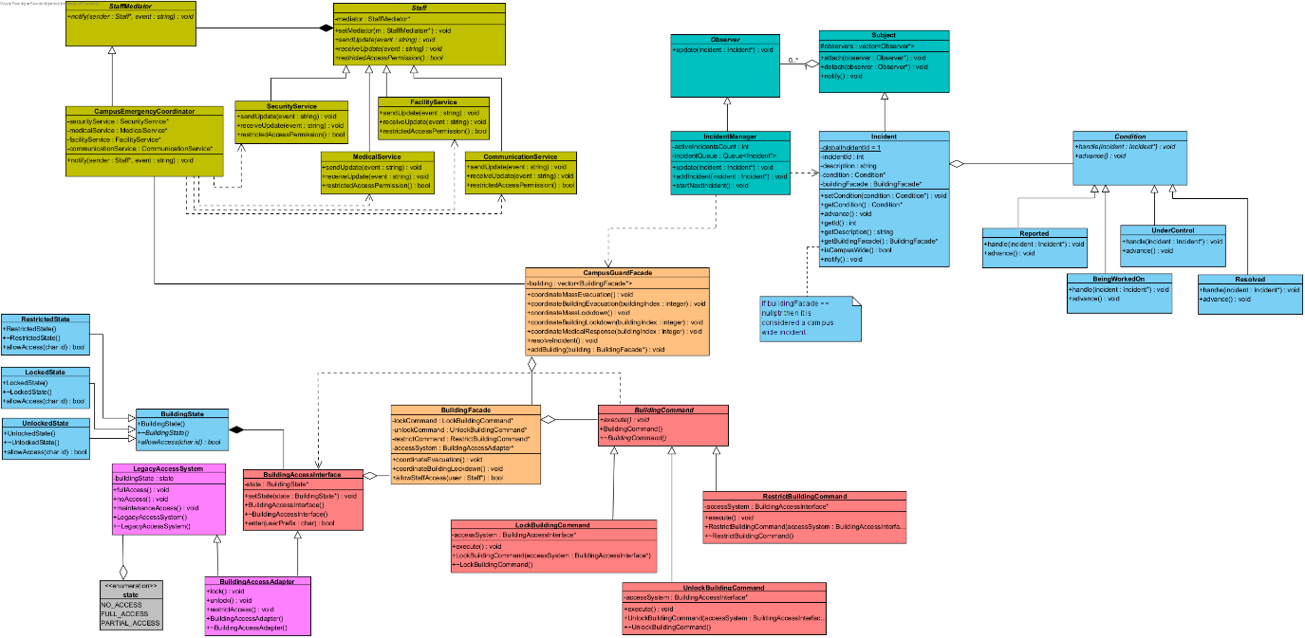

Gof Participants
COMMAND
Invoker | BuildingFacade
Command | BuildingCommand
ConcreteCommand | LockBuildingCommand  UnlockBuildingCommand  RestrictBuildingCommand
Receiver | BuildingAccessInterface

MEDIATOR
Mediator | StaffMediator
ConcreteMediator | CampusEmergencyCoordinator
Colleague | Staff
ConcreteColleague | SecurityService
ConcreteColleague | MedicalService
ConcreteColleague | FacilityService
ConcreteColleague | CommunicationService

ADAPTER
Target | BuildingAccessInterface
Adaptee | LegacyAccessSystem
Adapter | BuildingAccessAdapter

STATE
Context | Incident
State | Condition
ConcreteState | Reported
ConcreteState | BeingWorkedOn
ConcreteState | UnderControl
ConcreteState | Resolved

OBSERVER
Subject | Subject
ConcreteSubject | Incident
Observer | Observer
ConcreteObserver | IncidentMangaer

FAÇADE
Facade | CampusGuardFacade  BuildingFacade

Team-selected patterns
State: We used the State pattern to keep track of the condition of the incidents which CampusGuard manages and resolves.

Observer: We used observer to keep track of the number of incidents currently being dealt with. There are a limited number of teams available to deal with the incidents, so when a team is finished with their incident it notifies the manager that they are now free so another may start being resolved.

Behavioural Diagrams

Design Rationale
- We used a mediator for staff coordination, so that each colleague communicates through a centralized party in an emergency. If not used each colleague would have to contain a pointer to each other, making it complex and increasing coupling.
- Two-level Facade: BuildingFacade hides the Command/Adapter/State chain, while CampusGuardFacade keeps track of every building and can efficiently coordinate a mass evacuation or lockdown of every building on the campus.
- Ownership
  - BuildingAccessInterface has a compositional relationship with State and is responsible for deallocating its memory.
  - BuildingFacade has an aggregatinonal relationship with CampusGuard. This is to allow the user to choose whether to use the façade or directly interact with the BuildingFacade. This also allows for scalability, meaning this system can work for an individual building only as well

Gdb Evidence

#1
Bug:
- Segmentation fault during mass evacuation.
Location:
- BuildingAccessInterface::setState()
Cause:
- Commands contained duplicate accessSystem pointers, hiding the initialized base-class pointer.
Fix:
- Removed duplicate accessSystem members from Lock/Unlock/Restrict commands.
Initial result:
- “104 bytes definitely lost in 13 blocks”.
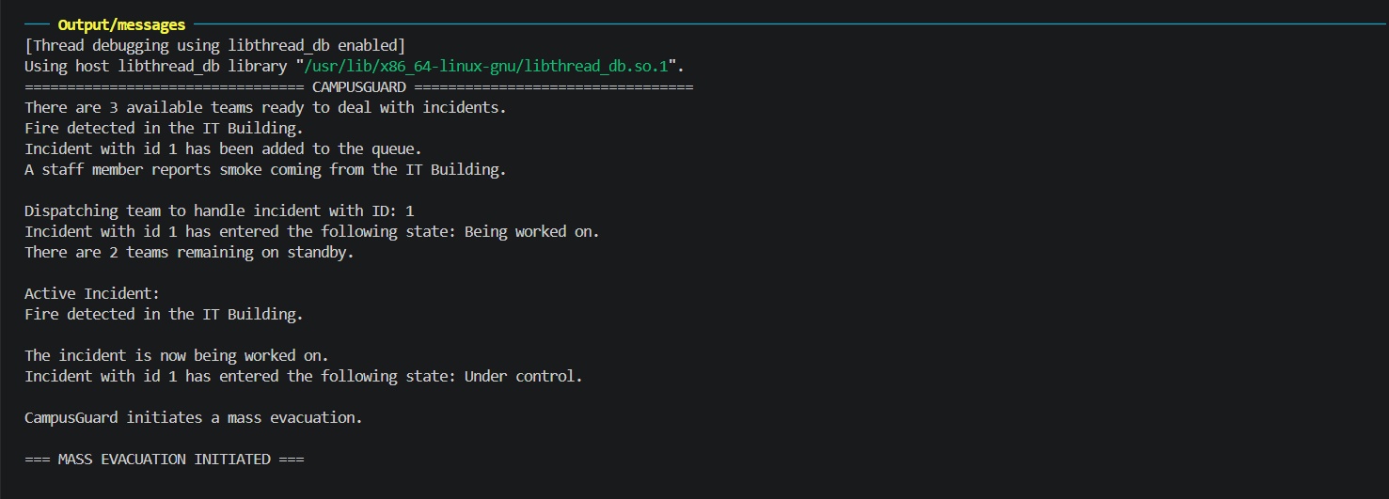
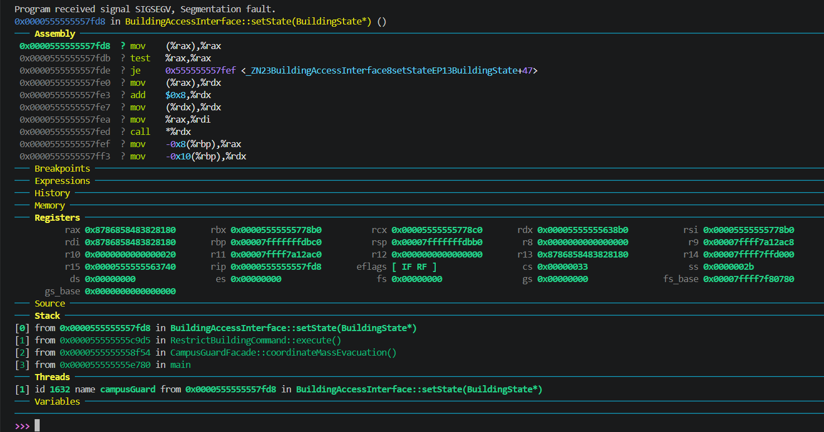

#2
After some modifications to the code and main, there was a memory leak in main
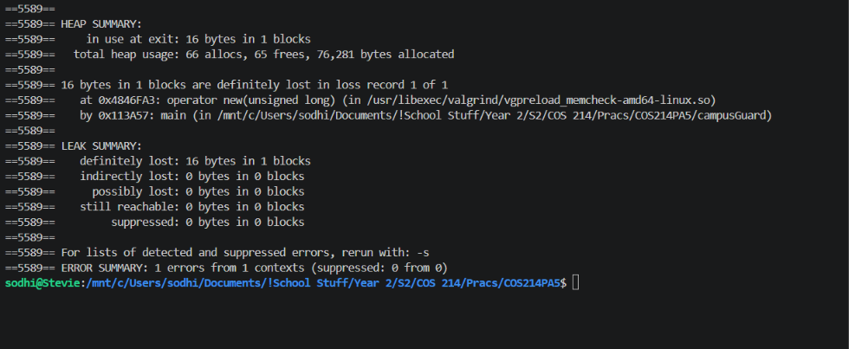
To find which variable was undeleted, we first thought to check which pointers aren’t null at the end. To do this, we set a breakpoint, then checked every pointer that was created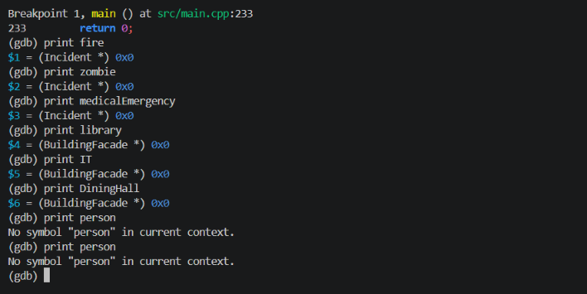
Person wasn’t showing up. Then we realised that it must’ve went out of scope, since it was created in an if statement, so gdb couldn’t see it, so we went and scanned the code, and saw we had not deallocated its memory, and did so.
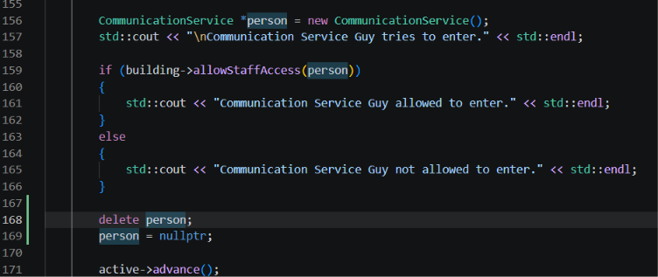
And now there are no memory leaks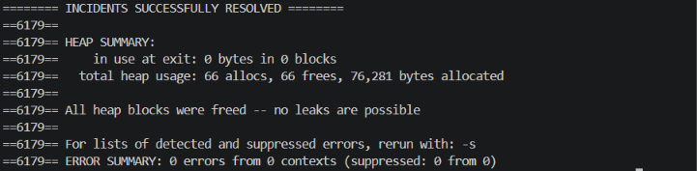

Valgrind Evidence
Cause:
State objects were being replaced without releasing the previous state.

Fixes:
- Added virtual destructor to Condition.
- Deleted previous state in Incident::setCondition().
- Deleted final state in Incident destructor.
- Added BuildingAccessInterface destructor to release
the final BuildingState object.

Final result:
All heap blocks were freed -- no leaks are possible.

