COS 214 Practical 5
Team members:
Showlon Hunter - u25502469
Tamima Alam Touhid - u24691284
Francois Venter - u25555202

Github repository link:
https://github.com/u25555202-maker/COS214-Prac5

CampusGuard
Task 1: Design Document

1.1. System Responsibilities
CampusGuard coordinates a university's response to an incident from the moment it is reported until it is resolved. Concretely, the system:
- registers an incident (type, location) and tracks its status through a defined lifecycle: Reported → Dispatched → Contained → Resolved;
- dispatches campus security, medical response, and facilities teams to an incident location;
- performs building-access actions (lock, unlock, restrict) as part of responding to an incident;
- lets an operator issue discrete actions (dispatch, evacuate, alert, cancel) that trigger real domain behaviour;
- coordinates response teams so that one team's action (e.g. security arriving on scene) automatically triggers appropriate action in other teams, without the teams knowing about each other directly;
- integrates with an existing campus paging system whose interface is incompatible with the interface CampusGuard's own components use; and
- exposes a single high-level entry point for reporting an emergency, so a client does not need to manually drive five separate subsystem calls in the correct order.

1.2. Class Structure Overview

Command
Class | Role | Key members | Associations
Command | Abstract Command | execute(), undo(), description() | —
DispatchUnitCommand | ConcreteCommand | unit, incident, location | receiver: ResponseComponent* (non-owning)
LockAreaCommand | ConcreteCommand (reversible) | access, area | receiver: AccessControlSystem* (non-owning)
AlertCommand | ConcreteCommand | channel, message, location | receiver: CommunicationChannel* (non-owning)
EvacuationCommand | ConcreteCommand | facilities, area, incident | receiver: FacilitiesTeam* (non-owning)
CancelCommand | ConcreteCommand | target | receiver: another Command* (non-owning)
OperatorConsole | Invoker | history: vector<unique_ptr<Command>> | owns every submitted Command

Mediator
Class | Role | Key members | Associations
ResponseMediator | Mediator interface | componentArrived(), componentFinished() | —
IncidentCoordinator | ConcreteMediator | security, medical, facilities, commChannel | non-owning references to all colleagues + comm channel
ResponseComponent | Abstract Colleague | name, mediator, dispatchTo() | non-owning reference to ResponseMediator
SecurityTeam / MedicalTeam / FacilitiesTeam | ConcreteColleague | team-specific domain methods | FacilitiesTeam also references AccessControlSystem

Adapter
Class | Role | Key members | Associations
CommunicationChannel | Target interface | sendAlert(message, location) | —
LegacyPagerSystem | Adaptee | broadcastPage(code, zoneId, payload) | —
LegacyPagerAdapter | Object Adapter | mapToPriorityCode(), mapToZoneId() | owns LegacyPagerSystem (unique_ptr)

Facade
Class | Role | Key members | Associations
EmergencyResponseFacade | Facade | reportEmergency(type, location) | owns AccessControlSystem, IncidentCoordinator, all three teams, LegacyPagerAdapter, OperatorConsole, Dashboard, AuditLogger, and every Incident it creates
AccessControlSystem | Subsystem service | lockArea(), unlockArea(), restrictArea() | referenced (non-owning) by FacilitiesTeam and LockAreaCommand

State
Class | Role | Key members | Associations
IncidentState | State interface | dispatch(), contain(), resolve(), name() | —
ReportedState / DispatchedState / ContainedState / ResolvedState | ConcreteState | one legal forward transition each; all others rejected | —
Incident | Context | state: unique_ptr<IncidentState> | owns its current IncidentState

Observer
Class | Role | Key members | Associations
Observer | Observer interface | update(Incident*) | —
Dashboard / AuditLogger | ConcreteObserver | update(Incident*) | —
Incident | Subject | observers: vector<Observer*>, attach(), notify() | non-owning references to attached Observers
Note that Incident deliberately plays two roles at once — State Context and Observer Subject.

1.3. GoF Participant Mapping
Pattern | Participant | Class(es)
Command | Command | Command (abstract)
 | ConcreteCommand | DispatchUnitCommand, LockAreaCommand, AlertCommand, EvacuationCommand, CancelCommand
 | Invoker | OperatorConsole
 | Receiver | ResponseComponent subclasses, AccessControlSystem, CommunicationChannel, another Command (for CancelCommand)
Mediator | Mediator | ResponseMediator (interface)
 | ConcreteMediator | IncidentCoordinator
 | Colleague | ResponseComponent (abstract)
 | ConcreteColleague | SecurityTeam, MedicalTeam, FacilitiesTeam
Adapter | Target | CommunicationChannel
 | Adaptee | LegacyPagerSystem
 | Adapter | LegacyPagerAdapter (object adapter, composition-based)
Facade | Facade | EmergencyResponseFacade
 | Subsystem classes | AccessControlSystem, IncidentCoordinator, SecurityTeam, MedicalTeam, FacilitiesTeam, LegacyPagerAdapter, OperatorConsole
State | Context | Incident
 | State | IncidentState
 | ConcreteState | ReportedState, DispatchedState, ContainedState, ResolvedState
Observer | Subject | Incident
 | Observer | Observer
 | ConcreteObserver | Dashboard, AuditLogger

1.4. Justification for the Two Additional Patterns

State - for Incident status

Problem it solves
An incident's operational status controls which actions are currently legal — you cannot resolve an incident that hasn't been contained, or dispatch one that's already dispatched. The State pattern instead makes each status responsible only for its own legal transitions; adding a new status means adding one new class, not touching existing ones.

Observer - for incident status changes

Problem it solves
Several independent parts of the system need to react whenever an incident's status changes — a dashboard for operators, an audit log for compliance — and that list is likely to grow (e.g. an SMS notifier later). Incident should not need to know about, construct, or directly call each of these. Having Incident directly call dashboard.update() and logger.log() inline would work initially, but couples Incident to concrete reporting classes and requires editing Incident every time a new consumer of status changes is added.

1.5. Ownership and Lifetime Decisions
Owner | Owns (via unique_ptr) | Rationale
EmergencyResponseFacade | AccessControlSystem, IncidentCoordinator, SecurityTeam, MedicalTeam, FacilitiesTeam, LegacyPagerAdapter, OperatorConsole, Dashboard, AuditLogger, every Incident it creates | The Facade is the single composition root for the whole subsystem; everything it wires together needs one clear owner, and the Facade's lifetime is the natural scope for “the campus response system.”
LegacyPagerAdapter | LegacyPagerSystem | The adapter is the only class permitted to talk to the legacy system; nothing else should be able to reach past it, so it owns it outright.
Incident | its current IncidentState | States are cheap, incident-specific, value-like objects with no reason to be shared; unique_ptr plus reset() cleanly destroys the old state when transitioning.
OperatorConsole | every Command submitted to it | Commands must stay alive after execute() so CancelCommand can later call undo() on them; the console's history is the natural, bounded lifetime for that.

1.6. Pattern Integration (Where the Six Patterns Interact)
- An operator (or the Facade, on their behalf) issues a Command (DispatchUnitCommand).
- Executing that command advances the incident's State (Reported → Dispatched), which fires Observer notifications to the dashboard and audit log.
- The command's receiver (a ResponseComponent) reports its arrival to the Mediator (IncidentCoordinator), which — without the component knowing any other component exists — coordinates a second colleague (FacilitiesTeam locking the area) and sends an alert.
- That alert travels through the Adapter (LegacyPagerAdapter) to reach the incompatible legacy paging system.
- All of the above, for the “report an emergency” workflow, is triggered by one Facade call (reportEmergency), while every subsystem piece it used remains independently callable.

Task 3: Two End-to-End Scenarios

Story 1 - Fire in the Engineering Building
Description

A fire is reported in the Engineering Building using EmergencyResponseFacade::reportEmergency(). The Facade coordinates the emergency workflow, commands dispatch response teams, the Incident changes state and notifies its observers, the Mediator coordinates the response teams, and alerts are sent to the legacy paging system through the Adapter.

Patterns demonstrated:

Façade -> Command -> Satate -> Observer -> Mediator -> Dispatcher

Incident progresses from Reported -> Dispatched -> Contained -> Resolved.

An invalid attempt to resolve an already resolved incident is rejected safely.

Story 2 - Gas Leak Evacuation in the Chemistry Lab
Description

A gas leak occurs in the Chemistry Lab. The operator directly uses OperatorConsole instead of the Facade. A LockAreaCommand locks the area, an EvacuationCommand causes Facilities to evacuate it, and the Mediator coordinates the handoff from Facilities to Medical. A CancelCommand then undoes the previous lockdown.

Patterns demonstrated:
Command, Mediator, State and Observer.
- CancelCommand demonstrates undo().
- Attempting to resolve the incident while it is only Dispatched is rejected.
- The incident is then correctly contained and resolved.

Task 4 - UML and Behavioural Diagrams

4.1 Final UML Class Diagram

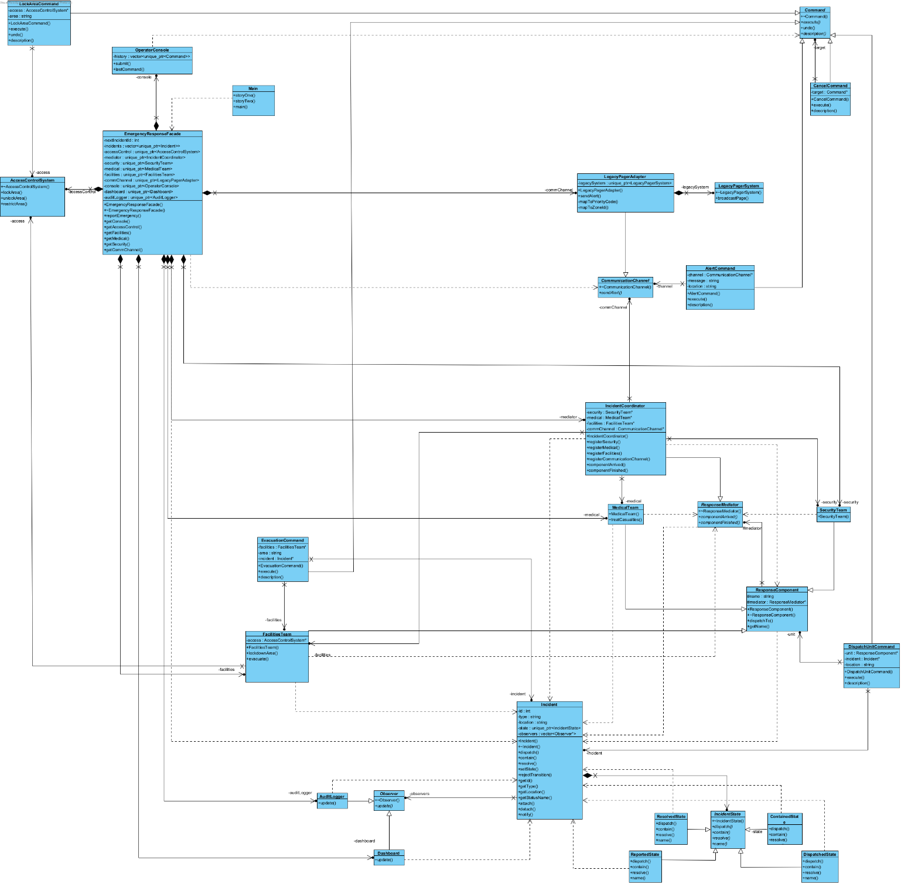

4.2 Sequence Diagram - Scenario 1

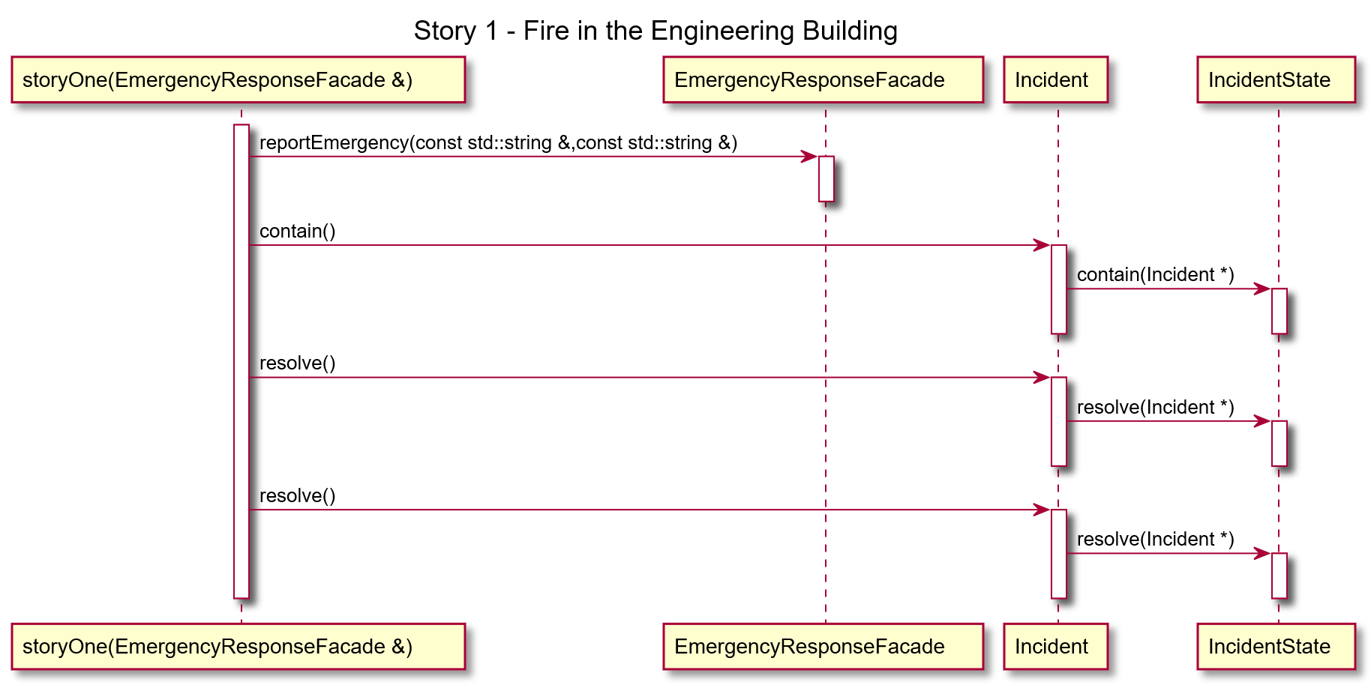

4.3 Sequence Diagram - Scenario 2

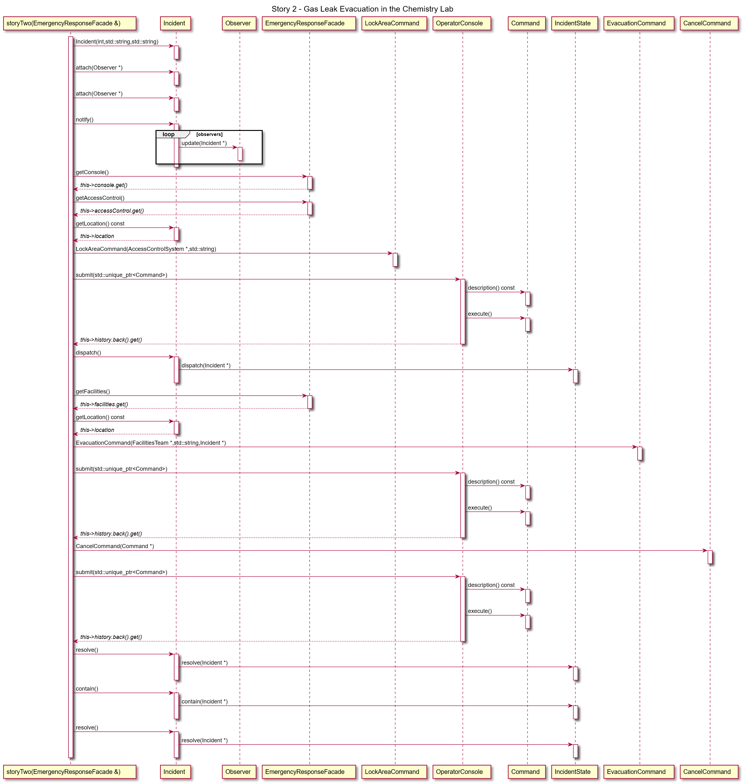

4.4 Additional Behavioural Diagram

Task 5 - Engineering Quality
5.2 Dockerfile
The Dockerfile creates an Ubuntu-based environment and installs the tools required to build, debug and analyse CampusGuard, including g++, make, GDB and Valgrind. The project files are copied into the container and compiled using the Makefile. When the container starts, the campusguard executable automatically runs the two demonstration scenarios.
5.3 docker-compose.yml
Docker Compose builds the CampusGuard image using the Dockerfile in the project directory and creates the campusguard container.
5.4 Docker Run Instructions
docker compose up –build
This builds the Docker image, compiles the complete CampusGuard application and starts the container. The application then automatically executes both end-to-end scenarios.

Remove container: docker compose down
5.5 Valgrind Evidence
docker compose run --rm campusguard bash
valgrind --leak-check=full --show-leak-kinds=all ./campusguard
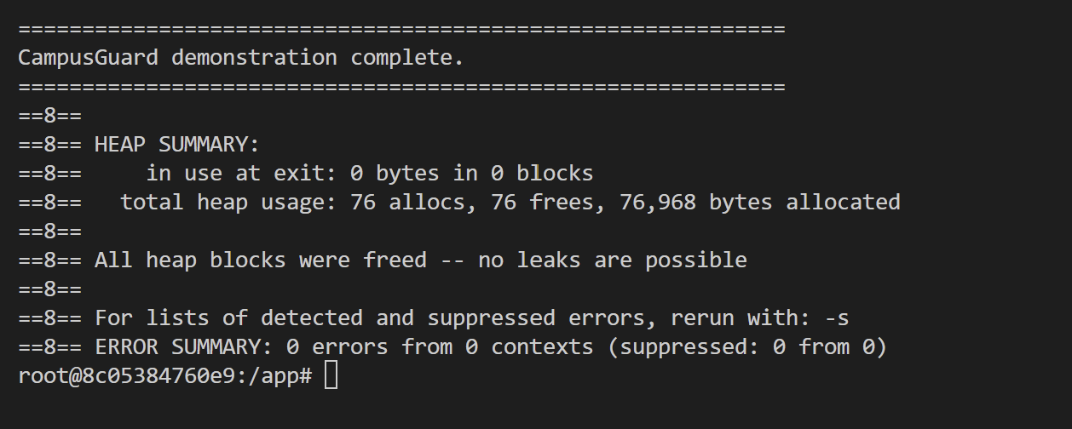
Valgrind was run on the final CampusGuard executable to check for memory leaks and memory-related errors. The program completed with 76 allocations and 76 frees, with 0 bytes remaining in use at exit. Valgrind reported that all heap blocks were freed and that no memory leaks were possible. The final error summary also reported 0 errors.
5.6 GDB Investigation
Bug: Dispatching the second response team caused an invalid state transition because the incident was already Dispatched.
Investigation: A breakpoint was placed in DispatchUnitCommand::execute(). GDB showed the incident was "Reported" on the first dispatch and "Dispatched" on the second.
Fix: incident->dispatch() is now only called when the incident is still Reported.

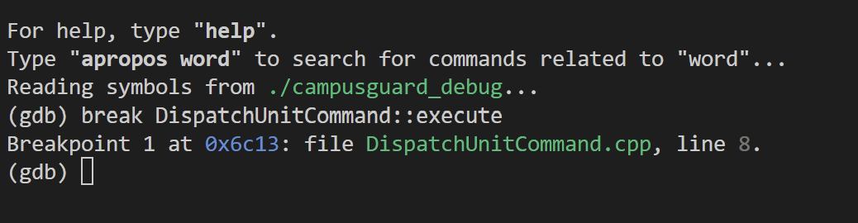
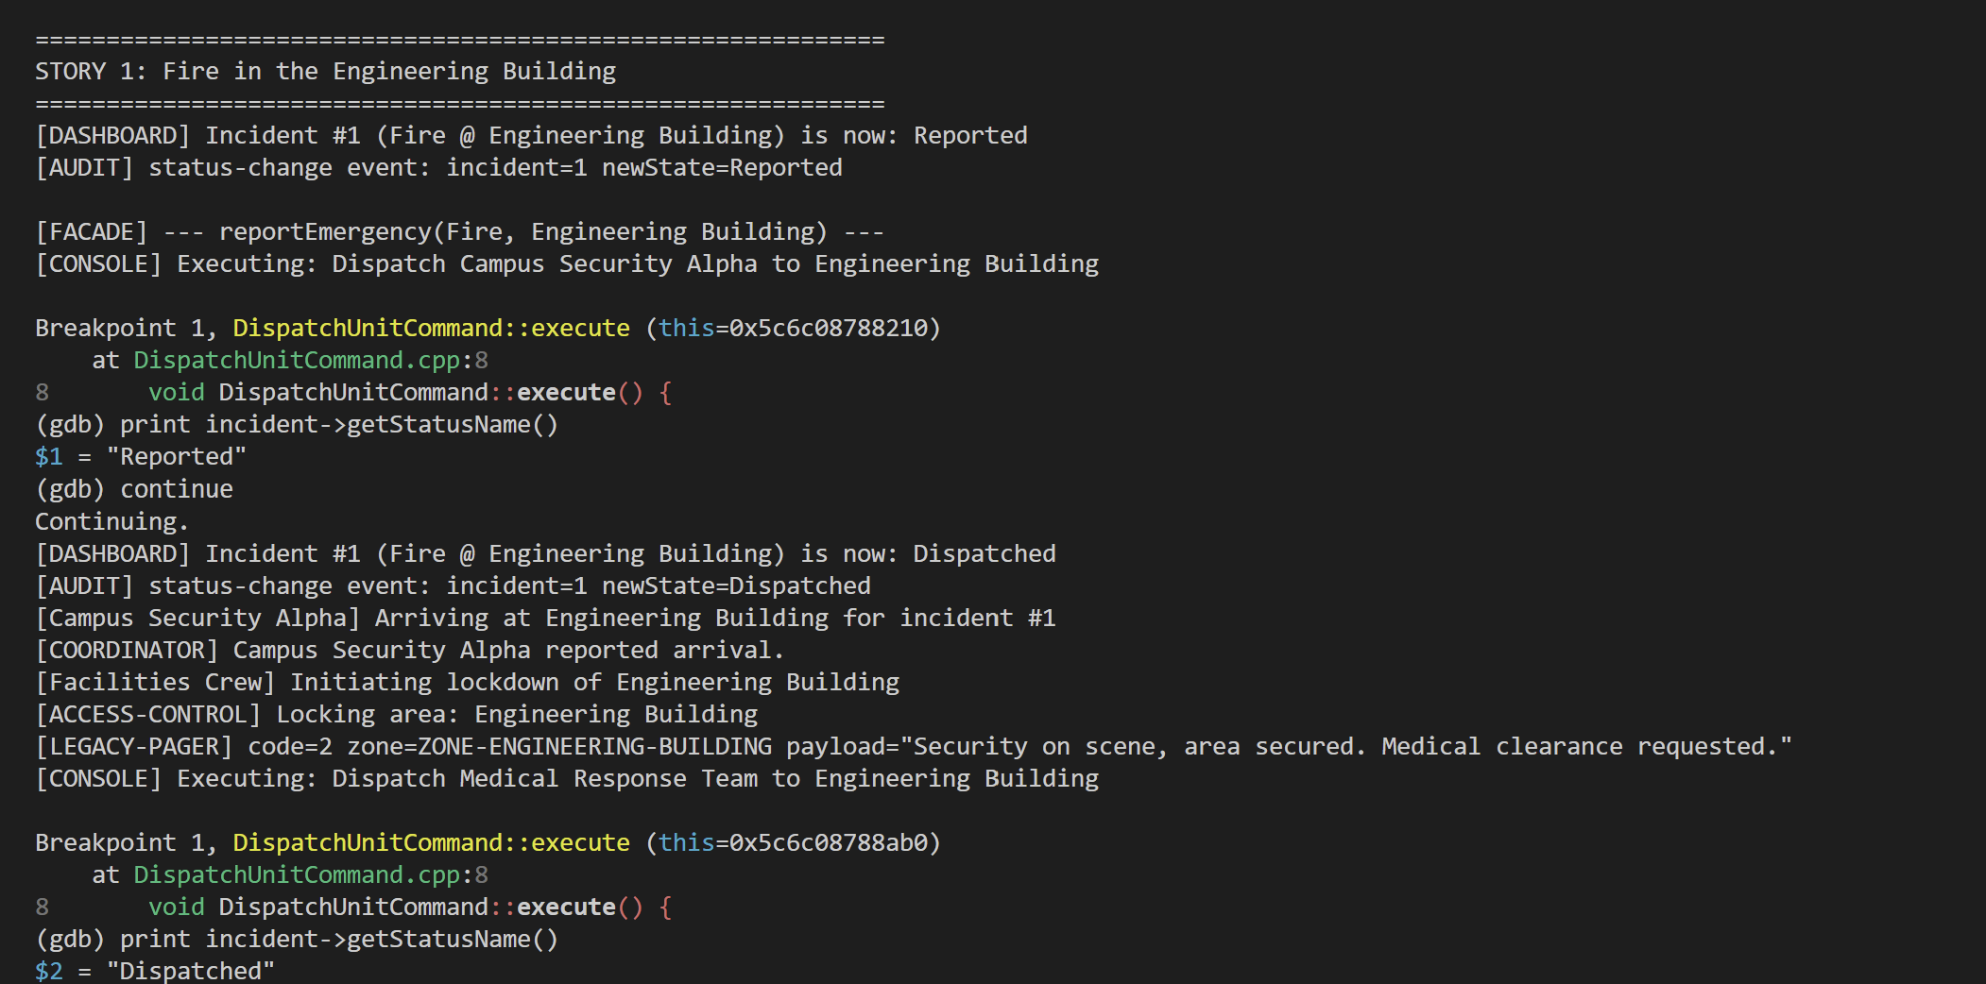
Collaboration reflection
The work was divided among the team based on the main areas of the project. One member focused on the system design and implementation of the six design patterns, including the class structure and pattern integration. Another member focused on the UML and behavioural diagrams, ensuring they matched the final implementation. The remaining work focused on the end-to-end scenarios and engineering quality, including main.cpp, the Makefile, Dockerfile, Docker Compose, Valgrind testing and the GDB investigation. The team then combined and reviewed the work for the final submission.
Contribution statements
Showlon:
Contributed to the system design and implementation of the six design patterns, including the class structure and integration between the patterns.
Francois:
Contributed to the UML class diagram and behavioural diagrams, ensuring that the diagrams reflected the final system implementation.
Tamima:
Contributed to the end-to-end scenarios and engineering quality, including main.cpp, Makefile, Dockerfile, Docker Compose, Valgrind testing and the GDB investigation.

