Question 24
#include<stdio.h>
int main ()

{
int x,n;
float y;
// Program to find value of y

printf("Enter value of n: ");
scanf("%d",&n);
printf("Enter value of x: ");
scanf("%d",&x);
if(n==1)
{
y=1+x;
printf("Value of y is :%f",y);
}
else if(n==2)
{
y=1+(x/n);
printf("Value of y is :%f",y);
}
else if(n==3)
{
y=1;
for(int i=0;i<3;i++)
y*=x;

printf("Value of y is :%f",y);
}
else if(n>3 || n<1)
{
y=1+(n*x);
printf("Value of y is :%f",y);
}
else
{
printf("Sorry");
}

return 0;
}
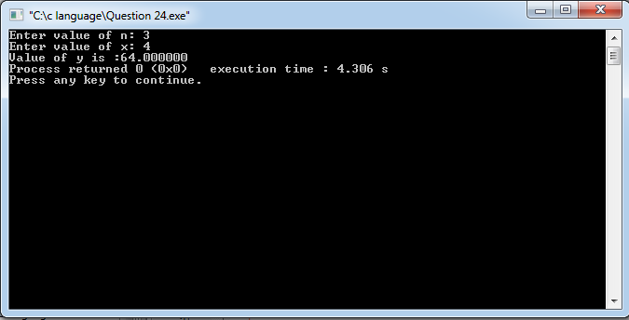

Question 25
#include<stdio.h>
int main()
{ // Table of a number
int n,Table;

printf("Enter n");
scanf("%d",&n);

for(int i=1;i<=10;i++)
{
Table=n*i;
printf("%d*%d=%d\n",n,i,Table);

}
return 0;
}
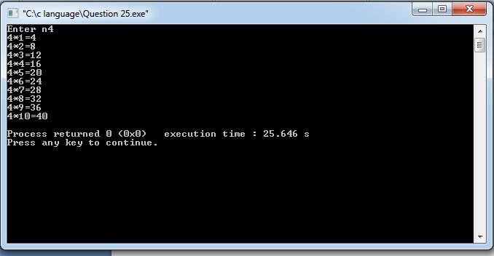
Question 26
#include<stdio.h>
int main()
{ // Print odd and even number
int n,sum,Sum,i;

printf("Enter value of n: ");
scanf("%d",&n);
sum=0;
Sum=0;
for(i=1;i<=n;i++){
if(i%2==0){
sum+=i;
}
else {
Sum+=i;
}

}
printf("Sum of even digits=%d\n",sum);
printf("Sum of odd digits =%d",Sum);
}
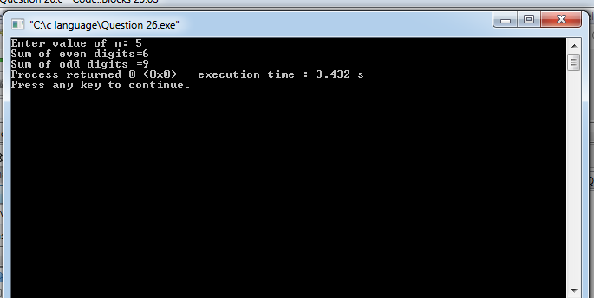
Question 27
#include<stdio.h>
int main()
{ //Number is prime or not
int n,is_prime=1;

printf("Enter number ");
scanf("%d",&n);

if(n<=1){
is_prime = 0;
}
else{
for(int i=2;i*i<=n;i++){
if(n%i==0) {

is_prime=0;
break;
}

}

}
if(is_prime){
printf("%d is a prime number\n",n);
}
else{
printf("%d is not a prime number\n",n);
}
}
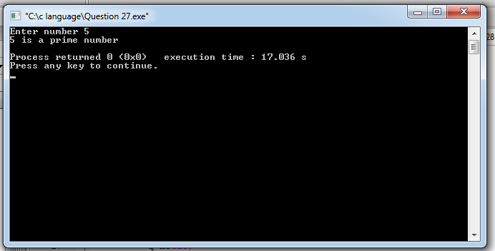
Question 28
#include<stdio.h>
int main()
// Check whether the number is Armstrong or not
{
int n,n2,n3,q,i,tamp,count=0,result=0;

printf("Enter n :");
scanf("%d",&n);
n2=n;
n3=n;

while(n2!=0){
n2=n2/10;
count++;
}
while(n!=0){
q=n%10;
tamp=1;
for(i=0;i<count;i++){
tamp*=q;
}
result+=tamp;
n=n/10;
}
if(result==n3){
printf("Is Armstrong");
}
else{
printf("Is not Armstrong");
}
}
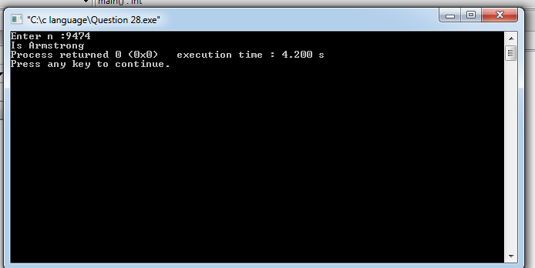
Question 29
#include<stdio.h>
int main()
{ // Check if a number is palindrome or not
int n,result,tamp,x;

printf("Enter number");
scanf("%d",&n);
tamp=n;

while(n!=0){
x=n%10;
result=result*10+x;
n=n/10;

}

if(tamp==result){
printf("Is a palindrome",result);
}
else{
printf("Is not a palindrome",result);
}
}
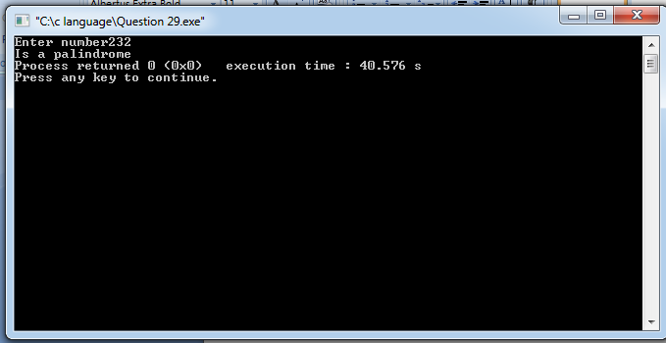
Question 30
#include<stdio.h>
int main()
{
//PROGRAM TO REVERSE OF A GIVEN NO.
int n,sum,x;

printf("Enter number :");
scanf("%d",&n);

while(n!=0){
x=n%10;
sum=sum*10+x;
n=n/10;
}

printf("Reverse of n:%d",sum);

return 0;

}

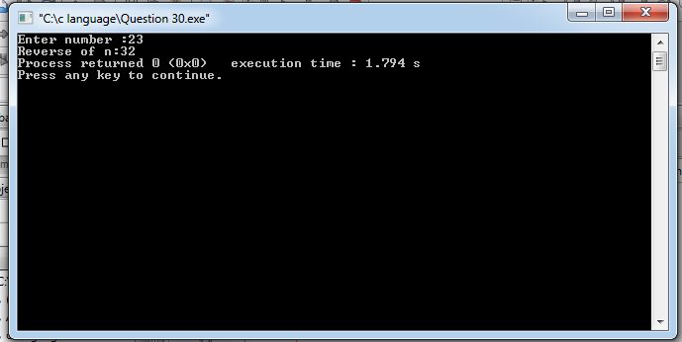

Question 31
#include<stdio.h>
int main()
{
//PROGRAM TO PRINT SUM OF INDIVIDUAL DIGITS OF A ‘N’ DIGIT NO.
int x,result,n;

printf("Enter number :");
scanf("%d",&n);
while(n!=0){
x=n%10;
result+=x;
n=n/10;
}
printf("Sum of Individual digits:%d",result);
}
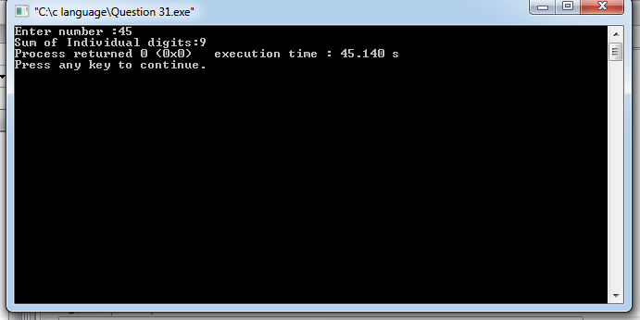
Question 32 (In Assignment 2 with arrays).
Question 33
#include<stdio.h>
int main()
{
//PROGRAM TO FINDOUT MAX AND MIN FROM ‘N’ NOS.
int num[9],i,n,max,min;

printf("Enter size of array:");
scanf("%d",&n);

printf("Enter array elements:");
for(i=0;i<n;i++){
scanf("%d",&num[i]);
}
printf("Array elements:");
for(i=0;i<n;i++){
printf("%d\n",num[i]);
}
printf("\n");
max=num[0];
min=num[0];
for(i=0;i<n;i++){
if(num[i]>max){
max=num[i];
}
if(num[i]<min&&num[i]!=max){
min=num[i];
}
}
printf("Max. no. out of n:%d\n",max);
printf("Min. no. out of n:%d",min);
}
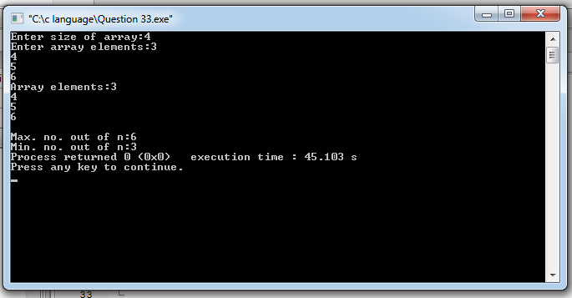
Question 34
#include<stdio.h>
// PROGRAM TO PRINT FIBONACCI SERIES.(0,1,1,2,3…)
int main(){
int N,N1,N2,n;

printf("Enter n:");
scanf("%d",&n);
N1=0,N2=1;
printf("Fibonacci series for %d terms:",n);
for(int i=0;i<=n;i++){
Printf(“%d”,N1);
N=N1+N2;
N1=N2;
N2=N;

}
return 0;
}
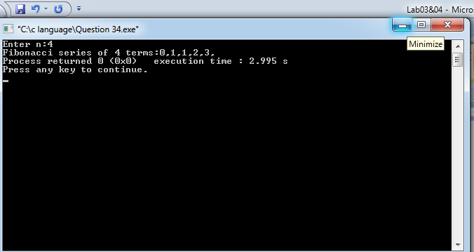
Question 35
//READ A NUMBER N AND PRINT A SINGLE DIGIT ANSWER SHOWING SUM OF DIGIT OF N
#include<stdio.h>

int main()
{
int n,i,result,r;

printf("Enter n: ");
scanf("%d",&n);

result=0;
while(n!=0){
i=n%10;
r=r+i;
n=n/10;
}
while(r!=0){
i=r%10;
result=result+i;
r=r/10;
}
printf("sum of digits of n:%d",result);
}
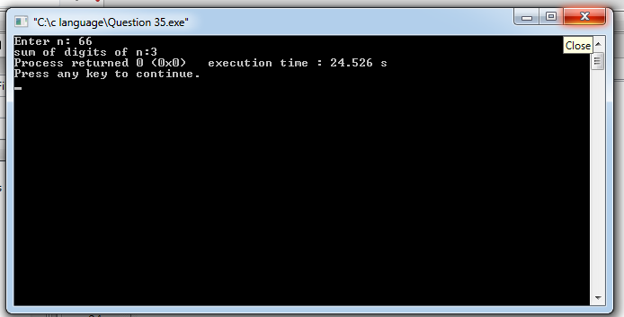
Question 36
#include<stdio.h>
int main(){
//PROGRAM TO PRINT 1,3,5,7,9………N.

int n,i,s;
printf("Enter n:");
scanf("%d",&n);
i=1;
printf("Odd Digits”);
do{
printf("%d\n",i);
i=i+2;
} while (i<=n);

}
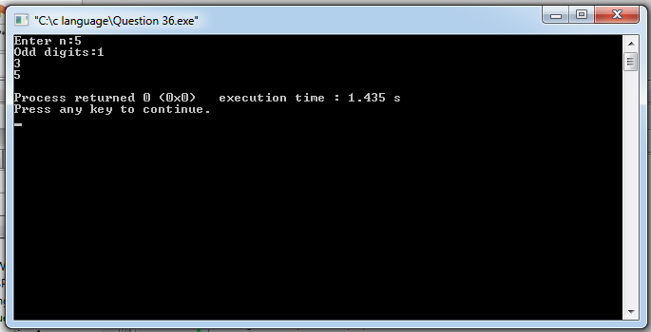
Question 37
#include<stdio.h>
int main(){
//PROGRAM TO PRINT 2,4,6,8,10,12………N.
int i,n;
printf("Enter n: ");
scanf("%d",&n);
i=0;
printf("Even digits: ");

while(i<n)
{
i+=2;
printf(“%d\n”,i);
}
}
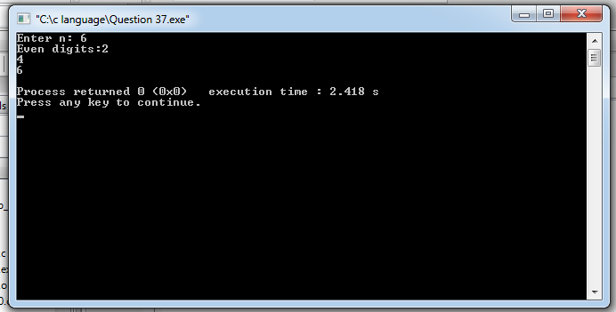
Question 38
//PROGRAM TO PRINT 1,4,9,16,25,………N.
#include<stdio.h>
int main()
{
int i,n;
printf("Enter n: ");
scanf("%d",&n);

i=1;
for(i=1;i<=n;i++){
int s=i*i;
printf("%d\n",s);
}
}
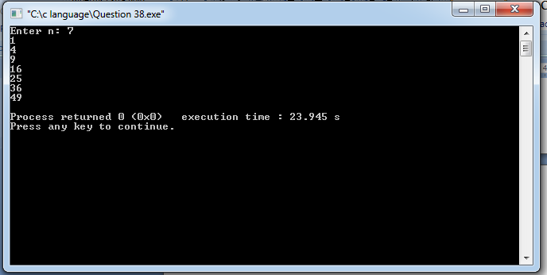
Question 39
#include<stdio.h>
int main(){
//PROGRAM TO PRINT 1/1!+2/2!+3/3!+4/4!,………N.
int x;
float i,f,X;

printf("Enter x:");
scanf("%d",&x);
f=1;
X=0;
for(i=1;i<=x;i++){
f=i*f;
X=X+i/f;
}
printf("Sum of %d terms of series : %f",x,X);
}
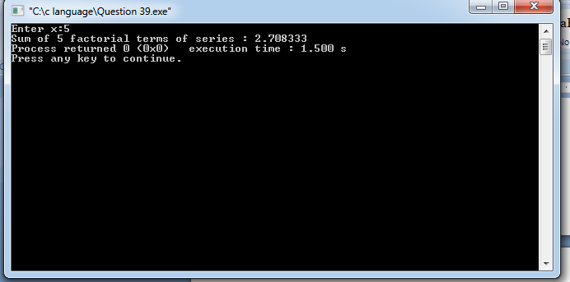
Question 40
#include<stdio.h>
//READ NUMBERS TILL A NEGATIVE NUMBER IS ENTERED AND CALCULATE SUM OF A LIST OF NUMBERS READ

int main(){

int n,sum2=0,i,sum;

do{
printf("Enter n: ");
scanf("%d",&n);
i++;
sum2=sum2+n;}while(n>0);
sum=sum2-n;
printf("Sum of list of numbers:%d",sum);

}
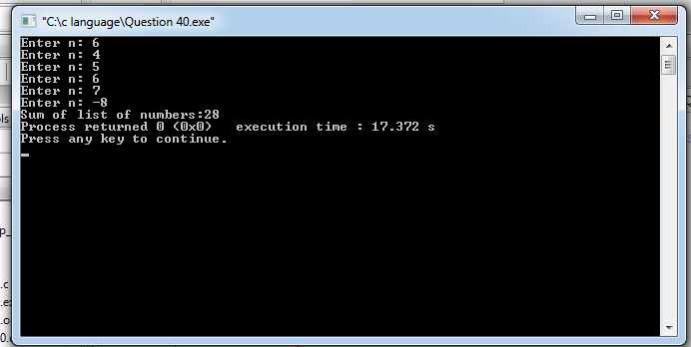
Question 41
#include<stdio.h>
int main(){

//READ A NUMBER N AND PRINT FACTOR OF N.(EX 28= 1,2,4,7,14,28)

int x,n,i;

printf("Enter n:");
scanf("%d",&n);
printf("factors are:");
for(i=1;i<=n;i++)
{
if(n%i==0){
if(i==1)
printf("%d",i);
else{
printf(",%d",i);
}
}

}

}
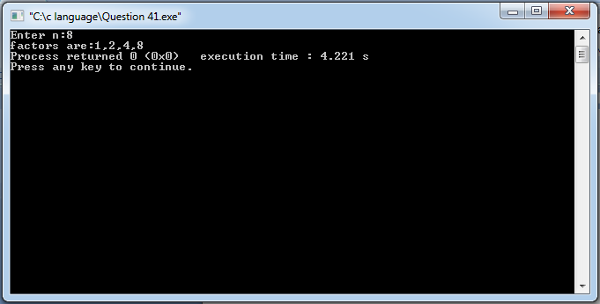
Question 42
//READ A NUMBER N AND PRINT IF N IS PRIME OR COMPOSITE.
#include<stdio.h>
int main()
{
int x,n,i;
printf("Enter n:");
scanf("%d",&n);
for(i=2;i<n;i++)
{
if(n%i==0)
x=1;
break;
}
if(x){
printf("Is composite");
}
else{
printf("Is prime");
}

}
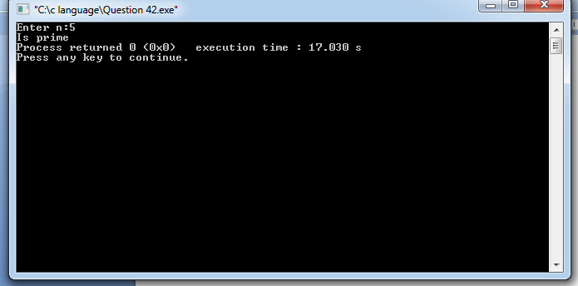
Question 43
/*WRITE A C PROGRAM TO CALCULATE THE COMMISSION FOR A SALES REPRESENTATIVE AS PER THE SALES
AMOUNT GIVEN BELOW.
If sales<=Rs. 500, commission is 5%
If sales> but <=2000, commission is Rs. 35 plus 10% above Rs. 500
If sales>2000 but <=5000, commission is Rs. 185 plus 12% above Rs. 2000
If sales>5000, commission is 12.5% */
#include<stdio.h>
int main()
{
float sale,c,sale0;

printf("Enter sale: ");
scanf("%f",&sale0);

if(sale0<=500){
c=(sale0/100)*5;
printf("Commission = %f",c);
}
else if(sale0>500&&sale0<=2000){
c=((sale0-500)/10)+35;
printf("Commission = %f",c);
}
else if(sale0>2000&&sale0<=5000){
c=((sale0-2000)/100)*12+185;
printf("Commission = %f",c);
}
else{
c=(sale0/100)*12.5;
printf("Commission = %f",c);
}

}
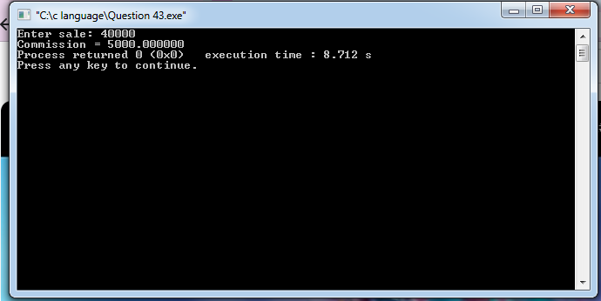

Question 44
/*WRITE A PROGRAM IN C FOR THE FOLLOWING.
AN ELECTRIC DISTRIBUTION COMPANY CHARGES ITS DOMESTIC CONSUMERS AS
FOLLOWS.
Consumption in unit Rate for Charge
0-200 Re 0.50 per unit
210-400 Rs. 100 plus Re 0.65 per unit excess of 200
401-600 Rs. 230 plus Re 0.80 per unit excess of 400
Above 600 Rs. 425 plus Rs. 125 per unit excess of 600
Print the amount to be paid by the consumer.*/
#include<stdio.h>
int main()
{
float amt,unit;

printf("Enter unit consumption : ");
scanf("%f",&unit);

if(0<unit<200)
{
amt=unit*0.5;
printf("Amount to be paid :Rs.%f",amt);
}
else if(210<unit<400)
{
amt=100+(unit-200)*0.65;
printf("Amount to be paid :Rs.%f",amt);
}
else if(401<unit<600)
{
amt=230+(unit-400)*0.8;
printf("Amount to be paid :Rs.%f",amt);
}
else if(unit>600)
{
amt=425+(unit-600)*125;
printf("Amount to be paid :Rs.%f",amt);
}
else
{
printf("Please enter valid no. of units");
}
}
