Question 1
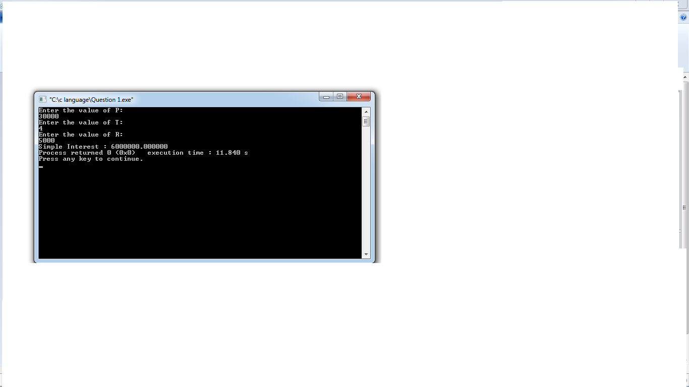
#include<stdio.h>
int main ()
{
// Simple interest
int P,T,R;
float SI;
printf("Enter the value of P:\n",P);
scanf("%d",&P);

printf("Enter the value of T:\n",T);
scanf("%d",&T);

printf("Enter the value of R:\n",R);
scanf("%d",&R);

SI=(P*T*R)/100;

printf("Simple Interest : %f ",SI);
return 0;

}

Question 2
#include<stdio.h>
int main ()
{
// Marks of 5 subjects and it's total
int Phy,Che,Math,Eng,AI,Total;
float Percentage;
printf("Physics: ",Phy);
scanf("%d",&Phy);
printf("Chemistry: \n",Che);
scanf("%d",&Che);
printf("Maths: \n",Math);
scanf("%d",&Math);
printf("English:\n",Eng);
scanf("%d",&Eng);
printf("Artificial Intelligence:",AI);
scanf("%d",&AI);

Total = (Phy+Che+Math+Eng+AI);
Percentage = (Total*100)/500;
printf("Total marks scored : %d\n",Total);
printf("Percentage of student: %f ",Percentage);

}
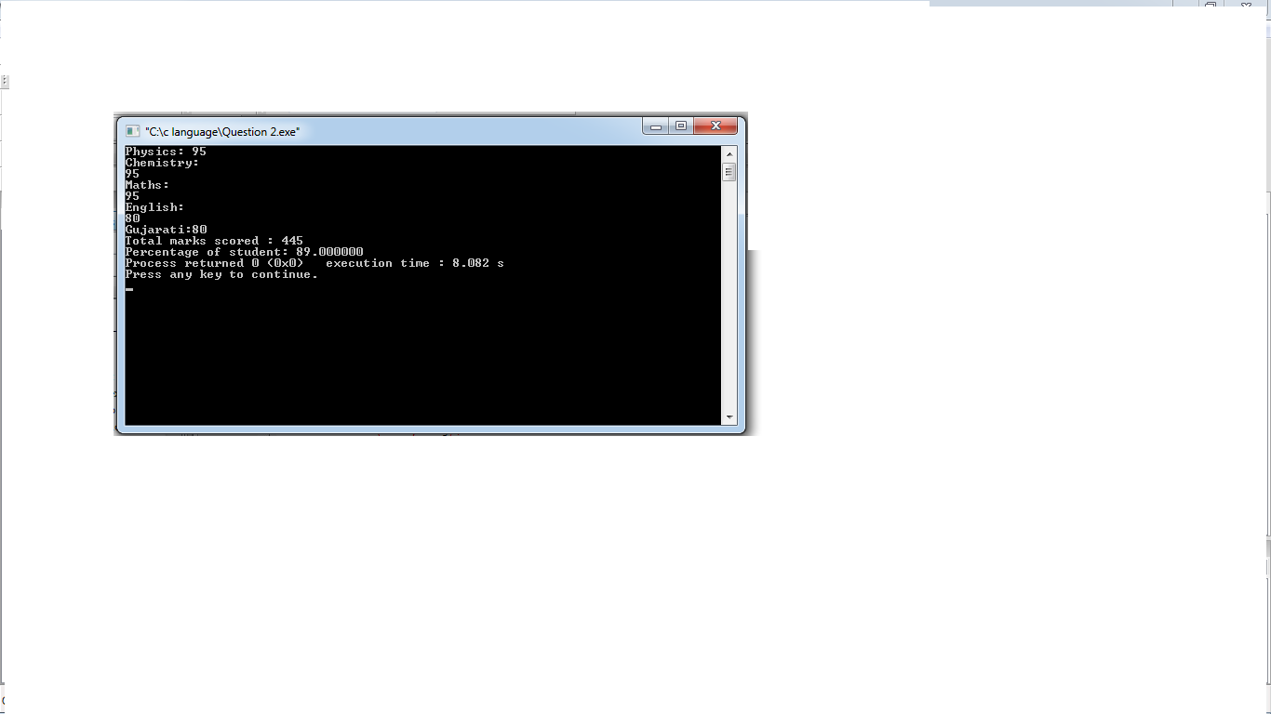

Question 3

#include<stdio.h>
int main()
{
//Gross Salary
int Salary,OA,Bonus,GrossSalary;

printf("Enter Your Annual : ",Salary);
scanf("%d",&Salary);
printf("Enter Other Allowances : ",OA);
scanf("%d",&OA);
printf("Enter Bonus : ",Bonus);
scanf("%d",&Bonus);

GrossSalary = Salary+Bonus+OA;

printf("Your Gross Salary : %d",GrossSalary);

return 0; }
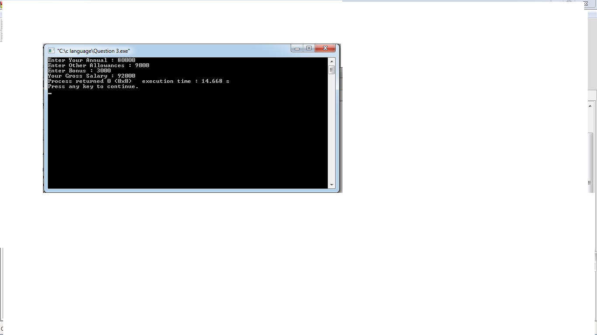

Question 4
#include<stdio.h>
int main ()
{
// Convert Temperature from Fahrenheit to Celsius
float C,T;

printf("Enter Temp: ");
scanf("%f",&T);

C = (T-32)*1.8;

printf("Temperature in Celsius : %f ",C);
return 0;
}
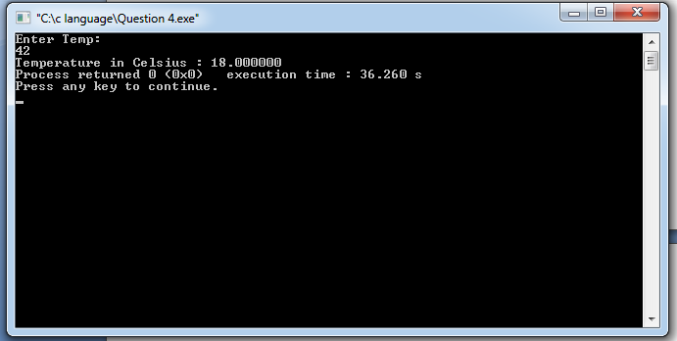

Question 5
#include<stdio.h>
int main()
{
// Swap two variables with using Third Variable
int a,b,c;
printf("Before Swapping\n");
printf("Enter a: ",a);
scanf("%d",&a);

printf("Enter b: ",b);
scanf("%d",&b);

c=a;
a=b;
b=c;

printf("After Swapping\n");

printf("Value of a : %d \n",a);
printf("Value of b : %d",c);
return 0;
}
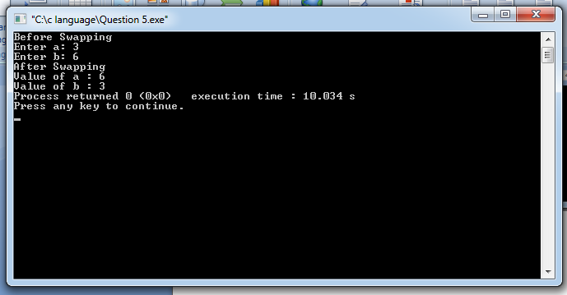

Question 6
#include<stdio.h>
int main()
{
// Swapping with two variables
int a,b;
printf("Before Swapping\n");

printf("Enter Value of a : ");
scanf("%d",&a);
printf("Enter Value of b : ");
scanf("%d",&b);
a=a+b;
b=a-b;
a=a-b;

printf("After Swapping\n");

printf("Value of a : %d \n",a);
printf("Value of b : %d ",b);

return 0;
}

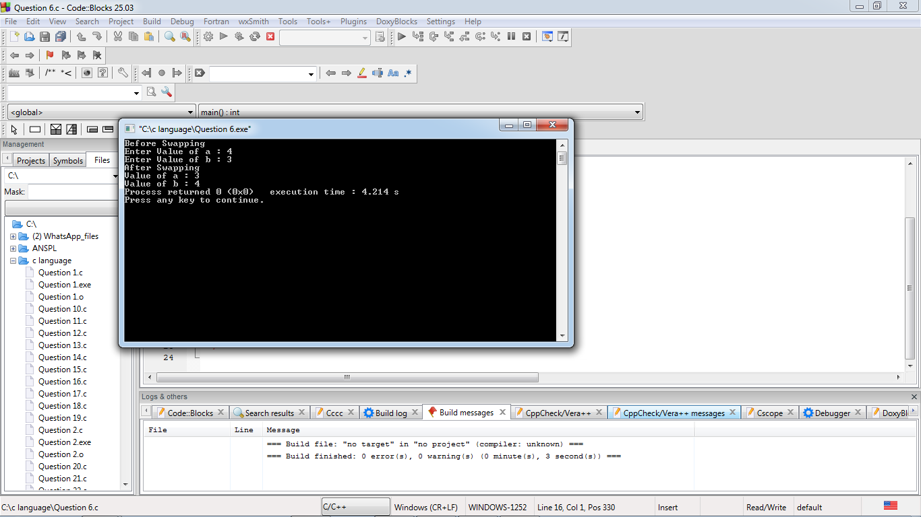

Question 7
#include<stdio.h>
int main()
{
// Area of Triangle
int H,B;
float A;
printf("Enter Height : ",H);
scanf("%d",&H);
printf("Enter Base : ",B);
scanf("%d",&B);

A=H*B*0.5;

printf("Area of Triangle : %f",A);
return 0;
}
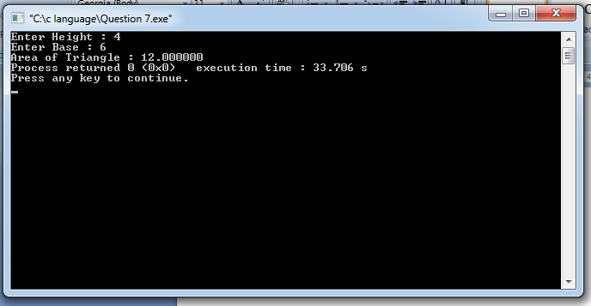

Question 8
#include<stdio.h>
int main ()
{
// Period of Revolution of Earth
float Hrs,Min,Sec,Days;

Sec= 31558150;
Min=Sec/60;
Hrs=Min/60;
Days=Hrs/24;

printf("Revolution Period in Minutes : %f\n",Min);
printf("Revolution Period in Hours : %f\n",Hrs);
printf("Revolution Period in Days : %f\n",Days);

return 0;
}
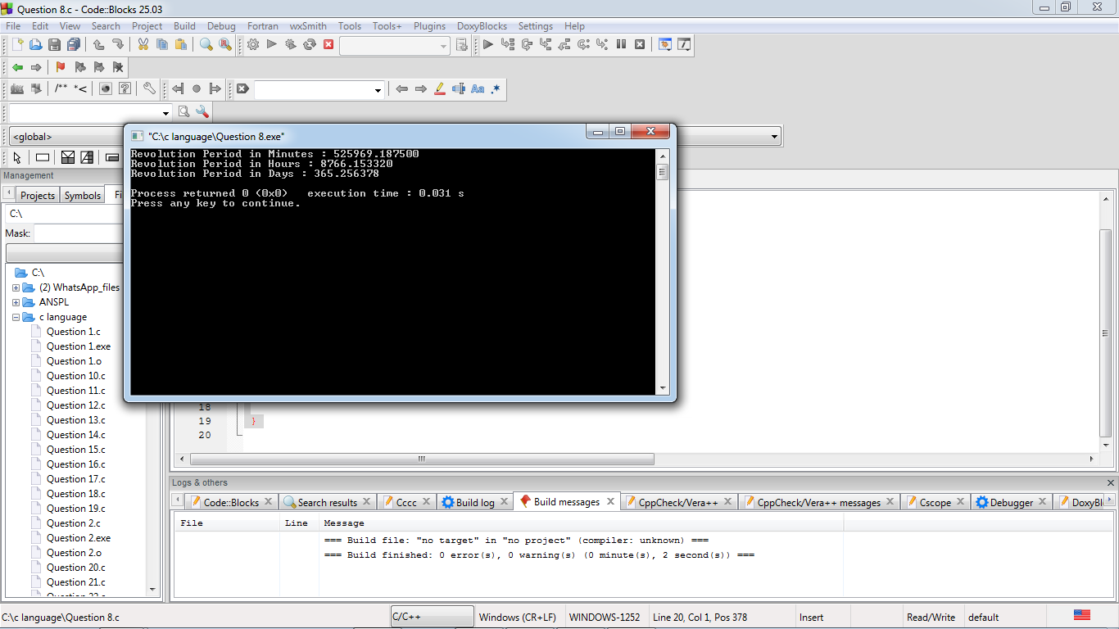

Question 9
#include<stdio.h>
int main ()
{
// Time Conversion
float Hrs,Min,Sec1,Sec2,Total;

printf("Enter Time(in Hrs): ",Hrs);
scanf("%f",&Hrs);
printf("Enter Time(in Min): ",Min);
scanf("%f",&Min);

Sec1=Hrs*3600;
Sec2=Min*60;
Total=Sec1+Sec2;

printf("Total Time In Seconds:%fs",Total);

return 0; }
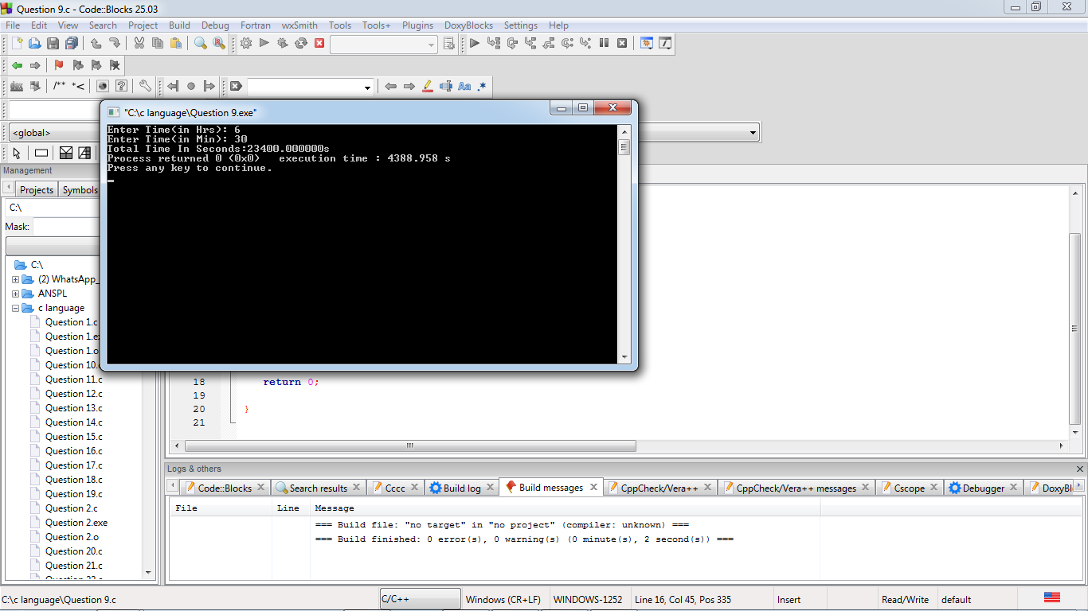

Question 10
#include<stdio.h>
int main()
{
//Calculate The CutOff Mark
int M,P,C,E;
float CM;
// M is marks of Maths out of 200
printf("Marks of Maths : ",M);
scanf("%d",&M);

// P is marks of Physics out of 200
printf("Marks of Physics : ",P);
scanf("%d",&P);

// C is marks of Chemistry out of 200
printf("Marks of Chemistry : ",C);
scanf("%d",&C);

// E is marks of Entrance Examination out of 100
printf("Marks of EE : ",E);
scanf("%d",&E);

// CM= Cutoff Marks
CM=M/2+P/2+C/2+E;

printf("CutOff Marks Of Student: %f ",CM);
return 0;
}
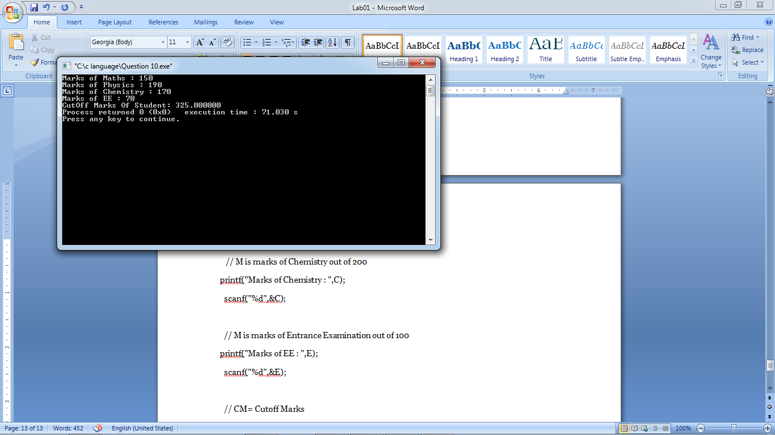

Question 11
#include<stdio.h>
int main()
{
// Read time in total second and convert it
int Sec,Hrs,Min,TotalSecond;

printf("Enter total second : ",TotalSecond);
scanf("%d",&TotalSecond);

Hrs=TotalSecond/3600;
TotalSecond=TotalSecond%3600;
Min=TotalSecond/60;
TotalSecond=TotalSecond%60;
Sec=TotalSecond%60;

printf("Time=%d:%d:%d",Hrs,Min,Sec);

return 0;
}
