Question 12
#include<stdio.h>
int main()
{
// ASCII Code of Any Character
char ch;

printf("Enter any Character: ",ch);
scanf("%c",&ch);
printf("The value of %c in %d is : ",ch);

}

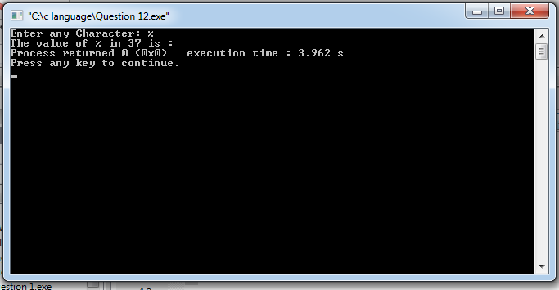

Question 13
#include<stdio.h>
int main()
{
// No. is Even or Odd
int X;

printf("Enter a Digit : ",X);
scanf("%d",&X);
if(X%2==0){
printf("Digit is Even");
}
else{
printf("Digit is Odd");
}
return 0;
}
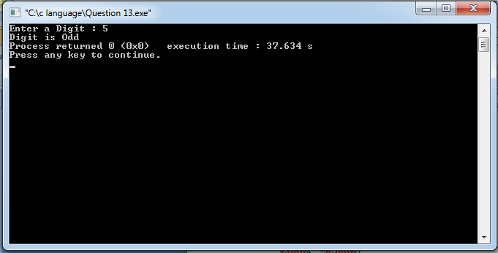

Question 14
#include<stdio.h>
int main()
{
// To Categorize a Character
char ch;

printf("Enter a Character: ");
scanf("%c",&ch);

if(ch>='A'&&ch<='Z'){
printf("It is a capital letter",ch);
}
else if(ch>='a'&&ch<='z'){
printf("It is a small letter",ch);
}
else if(ch>='0'&&ch<='9'){
printf("It is a digit ",ch);
}
else{
printf("It is a special symbol",ch);
}
return 0;
}
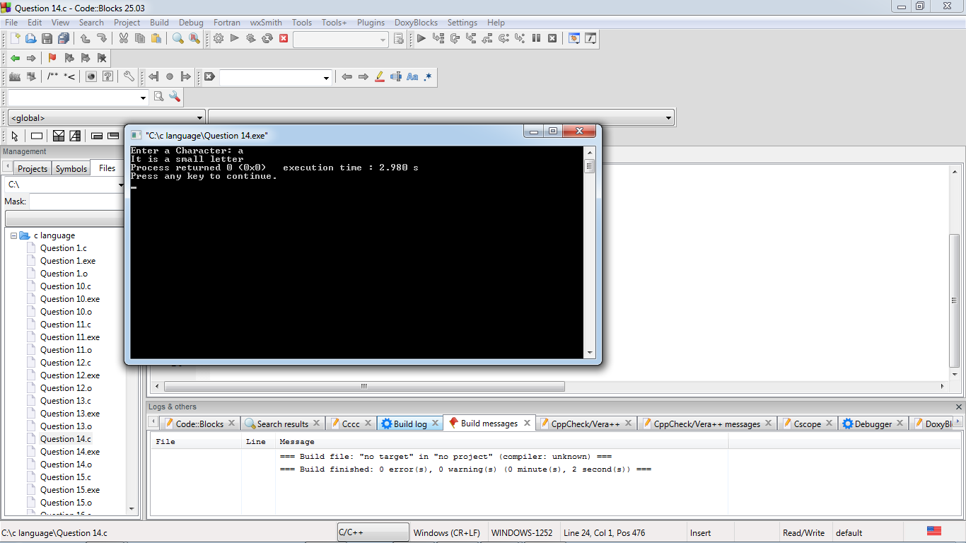
Question 15
#include<stdio.h>
int main ()
{

// Read 5 Subjects and print divisions
int m1,m2,m3,m4,m5,Total;
float Per;
/* m1 = marks of subject 1
m2 = marks of subject 2
m3 = marks of subject 3
m4 = marks of subject 4
m5 = marks of subject 5 */

printf("Enter m1 : ",m1);
scanf("%d",&m1);

printf("Enter m2 : ",m2);
scanf("%d",&m2);

printf("Enter m3 : ",m3);
scanf("%d",&m3);

printf("Enter m4 : ",m4);
scanf("%d",&m4);

printf("Enter m5 : ",m5);
scanf("%d",&m5);

Total = m1+m2+m3+m4+m5;
Per=(Total*100)/500;

printf("Total Marks= %d \n",Total);
printf("Percentage = %f \n",Per);

if(Per>=90 && Per<=100){
printf("A++");
}
else if(Per>=80 && Per<=90){
printf("A");
}
else if(Per>=50 && Per<=80){
printf("B");
}
else if(Per>=30 && Per<=50){
printf("C");
}
else{
printf("Fail");
}
return 0;
}

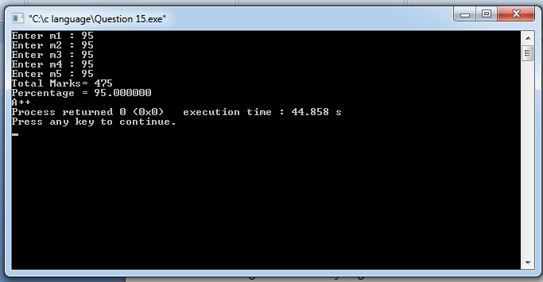
Question 16
#include<stdio.h>
int main()
{
// Find Max. Number
int a,b,c,Max;

printf("Enter the numbers : ",a,b,c);
scanf("%d,%d,%d",&a,&b,&c);

if(a>b){
printf("Maximum number is %d",a);
}
else if(c<b){
printf("Maximum number is %d ",b);
}
else{
printf("Maximum number is %d ",c);
}
return 0;
}

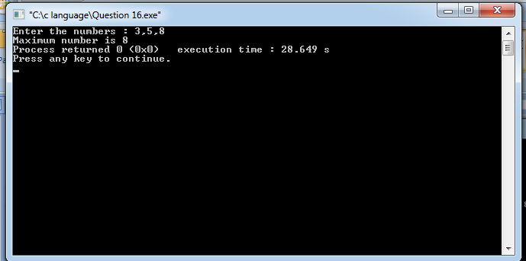

Question 17
#include<stdio.h>
int main()
{
// Find Max no. using &&
int a,b,c;

printf("Enter the numbers : ",a,b,c);
scanf("%d,%d,%d",&a,&b,&c);

if(a>b && a>c){
printf("Maximum number is %d",a);
}
if(b>a && b>c){
printf("Maximum number is %d",b);
}
if(c>a && c>b){
printf("Maximum number is %d",c);
}
return 0;
}
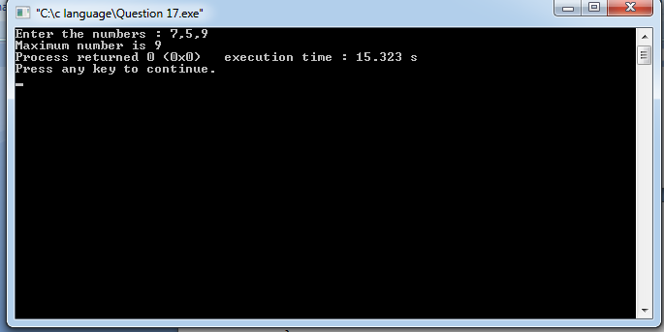
Question 18
#include<stdio.h>
int main ()
{
// Print Max. of 3 no. with conditional operator
int a,b,c,Max;
printf("Enter the numbers : ",a,b,c);
scanf("%d,%d,%d",&a,&b,&c);
{

Max = (a>b)?((a>c)?a:c):(b>c)?b:c;

}
printf("Maximum Number is %d",Max);
return 0;
}
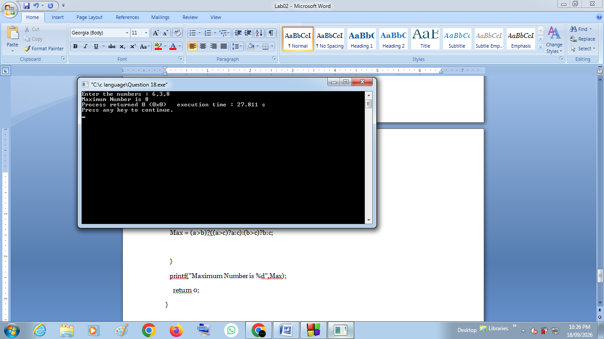

Question 19
#include<stdio.h>
int main()
{
// To check the case of a letter
char ch;

printf("Enter the letter : ",ch);
scanf("%c",&ch);

{
(ch>='A' && ch<='Z')?(printf("Letter is in Capital",ch)):(printf("Letter is in Small",ch));
}
return 0;
}
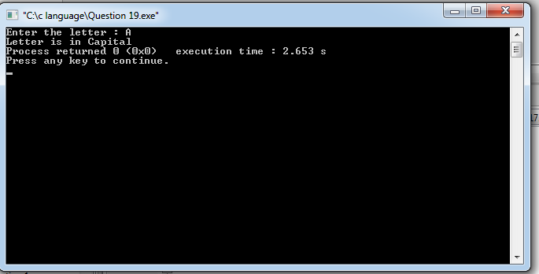
Question 20
#include<stdio.h>
int main ()
{
// Simple Calculator
int op;
float a,b;

printf("Enter numbers : ");
scanf("%f,%f",&a,&b);

printf("Enter your Operation(1-Add,2-Difference,3-Multiplication,4-division): ");
scanf("%d",&op);

switch(op) {
case 1 : printf("Result : %f",a+b);
break;

case 2 : printf("Result : %f",a-b);
break;

case 3 : printf("Result : %f",a*b);
break;

case 4 : if(b!= 0){
printf("Results : %f",a/b);
}
else{
printf("Error");
}
break;

default : printf("invalid input");
}
return 0;
}
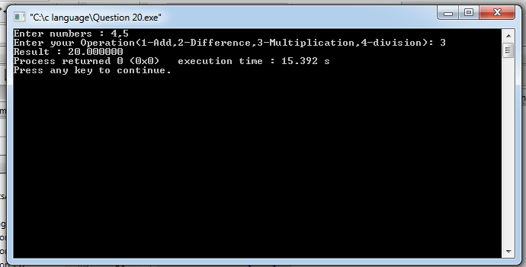
Question 21

#include<stdio.h>
int main ()
{
// Read two numbers and perform Arithmetic operation
int a,b,result;
char ch;

printf("Enter Operator(+,-,*,/): ");
scanf("%c",&op);

printf("Enter numbers:");
scanf("%d,%d",&a,&b);

switch(op){
case '+' :
result=a+b;
printf("Sum=%d",result);
break;
case '-' :
result=a-b;
printf("Diff.=%d",result);
break;
case '*' :
result=a*b;
printf("Multiplicaion=%d",result);
break;
case '/' :
result=a/b;
printf("DIvision=%d",result);
break;

default: printf("Please enter valid operator");
break;

}
return 0;

}
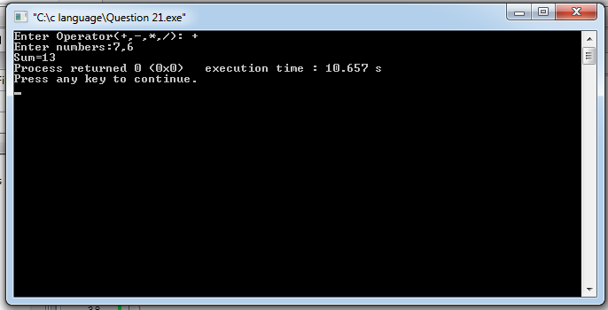

Question 22
#include<stdio.h>
int main ()
{
int i,a;

printf("Enter number: ");
scanf("%d",&a);
// Calculate Factorial of a number
int factorial=1;
for(i=1;i<=a;i=i+1)
{
factorial=factorial*i;
}
printf("Factorial of a :%d",factorial);

return 0;
}
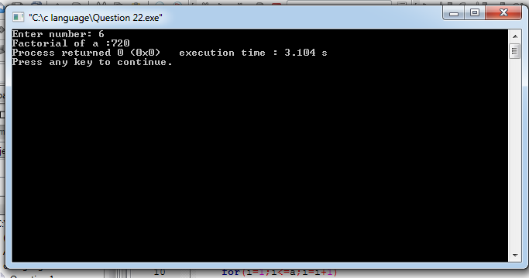
Question 23
#include<stdio.h>
int main ()
{ // Calculate power of number
float a,result;
int b;

printf("Enter base a : ");
scanf("%f",&a);

printf("Enter Exponent b : ");
scanf("%d",&b);
result=1;
for(int i=0;i<b;i++){
result*=a;
}

printf("Answer =%f",result);
return 0;
}

