**Flow chart**

## **Flow chart explaining how the actual program will work**

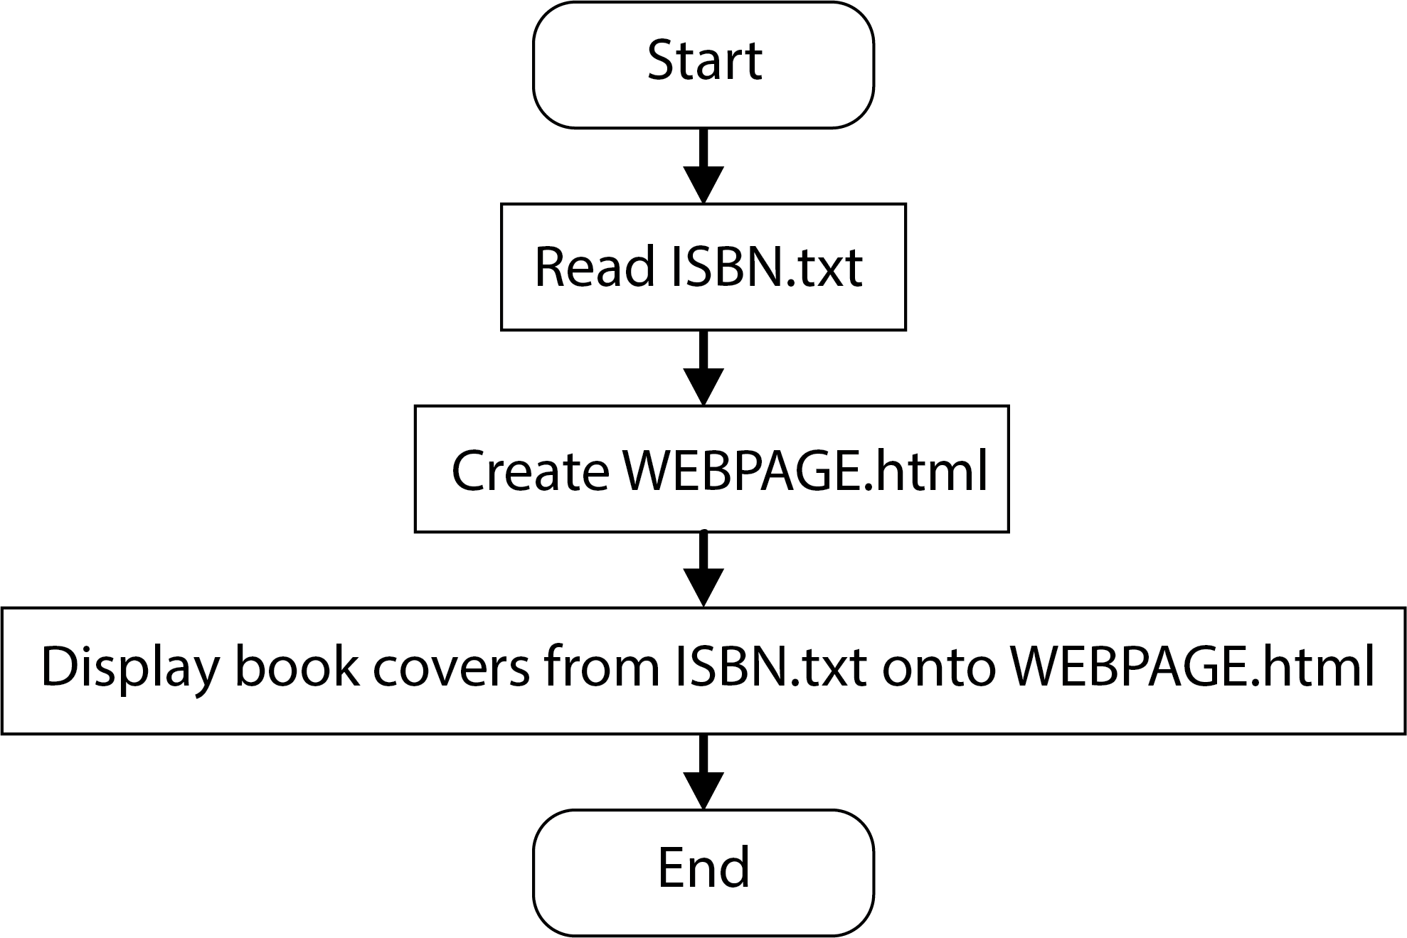

## **Flow chart explaining how the HTML file works**

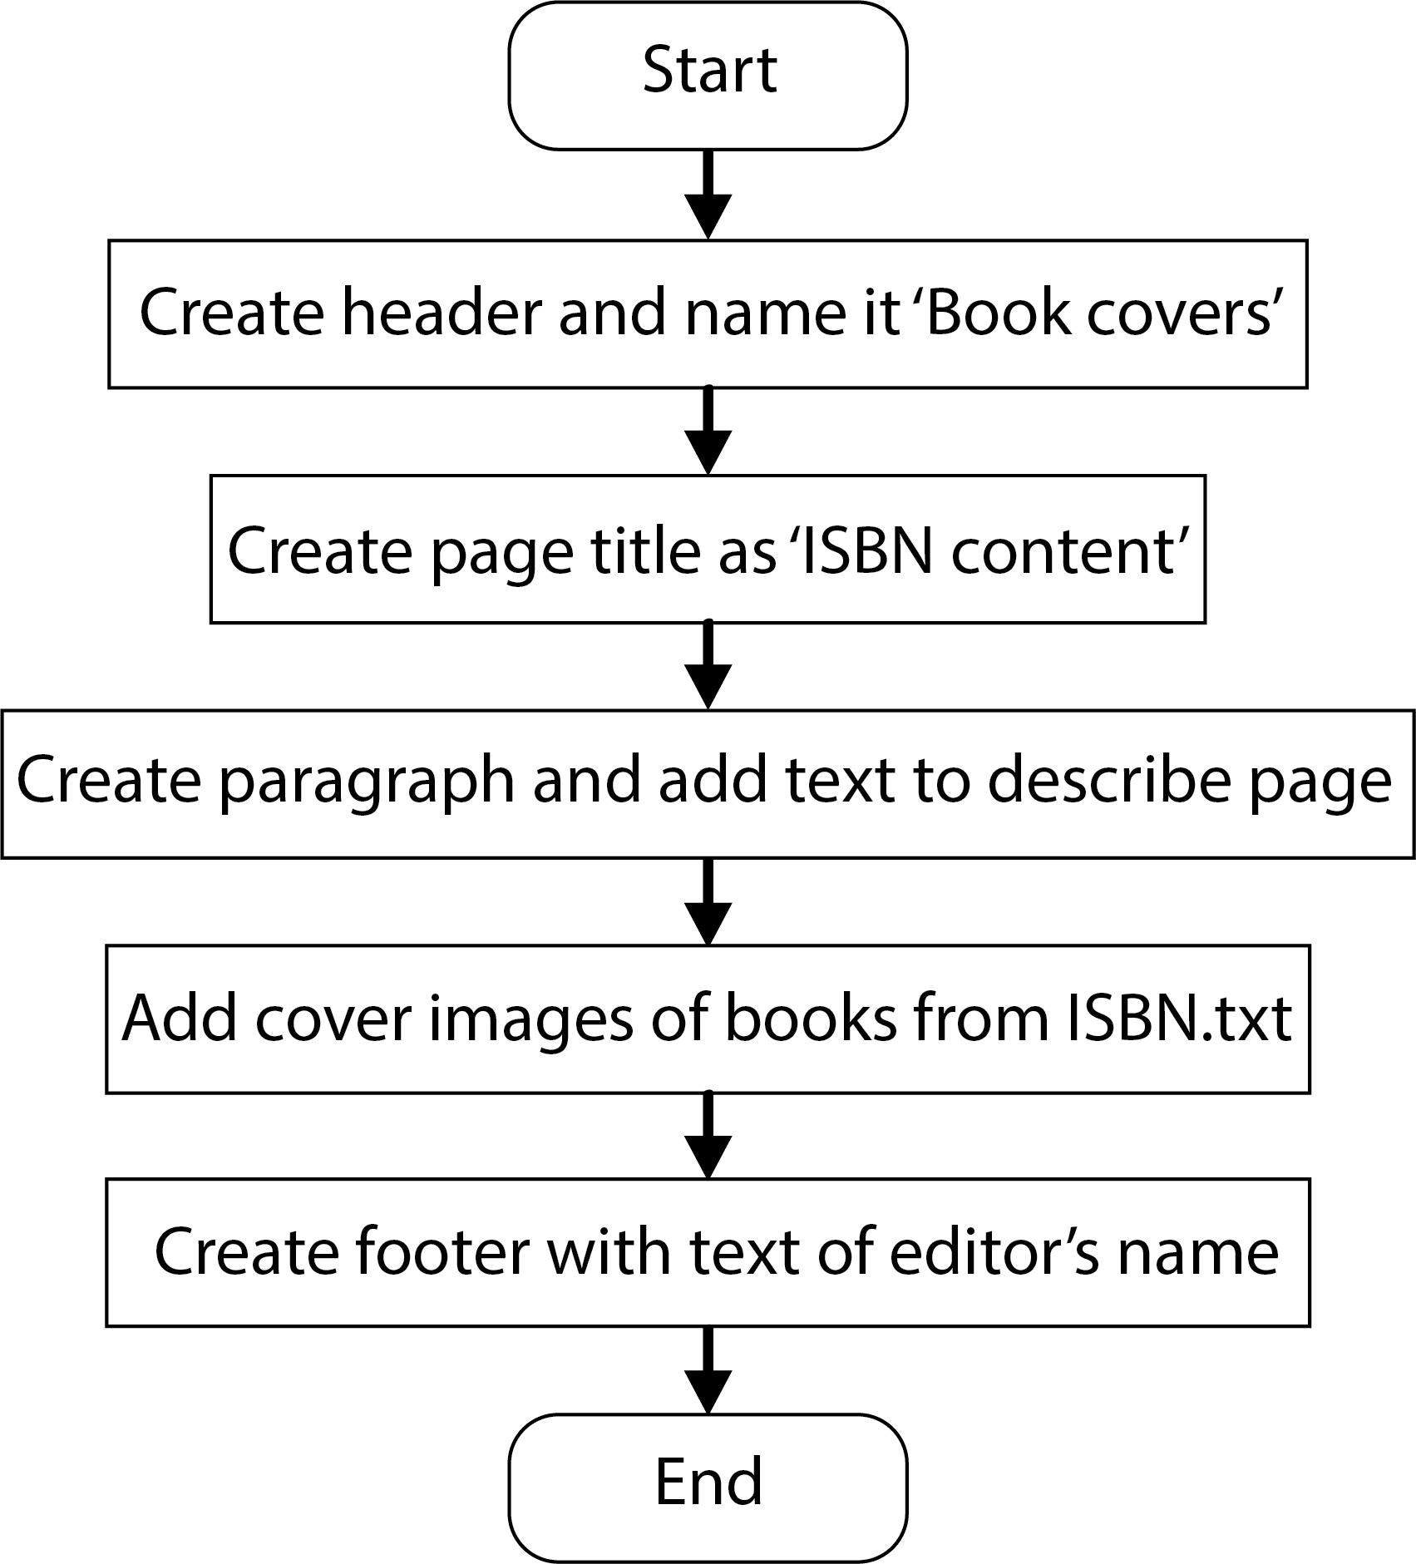

## **Flow chart explaining how the Python code works**

