SAT I Class
Xilin Northwest Chinese School
Instructor: Chunyun Liu
Phone: 224-433-0866
Email: chunyun_liu@yahoo.com

About This Class
The main objective of this class is to help the students become familiar with the new designed SAT test style and try to improve their skills in solving the SAT questions. This class covers only the mathematical area of the SAT tests and we will discuss different topics in each week throughout the year. By the end of the year, the students will learn some strategy and SAT problem solving skills to solve all kinds of SAT problems and also the students will be trained to use logical way to think and solve the SAT problem. Furthermore, the courses go beyond the basics and provide a deeper understanding of the topics and train problem solving skills so that tricky problems become easy. With plenty of real SAT practice problems and a rigorous and encouraging atmosphere, students become much more comfortable with the new designed SAT mathematics tests.

Prerequisite
Students in this class should have already had some basic knowledge in intermediate algebra and plane geometry. High school students, as well as gifted middle school students are invited to take this SAT class.

Reference books(Students must buy)

. Barron's Math Workbook for the NEW SAT, 6th Edition (Barron's Sat Math Workbook)
https://www.amazon.com/Barrons-Math-Workbook-NEW-SAT/dp/1438006217/ref=tmm_pap_swatch_0?_encoding=UTF8&qid=1470001151&sr=1-1-spell

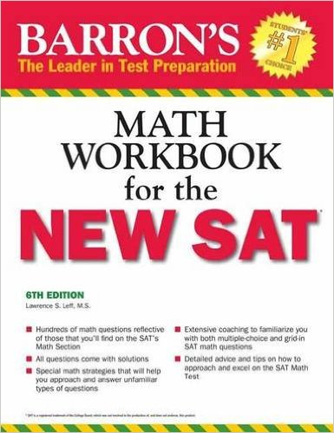

. The Official Study Guide for the new SAT (2016 Edition)
http://www.amazon.com/Official-SAT-Study-Guide-2016/dp/1457304309/ref=sr_1_3?s=books&ie=UTF8&qid=1440550742&sr=1-3&keywords=sat
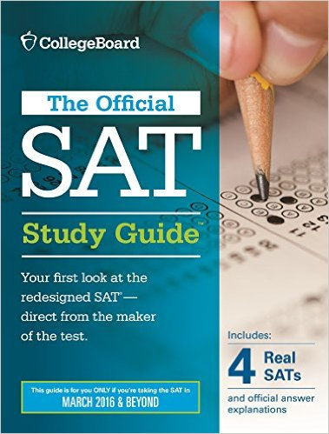

. 8 Practice Tests for the SAT 2017: 1,200+ SAT Practice Questions (Kaplan Test Prep)
https://www.amazon.com/Practice-Tests-SAT-2017-Questions/dp/1506202276/ref=sr_1_1?s=books&ie=UTF8&qid=1470000697&sr=1-1&keywords=8+practice+sat+test

