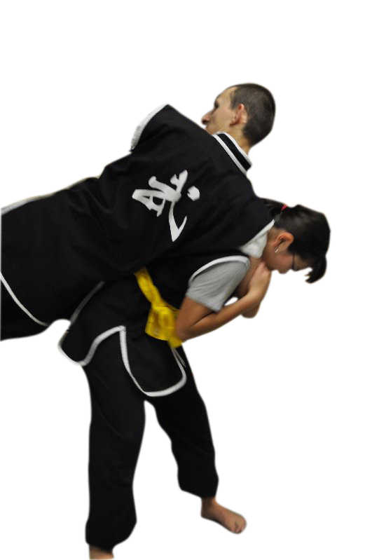Traditional Kung Fu for Self-Defense

Traditional Chinese Martial Arts have been used for self-protection for thousands of years. This class uses techniques from Taiji Chuan (Tai Chi Chuan) and Cai Li Fo (Choy Li Fut) to show students how to protect themselves. Learn how to throw a person using Shuai Jiao techniques from two different Traditions. Students will also study Chin Na as well as Punching and Kicking Techniques in real world Self-Defense situations.

This class will be limited to Teens and Adults, students should wear comfortable & fitting clothes, and no Uniforms are required.

**Ning Laoshi - Taiji Chuan (Tai Chi Chuan)**

Ning Laoshi began his training in Yang style Tai Chi Chuan 21 years ago. He is a disciple of Grand Master Yang Jun and his Shigong GM Yang Zhen Dou. He has also trained in San Shou full contact fighting. Believing that Tai Chi Chuan is first and foremost a martial art, and Shifu Ning teaches all of the applications and traditional training drills that Tai Chi Chuan has to offer.

**Whorton Shifu – Cai Li Fo (Choy Li Fut)**

Whorton Shifu has been Practicing Martial arts since 1983 and has been practicing Cai Li Fo for the last 18 years with Grand Master Sam Ng. Ng Family Chinese Martial Arts Association is located in Chicago. He is a 6th generation Student and has been teaching in the Schaumburg area for the last 10 years.