Assignment 2- Case Study

Stage 3 Lab Activities

SmartCare Domain Modelling
AI OFF -> AI ON -> COMPARE -> VERIFY | 1 hour

A - Requirements Review
Highlight nouns, verbs and business rules in SmartCare v0.2.
Nouns: Patient, Practitioner, Appointment, name, date, time, status, history, booking, availability.

Verbs: create, view, update, prevent, check, change, display,

B - Candidate Classes
Record candidate concepts, supporting requirements, state and behaviour.
Candidate | Class? | Reason
Patient | Yes | Appears in multiple requirements (FR‑01, FR‑02, FR‑03, FR‑10, FR‑11); has clear state and behaviour.
Practitioner | Yes | Required for booking (FR‑06), viewing (FR‑05), and duplicate‑check logic (FR‑07).
Appointment | Yes | Central scheduling concept; required for booking, status updates, viewing, and history (FR‑06–FR‑10, FR‑12).
Name | No | Attribute of Patient/Practitioner, not a standalone business concept.
Clinic | No | Not mentioned in requirements; no behaviour or state defined.
Database | No | Technical implementation detail, not part of the domain model.
Cancellation | No | Represented as an Appointment status (FR‑08), not a separate entity.
Status | No | Attribute of Appointment (FR‑08), not a standalone class.

C - CRC Cards
Create CRC cards for Patient, Practitioner and Appointment.

Patient
Responsibilities | Collaborators
Store patient details (name, contact info). | Appointment
Provide patient information when viewed or searched. | Appointment

Practitioner
Responsibilities | Collaborators
Store practitioner details. | Appointment
Provide practitioner information for scheduling and viewing. | Appointment

D - UML Model
Draw classes, attributes, operations, associations and multiplicities.

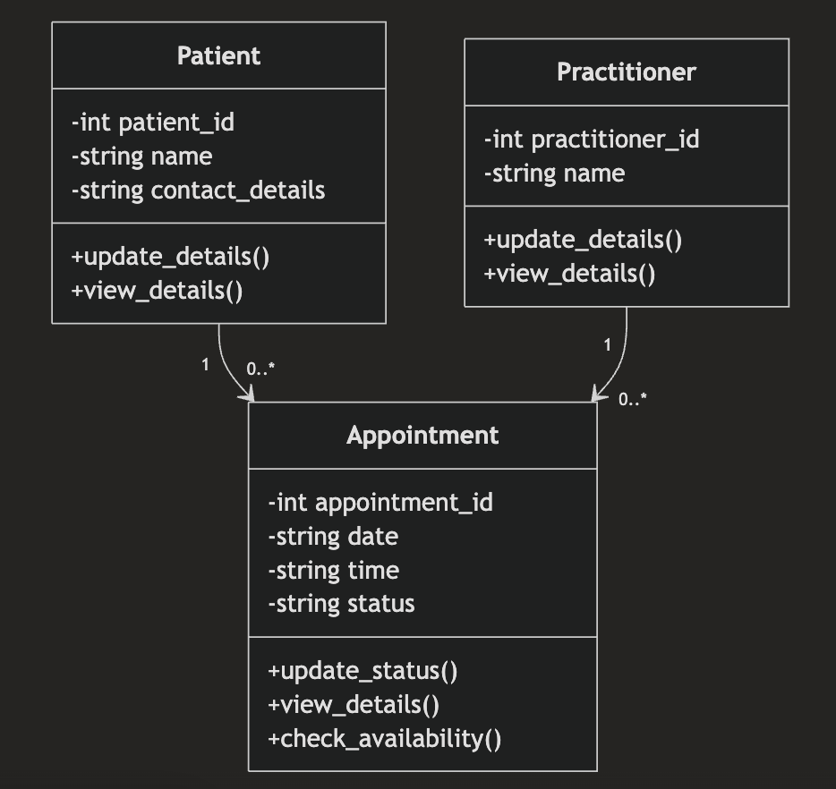

E - AI Design Review
Ask AI to suggest classes and relationships using only confirmed requirements; require supporting requirement IDs.
“Using only confirmed requirements FR-01 to FR-12, suggest domain classes and relationships. Cite supporting requirement IDs. Do not add technical or manager/controller classes unless directly supported.”

F - Compare and Decide
Record at least one accepted, modified and rejected AI suggestion.
AI suggestion | Evidence | Decision | Reason | Model change
Add AppointmentHistory class | FR-10 | Modified | History is required but separate class not justified | Kept as Appointment association
Add PatientManager | None | Rejected | Not a domain concept | No change
Patient linked to Appointment | FR-06, FR-10 | Accepted | Supported by requirements | Added association

G - Python Skeletons
Create simple Patient, Practitioner and Appointment class skeletons.

class Patient:
def __init__(self, patient_id, name, contact_details):
self.patient_id = patient_id
self.name = name
self.contact_details = contact_details

class Practitioner:
def __init__(self, practitioner_id, name):
self.practitioner_id = practitioner_id
self.name = name

class Appointment:
def __init__(self, appointment_id, patient, practitioner, date, time, status):
self.appointment_id = appointment_id
self.patient = patient
self.practitioner = practitioner
self.date = date
self.time = time
self.status = status

H - Consistency Check
Check model-code consistency; do not implement full behaviour yet.

Reflection
What modelling decision was hardest? Where did AI over-design? What evidence supported your final choices?

What modelling decision was hardest?
Deciding whether appointment history should be a separate class. FR-10 requires history, but the confirmed requirements do not justify a full AppointmentHistory class yet. Keeping history as part of the Appointment association/filtering was simpler and better supported.

Where did AI over-design?
AI suggested manager/controller classes such as PatientManager, AppointmentManager, ClinicController, NotificationManager, and ScheduleEngine. These are not in the confirmed requirements and add unnecessary complexity.

What evidence supported final choices?
The final model uses only Patient, Practitioner, and Appointment, because these are directly traceable to FR-01–FR-12. Associations are supported by FR-06, FR-07, and FR-10. Inheritance was rejected because an appointment is not a type of patient or practitioner. Status and cancellation are attributes/values of Appointment, not separate classes, because of FR-08.

