SmartCare v0.3 - Domain Model Workbook
Week 6 student resource

Requirement-to-Concept Trace
Requirement | Concept | State/behaviour | Decision
FR‑01: Create patient record | Patient | Stores name, contact details; supports create/update | Included
FR‑02: View patient record | Patient | Provides readable patient attributes | Included
FR‑03: Update patient record | Patient | Allows modification of stored attributes | Included
FR‑04: Create practitioner record | Practitioner | Stores practitioner details; supports create/update | Included
FR‑05: View practitioner record | Practitioner | Provides readable practitioner attributes | Included
FR‑06: Book appointment | Appointment | Stores patient, practitioner, date, time | Included
FR‑07: Prevent duplicate bookings | Appointment | Checks practitioner availability before booking | Included
FR‑08: Update appointment status | Appointment | Status changes (booked, completed, cancelled) | Included
FR‑09: View appointment details | Appointment | Displays stored appointment attributes | Included
FR‑10: Appointment history | Appointment | Past appointments remain accessible | Included
FR‑11: Search patient by name | Patient | Supports lookup by stored attributes | Included
FR‑12: Search appointment by date/practitioner | Appointment | Supports filtering by attributes | Included

CRC Cards

Patient
Responsibilities | Collaborators
Store patient details (name, contact info). | Appointment
Provide patient information when viewed or searched. | Appointment

Practitioner
Responsibilities | Collaborators
Store practitioner details. | Appointment
Provide practitioner information for scheduling and viewing. | Appointment

Appointment
Responsibilities | Collaborators
Store appointment details (patient, practitioner, date, time, status). | Patient, Practitioner
Prevent duplicate bookings by checking practitioner availability. | Practitioner
Update and display appointment status. | Patient, Practitioner

Optional class
Responsibilities | Collaborators
Provide access to past appointments for a patient. | Appointment, Patient
Store cancelled/completed appointments for history. | Appointment

UML Class Diagram
Insert/draw UML here. Include defensible relationships and multiplicities.

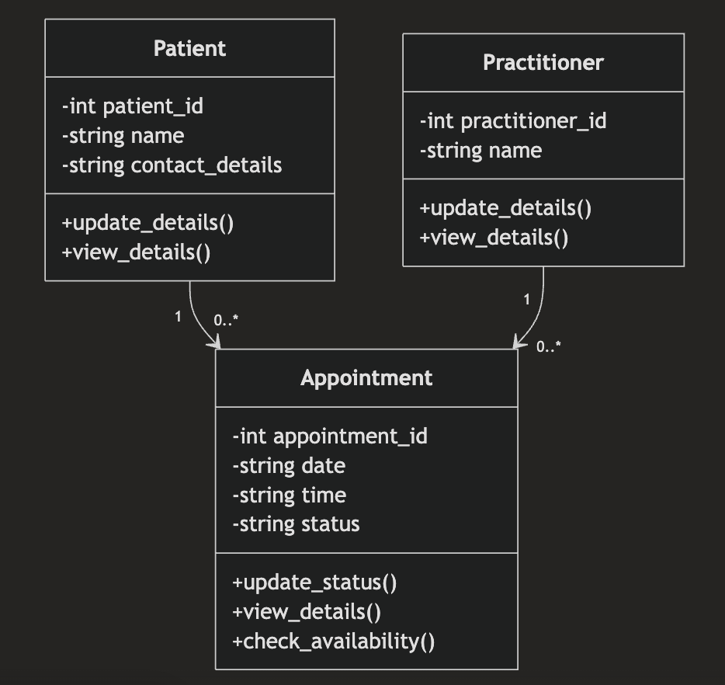

Design Rationale
Explain class selection, responsibility allocation and key relationships.

The domain model uses three main classes: Patient, Practitioner, and Appointment because they are directly supported by the SmartCare requirements. Patient stores patient information, Practitioner stores practitioner information, and Appointment manages booking details and status updates.

Responsibilities were assigned to the class that owns the relevant data. Patient manages patient details, Practitioner manages practitioner details, and Appointment manages appointment date, time, status, and duplicate-booking checks.

Associations were chosen instead of inheritance because an Appointment is not a type of Patient or Practitioner. A patient can have many appointments, and a practitioner can have many appointments, while each appointment is linked to one patient and one practitioner.

Additional classes such as Clinic or NotificationManager were excluded because they are not supported by the confirmed requirements and would add unnecessary complexity

AI Design Review Record
AI suggestion | Evidence | Decision | Reason | Model change
Add AppointmentHistory class | FR-10 | Modified | History is required but separate class not justified | Kept as Appointment association
Add PatientManager | None | Rejected | Not a domain concept | No change
Patient linked to Appointment | FR-06, FR-10 | Accepted | Supported by requirements | Added association

