Assignment 2- Case Study (8995-G level Task)

Stage 5 Lab Activities

Refactoring SmartCare into a Layered Architecture
HUMAN ANALYSIS -> REFACTOR -> AI REVIEW -> VERIFY | 1 hour

A - Inspect SmartCare v0.4
Identify domain, workflow, data-access and presentation responsibilities currently mixed together.
SmartCare v0.4 mixed responsibilities:
- Domain classes stored state and validated rules and (in earlier drafts) managed workflow.
- No clear boundary between booking coordination and domain behavior.
- No repository abstraction, so persistence would have to be added directly into domain or service code.
- No presentation layer, so any UI code would sit alongside business rules
Problem | Evidence | Impact | Refactoring
Workflow coordination inside domain | Appointment handles booking checks and status | Violates SRP | Introduce AppointmentService
Data access inside domain | SQL/file ops in domain methods | Hard to test | Move to Repository/Persistence
UI contains business rules | UI decides valid cancellations | Rules can be bypassed | Move rules to Domain/Service
Direct storage dependency | Classes reach for files/DB | Hard to swap storage | Repository abstraction
Mixed presentation and domain | I/O code in domain objects | Poor separation of concerns | Move to Presentation
Low cohesion | One class does too much | Increased complexity | Split across layers
Concrete persistence dependency | Service depends on SQLite | Tight coupling | Depend on Repository interface

B - Propose Architecture
Draw Presentation -> Service -> Domain, with Service using a Repository abstraction and Persistence implementing it.
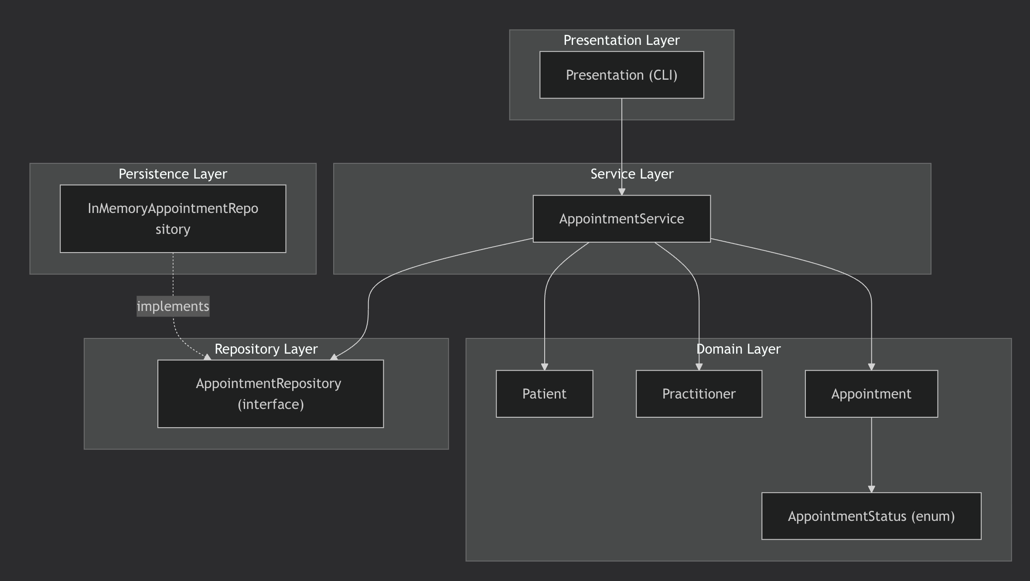

C - Create Package Structure
Create domain/, services/, repositories/, persistence/ and presentation/ or a justified equivalent.

D - Introduce AppointmentService
Move workflow coordination into a focused service without stealing Appointment domain behaviour.

E - Repository Abstraction
Define a small AppointmentRepository contract using only current use-case needs.

F - AI Architecture Review
Ask AI to review dependency direction, misplaced responsibilities and unnecessary complexity; request simplest justified improvements.
AI suggestion | Observed problem? | Decision | Reason | Verification
Introduce AppointmentService | Yes -workflow inside domain | Accepted | Fixes SRP violation; matches lab requirement. | FR-06–FR-09 trace to service methods.
Introduce AppointmentRepository | Yes -direct storage coupling | Accepted | Enables DIP and testability. | Service depends on interface, not implementation.
Add SQLiteAppointmentRepository now | No current need | Deferred | In-memory implementation is enough for current scope. | Can be added later without changes to service/domain.
Add PatientService and PractitionerService | Not currently justified | Deferred | Patient/Practitioner currently only store data; no multi-step workflow. | Revisit if workflows appear.
Split repository into 6 interfaces | Over-engineering | Rejected | One small interface is enough for current needs. | ISP concern is not yet triggered.
Microservices + event bus | Not supported by requirements | Rejected | Single small clinic system; no async workflows. | Brief says "small, maintainable" system.
Dependency-injection framework | Not justified | Rejected | Constructor injection is sufficient and clearer. | Lab prompt: no frameworks unless justified.
Move status rules into the service | No | Rejected | Rules belong to Appointment (Stage 4 Activity 3). | Domain invariants preserved.

G - Refactor and Verify
Apply only justified changes and confirm required behaviour remains unchanged.
Refactor steps performed:
- Moved Patient, Practitioner, Appointment, AppointmentStatus into domain/.
- Extracted workflow coordination into services/appointment_service.py.
- Defined repositories/appointment_repository.py with six use-case methods.
- Implemented persistence/in_memory_appointment_repository.py.
- Added empty presentation/cli.py placeholder only (no UI yet).
- Left all status-transition rules inside Appointment.

H - Reflection
Document one AI suggestion accepted, one modified and one rejected/deferred.
Accepted: The suggestion to introduce AppointmentService. It directly fixed an SRP violation by moving workflow coordination out of the domain and matched the lab’s required layer structure.

Modified: The suggestion to introduce a repository abstraction was accepted, but reduced to six methods covering only current use cases. AI originally proposed a larger interface, which would have violated ISP.

Rejected / Deferred: Microservices, an event bus, six separate interfaces and a dependency-injection framework were rejected. They are not justified by the small, single-clinic SmartCare brief. A SQLite repository was deferred; the in-memory implementation is sufficient for the current stage and can be replaced later without touching domain or service code.

Suggested AI prompt
Act as a software architecture reviewer. Review this small SmartCare Python system against separation of concerns, cohesion, coupling and introductory SOLID principles. Identify concrete layer violations and dependency risks. Prefer the simplest refactoring that solves an observed problem. Do not introduce frameworks, microservices or patterns unless current requirements justify them.

