SmartCare v0.3 - Domain Model Workbook
Week 6 student resource

Requirement-to-Concept Trace
Requirement | Concept | State/behavior | Decision
FR-01 (record new appointment) | Appointment | Behavior | Modelled as a responsibility of Appointment, since it involves storing patient, practitioner, and time together as one record
FR-02 (search for appointment) | Appointment | Behavior | Modelled as a responsibility of Appointment because searching involves looking through existing appointment records, not patient or practitioner data directly
FR-03 (cancel appointment) | Appointment | Behavior | Modelled as a responsibility of Appointment because cancelling directly affects the appointment record itself, not patient or practitioner data
FR-04 (update appointment) | Appointment | Behavior | Modelled as a responsibility of Appointment because updating directly affects the appointment record itself, not patient or practitioner data
FR-05 (confirm booking) | Appointment | Behavior | Modelled as a responsibility of Appointment because confirming a booking directly affects the appointment record itself, not patient or practitioner data
FR-06 (detect conflict) | Appointment | Behavior | Modelled as a responsibility of Appointment because detecting a conflict directly involves comparing existing appointment records, not patient or practitioner data
FR-08 (validate required fields) | Appointment | Behavior | Modelled as a responsibility of Appointment because validating the required fields prevents incomplete or incorrect data from affecting the appointment record and causing scheduling confusion
FR-09 (reject invalid appointment) | Appointment | Behavior | Modelled as a responsibility of Appointment because rejecting an invalid appointment is a distinct action following validation (FR-08), directly reducing complications in the appointment list
FR-10 (display all appointments) | Appointment | Behavior | Modelled as a responsibility of Appointment because displaying appointments directly works with the appointment list/records themselves
FR-12 (unique identifier) | Appointment | State | Stored as an attribute of Appointment because a unique identifier helps keep appointment records clearer and avoids confusion, especially when patients or practitioners share the same name

CRC Cards

Patient
Responsibilities | Collaborators
Store the patient's name | Appointment
Be linked to the associated appointments

Practitioner
Responsibilities | Collaborators
Store the practitioner's name | Appointment
Be linked to the associated appointments

Appointment
Responsibilities | Collaborators
Store patient, practitioner, appointment time, confirmation/cancellation status, and a unique identifier | Patient, Practitioner
Confirm successful booking, update, cancel bookings and flag double bookings | Practitioner

Optional class
Responsibilities | Collaborators
n/a | n/a
n/a | n/a

UML Class Diagram
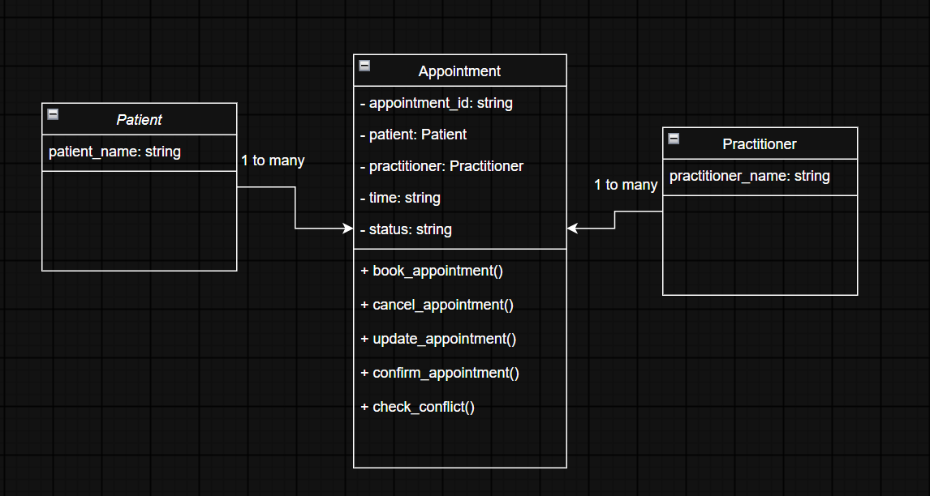

Design Rationale
Explain class selection, responsibility allocation and key relationships.
CLASS SELECTION:
The classes Patient, Practitioner, and Appointment have been selected as primary classes because they contain crucial information for designing and operating the system and are either directly hinted in the requirements of the client. The other possible concepts like Clinic and Database are relevant factors in an operational system but not of immediate importance in this specific system considering the real requirements of the client. Adding them at this point would only complicate the design of the system unnecessarily.

RESPONSIBILITY ALLOCATION:
Appointment holds most of the system's responsibilities because it is the central focus of the whole system. Since SmartCare is built primarily to support easy and successful booking and record-keeping of appointments, most of the system's actions relate directly to managing appointments including booking, confirmation, cancellation, updating, detecting and rejecting double bookings, and validating input to ensure accurate, reliable records. Patient and Practitioner however, remain of minimal operations in this system, since their role is primarily to be linked to appointments rather than to independently perform actions themselves.

KEY RELATIONSHIPS:
Patient-to-Appointment and Practitioner-to-Appointment relationships are both described by one-to-many relationships as multiple appointments can be made for one patient, for instance with different practitioners or different specializations, but each appointment is associated with just one patient. Similarly multiple appointments can also be made for one practitioner within a single day but each appointment is done with just one practitioner.
There is no inheritance in this design, since Patient, Practitioner, and Appointment represent different, unrelated categories of information rather than variations of the same underlying type. Instead of inheriting from one another these classes collaborate directly to successfully store and utilize the information collected across the system.

AI Design Review Record
AI suggestion | Evidence | Decision | Reason | Model change
Appointment carries too many responsibilities, mixing single-record behaviour with collection-level operations | Yes, directly traced across the CRC card and Requirement-to-Concept Trace | MODIFY | A single Appointment object should only manage its own data and actions (confirm, cancel, update, self-validate). Collection-level operations don't naturally belong to one instance | Revised and in future will be mindful of Appointments responsibilities so they are focused on a single record's own behavior e.g. search, display-all, and conflict-checking are operated on list/collection as a whole.
Search (FR-02) is difficult to justify as a responsibility of a single Appointment object | Yes, directly traced across the CRC card and Requirement-to-Concept Trace | MODIFY | Same reasoning as above as searching requires looking across many records, not one | Search is now treated as an operation performed on the appointments collection, not an individual Appointment's responsibility.
Display All (FR-10) requires access to a collection, not just one instance | Yes, directly traced across the CRC card and Requirement-to-Concept Trace | MODIFY | Same issue as above - displaying "all" inherently requires the full list, not a single object | Display-all is now treated as an operation on the appointments collection as a whole.
Conflict detection requires access to other existing appointments, which isn't explained by the CRC card | Yes, directly traced across the CRC card and Requirement-to-Concept Trace | MODIFY | Checking for conflicts means comparing against other records, which a single Appointment instance cannot do alone | Conflict detection is now understood as comparing a new appointment against the existing appointments list/collection.

