Terrain Neighboring Guide
Author: Kyle Gillen – Visit www.deepspacelabs.net/terrain_slicing.html to find full documentation
Contact me at kgillen@deepspacelabs.net if you have any questions or concerns

4.x.x Users
To add some functionality, please perform the following two steps (unless you’ve already performed them).

1) Delete the SliceTerrain.js file found in the editor folder. This file is for 3.x users and does not contain some functionality available to 4.x users.

2) Open the SliceTerrain.txt file and resave it as SliceTerrain.js (so Unity recognizes it as a JavaScript file). This file contains code for copying terrain materials and terrain texture normal maps.

A Quick Word . . .
The SetNeighbors JavaScript works in conjunction with the SetNeighborsEditor JavaScript to make setting neighbors easy. By default the terrain slicing script automatically sets the terrain neighbors, but unfortunately this is only useful for seeing how your terrain slices fit together seamlessly in the short term.

In order for your terrains to look seamless to the people who will eventually play your game, the neighbors have to be set each time your game is started. Fortunately, this process is now as easy as clicking a couple of buttons.

Before Using
In order for this script to function properly it’s required that all the terrains edges line up perfectly, and that each terrain only neighbors one other terrain on each of its sides. The terrains can vary in width and length, however in order for the edges to line up perfectly, all terrains in a single column must have the same width (size along x axis), while all terrains in a single row must have the same length (size along z axis). The terrains must also be touching (In the first picture below, for example, if terrain 1 has a width of 100 and is at position x = 0, z = 0, terrain 2 must have a position of x = 100, z = 0.
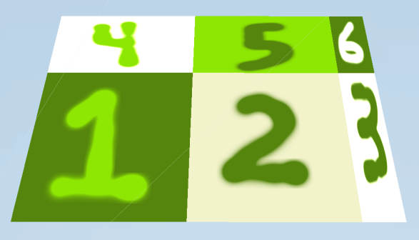
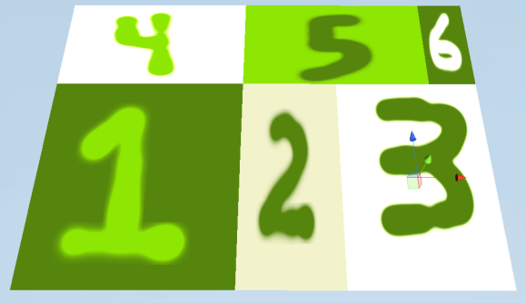

Acceptable Layout
Unacceptable Layout

To Use
To use the SetNeighbors JavaScript, drag and drop it onto the first terrain of the group of terrains you wish to neighbors. This group need not be located at position 0, 0, 0.

If you have created your terrain group by slicing a big terrain into smaller slices using the SliceTerrain script, determining which terrain is the first terrain is as easy as finding the terrain ending in 1_1.

If you’re group was created in some other way, then determine which terrain is the first terrain by first moving your view of the terrain group so that the gizmo looks like it does in the picture below, with the blue arrow pointing away from your view and the red arrow pointing to the right.
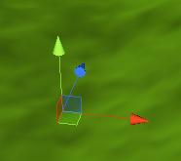

The first terrain will be the bottom left terrain from this view. Another way to find it is to find the terrain with the smallest x and z value (among all the terrains of your group) for its position.
Once you’ve dragged the script onto the first terrain, you’ll see the following options appear in the Inspector while you have this terrain selected:
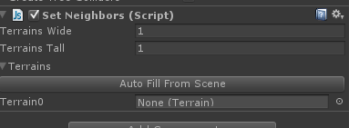

Terrains Wide is the number of terrains in a single row that exist along the groups x axis.

Terrains Tall is the number of terrains in a single column that exist along the groups z axis.

Set these values to reflect the dimensions of your terrain group. If you used the SliceTerrain JavaScript to create your terrain group, these values are the same as the “Slicing Dimensions” selected in the SliceTerrain Window.

After entering the Terrains Wide and Terrains Tall values, the area below the “Auto Fill From Scene” button will expand so there are enough terrain fields to accommodate all the terrains in your group. At this point you can drag and drop or select each terrain individually, making sure that the terrains are in the correct order (bottom left first, then the terrain to the right second, starting at the left side for each new row, working left to right and from bottom to top always).

A much simpler way of doing this has been implemented, however, and so I don’t recommend manually selecting each terrain. Simply press the Auto Fill From Scene button, and as long as you entered the correct values for Terrains Wide and Terrains Tall, and followed the previous directions, the terrains should appear in the correct order.

Now press play to see the neighboring in action!

Remember, this is not a stitching script. This script assumes you have tiled your terrains perfectly already. Its only use is to set the neighbors for your terrains.

If any part of this script does not work to your satisfaction, or you have questions, please contact me at kgillen@deepspacelabs.net. Include details of the issue you’re facing. If you can provide a link to somewhere I can download your project to test it myself, please feel free to do so.

