**Department of Knowledge Building and Engineering**

*Zhang Yuchen, Zhao Liyuan*

**Abstract**

Knowledge building and engineering helps in development of a communication tool for experts through the IT technology. The aim of the research is to develop a platform whereby public could get a “pre-consultation” online via a questionnaire. The targeted disease is cardio vascular diseases. Information was obtained from medical experts. Users of this application would make a decision to consult medical help after completion of the questionnaire. The application showed the performance of human expert in reasoning and decision-making tasks via technology application.

**Introduction**

Cardiovascular disease is the leading cause of death globally and is projected to remain so. It has no geographic, gender or socio-economic boundaries. Everyday 15 people die from cardiovascular disease (heart disease and stroke) in Singapore. Cardiovascular disease accounted for 31.6% of all deaths in 2009. This means that 1 out of 3 deaths in Singapore is due to heart disease or stroke.

|  |
| --- |
|  |
| ***Deaths from cardiovascular disease*** |
|  |
| |  |  |  |  | | --- | --- | --- | --- | |  | **2007** | **2008** | **2009** | | Total No. of Deaths | 17,140 | 17,222 | 17,101 | | % of Total Deaths |  |  |  | | Ischaemic Heart Disease | 19.8% | 20.1% | 19.2% | | Cerebrovascular Disease  (including stroke) | 8.7% | 8.3% | 8.0% | | Other Heart Diseases | 4.3% | 4.0% | 4.4% | | Total % | 32.8% | 32.4% | 31.6% | |  | | | | | Total | 5,622 | 5,580 | 5,404 | |
|  |
| *Source: Ministry Of Health* |

Cardiovascular disease is a generic term used to refer to any abnormality of the heart and/or the vascular system. These abnormalities may be caused by degenerative changes in the blood vessels, extraneous infections, or congenital defects. The more common types of cardiovascular disease include:

* Atherothrombosis
* Atherosclerosis
* Coronary Heart Disease and Angina
* Heart Attack
* Stroke
* Heart failure
* Congenital Heart Disease
* Arrhythmias
* Sudden Cardiac Death

A wide range of tests are available to diagnose the different forms and stages of heart disease. In general, a doctor will start by taking the patient’s medical history and conducting a physical examination. Depending on the symptoms and severity of a heart patient’s condition, a variety of treatment options may be available. These range from non-invasive treatment such as medication if the patient’s symptoms are mild to invasive treatment if his condition is more serious. At the other extreme, should the patient be suffering from end-stage heart failure, a heart transplant may be necessary.

An application that made use of human expert reasoning and decision-making developed with an excellent system of knowledge could help the public in many areas. The research was based solely on the development of a questionnaire about the cardio vascular diseases.

**Methodology**

Research of cardio vascular diseases and consultation with Doctor Li Zhiqiang, the questionnaire focused on 8 kinds of basic cardio vascular diseases. Symptoms of the different kinds of diseases could also be found on many websites. Information found was classified and divided by the type of heart diseases into different groups. Rule and prompt of the expert system was developed with the use from the website, <http://www.expertise2go.com/> and the expert system was built up from the knowledge gathered.

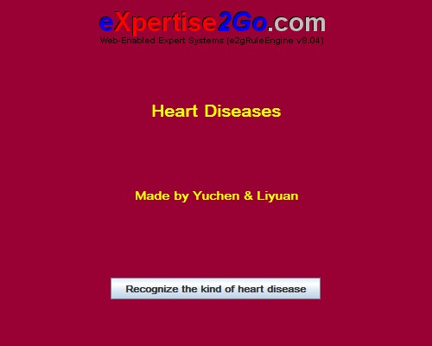

*Picture 1: Application sample 1*

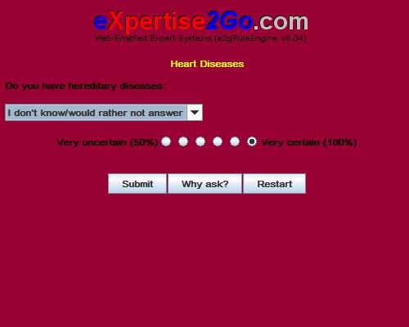

*Picture 2: Application sample 2*

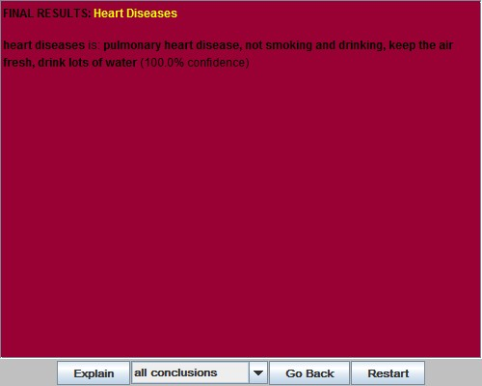

*Picture 3: Application sample 3*

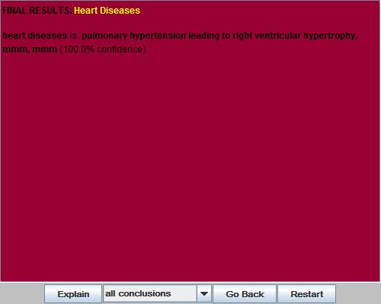

*Picture 4: Application sample 4*

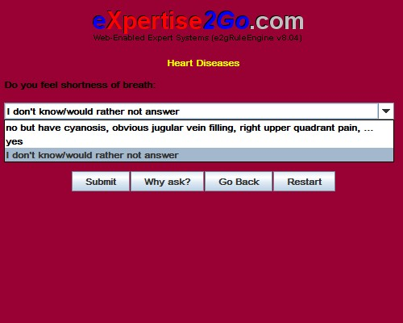

*Picture 5: Application sample 5*

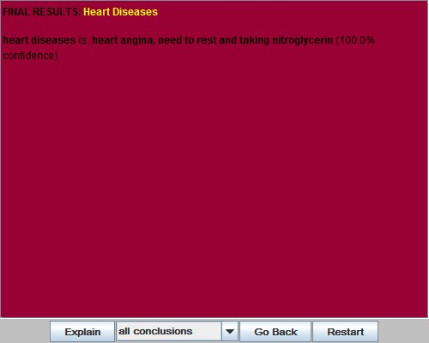

*Picture 6: Application sample 6*

**Results**

The application was trial with 8 patients and found to be approximately 90% accurate with regards to the current health conditions. This has proven to be useful for patients with cardio vascular diseases in terms of knowledge building and decision making.

**References**

www.myheart.org.sg – Singapore Heart Foundation

www.moh.gov.sg – Ministry of Health

http://zhidao.baidu.com/question/237895894.html

http://www.wuhunews.cn/news/201109/310458.html

http://baike.baidu.com/view/29208.htm

http://baike.baidu.com/view/99347.htm

http://baike.baidu.com/view/124987.htm

http://www.med66.com/html/2008/9/zh80381157122980022409.html

http://baike.baidu.com/view/76126.htm