ASSUMPTION UNIVERSITY / COMPUTER SCIENCE

BLACKJACK
ARENA
A Real-Time Multiplayer Blackjack Web Application
with Neural Network Strategy Assistance
PROJECT PROPOSAL REPORT — REVISED DRAFT / SENIOR PROJECT I / SEMESTER 2/2026
Team name: [ENTER TEAM NAME]
Nay Thura Aung | 6715030
Thura Oo | 6715031
Thaw Linn Oo | 6715032
Prepared for proposal review • 22 October 2026

DOCUMENT STATUS
Proposal-stage document. The full web application has not been implemented. A terminal-only neural-network experiment has generated model artifacts, but integration, measured evaluation, and deployment remain planned work. The architecture and UI figures are conceptual. Confirm team details before submitting.

1. Executive Summary
Blackjack Arena is a proposed browser-based game combining single-player Blackjack, private real-time multiplayer rooms, player accounts, and two machine-learning features powered by one trained neural network. The AI Bot will use the model to automatically select Hit or Stand for its own hand. The Analysis AI will use the same model to recommend an action to a human player without acting on their behalf. Its accompanying explanation will be generated separately from the recommendation.
The network will use four game-state inputs, two hidden layers (16 and 8 neurons), and two Hit/Stand outputs. Offline supervised learning will use TensorFlow with labeled Blackjack situations. During gameplay, a small Python FastAPI service can load a converted PyTorch checkpoint and return predictions to the Node.js backend. No paid external AI API is required.
The game is for entertainment and strategy learning only. It will have no real-money bets, deposits, withdrawals, or cash rewards. The main stack remains React, Node.js, Express.js, Socket.IO, and MongoDB.

2. Context and Problem Statement
New Blackjack players can find it difficult to choose between Hit and Stand. Playing with friends requires an accessible invitation process and synchronized game turns. Simple win/loss screens do not necessarily help users understand decisions. Some users also prefer a casual game without financial stakes. These are design motivations, not measured findings from user research; several existing platforms already address aspects of them.

3. Objectives
- Build a responsive, server-authoritative Blackjack website with accurate game rules.
- Provide solo gameplay with computer-controlled tablemates and private multiplayer rooms for 2–4 people.
- Train and evaluate a small neural network for Hit/Stand decision prediction.
- Reuse that model for autonomous bots and an advisory-only human strategy assistant.
- Implement secure accounts, game history, statistics, tests, and a deployable system.

4. Scope and Boundaries
Area | Included in project
Accounts | Register, log in, profile, completed-round history, win/loss/push statistics
Single-player | Human player, fixed-rule dealer, and neural-network-controlled tablemates
Multiplayer | Private code-based rooms for 2–4 human players with synchronized turns
ML features | Shared trained Hit/Stand model used for bots and advisory recommendations
Gameplay | Six-deck shoe, Hit/Stand only, dealer stands on all 17s, correct hand scoring
Delivery | Website, trained model/checkpoint, evaluation evidence, code and documentation

Excluded from the first version: real-money gambling, virtual monetary betting or cash-outs, leaderboards, chat, custom avatars, additional modes, Split, Double Down, Insurance, and Surrender. The trained model will not update itself continuously from players’ wins or losses.

5. Review of Existing Solutions
The comparison below summarizes feature information from the providers’ official websites; it is not a usability study or evidence that a site lacks a feature not listed.
Website | Illustrated capabilities | Implication
Soft 17  soft17.club | Browser Blackjack; private invitation-code tables; play-money chips | Private multiplayer tables are established.
Board Game Land  boardgameland.jp/en/blackjack | Solo games, invited friends, computer-controlled tablemates | Solo play and automated players are established.
Wit’s Games  witsgames.com/blackjack | Private live tables; separate strategy training tools | Game coaching and friend play are both known.

Our proposed emphasis is an integrated student-built product that combines private real-time rooms, trained-model computer players, in-game model recommendations, and account-based history. We do not claim to invent Blackjack, multiplayer play, or strategy guidance.

6. Functional and Gameplay Design

6.1 Main user journeys
- Account: register or sign in; open home page and personal profile.
- Single-player: start a round, view hand, optionally request model advice, choose Hit or Stand, and view results.
- AI-controlled players: on their turns, request a model prediction and automatically perform a valid action through the game engine.
- Multiplayer: create/join a private room, start a game, take synchronized turns, and receive the round result.
- History: save completed rounds and update cumulative statistics.

6.2 Agreed Blackjack rules
Rule | Planned behavior
Deck | Six standard decks shuffled together; reshuffle when needed
Hand values | Number cards face value; face cards 10; Ace 1 or 11
Initial deal | Two cards per player and dealer; one dealer card hidden
User actions | Hit or Stand only; bust occurs above 21
Dealer | Hits at 16 or below; stands at all 17s including soft 17 (S17)
Natural Blackjack | Ace + ten-valued card as initial two cards; outranks ordinary 21
Results | Win, loss, push; two naturals push; no financial mechanics

6.3 Server-side control
The backend will own deck order, hidden dealer cards, turn validation, and result calculation. Clients will receive only permitted game information. AI predictions are suggestions or bot actions submitted to the same validated game engine, never a shortcut around game rules.

7. Neural Network Methodology

7.1 Model architecture and inputs
The project will use a small feedforward Multilayer Perceptron (MLP) for supervised classification. It is an experimental starting architecture rather than a proven optimal configuration.
Stage | Neurons | Activation
Input | 4 | None
Hidden 1 | 16 | ReLU
Hidden 2 | 8 | ReLU
Output | 2 | Softmax: Stand / Hit

The four numerical inputs are: (1) player hand total, (2) dealer visible card value (Ace = 11), (3) usable-Ace flag, and (4) player card count. Values must be normalized consistently for training and inference. The model must never receive the dealer’s hidden card or the order of undealt cards.
Trainable parameters: (4×16 + 16) + (16×8 + 8) + (8×2 + 2) = 234 weights and biases in total. The two outputs are action scores, not probabilities of winning.

7.2 Dataset, training, and evaluation
- Generate legal Blackjack hand situations from a six-deck game simulator.
- Assign supervised target labels using a verified Hit/Stand-only reference strategy. The reference supplies labels and evaluation criteria; the live model makes the decisions.
- Split distinct states across train, validation, and test partitions to avoid duplicated-state leakage.
- Train with TensorFlow, backpropagation, Adam optimizer, and categorical classification loss; begin with learning rate 0.001 and early stopping.
- Measure held-out accuracy, confusion matrix, disagreements with reference cases, and behavior in simulated rounds. No accuracy result is claimed in advance.
The network learns to imitate labeled reference decisions rather than discovering strategy through reinforcement learning. It does not automatically improve from a person’s win/loss statistics. A lost hand does not necessarily imply a poor decision because card draws are random.

7.3 Two uses of one model
AI Bot | Analysis AI
Reads its own visible game state and requests a model action. | Reads the human hand and dealer upcard, requesting the same model prediction.
The backend automatically executes the predicted legal action. | The UI displays the recommendation; the human decides.
No automatic commentary needed. | A separate explanation component describes the reference strategy and flags disagreements; it does not claim to expose neural reasoning.

8. Technical Architecture and Security
React will present the game. Node.js and Express.js will handle REST requests, authentication, and the authoritative game engine. Socket.IO will synchronize multiplayer sessions, and MongoDB will store user data and completed rounds. A separate Python FastAPI service will expose neural-network inference to Express.
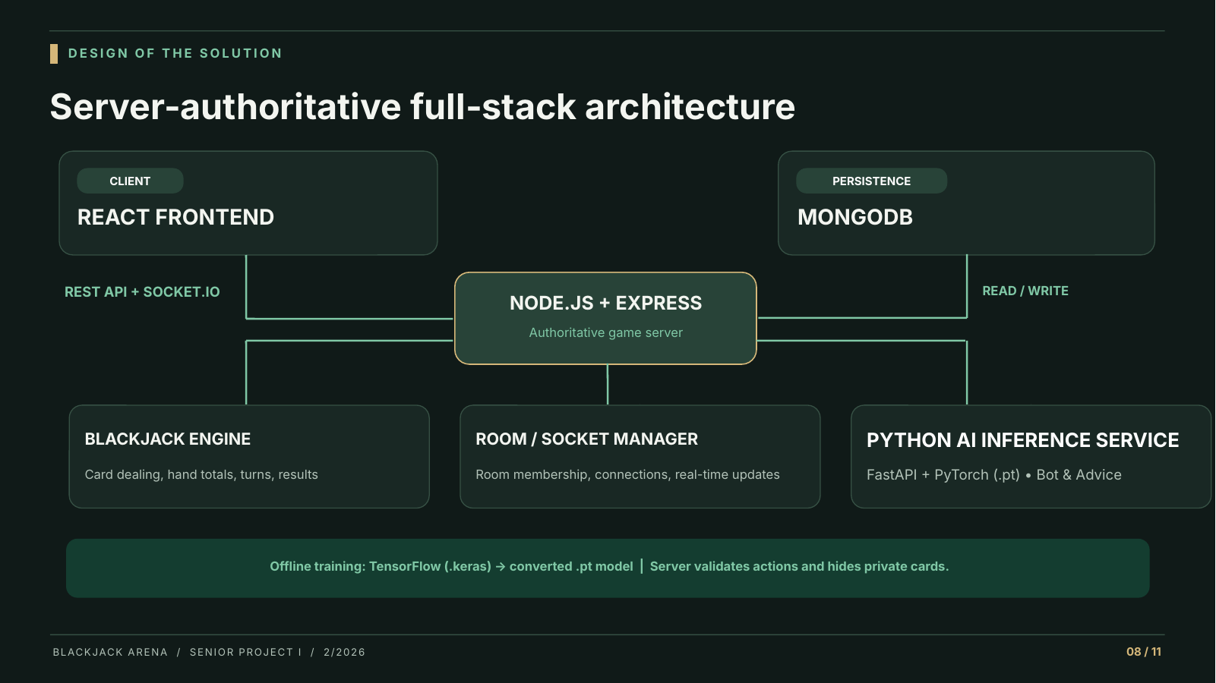
Figure 1. Proposed architecture. Offline training uses TensorFlow (.keras); runtime inference may use a converted PyTorch (.pt) checkpoint served with FastAPI.

8.1 Model deployment workflow
Train offline in TensorFlow → save .keras model → convert and verify equivalent PyTorch .pt weights → start FastAPI inference service → Express sends trusted hand state → return Hit/Stand → game engine validates execution or React displays advice. A .pt file is a PyTorch checkpoint, not TensorFlow’s native model format.

8.2 Data storage and access control
Collection | Indicative fields
users | _id, username, email, passwordHash, createdAt
rounds | _id, userId, mode, result, playerTotal, dealerTotal, finishedAt
stats | userId, gamesPlayed, wins, losses, pushes, updatedAt

Room state may initially be kept in server memory. Express and Socket.IO must validate identity and turn permissions; the Python service must receive only limited, permitted game-state features. The ML endpoint should not be directly trusted as game authority.

9. Proposed User Interface
The following four interface designs are proposal mockups, not implemented application screens. The four user journeys are: mode selection, single-player table with advice, code-based multiplayer lobby, and user statistics.
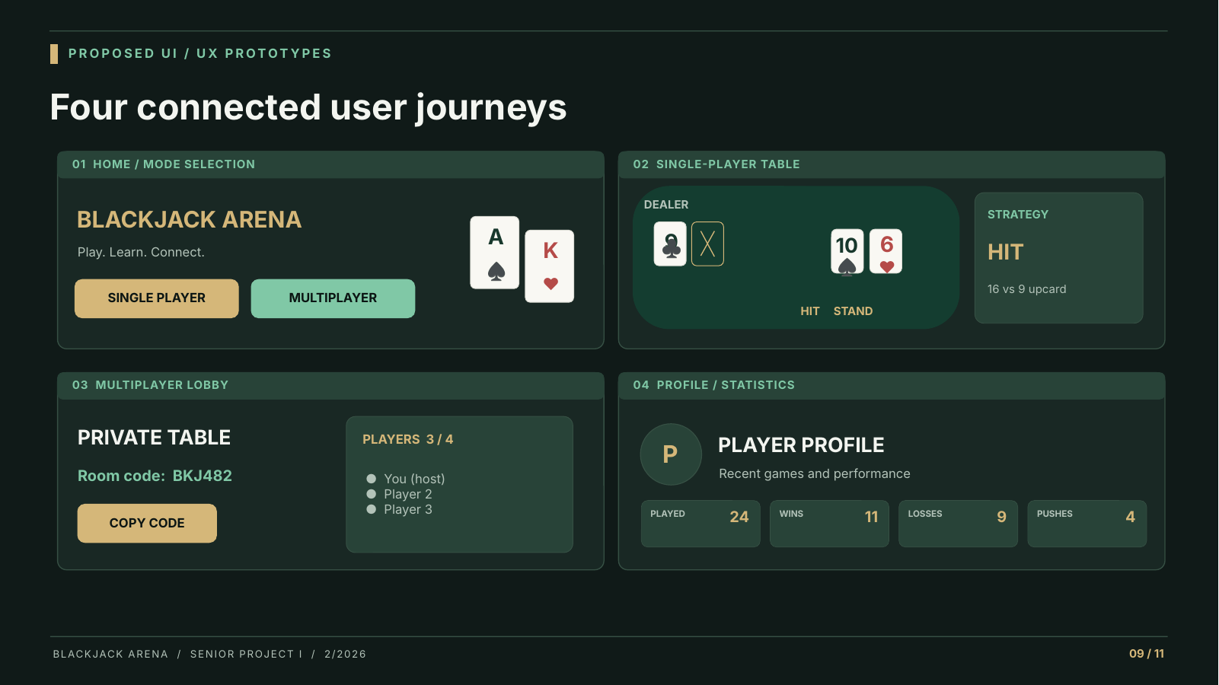
Figure 2. Four conceptual UI/UX mockups for Blackjack Arena; content and appearance may change during implementation.

10. Development Plan
The following 15-week allocation is provisional, not an official university checkpoint schedule. Work will be demonstrated incrementally and adjusted with advisor input.
Weeks | Main work | Reviewable result
1–2 | Requirements, UI/UX, database and architecture | Approved plan and refined prototype
3–5 | Blackjack rules engine and single-player UI | Playable basic local game with tests
6–8 | Accounts, MongoDB, private real-time rooms | Authenticated multiplayer prototype
9–11 | Dataset refinement, model testing, FastAPI integration | Bot and assistant use same validated model
12–13 | End-to-end security, model and UI testing | Stable integrated build and test results
14–15 | Deployment, fixes, report and demonstration | Deployed MVP and project evidence

11. Team Ownership and Acceptance Tests
Responsibility | Suggested lead
React interface and Figma-style prototyping | Member 1
Express, MongoDB, Socket.IO, authentication | Member 2
Blackjack engine, training experiment, inference integration | Member 3
Testing, integration, documentation, demos | All team members

Testing evidence
- Game engine: tests for hard/soft hands, multiple Aces, natural Blackjack, pushes, dealer S17, and busts.
- Real-time rooms: two to four clients observe consistent turns; unauthorized actions and hidden cards are rejected.
- Neural network: held-out test accuracy, confusion matrix, illegal-action checks, training reproducibility, and TensorFlow/PyTorch prediction parity.
- AI Bot and assistant: bots act automatically; humans receive advice only; neither bypasses turn validation.
- Account and UI: login, durable statistics, and usable desktop/mobile core flows.

12. Risks and Mitigations
Risk | Proposed mitigation
Model predicts a poor move | Evaluate on held-out game states, compare with reference decisions, report limitations.
TensorFlow to PyTorch conversion mismatch | Test converted .pt predictions against original .keras outputs.
Python service outage or hosting cost | Test service independently; use controlled error handling; choose compatible hosting.
Multiplayer desynchronization | Centralize game authority; add turn IDs and event-level tests.
Overambitious scope | Exclude chat, leaderboards, cash features, and advanced Blackjack actions.

13. Expected Deliverables
- Responsive deployed Blackjack application with user registration and profiles.
- Working single-player gameplay with autonomous neural-network-controlled players.
- Private real-time multiplayer rooms for two to four human players.
- Human-facing neural-network Hit/Stand recommendations and separate explanations.
- Reproducible training script, saved model artifact(s), inference API, and measured evaluation results.
- MongoDB-backed round history and statistics; documented tests, source code, and final report.

14. Conclusion
Blackjack Arena combines a server-controlled card game with synchronized social play and one supervised neural network used in two ways: automated bot decisions and player-facing strategy advice. The updated technical scope includes model training, checkpoint conversion, Python inference, and controlled integration with the Node.js game engine. The model is not claimed to learn continuously or to guarantee winning. Successful delivery will depend on measured tests, technical integration, and advisor feedback.

15. References and Source Notes
- Assumption University. AU CS/IT Senior Project: General Guidelines for 2/2026. Course handout.
- Soft 17. https://www.soft17.club/ (reviewed 19 October 2026).
- Board Game Land. https://boardgameland.jp/en/blackjack (reviewed 19 October 2026).
- Wit’s Games. https://witsgames.com/blackjack (reviewed 19 October 2026).
- TensorFlow / Keras and PyTorch. Official framework documentation for training, saving models, and loading checkpoints.

Key distinctions for reviewers
Neural-network outputs are Hit/Stand predictions—not win probabilities or proof of optimal play. Basic strategy labels guide supervised training, but live Bot and Analysis AI decisions come from the trained model. The Analysis AI explanation component remains separate from the network prediction. No paid external AI model API is required.

A. Proposed Repository Organization (Appendix)
One practical repository layout for implementation. The Python AI service is separate from the Express game server; active gameplay never needs to run model training.
blackjack-arena/
├── frontend/
│ └── src/
│ ├── components/blackjack/
│ ├── components/ai/StrategyAssistant.jsx
│ ├── components/multiplayer/
│ ├── pages/
│ └── services/api.js
├── backend/
│ └── src/
│ ├── game/blackjackEngine.js
│ ├── game/handCalculator.js
│ ├── sockets/roomManager.js
│ ├── services/mlClient.js
│ ├── models/User.js
│ └── server.js
├── ai_service/
│ ├── blackjack_nn.py # Offline TensorFlow training
│ ├── blackjack_ai_api.py # FastAPI + PyTorch inference
│ ├── models/
│ │ ├── blackjack_nn.keras # Training artifact
│ │ └── blackjack_nn.pt # Converted checkpoint
│ ├── tests/
│ └── requirements.txt
├── docs/
│ ├── system-architecture/
│ ├── ux-prototypes/
│ └── training-evaluation/
└── README.md
Note: the precise names and folders may change as the repository grows. Model versioning and deployment secrets should be handled separately from published source files.

