**How to compile and run a simple MS-MPI program**

1. Download MS-MPI SDK and Redist installers and install them. The download link can be found at our homepage <https://msdn.microsoft.com/en-us/library/bb524831.aspx>

網上似乎說要使用mpi4py建議使用 MS-MPI v10.0

https://www.microsoft.com/en-us/download/details.aspx?id=57467

1. 設定環境變數

控制台 -> 系統 -> 進階系統設定 -> 環境變數 -> Path -> 編輯

新增 C:\Program Files\Microsoft MPI\bin

C:\Program Files (x86)\Microsoft SDKs\MPI

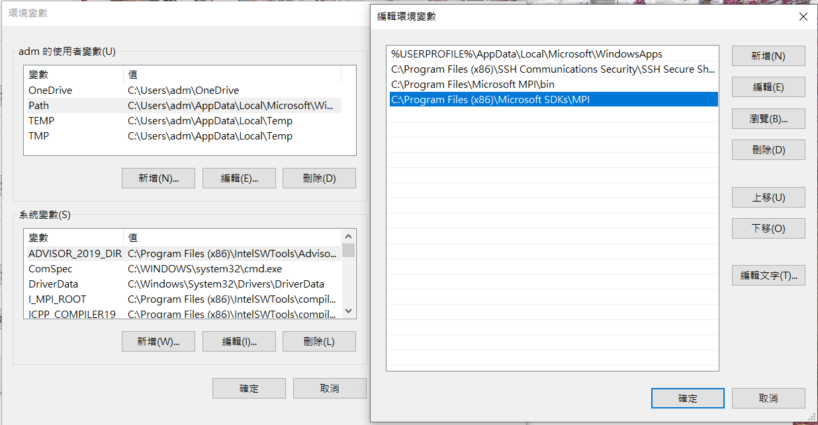

1. After installation you can verify that the MS-MPI environment variables have been set (you will want to use these env vars in Visual Studio)

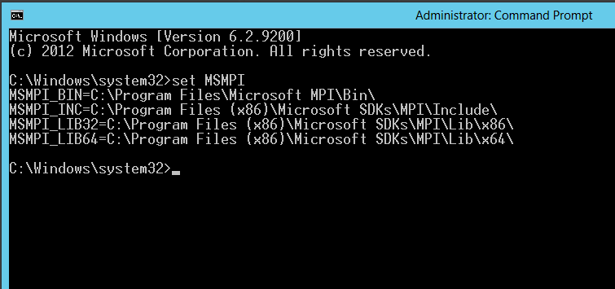

1. Open up Visual Studio and create a new Visual C++ Win32 Console Application project. Let’s name it ConsoleApplication1 and use default settings.
2. Setup the include directories so that the compiler can find the MS-MPI header files. Note that we will be building for 64 bits so we will point the include directory to $(MSMPI_INC);$(MSMPI_INC)\x64.

專案 -> 屬性 -> C/C++ -> 一般 -> 其他Include 目錄

加入 $(MSMPI_INC);$(MSMPI_INC)\x64

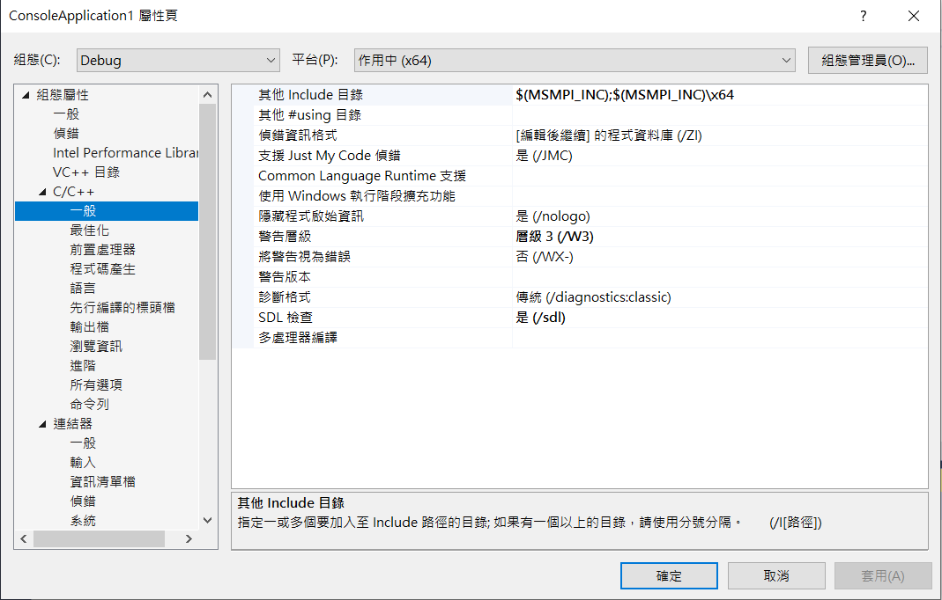

1. Setup the linker lib (notice I add msmpi.lib to the additional dependencies and also add $(MSMPI_LIB64) to the Additional Library Directories). Note that we will be building for 64 bits so we will point the Additional Library Directories to $(MSMPI_LIB64).

連接器 -> 一般 -> 其他程式庫目錄

加入 $(MSMPI_LIB64)

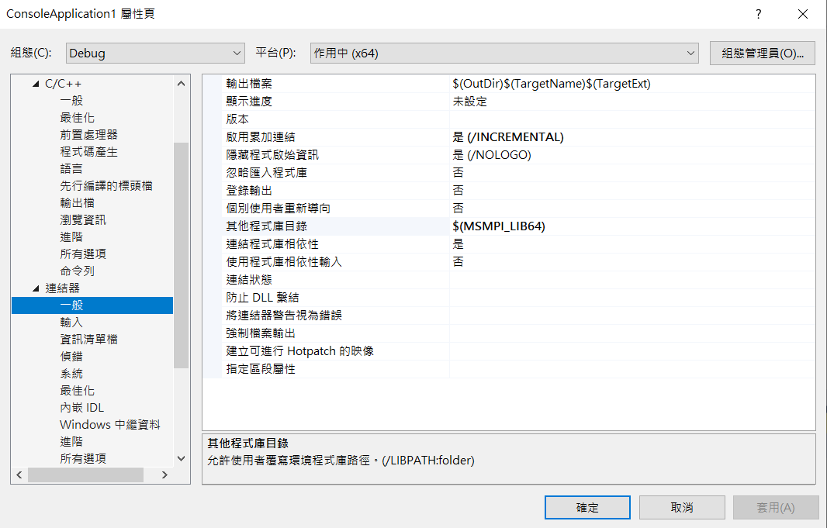

連接器 -> 輸入 -> 其他相依性

加入 msmpi.lib

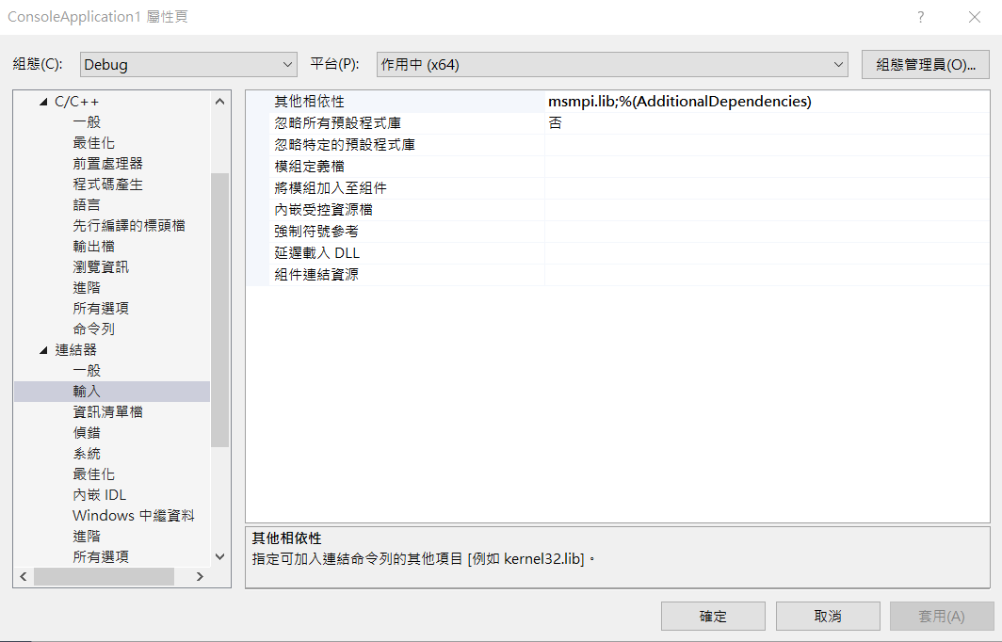

然後進行 建置

1. 然後到專案生成之執行檔位置執行

命令為 mpiexec –n 20 ConsoleApplication1.exe

