**Company Simulation in Tally ERP 9 – FY 2017–2018**

Simulated entity: Aarav Foods Private Limited (Karnataka) | Books: 01-Apr-2017 to 31-Mar-2018 | Currency: INR

# 1. Project Overview

This project simulates a full-year accounting cycle in Tally ERP 9 for an FMCG-style business. It covers master setup (ledgers, items, godowns, cost centers), large-volume transactions, and both pre-GST (VAT/CST) and GST regimes. The dataset includes sales, purchases, receipts, payments, journals, contra entries, returns (CN/DN), stock movements, import bills of entry, and a bank statement for BRS.

# 2. Scope & Data Volumes

**Masters:**

• Ledgers (customers/suppliers & tax ledgers), Units, Godowns, Stock Items, Cost Centers

**Transactions:**

• Sales (360), Purchases (240), Receipts (300), Payments (300), Journal (120), Contra (48)

• Credit Notes (60), Debit Notes (50), Stock Journals (60), Bills of Entry (20), Bank Statement (240)

# 3. Tax Regimes & Assumptions

• Pre-GST (Apr–Jun 2017): intra-state VAT 14.5% and inter-state CST 2%.  
• GST (from 01-Jul-2017): standard rate 18% split into CGST/SGST for intra-state and IGST for inter-state.  
• Freight and round-off are included as part of invoice valuation for consistency.

# 4. Masters Setup in Tally

Create the following before voucher entry or XML import:  
• Sales - Domestic, Sales - Interstate  
• Purchase - Domestic, Purchase - Interstate  
• Output CGST/SGST/IGST and Input CGST/SGST/IGST  
• Party ledgers (from CSV), Stock Items & Units, Godowns (Bengaluru WH, Mumbai WH), Cost Centers (Retail, Wholesale, Online).

# 5. Process Flow

1) Load/prepare masters.  
2) Post sales/purchases by date with appropriate tax regime (VAT/CST vs GST) and intra/inter-state logic.  
3) Record receipts and payments via Cash/HDFC Bank; use Contra for cash–bank movements.  
4) Use Credit/Debit Notes for returns and rate differences.  
5) Move inventory across godowns via Stock Journals.  
6) Record imports using Bills of Entry (CIF uplift, BCD 10%, IGST 18%).  
7) Reconcile bank using the provided bank statement.

# 6. Key Analytics & Visuals

6.1 Monthly Sales (Grand Total)

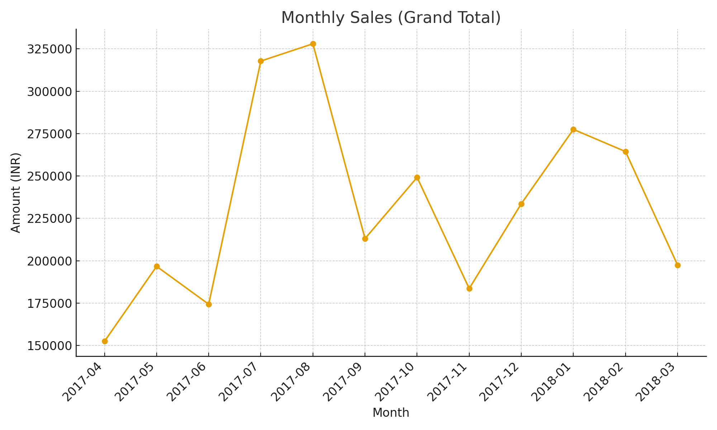

6.2 Monthly Purchases (Invoice Total)

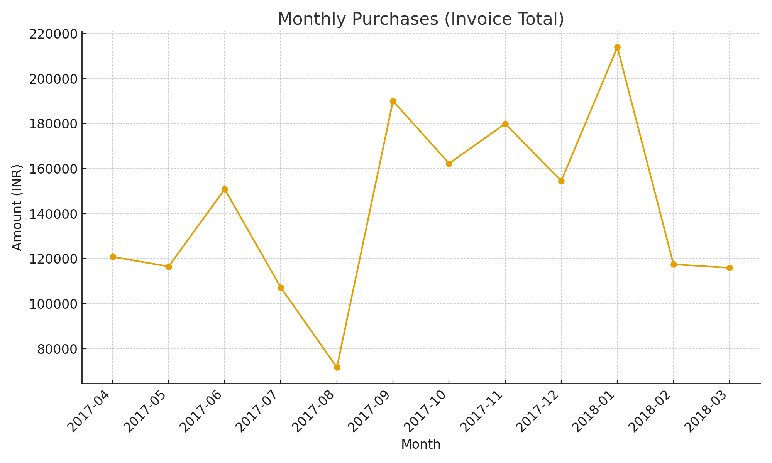

6.3 GST Summary – Output vs Input Totals

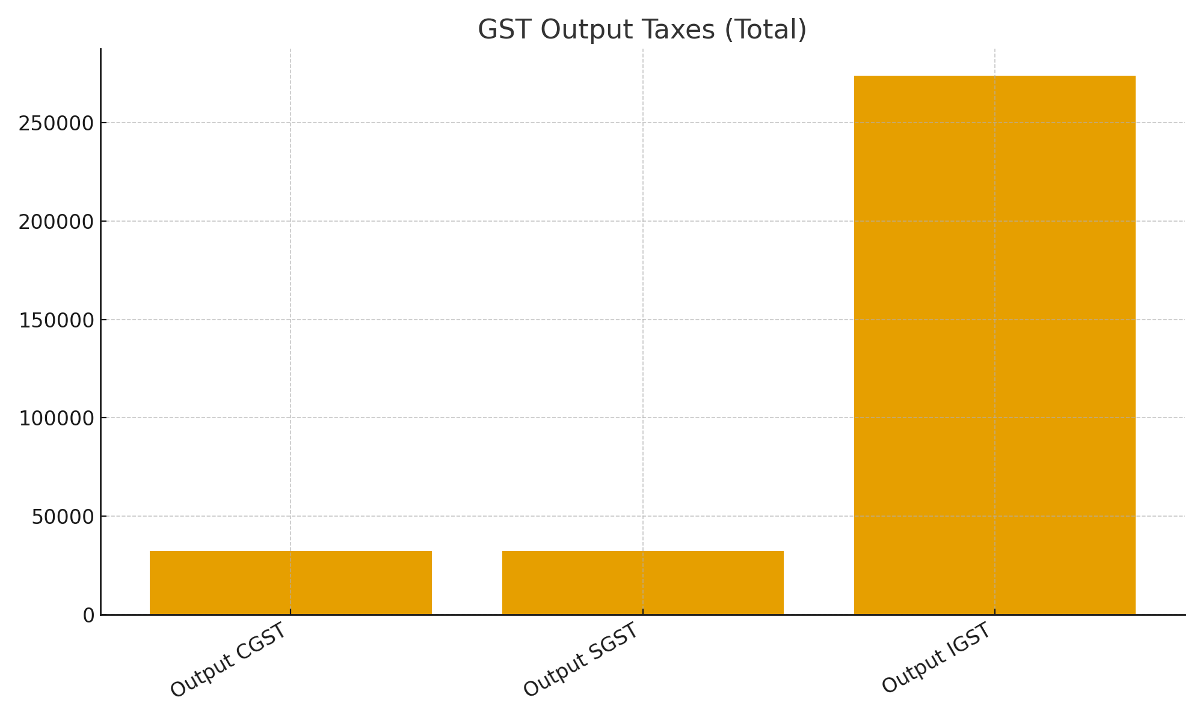

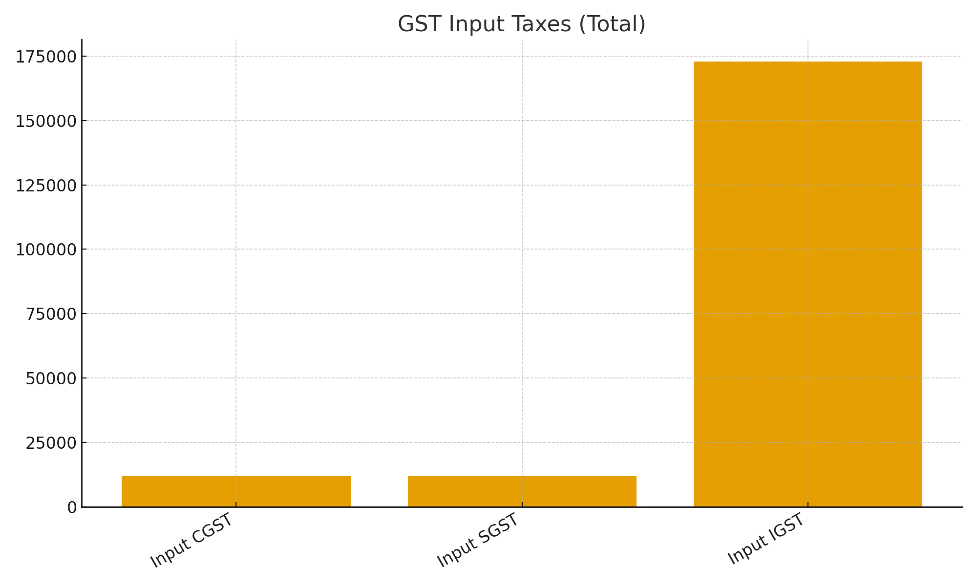

6.4 Channel-wise Sales (Monthly)

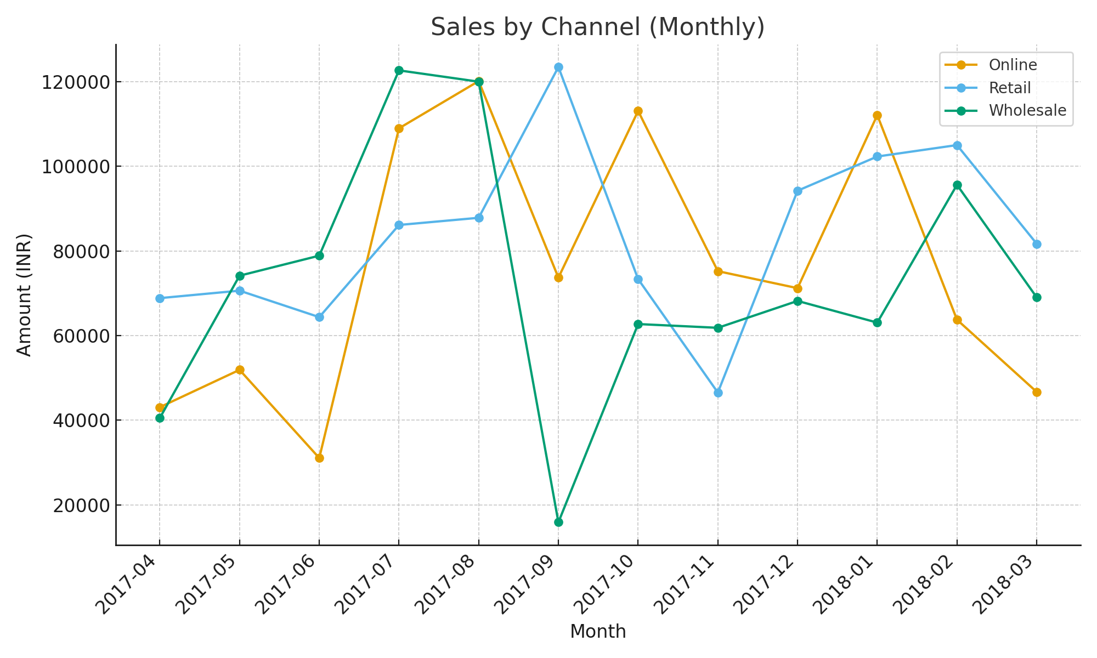

# 7. Top Parties by Value

7.1 Top Customers (by Sales Grand Total)

|  |  |
| --- | --- |
| Customer Ledger | Sales (INR) |
| Customer 38 - Tamil Nadu | 148387.96 |
| Customer 09 - Karnataka | 130160.22 |
| Customer 24 - Karnataka | 124457.17 |
| Customer 20 - Telangana | 122834.88 |
| Customer 06 - Karnataka | 109893.09 |
| Customer 12 - Gujarat | 97192.05 |
| Customer 39 - Uttar Pradesh | 94781.12 |
| Customer 27 - Telangana | 92934.47 |
| Customer 32 - Telangana | 87193.48 |
| Customer 16 - Rajasthan | 84462.18 |

7.2 Top Suppliers (by Purchase Invoice Total)

|  |  |
| --- | --- |
| Supplier Ledger | Purchases (INR) |
| Supplier 20 - Rajasthan | 116920.07 |
| Supplier 24 - Karnataka | 95026.54 |
| Supplier 16 - Maharashtra | 90319.57 |
| Supplier 22 - Delhi | 89705.08 |
| Supplier 08 - Gujarat | 84333.34 |
| Supplier 07 - Gujarat | 83568.75 |
| Supplier 30 - Uttar Pradesh | 80587.33 |
| Supplier 23 - Uttar Pradesh | 72155.14 |
| Supplier 17 - Delhi | 71108.79 |
| Supplier 01 - Delhi | 62909.24 |

# 8. Reports & What to Look For

• Trial Balance / Profit & Loss / Balance Sheet – confirm ledger balances and year-end position.  
• GSTR-like views – verify Output vs Input tax and net liability month-wise.  
• Stock Summary – check godown-wise and item-wise valuation and movements.  
• Cost Center (Profitability) – analyze Retail vs Wholesale vs Online channel performance.  
• Bank Reconciliation – match book vs bank using provided bank statement.

# 9. XML Import Instructions (GST-Era)

Use the bulk XML files provided:  
• Tally_Sales_GST_All.xml  
• Tally_Purchases_GST_All.xml  
• Tally_GST_All_Vouchers.xml (combined)  
  
Gateway of Tally → Import of Data → Vouchers → select XML. Ensure ledger names match exactly.

# 10. Appendix & Files

• Dataset workbook: Tally_ERP9_FY2017-18_Project_Dataset.xlsx  
• CSV bundle (masters + vouchers): Tally_ERP9_FY2017-18_Tally_CSVs.zip  
• Dashboard: Tally_ERP9_FY2017-18_Dashboard.xlsx  
• XML import samples (GST-era, bulk): Tally_Sales_GST_All.xml, Tally_Purchases_GST_All.xml, Tally_GST_All_Vouchers.xml  
• XML notes: Tally_XML_Notes.txt