COMP2120 Assignment 5
Apache Tika — Group Report

1. Introduction and Project Selection
For Assignment 5, our group chose Apache Tika as the open-source project we wanted to contribute to.
We first looked through the recommended repositories. However, some of the issues we were interested in already had contributors working on them or proposed solutions. Because of this, we decided to look at other projects.
We eventually selected Apache Tika because it is written in Java, which we were already familiar with from the course. Tika is used to identify file types and extract text and metadata from different documents. This made its main purpose relatively easy for us to understand.
Another reason was that Tika is an active project with existing documentation, tests, and issues. We wanted to work on real problems that were challenging enough to learn from but still manageable within the assignment period.
Overall, we thought Apache Tika was a suitable choice for our group's experience and available time.
2. Issue Selection
When selecting issues, we considered four main factors: difficulty, size, time, and workload.
We preferred issues that had a clear problem, a limited scope, and results that could be checked through regression tests. We also wanted different members to work on separate tasks without making too many changes to the same part of the codebase.
We selected the following implementation issues.

TIKA-4431 — CSV Filename Detection
We selected this issue because it involved a clear problem with filenames containing a hash symbol (`#`). A CSV file could be incorrectly detected as plain text because the filename was treated as part of a URI. The problem was easy to describe and could be tested using filenames with different extensions and special characters.

TIKA-4408 — Python Shebang Detection
We chose this issue because some Python scripts were being incorrectly identified as Shell scripts. The issue provided specific examples that we could use to reproduce the problem. We could also test different Python and Shell scripts to check whether the fix worked without affecting existing behaviour.

TIKA-4694 — Word Document Metadata
This issue was suitable because Tika was not returning line and paragraph counts for older Microsoft Word documents. These values were already stored in the document properties, so we expected that the problem could be solved using existing APIs. We could also use an existing test document to verify the output.

TIKA-4478 — Jenkinsfile Detection
We also selected TIKA-4478 because it had a clear problem and a manageable scope.Apache Tika could already recognise Groovy files with the `.groovy` extension, but it could not recognise files named `Jenkinsfile`.We thought this issue was suitable because it did not require major changes to the project. It also had clear expected results, making it possible to test the correct filename and important boundary cases, such as `jenkinsfile` and `Jenkinsfile.txt`.

Overall, these issues gave our group different tasks that could be investigated, tested, and reviewed within the available time.
3. Team Organisation and Collaboration
Our group consisted of five members. Each implementation issue had a main owner responsible for investigating the problem, making changes, and preparing tests.

Group Member GitHub Username Main Responsibility
Kyubin Park u8026876 TIKA-4431
Jiajun Li Lynnbb88 TIKA-4408
Vivek Dinesh Suryawanshi Vivek-Suryawanshi TIKA-4694
Brett Wilson ragingvegetable TIKA-4478
JinTian Zhang zjt060523terry Code reviews

We used GitHub Issues to organise the work and record progress. Each contributor worked on a separate branch and opened a Pull Request when their implementation was ready for group review.Other members could then check the code changes, review test coverage, and leave suggestions. This helped us keep a record of what each person worked on and what feedback they received.
4. Contribution and Review Process
Our contribution process started with the official Apache Tika Jira issues.
For each selected issue, we created a corresponding GitHub Issue in our group repository. This helped us assign responsibilities, record progress, and link the work to the original Apache issue.
The contributors then investigated the relevant code, created development branches, and prepared their proposed fixes. Regression tests were used to check the reported problems and confirm the results after the changes.
After implementation, contributors opened Pull Requests in our shared repository. Other group members reviewed the changes and provided feedback.
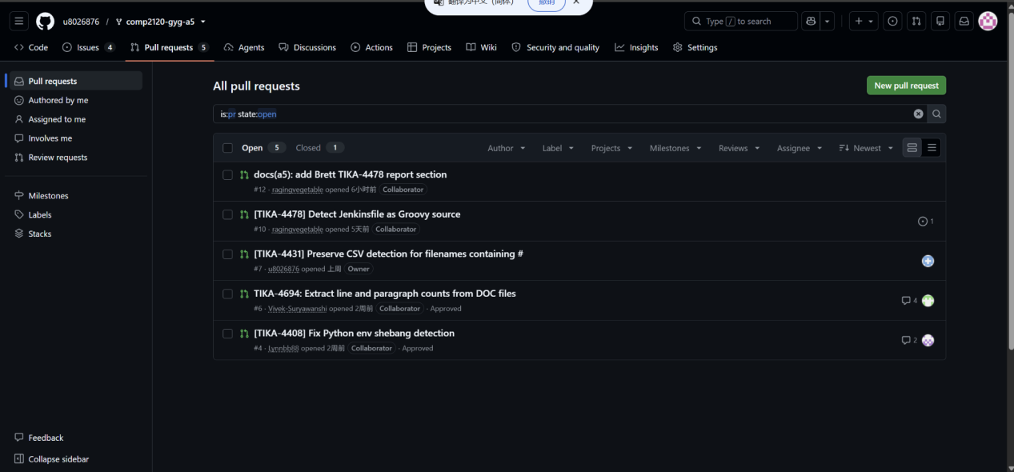
Figure 1. Pull requests in our group GitHub repository, showing four implementation PRs
Our reviews focused on several areas: whether the change addressed the reported problem, whether it followed the existing code structure, whether the regression tests covered important cases, and whether there were possible edge cases.
Apache Tika also has specific contribution requirements. Official PRs should reference a Jira issue, include relevant tests and documentation changes, and follow the required title format, such as `[TIKA-4694] Description`.
We distinguished between group review comments and formal GitHub approvals.
Our group repository used a review policy requiring approval from another group member. The course instructions also describe majority-group review and tutor checking before opening a project PR. These requirements and the actual reviews performed need to be distinguished when reporting our work.
5. Issue Implementation and Testing
5.1 TIKA-4431 — CSV Filename Detection

5.2 TIKA-4408 — Python Shebang Detection

5.3 TIKA-4694 — Word Document Metadata

5.4 TIKA-4478 — Jenkinsfile Detection
6. Code Review Contributions
Reviews focused on understanding the proposed changes, checking important test cases, and identifying possible improvements.

6.1 TIKA-4431 — CSV Filename Detection
For TIKA-4431, JinTian reviewed the proposed changes in `MimeTypes.java`, the regression tests in `TikaDetectionTest.java`, and the changelog entry.
The main issue JinTian examined was how Tika handled the hash symbol in local filenames compared with URLs.
JinTian checked whether the new logic preserved the filename extension for local filenames while keeping the existing fragment behaviour for explicit URLs, also considered query strings, encoded characters, and different filename extensions.
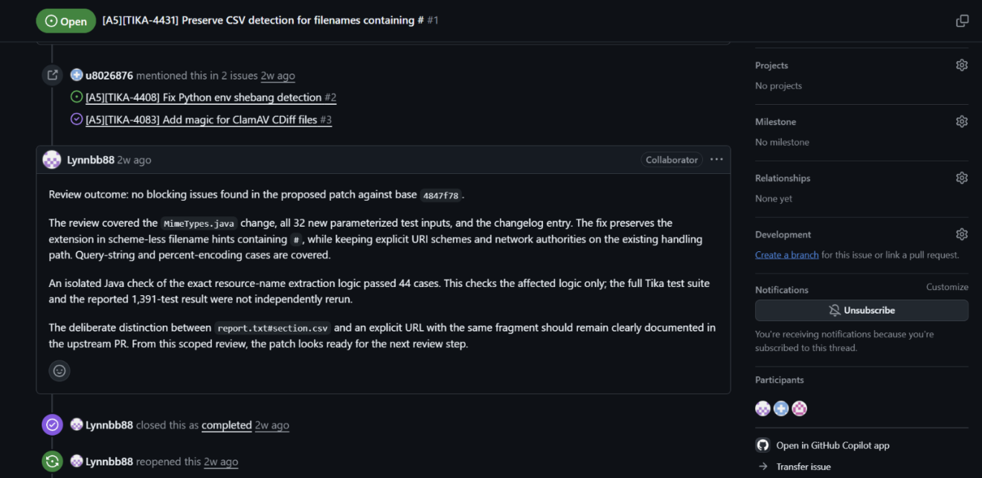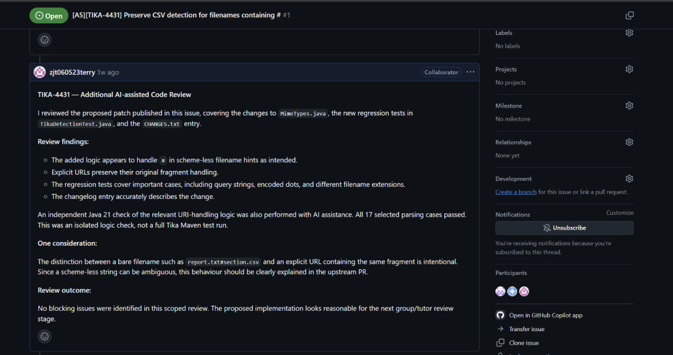
6.2 TIKA-4408 — Python Shebang Detection
For TIKA-4408, JinTian reviewed the changes to the Python MIME detection rules and the related regression tests.
The original rule matched part of the Python shebang at offset 1. The proposed fix changed the matching logic to identify the correct prefix from the beginning of the file.
JinTian checked the explanation of the change and whether the tests covered both Python and Shell detection, also suggested adding a test using ordinary text such as `x/bin/env python`. This could help prevent the old false-positive detection problem from returning.
Another case raised was `#!/usr/bin/env -S python3`. However, this was outside the scope of the proposed fix.
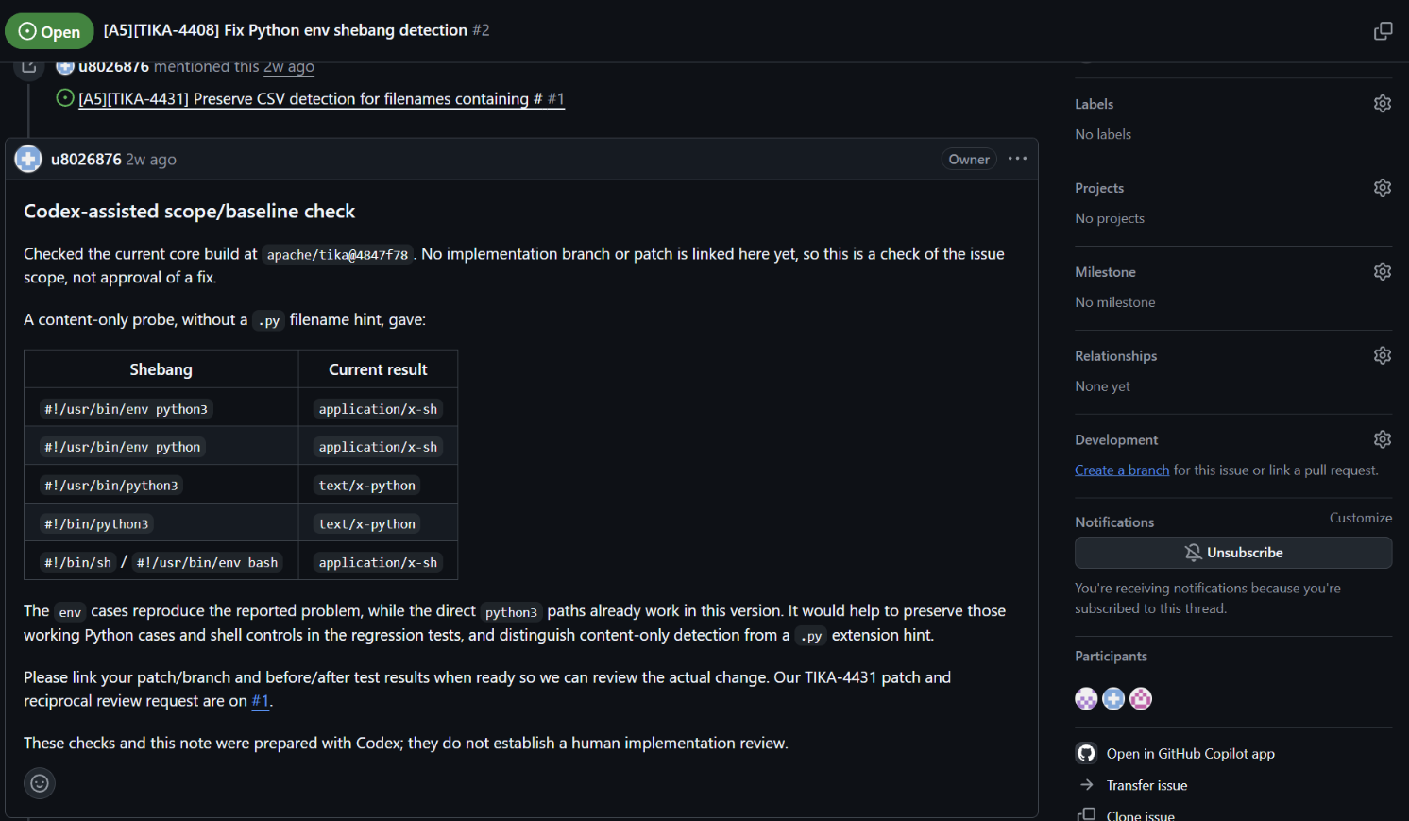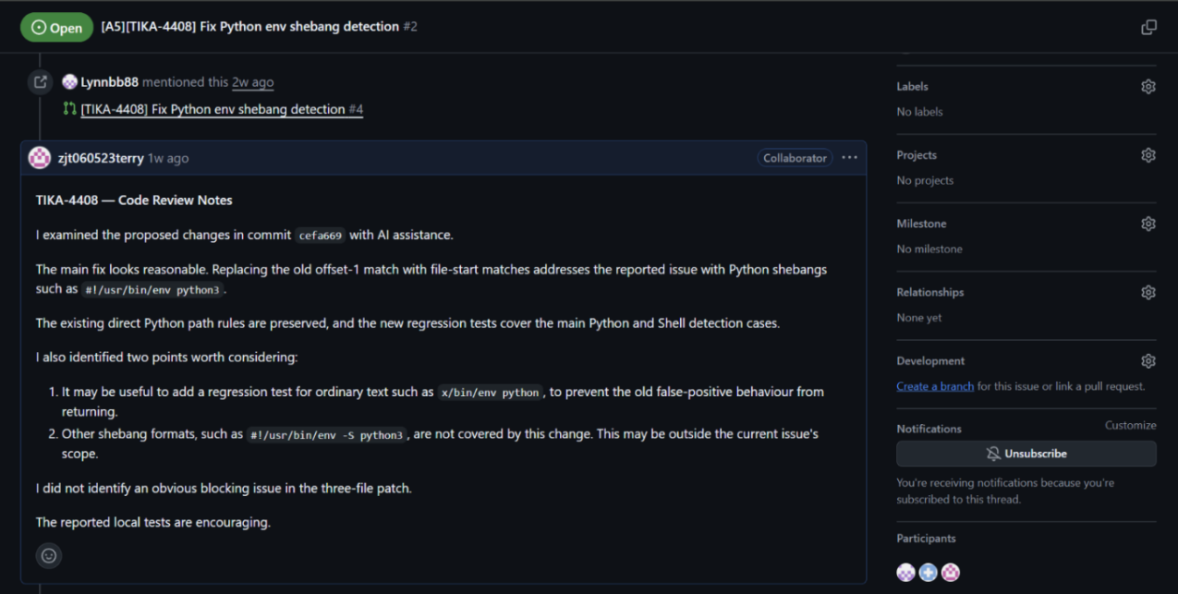
6.3 TIKA-4694 — Word Document Metadata
For TIKA-4694, JinTian reviewed the changes in `SummaryExtractor.java`, the regression test in `WordParserTest.java`, and the changelog.
The implementation used existing methods to extract stored line and paragraph counts from older Word documents.
JinTian checked how the new metadata mappings worked with the existing `set(Property, int)` method. This method only stores positive values, so zero or missing counts are not added to the metadata.
The regression test checked a document containing 12 lines and 3 paragraphs.
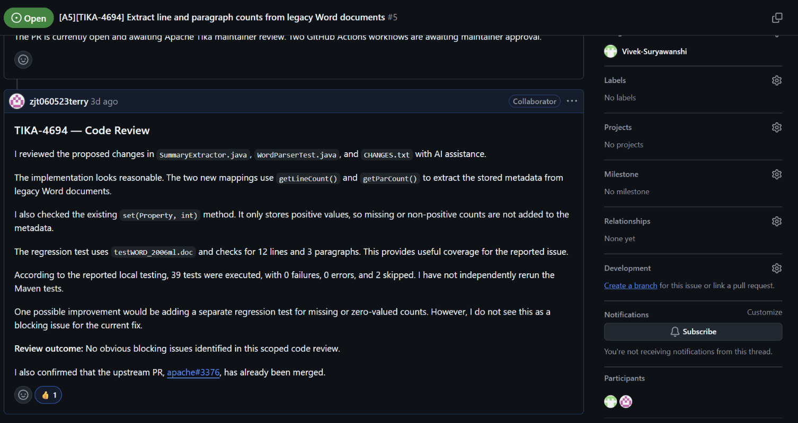
6.4 TIKA-4478 — Jenkinsfile Detection
For TIKA-4478, JinTian reviewed the new filename matching rule in `tika-mimetypes.xml` and the regression test in `MimeDetectionTest.java`.
The implementation added an exact `Jenkinsfile` pattern to the existing Groovy MIME type.
JinTian checked the three main test cases: `Jenkinsfile`, lowercase `jenkinsfile`, and `Jenkinsfile.txt`.
JinTian also suggested adding more boundary tests, such as `scripts/Jenkinsfile` and `Jenkinsfile.bak`, to check path handling and similar filenames.
Before an official Apache submission, JinTian reminded the contributor to use the required `[TIKA-4478] Description` PR title format and to disclose AI-assisted development according to Apache's guidelines.
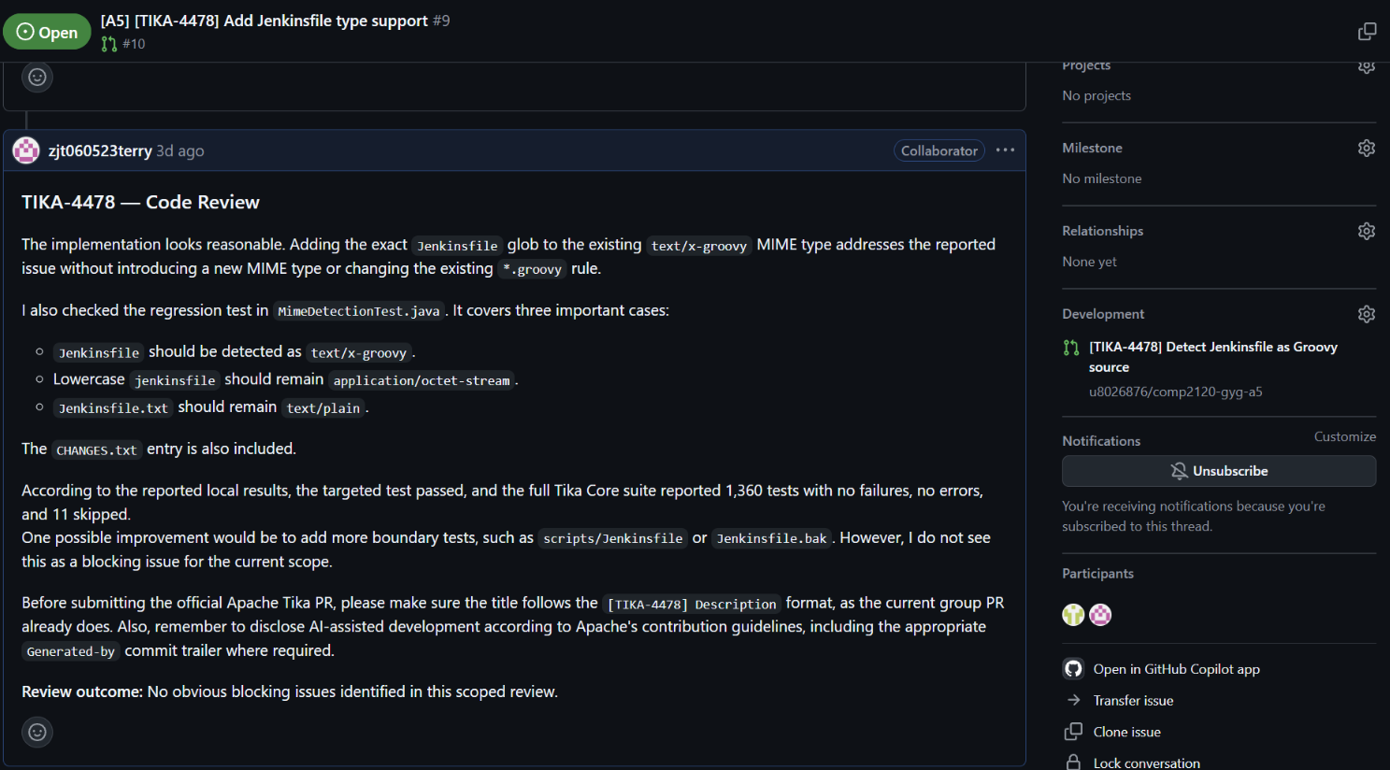

7. Pull Request Outcomes
Our group created four internal Pull Requests corresponding to the four main implementation issues.
Issue Group PR Outcome
TIKA-4431 #7 Open in group repository
TIKA-4408 #4 Open in group repository
TIKA-4694 #6 Group PR open; official Apache PR merged
TIKA-4478 #10 Open in group repository
The most important outcome was TIKA-4694.
Vivek submitted the fix to the official Apache Tika repository as PR #3376. This PR was merged on 21 October 2026.
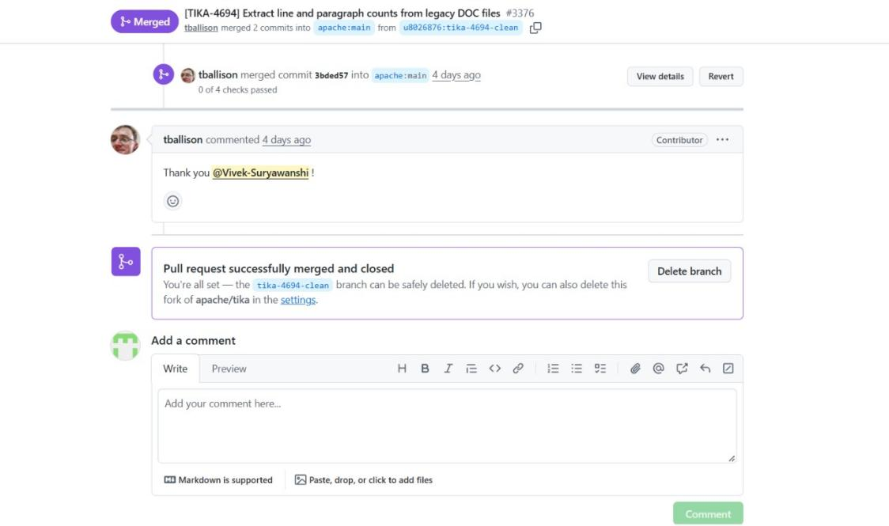
This showed that at least one of our group's contributions was accepted into the real open-source project.
Overall, our group produced code changes, regression tests, review discussions, and a successful upstream contribution.

8. Challenges and Reflection
One challenge was understanding an existing open-source codebase.
Unlike our previous assignments, we were not building everything from the beginning. We had to understand how Apache Tika was already organised and make changes that followed the project's existing conventions.
Another challenge was testing. Some members experienced problems with Maven dependencies and local build environments. We also needed to understand why regression tests should fail before a fix and pass afterwards.
Code review was another important learning experience.
At first, it was easy to focus only on whether the proposed fix looked correct. However, reviewing the different issues showed that it was also important to consider edge cases and possible effects on existing behaviour.
For example, the CSV issue involved differences between local filenames and URLs, while the Python issue involved both incorrect detection and possible false positives.
We also used AI tools to help understand code and identify possible problems. These tools were useful, but we still needed to check the suggestions carefully and distinguish AI-assisted analysis from independently verified results.
This assignment helped us understand that contributing to an open-source project involves more than writing code. It also requires testing, documentation, communication, review, and following the project's contribution rules.

9. Conclusion
In this assignment, our group worked on Apache Tika and investigated several issues related to file type detection and document metadata.
We organised our work using GitHub Issues, branches, and Pull Requests. Group members implemented fixes, added regression tests, and reviewed each other's changes.
One contribution, TIKA-4694, was successfully merged into the official Apache Tika repository. The other proposed fixes remained available in our group repository for review and further work.
Through this experience, we gained a better understanding of how real open-source projects are developed, tested, and maintained.

References and Supporting Evidence
- Apache Tika Repository: https://github.com/apache/tika
2. Group Repository: https://github.com/u8026876/comp2120-gyg-a5
3. Apache Tika Contribution Guidelines: https://tika.apache.org/contribute.html
4. TIKA-4431 Group Issue: https://github.com/u8026876/comp2120-gyg-a5/issues/1
5. TIKA-4408 Group Issue: https://github.com/u8026876/comp2120-gyg-a5/issues/2
6. TIKA-4694 Group Issue: https://github.com/u8026876/comp2120-gyg-a5/issues/5
7. TIKA-4478 Group Issue: https://github.com/u8026876/comp2120-gyg-a5/issues/9
8. TIKA-4694 Official PR: https://github.com/apache/tika/pull/3376

