TIKA 4431 MIME detection with number signs
  - Kyubin Park | GitHub u8026876 | COMP2120 Assignment 5
This contribution fixes a filename-hint error in Apache Tika core. CSV content named Lorem-Ipsum#123.csv was classified as text/plain because URI parsing removed the part containing the .csv extension. The change preserves that extension for filename-like inputs while retaining existing handling of explicit URLs. The published group patch has regression coverage and recorded peer review. [1-4]

Issue selection and value
TIKA-4431 was a suitable contribution because changing only the filename reproduced the fault, giving a clear comparison before and after the fix. The affected code was confined to filename-hint extraction in tika-core, but the shared API accepts filenames, paths and URLs, making compatibility the main design challenge. Correcting this step preserves the CSV extension hint when a number sign is literal, while retaining fragment handling for explicit URLs. [1,3,4,9]

Problem and relevant code
The original report compares identical content under Lorem-Ipsum.csv and Lorem-Ipsum#123.csv. The first name yields text/csv; adding the number sign changes the result to text/plain. The reproduction uses UTF-8 bytes for a short semicolon-separated document, so the input content stays constant while the resource name changes. [1,4]
Lorem;Ipsum;
1;2;
3;4;
Tika.detect(byte[], String) passes the document name into the stream-based API, which stores it as TikaCoreProperties.RESOURCE_NAME_KEY. Within the detection process, MimeTypes reads content evidence and then uses the resource-name hint to refine compatible candidate types. The affected branch constructs a java.net.URI and extracts its path before looking up the filename. [3,9]
A bare name such as Lorem-Ipsum#123.csv is also valid relative-URI syntax. URI parsing interprets #123.csv as a fragment, leaving the path Lorem-Ipsum. Consequently, the filename lookup loses the .csv hint that can specialise the sample content from plain text to CSV. The fix belongs in this name-extraction step; the CSV input and MIME registry do not need changes. [1,3]

Implementation and compatibility
The patch adds ten production lines to MimeTypes.java. After URI construction, the additional rule runs only when both the scheme and raw authority are absent. It locates the first question mark, then compares the final raw number sign and dot before that boundary. If a number sign precedes the last dot, literal number signs are escaped as %23 and the URI is reparsed. Existing path extraction, filename lookup and hint application then continue. [3]
This condition preserves the filename heuristic without reinterpreting explicit URL fragments. It uses original characters before percent decoding, so %2E does not become a dot for the boundary decision. Restricting the comparison to the part before the first question mark also prevents a dot in a query value from driving that decision. [3,4]

Regression coverage and design limits
The 32 new parameterised inputs exercise both content-plus-name detection and name-only detection. Alongside the existing test, JUnit reports 33 detection cases. Coverage includes ordinary and repeated number signs, uppercase extensions, dotted names, relative and absolute paths, Windows paths, spaces, encoded hashes, query strings, explicit URI schemes and network authorities. HTTP and FTP script-name controls preserve their existing context-dependent results. [4]
Resource name | Expected result
report.txt#section.csv | text/csv
https://example.test/report.txt#section.csv | text/plain
report.txt#section%2Ecsv | text/plain
report.csv#section?download=.txt | text/csv

These examples state a deliberate compatibility choice. A scheme-less string can denote either a filename or a relative URI, so the rule cannot determine caller intent in every case. The bare name above supplies a CSV filename hint, while the explicit URL retains its .txt path hint. A filename hint is not proof that arbitrary content is CSV. This ambiguity remains a documented limitation of an API that accepts names, paths and URLs as strings. [2-4,9]

Validation of the published patch
The following results were recorded on 21 October 2026 for the group-base patch, using Windows and JDK 21. The inspected checkout remains at published head 86483a6. On 29 October, SHA-256 checks matched all three changed files to the recorded validation snapshot, and PR 7 still identified the same head. The table cites those dated executions for the published patch. [2,8]
Check | Reported cases | Failures | Errors | Skipped
Detection tests with production fix removed | 33 | 9 | 0 | 0
Detection tests with production fix restored | 33 | 0 | 0 | 0
Core unit run | 1,391 | 0 | 0 | 11
Alternate XML provider run | 12 | 0 | 0 | 2
Core integration test TikaIT | 1 | 0 | 0 | 0

The negative control retained the new tests and removed only the production fix. Its nine failures demonstrate that the regression cases distinguish the faulty implementation from the corrected one. The restored patch also passed annotation-processor tests, Checkstyle, Spotless, forbidden-API checks and Apache RAT, ending with Maven BUILD SUCCESS. Counts above belong to separate executions and are not added into a single total. [2,8]
./mvnw.cmd clean install -pl tika-core -am -Ppedantic -Dtika.test.locale=random
The command omits the machine-specific local Maven-cache argument. Validation covers tika-core and reactor prerequisites. It does not establish a successful build of every Tika module, remote CI success, or upstream acceptance. The 29 October API check returned no GitHub check runs for the published head. No performance benchmark was recorded. [2,8]

Review and contribution process
The change is limited to MimeTypes.java, TikaDetectionTest.java and CHANGES.txt: 77 added lines and no removed lines. No public API or dependency is added. The changelog identifies the user-visible detection correction, and the commits reference TIKA-4431. This follows the project guidance to keep fixes focused, include a regression test that fails without the change, document user-visible changes, and identify the Jira issue. [2,7]
The patch and evidence were shared in group issue 1 before group PR 7. The dated record shows the following stages. [2,10]
15 October 2026. Candidate tests exposed encoded-dot and query-string failures; the boundary rule was revised to use raw characters. [8]
17 October 2026. Jiajun Li reviewed the logic, all 32 new inputs and the changelog. His isolated Java check passed 44 cases. [5]
21 October 2026. The group-base patch passed the recorded validation and was opened as PR 7. Jintian Zhang's AI-assisted parsing check passed 17 cases. [2,6,8]
The reviewed additions were ported to group base 76b33fa, preserving existing group changes. Commits 75dbff0, 4a76680 and 86483a6 contain the changelog, production change and regression tests respectively. On 1 November 2026, group PR 7 remained open and unmerged at head 86483a6. A bounded Apache PR search found no TIKA-4431 match, so upstream submission or maintainer acceptance is not claimed. [2,11]

Individual contribution and collaboration
I am the accountable owner of TIKA-4431 under u8026876. My contribution comprises the filename-hint correction, regression coverage and changelog in the three commits listed above. I used Codex to assist the investigation, implementation, test design and execution, porting, and publication preparation. Codex also assisted with drafting and revising this section from the cited records.
Jiajun Li (Lynnbb88) and Jintian Zhang (zjt060523terry) contributed the scoped reviews and isolated checks above. Both reported no blocking findings and asked for the filename versus explicit-URL distinction to remain clear upstream. These isolated checks are separate from the core Maven validation. [5,6]

Reflection and possible improvements
My main challenge was deciding correct behaviour when a string could follow either URL or filesystem conventions. A number sign can be literal in a filename and starts a fragment in a URI. Preserving everything after it would fix the reported filename but could change explicit URL behaviour. I therefore had to justify which interpretation the fix should preserve.
The final rule retains URI handling for an explicit scheme or authority and applies a narrower filename heuristic otherwise. It makes the input contract clearer, but cannot prove caller intent. I learned to define correctness through explicit examples of each interpretation and regression tests at that boundary. [3,4,9]
The investigation also exposed two implementation traps: decoded fragments made encoded dots look like extension boundaries, while a later candidate still let a query-string dot affect the decision. Saved records show two initial-candidate failures and one intermediate query-related failure. The final raw-character comparison excludes both cases. [8]
For similar fixes, I would write the filename and URL cases as a decision table before implementation and use it to focus early review. A future API that distinguishes filenames, paths and URLs could reduce the ambiguity, subject to compatibility work. Broader integration validation and measured performance checks remain follow-ups. [3,4,8,9]

References and evidence
Source links identify the issue, exact published revision and peer reviews. PR status and the bounded upstream search were checked on 1 November 2026. Validation runs were performed on 21 October, with candidate investigations on 15 October. Figures 1 and 2 reproduce dated test output and review evidence within this document.
[1] TIKA-4431 original bug report
https://issues.apache.org/jira/browse/TIKA-4431
[2] Group PR 7 implementation validation and submission status
https://github.com/u8026876/comp2120-gyg-a5/pull/7
[3] MimeTypes source at the published commit
https://github.com/u8026876/comp2120-gyg-a5/blob/86483a61d15e22a03f1bbdf6e0c199012baa34ed/tika-core/src/main/java/org/apache/tika/mime/MimeTypes.java#L564-L611
[4] TikaDetectionTest regression inputs at the published commit
https://github.com/u8026876/comp2120-gyg-a5/blob/86483a61d15e22a03f1bbdf6e0c199012baa34ed/tika-core/src/test/java/org/apache/tika/TikaDetectionTest.java#L31-L95
[5] Jiajun Li scoped peer review
https://github.com/u8026876/comp2120-gyg-a5/issues/1#issuecomment-6233761379
[6] Jintian Zhang scoped peer review
https://github.com/u8026876/comp2120-gyg-a5/issues/1#issuecomment-6311411395
[7] Apache Tika contribution guidance
https://tika.apache.org/contribute.html
[8] Saved validation records dated 21 October 2026. Figure 1 reproduces the negative-control and restored detection output. The core result and build command are recorded in group PR 7 [2]. Original logs, XML reports and hashes are retained in the local evidence package; candidate logs dated 15 October support the iteration account.
[9] Tika detection API source at the published commit
https://github.com/u8026876/comp2120-gyg-a5/blob/86483a61d15e22a03f1bbdf6e0c199012baa34ed/tika-core/src/main/java/org/apache/tika/Tika.java#L183-L334
[10] Group issue 1 ownership and review record
https://github.com/u8026876/comp2120-gyg-a5/issues/1
[11] Apache Tika ticket search checked on 1 November 2026
https://github.com/apache/tika/pulls?q=is%3Apr+TIKA-4431

Reproducibility record
Published group head: 86483a61d15e22a03f1bbdf6e0c199012baa34ed. Group base: 76b33fa0ea016ceb50b7941b8176252855e8ac4d. Figure 1 reproduces the saved detection output. References 2, 5, 6 and 10 link the validation and review discussion. The original build logs, XML reports, file hashes and candidate logs remain in the local handoff evidence package.

Evidence screenshots
The figures preserve the dates and scope of the recorded validation and peer review. Both screenshots were captured on 1 November 2026.
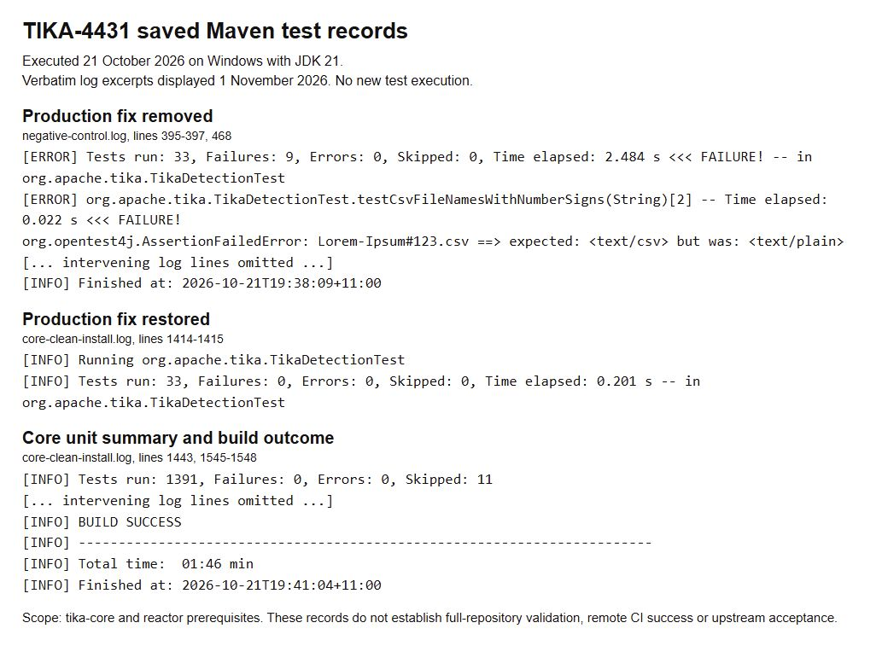
Figure 1. Verbatim excerpts from the saved Maven logs, executed on 21 October 2026. Removing only the production fix caused nine of 33 detection cases to fail; restoring it gave zero failures. [8]
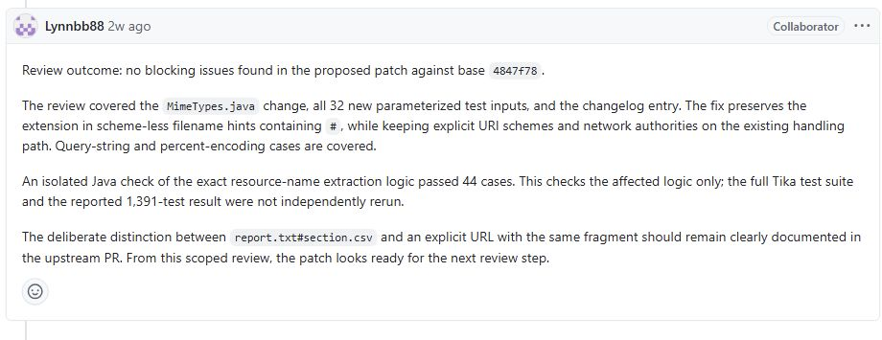
Figure 2. Jiajun Li (Lynnbb88) recorded no blocking findings on 17 October 2026. His 44-case check covered the extraction logic; he did not independently rerun the full Tika suite. [5]

