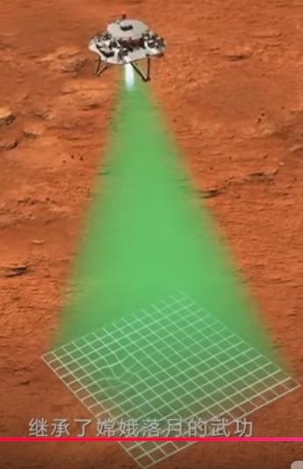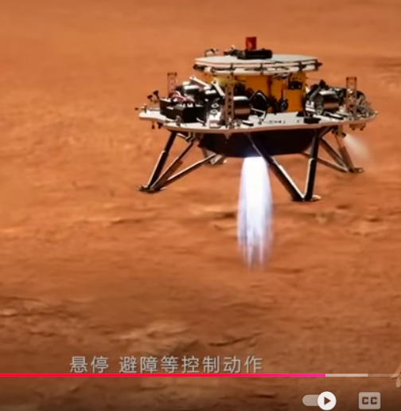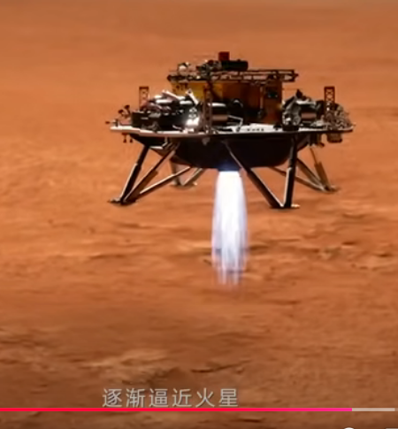

|  |  |  |  |  |  |  |  |  |  |  |  |  |  |  |  |  |  |  |
| --- | --- | --- | --- | --- | --- | --- | --- | --- | --- | --- | --- | --- | --- | --- | --- | --- | --- | --- |
|  |  |  |  |  |  |  |  |  |  |  |  |  |  |  |  |  |  |  |
|  |  |  |  |  |  |  |  |  |  |  |  |  |  |  |  |  |  |  |
|  |  |  |  |  |  |  |  |  |  |  |  |  |  |  |  |  |  |  |
|  |  |  |  |  |  |  |  |  |  |  |  |  |  |  |  |  |  |  |
|  |  |  |  |  |  |  |  |  |  |  |  |  |  |  |  |  |  |  |
|  |  |  |  |  |  |  |  |  |  |  |  |  |  |  |  |  |  |  |
|  |  |  |  |  |  |  |  |  |  |  |  |  |  |  |  |  |  |  |
|  |  |  |  |  |  |  |  |  |  |  |  |  |  |  |  |  |  |  |
|  |  |  |  |  |  |  |  |  |  |  |  |  |  |  |  |  |  |  |
|  |  |  |  |  |  |  |  |  |  |  |  |  |  |  |  |  |  |  |
|  |  |  |  |  |  |  |  |  |  |  |  |  |  |  |  |  |  |  |
|  |  |  |  |  |  |  |  |  |  |  |  |  |  |  |  |  |  |  |
|  |  |  |  |  |  |  |  |  |  |  |  |  |  |  |  |  |  |  |
|  |  |  |  |  |  |  |  |  |  |  |  |  |  |  |  |  |  |  |
|  |  |  |  |  |  |  |  |  |  |  |  |  |  |  |  |  |  |  |
|  |  |  |  |  |  |  |  |  |  |  |  |  |  |  |  |  |  |  |
|  |  |  |  |  |  |  |  |  |  |  |  |  |  |  |  |  |  |  |
|  |  |  |  |  |  |  |  |  |  |  |  |  |  |  |  |  |  |  |
|  |  |  |  |  |  |  |  |  |  |  |  |  |  |  |  |  |  |  |

'第一題，載入361(19*19)個圖資，1為平地，用白色表示，0為傾斜地，用紅色表示。

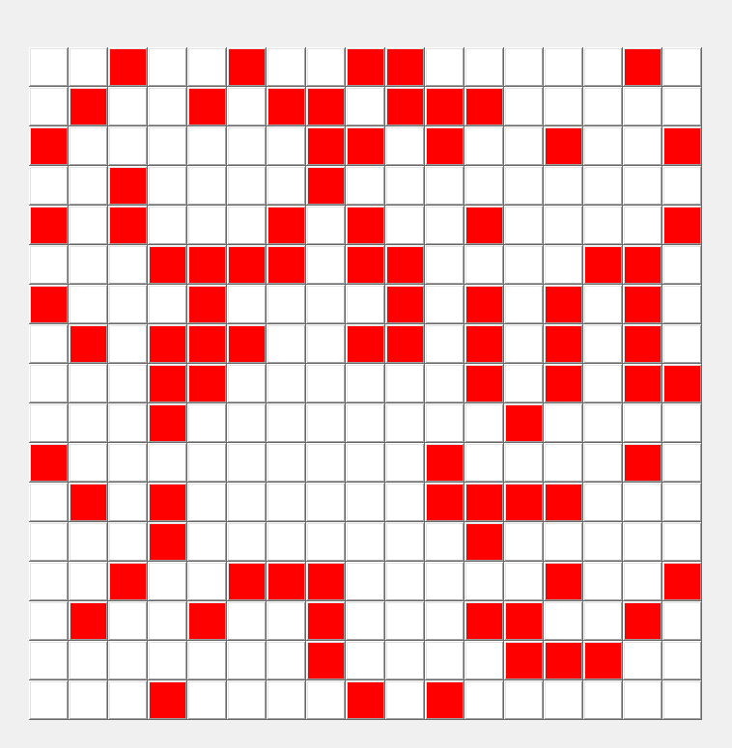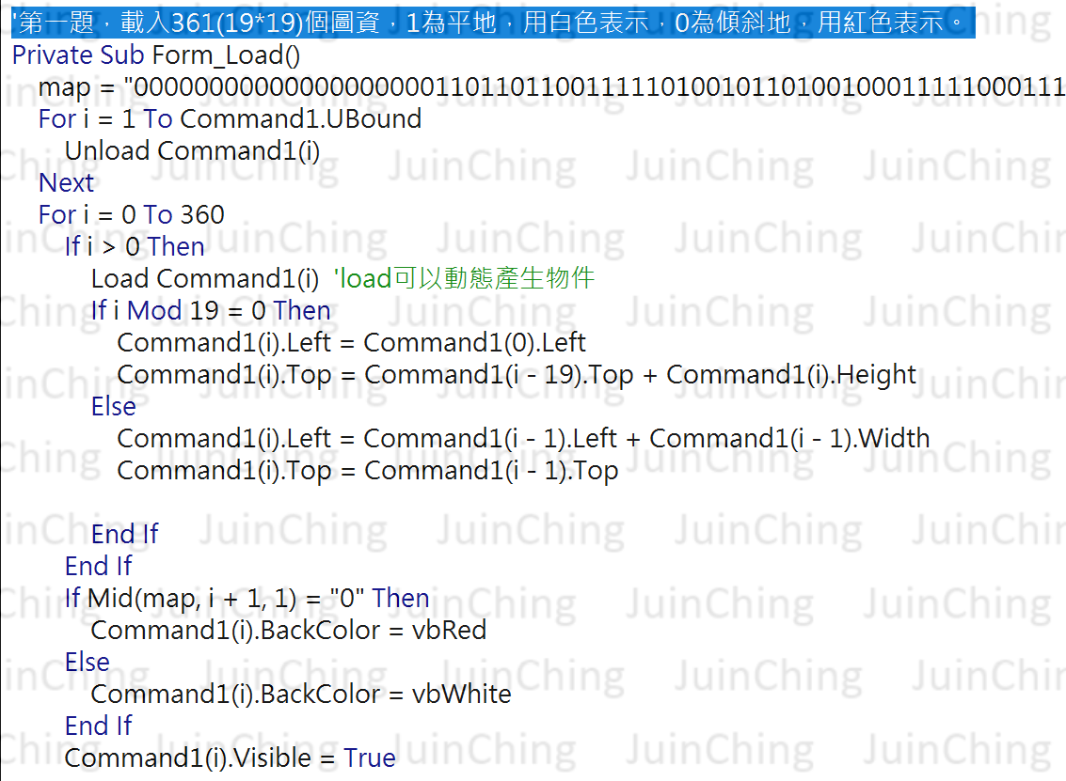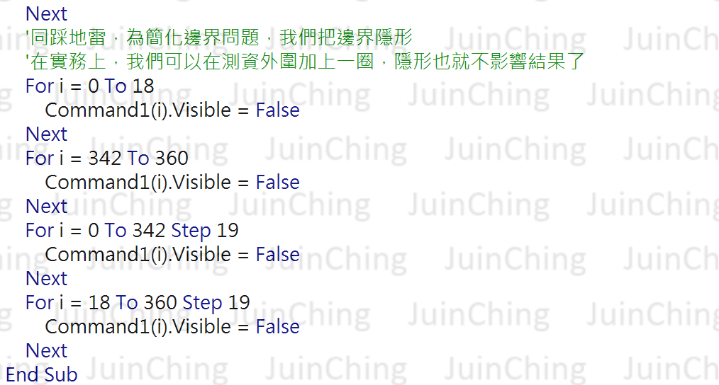

'第二題、計算累計高度

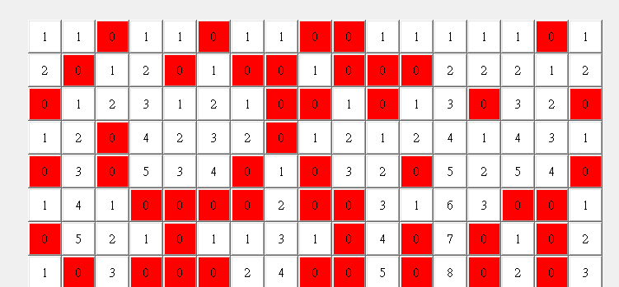

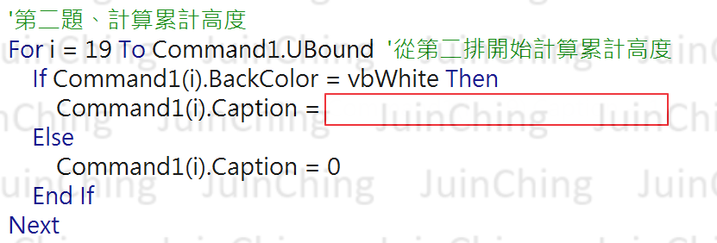

**'第三題、找出最大矩形**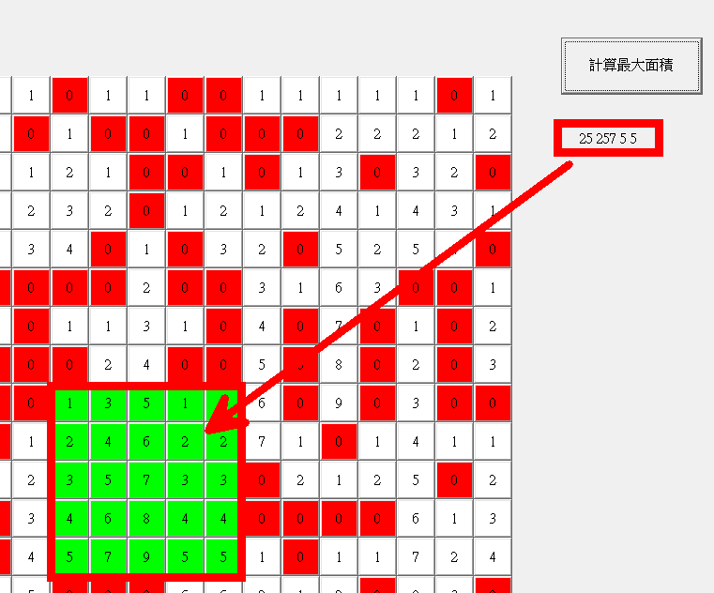

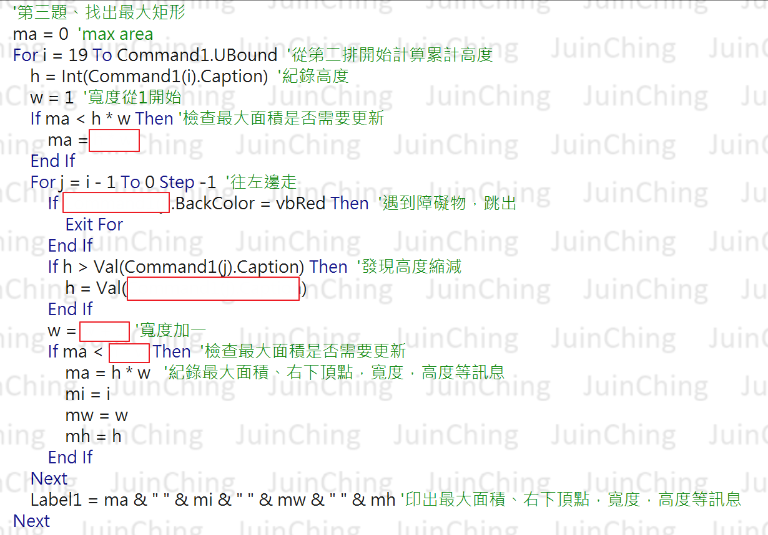

## '第四題，把降落點以綠色顯示

