Template Header

Test Paper
This is a paragraph.
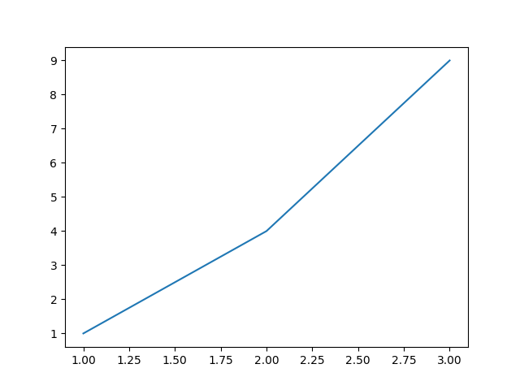
Test Figure

Conclusion
End of paper.

