Alternatives and Variations

========================
Initial Draft - Incomplete

The Frequency Reference is made up of just a few functional blocks connected as shown below.
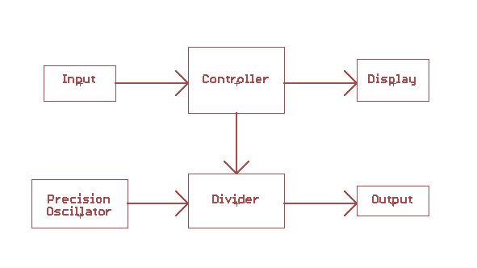
The heart of the device is the precision oscillator. The final output frequency is an integer division of the oscillator. The output block in this case is merely a resistor and a BNC connector. The divider circuit is an integrated peripheral of the controller. Once the divider is set up by the controller, it operates independently. The controller can change the setup of the divider at any time and does so in response to input.** Input can either be the rotary encoder / switch or the USB/serial port. Note that the controller sends setup information to the divider but does not ever read anything back. The display is driven by the controller and does not rely on the state of the divider.

The precision and stability of the entire circuit depends on the oscillator. The nominal design uses the RTX0230LC which actually has unknown precision and stability but has been tested (see EEVBlog thread) to be pretty good considering it costs around a dollar. To make a better reference, choose an oscillator with better specs. Rev-B of the circuit board retains support for the RTX0230LC but also allows for oscillators with very good published specifications for, granted, a lot more money. Because most of the circuit is digital, the overall precision of the device increases with the better oscillator. That is, the fact that the rest of the circuit is cheap does not mean that it degrades the better oscillator performance.

Here are a few examples of oscillator parts that will work with the Rev-B PCB.

<OSCTable>

**Changing frequencies is not phase synchronous. When the change occurs, the clock is stopped, the new divisor (or prescaler) value is programmed, the count is zero’d, then the clock is restarted.

Other Frequencies

The board and software do not really know what frequency they are running at. You could therefore substitute other frequency oscillators. The output frequency would scale but otherwise everything would work the same. The maximum frequency is in the neighborhood of 20MHz. Higher frequencies would be over-clocking the controller, but it will still work up to a point. Lower frequencies are also okay, however the display might start to flicker as the lower clock means a slower controller. In either case baud rates will need to be scaled for correct serial communications.

As an example, the exact same code will run on a SparkFun Redboard (Arduino Uno clone) which runs at 16MHz and derives its clock from a ceramic resonator rather than a crystal. The software works fine (with degraded accuracy, tempco and jitter), however the frequency table shifts down to the following.

Frequency Display Scale
(Hz) (Implied)
8,000,000 10.00 MHz
4,000,000 5.000 MHz
2,000,000 2.500 MHz
1,600,000 2.000 MHz
1,000,000 1.250 MHz
800,000 1.000 MHz
400,000 500.0 kHz
320,000 400.0 kHz
250,000 312.5 kHz
200,000 250.0 kHz
160,000 200.0 kHz
100,000 125.0 kHz
80,000 100.0 kHz
64,000 80.0 kHz
40,000 50.0 kHz
32,000 40.0 kHz
20,000 25.0 kHz
16,000 20.0 kHz
10,000 12.5 kHz
8,000 10.0 kHz
6,400 8000 Hz
4,000 5000 Hz
3,200 4000 Hz
2,500 3125 Hz
2,000 2500 Hz
1,600 2000 Hz
1,000 1250 Hz
800 1000 Hz
640 800 Hz
400 500 Hz
320 400 Hz
200 250 Hz
160 200 Hz
122.0722 153 Hz

Note that the display does not change since it is unrelated to the actual frequency. You can make the display correct (sort of, without more work, decimals will be wrong sometimes) by substituting the following data table in the source.

static uint16_t dispFreq[] = {
8000, // 8,000,000
4000, // 4,000,000
2000, // 2,000,000
1600, // 1,600,000
1000, // 1,000,000
8000, // 800,000
4000, // 400,000
3200, // 320,000
2500, // 250,000
2000, // 200,000
1600, // 160,000
1000, // 100,000
800, // 80,000
640, // 64,000
400, // 40,000
320, // 32,000
200, // 20,000
160, // 16,000
100, // 10,000
8000, // 8,000
6400, // 6,400
4000, // 4,000
3200, // 3,200
2500, // 2,500
2000, // 2,000
1600, // 1,600
1000, // 1,000
800, // 800
640, // 640
400, // 400
320, // 320
200, // 200
160, // 160
122 // 122
};

By further adjusting these tables, oscillators of other frequencies can be accommodated.

Cost

The original intent of the “$3 Frequency Standard” has been compromised by the cost of the rotary encoder, PCB and display circuitry. Still the entire cost remains under $22 total, which is not too bad in my opinion. Here is a cost breakdown of the BOM.

If this is too expensive for you, the cost can be lowered by not populating various parts of the PCB.

You can eliminate the display by not populating DISP1, U3 and C9. The device will operate the same. You can use an external frequency counter to see where you are at.

The device will also operate if you do not populate the rotary encoder. Then user input will need to be supplied over the serial interface.

You can choose to not populate the power switch. Either remotely wire a cheaper switch or just jumper the NO to C pins on each side. You can choose to not populate the power input connector by just soldering wires in directly (or by powering only off of USB through the FTDI connector). If you only power from USB/FTDI you can choose to not populate the voltage regulator, U2, and associated components, C7, D1, FB2, R2, & R3.

If you exercise all of these, the cost comes out to be $14.37. You can squeeze out a few more dollars if you forego things like the BNC connector and use cheaper components, but the output signal will suffer.

