Reference key Readme

In this demo, we are going to use a reference_id as foreign key instead of id(primary key) as foreign key in other table.

Here we have 2 tables(described below with columns) :

Users :
id(primary key), name, email, password, user_id(reference key)

Profile:
id(primary key), profile_id(reference_key), user_id(foreign key)

To get the data into user table, let’s add some fake values.

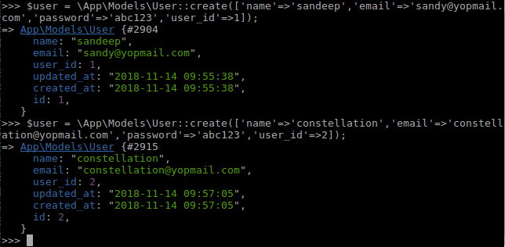

We also add data to profile table :
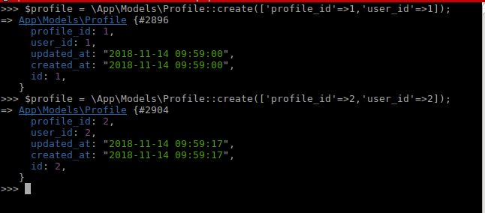
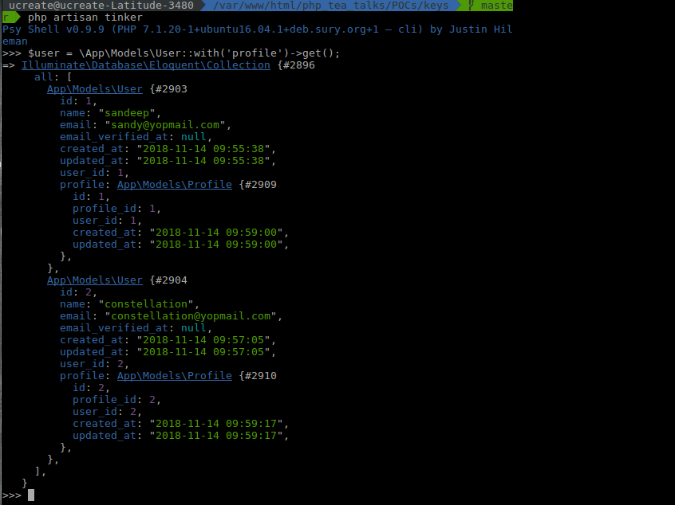
Now since we have both user and profile tables linked with reference is column : user_id, here we get the user data along with the profile information.

We get this data as we have defined profile relation in user model as :

return $this->hasOne('App\Models\Profile', 'user_id', 'user_id');

The user_id of profile to user_id of user table!!

*************************

