Email POC

Wwe are check the four different ways to sending a mail.

- Mail with Queue
- Custom solution For Mail
- Sending Mail via Command
- Sending mail via dispatching a job

1. Mail with Queue

With this method first we need to create the migrations for the queue via run the following command

# php artisan queue:table
# php artisan migrate

After these command we have to create a Mailable Class to send mail via the queue functionality. For this purpose we need to run the following command:

# php artisan make:mail TestMail

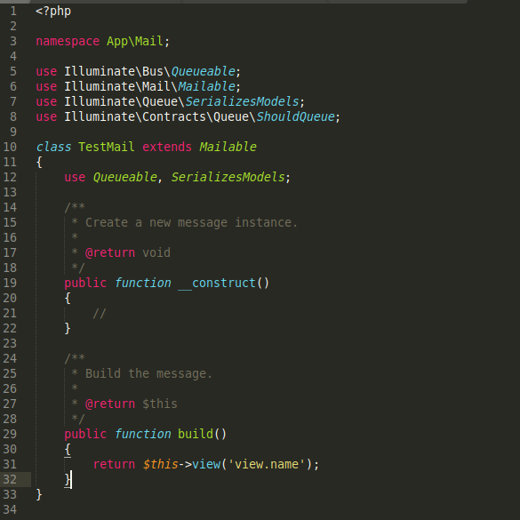
Deafult file will be looks like :

But For my convicence and according to my need i update this file like :

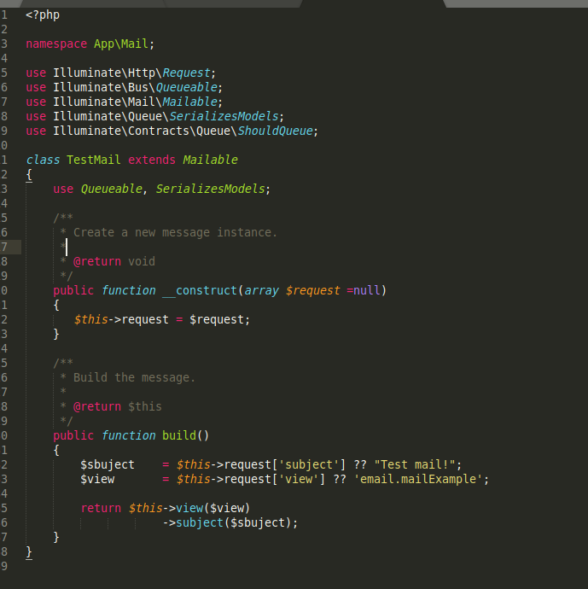

Here i use the Request parameters to make the dynamic view and subject for the email and also i set the default parameters to make it working fine.

I create a saparate folder email in view dicrectory for email templates. For testing purpose i crate a mailExample template here.

After that i created a MailController and to this request i create an action mail_queue(Request $request)
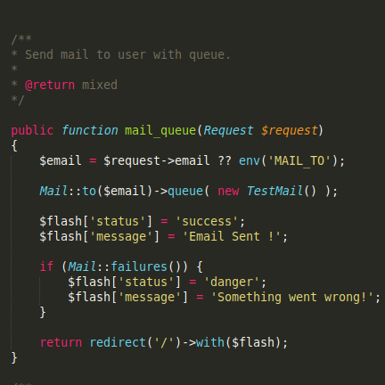

With this Mail::to(‘example@example.com’)->queue( new TestMail() ); a request is generated and create a new entry in jobs table.

To execute this job we have to run the queue:listen command if we not execute this command all these kind of job are on pending stage.

So thats why in local system we can exeute this command in terminal.

Or on staging we can write this command in Procfile on root directory.

We can also delay this emial with later method like:

Mail::to(‘example@example.com’)->later( $when , new TestMail() );

Here $when = now()->addMinutes(10);

2. Custom solution For Mail

With this method

