

**School of Computer Science and Engineering**

**Programme :** B.Tech(CSE)

**Course Title :** Image Processing

**Course Code :** CSE4019

**Slot :** E1

**Title: Image Cryptography**

**Team Members:**

Nagireddi Uday | 19BCE1317

**Faculty:** Dr. Geetha S **Sign:**

**Date:**

**Contents:**

1. Abstract
2. Introduction
3. Problem Statement
4. Methods
5. Results and Analysis
6. Conclusion
7. References
8. **Abstract**

During the past years the amazing developments in the field of network communications have created a great requirement for secure image transmission over the Internet. Since the Internet is a public network it is not so secure for the transmission of confidential images. Cryptographic techniques need to be applied to meet this challenge.

Today security is an integral part of every technology and implementation. Cryptography is perhaps the most widespread form of secure communication.

In this IT driven society Image protection has become an important issue for communication of digital images through the networks. Encryption is one of the ways to provide the security of digital images.

Image encryption techniques convert the original image to another image that is hard to understand. To keep the image confidential, it is essential that nobody could get to know the content without a key for decryption.

In this project we are implementing a few encryption algorithms such as Simple cryptography and Chaos Maps.

1. **Introduction**

Image protection has become an important issue for communication of digital images through the networks. The image cryptography is one of the practices employed for securing the information content of the image using strong encryption algorithms.

Encryption is one of the ways to provide the security of digital images. Image encryption techniques convert the original image to another image that is hard to understand. To keep the image confidential, it is essential that nobody could get to know the content without a key for decryption.

The image encryption is a way to transmit the image securely over the network so that no unauthorized or any unknown user is able to decrypt the image. Image encryption, video encryption have applications in many fields

including internet communication, transmission, military communication, etc.

1. **Problem Statement**

During the past years, the amazing developments in the field of network communications have created a great requirement for secure image transmission over the Internet.

Since the Internet is a public network it is not so secure for the transmission of confidential images. Cryptographic techniques need to be applied to meet this challenge.

Today security is an integral part of every technology and implementation. Cryptography is perhaps the most widespread form of secure communication.

In this IT-driven society Image protection has become an important issue for the communication of digital images through networks. Encryption is one of the ways to provide the security of digital images.

Image encryption techniques convert original images to another image that is hard to understand. To keep the image confidential, it is essential that nobody could get to know the content without a key for decryption.

1. **Methods**

**4.1 Simple Cryptography**

In simple cryptography we have Encryption and Decryption using simple algorithms. Encryption is nothing but a simple process in which we convert our image or information into an encrypted or unreadable mode to prevent it from unauthorized access and keep it private and secure. Similarly, Decryption is nothing but a process of converting our encrypted image or information into a viewable form.

**4.2 Chaos Maps**

Chaos-based image encryption, commonly known as a chaotic system, is an approach to encrypting an image that involves chaotic maps, which are rows of random numbers generated by a mathematical calculation with certain initial values. Chaotic systems are a simple sub-type of nonlinear dynamical systems. They may contain very few interacting parts and these may follow very simple rules, but these systems all have a very sensitive dependence on their initial conditions. Despite their deterministic simplicity, over time these systems can produce totally unpredictable and wildly divergent (aka, chaotic) behavior.

In Chaos Maps we are using two of its maps to encrypt and decrypt the image, i.e,

**Arnold Cat Map**

Arnold's Cat Map is a chaotic map often used for pixel manipulation. It randomizes the pixel positions in an image by stretching and folding the image. When an optimal number of iterations of the transformation is applied on the image, the resulting image becomes incomprehensible and hence encrypted.

For this implementation the transform applied on the image is:

R( [x,y] ) = [ (x + y) mod n, (x + 2y) mod n ]

* where n is the dimensions of the image

**Henon Map**

The Hénon map is a discrete-time dynamical system. It is one of the most studied examples of dynamical systems that exhibit chaotic behavior. The Hénon map takes a point (xn, yn) in the plane and maps it to a new point.

Given initial conditions (x0,y0), a henon map is given by the following equations:

(Xn+1) = (Yn) + 1 − a.(Xn)

(Yn+1) = b * (Xn)

The map depends on two parameters, a and b, which for the classical Hénon map have values of a = 1.4 and b = 0.3. For the classical values the Hénon map is chaotic. For other values of a and b the map may be chaotic, intermittent, or converge to a periodic orbit.

1. **Results and Analysis**

We are running the simple encryption algorithm and decryption algorithm rendering the image so that it cannot be viewed.

Input image: (naruto.png)



Image after running ‘python Encryption.py’,

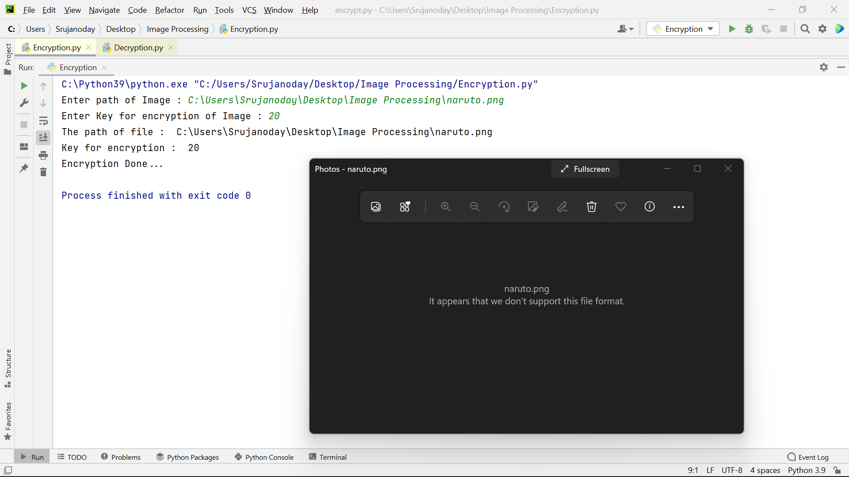

Image after running ‘python Decryption.py’,

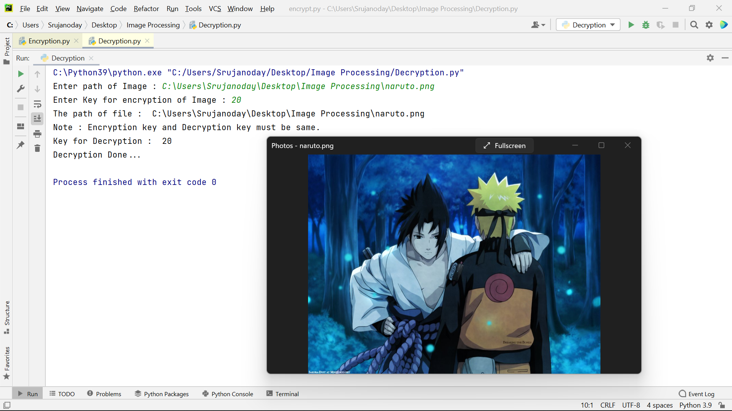

This is the output we got from Simple Encryption and Decryption.

Now we are viewing the output from Chaos Maps methods.

First is by using **Arnold Cat Map** method,

Input image,

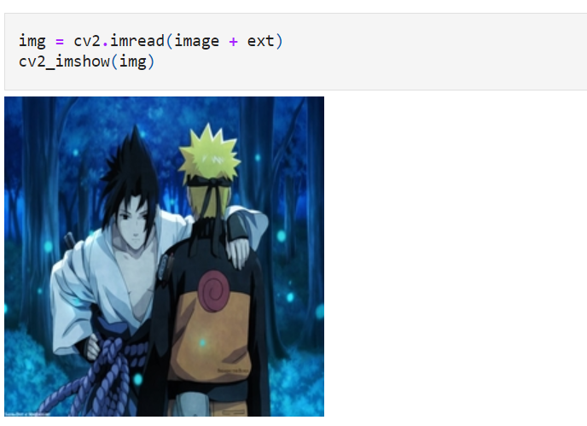

Image after Encryption,

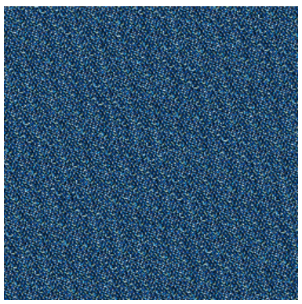

Image after Decryption,



Now we are using **Henon Map** method,

Input image,

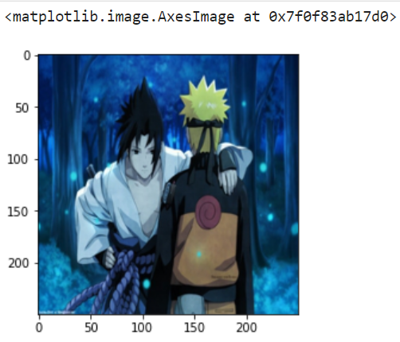

Image after encryption,

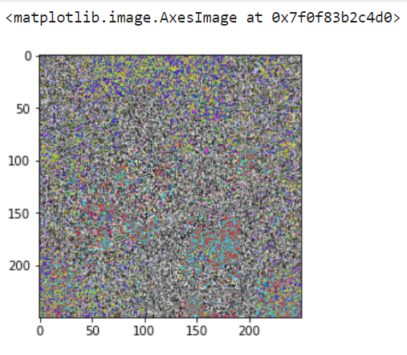

Image after decryption,

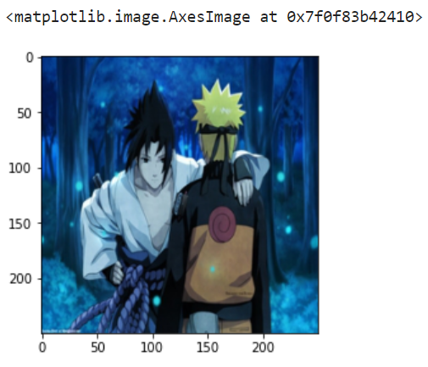

1. **Conclusion**

In this project, we encrypted and decrypted an image using different methods such as Simple Encryption and Decryption and Chaos Maps. It requires two things, data, and key, and when the required operation is applied on both the operands i.e data and key, the data gets encrypted but when the same process is done again with the same key-value data gets decrypted.

In this project, we are looking to find a way to send secure images across the internet for any purpose. We can find image cryptography being used in medical fields, military communication, online school exams, research fields, etc. All these fields use image cryptography just so that their competitors don’t get their hands on it and claim what’s not theirs.

1. **References**

* Survey on deep learning applications in digital image security | spiedigitallibrary.org <https://www.spiedigitallibrary.org/journals/optical-engineering/volume-60/issue-12/120901/Survey-on-deep-learning-applications-in-digital-image-security/10.1117/1.OE.60.12.120901.full?SSO=1>
* Secure Image Transmission Using Style Transfer | SpringerLink <https://link.springer.com/chapter/10.1007/978-981-16-3690-5_63>
* A New Algorithm for Digital Image Encryption Based on Chaos Theory <https://doi.org/10.3390/e23030341>
* Contrast-Enhanced Color Visual Cryptography for (k, n) Threshold Schemes | ACM Transactions on Multimedia Computing, Communications, and Applications <https://dl.acm.org/doi/abs/10.1145/3508394>
* A Survey on Image Encryption using Chaos-based Techniques |(IJACSA) International Journal of Advanced Computer Science and Applications <https://www.proquest.com/openview/9152c699e21701ef526aafa2470a9431/1?pq-origsite=gscholar&cbl=5444811>