Today we had a quick review on UNIX and its commands. We used VIM and GIT Bash to try using the commands.

The topics we covered were file management, directories, file permission, environment, basic utilities.

Apart form that we used nano and vi editor to edit and write into the files.

While we were using GIT Bash chmod command was not working because of some permission issues hence we downloaded the ubuntu to perform the commands.

Later we used this learned knowledge to complete a set of 5 tasks given by the instructor. I am pasting the images of the said done tasks.

* Task 1 and Task 2

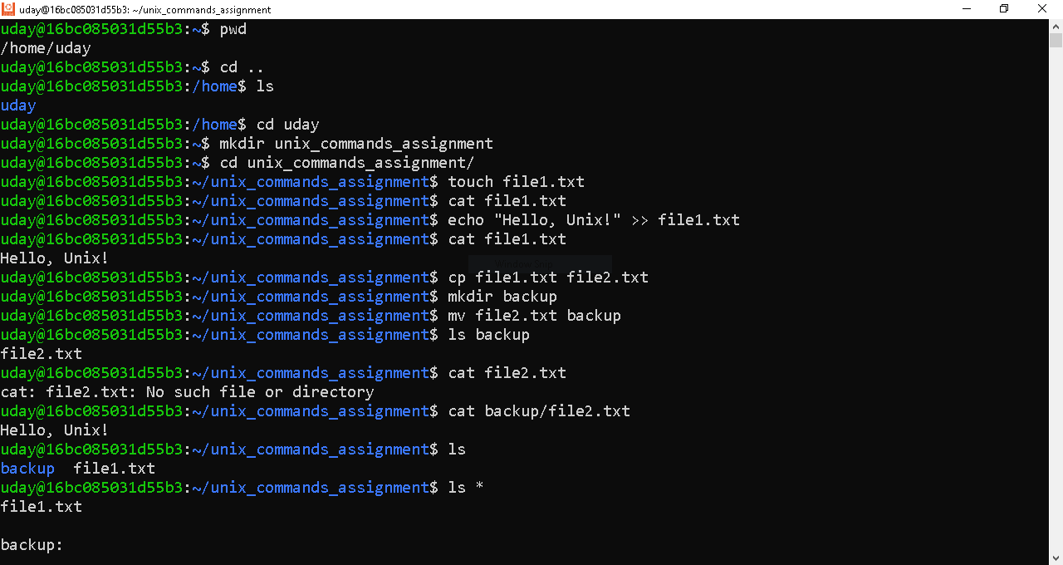

* Task 3

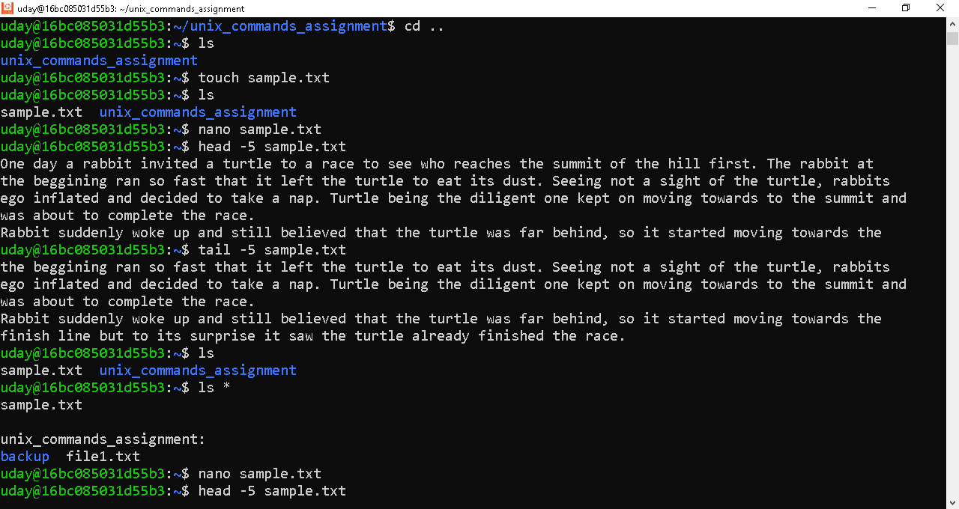

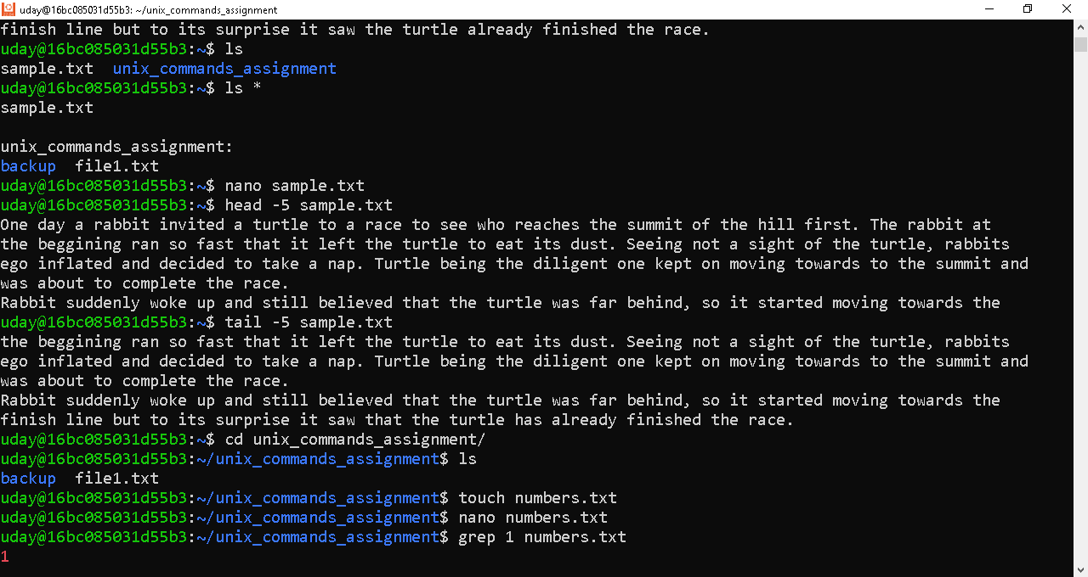

* Task 4

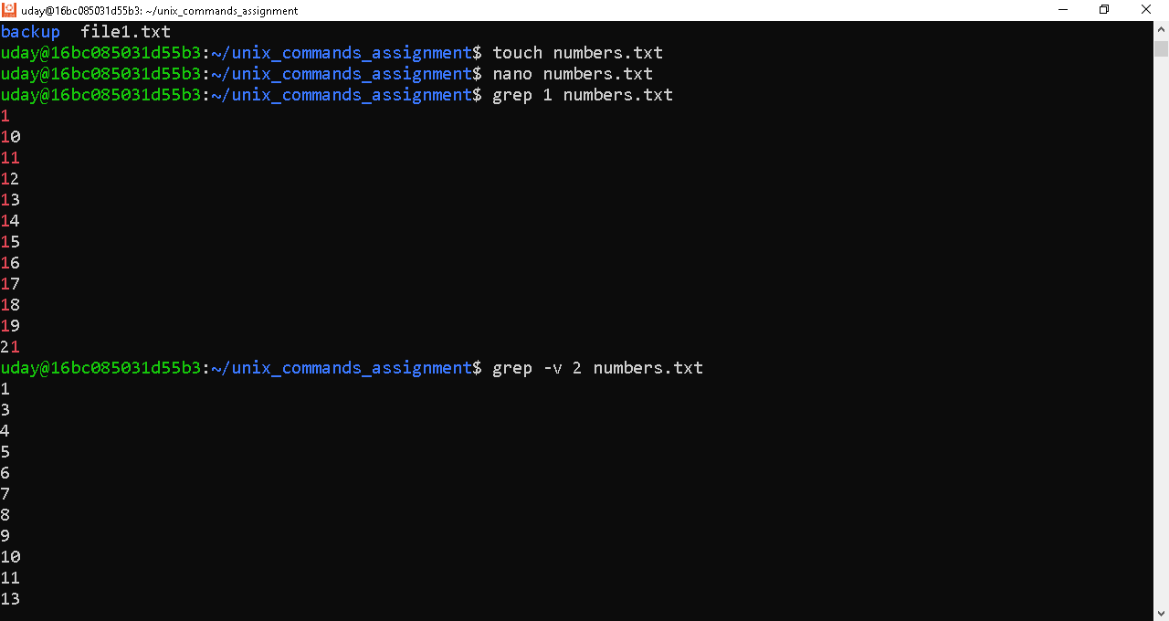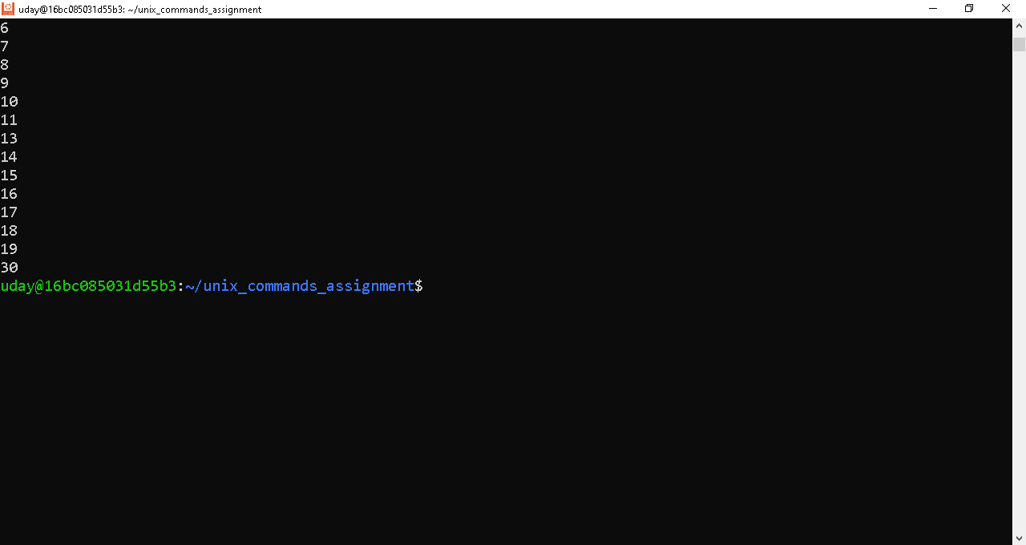

* Task 5

Task5