**สะบันงา นวดแผนไทย&สปา**

[**ที่อยู่**](https://www.google.com/search?rlz=1C1SQJL_thTH824TH824&q=%E0%B8%AA%E0%B8%B0%E0%B8%9A%E0%B8%B1%E0%B8%99%E0%B8%87%E0%B8%B2+%E0%B8%99%E0%B8%A7%E0%B8%94%E0%B9%81%E0%B8%9C%E0%B8%99%E0%B9%84%E0%B8%97%E0%B8%A2%26%E0%B8%AA%E0%B8%9B%E0%B8%B2+%E0%B8%AD%E0%B8%B3%E0%B9%80%E0%B8%A0%E0%B8%AD%E0%B9%80%E0%B8%A1%E0%B8%B7%E0%B8%AD%E0%B8%87%E0%B8%99%E0%B8%84%E0%B8%A3%E0%B8%A8%E0%B8%A3%E0%B8%B5%E0%B8%98%E0%B8%A3%E0%B8%A3%E0%B8%A1%E0%B8%A3%E0%B8%B2%E0%B8%8A+%E0%B8%97%E0%B8%B5%E0%B9%88%E0%B8%AD%E0%B8%A2%E0%B8%B9%E0%B9%88&stick=H4sIAAAAAAAAAD2MPQuCYBSFaQgaoqE9cGpokRr9N6IRpShl0JoQGM2BfQ31OhRBUIZ03n9zfkp6g5bDcy_nOY1Wu2mOzP7A96eThRf0Op5jmX7o2PNxGPzBsl13NowiVU9rxJ14EgfiReyJhMgNoSuxpY6JU3XqFZESqivG8dd6EG_qJXGuuIIL8ZF_IhullBE3yYLYCWRSKzMnNobMFtRr0RShS_4CQrpmecoAAAA&ludocid=9218172652218481966&sa=X&ved=2ahUKEwjm4OqszubjAhVFvI8KHU6DA1QQ6BMwA3oECAEQIQ)**:**ซอย วันดีโฆษิตกุลพร เมือง อำเภอเมืองนครศรีธรรมราช นครศรีธรรมราช 80000

[**ชั่วโมง**](https://www.google.com/search?rlz=1C1SQJL_thTH824TH824&q=%E0%B8%AA%E0%B8%B0%E0%B8%9A%E0%B8%B1%E0%B8%99%E0%B8%87%E0%B8%B2+%E0%B8%99%E0%B8%A7%E0%B8%94%E0%B9%81%E0%B8%9C%E0%B8%99%E0%B9%84%E0%B8%97%E0%B8%A2%26%E0%B8%AA%E0%B8%9B%E0%B8%B2+%E0%B8%AD%E0%B8%B3%E0%B9%80%E0%B8%A0%E0%B8%AD%E0%B9%80%E0%B8%A1%E0%B8%B7%E0%B8%AD%E0%B8%87%E0%B8%99%E0%B8%84%E0%B8%A3%E0%B8%A8%E0%B8%A3%E0%B8%B5%E0%B8%98%E0%B8%A3%E0%B8%A3%E0%B8%A1%E0%B8%A3%E0%B8%B2%E0%B8%8A+%E0%B8%8A%E0%B8%B1%E0%B9%88%E0%B8%A7%E0%B9%82%E0%B8%A1%E0%B8%87&ludocid=9218172652218481966&sa=X&ved=2ahUKEwjm4OqszubjAhVFvI8KHU6DA1QQ6BMwBXoECAEQNQ)**: เปิด** ⋅ ปิด 20:00

|  |  |
| --- | --- |
|  |  |
|  |  |
|  |  |
|  |  |
|  |  |
|  |  |
|  |  |

[**โทรศัพท์**](https://www.google.com/search?rlz=1C1SQJL_thTH824TH824&q=%E0%B8%AA%E0%B8%B0%E0%B8%9A%E0%B8%B1%E0%B8%99%E0%B8%87%E0%B8%B2+%E0%B8%99%E0%B8%A7%E0%B8%94%E0%B9%81%E0%B8%9C%E0%B8%99%E0%B9%84%E0%B8%97%E0%B8%A2%26%E0%B8%AA%E0%B8%9B%E0%B8%B2+%E0%B8%AD%E0%B8%B3%E0%B9%80%E0%B8%A0%E0%B8%AD%E0%B9%80%E0%B8%A1%E0%B8%B7%E0%B8%AD%E0%B8%87%E0%B8%99%E0%B8%84%E0%B8%A3%E0%B8%A8%E0%B8%A3%E0%B8%B5%E0%B8%98%E0%B8%A3%E0%B8%A3%E0%B8%A1%E0%B8%A3%E0%B8%B2%E0%B8%8A+%E0%B9%82%E0%B8%97%E0%B8%A3%E0%B8%A8%E0%B8%B1%E0%B8%9E%E0%B8%97%E0%B9%8C&ludocid=9218172652218481966&sa=X&ved=2ahUKEwjm4OqszubjAhVFvI8KHU6DA1QQ6BMwBnoECAEQPQ)**:**089 971 9201

**ภาพประกอบ**

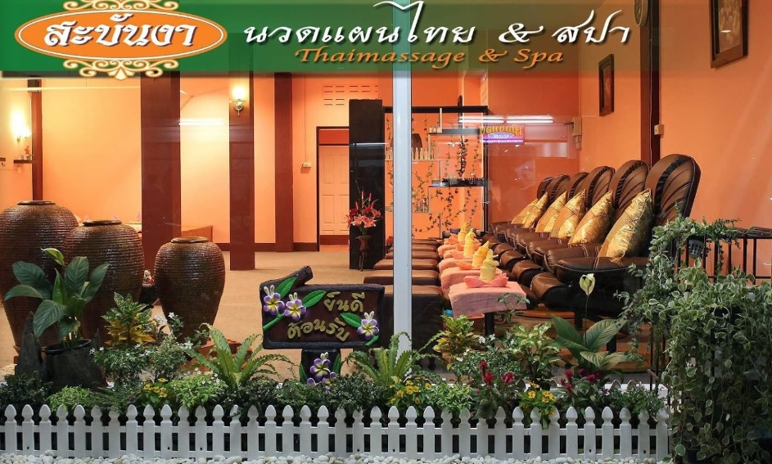

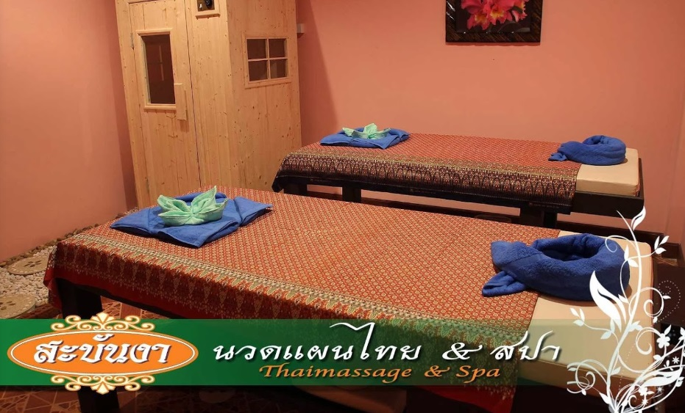

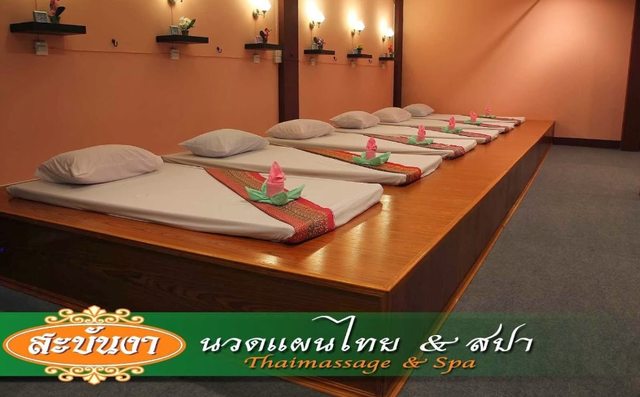

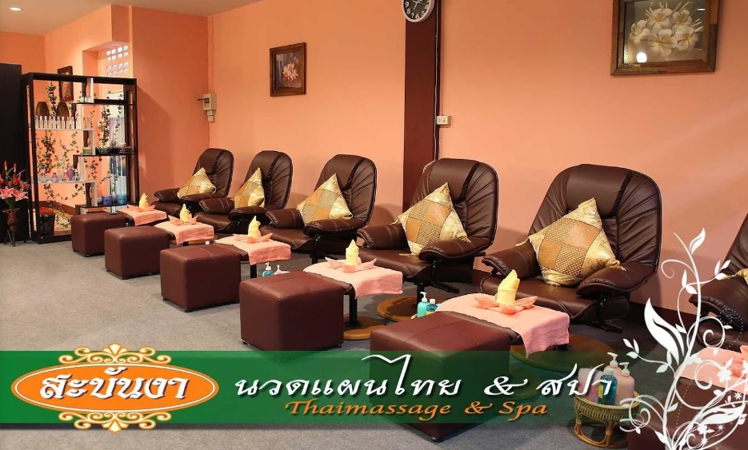

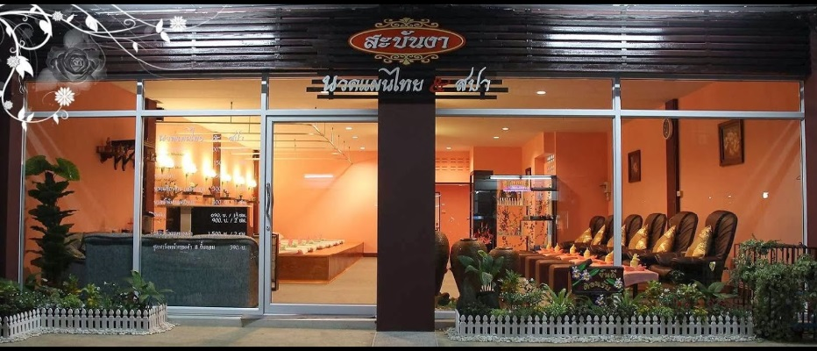

**สวคนธ์สปา | สปา นครศรีธรรมราช นวดแผนไทย อยู่ไฟโบราณ**

[**ที่อยู่**](https://www.google.com/search?rlz=1C1SQJL_thTH824TH824&q=%E0%B8%AA%E0%B8%A7%E0%B8%84%E0%B8%99%E0%B8%98%E0%B9%8C%E0%B8%AA%E0%B8%9B%E0%B8%B2+%7C+%E0%B8%AA%E0%B8%9B%E0%B8%B2+%E0%B8%99%E0%B8%84%E0%B8%A3%E0%B8%A8%E0%B8%A3%E0%B8%B5%E0%B8%98%E0%B8%A3%E0%B8%A3%E0%B8%A1%E0%B8%A3%E0%B8%B2%E0%B8%8A+%E0%B8%99%E0%B8%A7%E0%B8%94%E0%B9%81%E0%B8%9C%E0%B8%99%E0%B9%84%E0%B8%97%E0%B8%A2+%E0%B8%AD%E0%B8%A2%E0%B8%B9%E0%B9%88%E0%B9%84%E0%B8%9F%E0%B9%82%E0%B8%9A%E0%B8%A3%E0%B8%B2%E0%B8%93+%E0%B8%A3%E0%B9%88%E0%B8%AD%E0%B8%99%E0%B8%9E%E0%B8%B4%E0%B8%9A%E0%B8%B9%E0%B8%A5%E0%B8%A2%E0%B9%8C+%E0%B8%97%E0%B8%B5%E0%B9%88%E0%B8%AD%E0%B8%A2%E0%B8%B9%E0%B9%88&stick=H4sIAAAAAAAAAOPgE-LVT9c3NEwyLc_NM64y0JLNTrbSz8lPTizJzM-DM6wSU1KKUouLF7EeZXywY9WDHcsf7Gh5sGPmgx0zHuzsAYvMfrBjk0KNAoINlgYqWvxgxwowuRWkGsQAooVgctODHV0QdUDzpjzY2fhgxxwQdydQ2_QHOxYB5dYCqQc7dj7Y2QEWnf9gZ9ODHbNguicrgFhAOZA6oDHzHuzYApbe-WDHUpDOnT0KYKO2whRBDQMAfjjEU_kAAAA&ludocid=17003880550609144804&sa=X&ved=2ahUKEwiHlseb0ubjAhUDuo8KHRhDA_8Q6BMwA3oECAEQIQ)**:**438 ม.2 เสาธง ร่อนพิบูลย์ นครศรีธรรมราช 80130

[**ชั่วโมง**](https://www.google.com/search?rlz=1C1SQJL_thTH824TH824&q=%E0%B8%AA%E0%B8%A7%E0%B8%84%E0%B8%99%E0%B8%98%E0%B9%8C%E0%B8%AA%E0%B8%9B%E0%B8%B2+%7C+%E0%B8%AA%E0%B8%9B%E0%B8%B2+%E0%B8%99%E0%B8%84%E0%B8%A3%E0%B8%A8%E0%B8%A3%E0%B8%B5%E0%B8%98%E0%B8%A3%E0%B8%A3%E0%B8%A1%E0%B8%A3%E0%B8%B2%E0%B8%8A+%E0%B8%99%E0%B8%A7%E0%B8%94%E0%B9%81%E0%B8%9C%E0%B8%99%E0%B9%84%E0%B8%97%E0%B8%A2+%E0%B8%AD%E0%B8%A2%E0%B8%B9%E0%B9%88%E0%B9%84%E0%B8%9F%E0%B9%82%E0%B8%9A%E0%B8%A3%E0%B8%B2%E0%B8%93+%E0%B8%A3%E0%B9%88%E0%B8%AD%E0%B8%99%E0%B8%9E%E0%B8%B4%E0%B8%9A%E0%B8%B9%E0%B8%A5%E0%B8%A2%E0%B9%8C+%E0%B8%8A%E0%B8%B1%E0%B9%88%E0%B8%A7%E0%B9%82%E0%B8%A1%E0%B8%87&ludocid=17003880550609144804&sa=X&ved=2ahUKEwiHlseb0ubjAhUDuo8KHRhDA_8Q6BMwBXoECAEQNQ)**: ปิด** ⋅ เปิด 08:30 อา.

|  |  |
| --- | --- |
|  |  |
|  |  |
|  |  |
|  |  |
|  |  |
|  |  |
|  |  |

[**โทรศัพท์**](https://www.google.com/search?rlz=1C1SQJL_thTH824TH824&q=%E0%B8%AA%E0%B8%A7%E0%B8%84%E0%B8%99%E0%B8%98%E0%B9%8C%E0%B8%AA%E0%B8%9B%E0%B8%B2+%7C+%E0%B8%AA%E0%B8%9B%E0%B8%B2+%E0%B8%99%E0%B8%84%E0%B8%A3%E0%B8%A8%E0%B8%A3%E0%B8%B5%E0%B8%98%E0%B8%A3%E0%B8%A3%E0%B8%A1%E0%B8%A3%E0%B8%B2%E0%B8%8A+%E0%B8%99%E0%B8%A7%E0%B8%94%E0%B9%81%E0%B8%9C%E0%B8%99%E0%B9%84%E0%B8%97%E0%B8%A2+%E0%B8%AD%E0%B8%A2%E0%B8%B9%E0%B9%88%E0%B9%84%E0%B8%9F%E0%B9%82%E0%B8%9A%E0%B8%A3%E0%B8%B2%E0%B8%93+%E0%B8%A3%E0%B9%88%E0%B8%AD%E0%B8%99%E0%B8%9E%E0%B8%B4%E0%B8%9A%E0%B8%B9%E0%B8%A5%E0%B8%A2%E0%B9%8C+%E0%B9%82%E0%B8%97%E0%B8%A3%E0%B8%A8%E0%B8%B1%E0%B8%9E%E0%B8%97%E0%B9%8C&ludocid=17003880550609144804&sa=X&ved=2ahUKEwiHlseb0ubjAhUDuo8KHRhDA_8Q6BMwBnoECAEQPQ)**:**089 651 0024

**ภาพประกอบ**

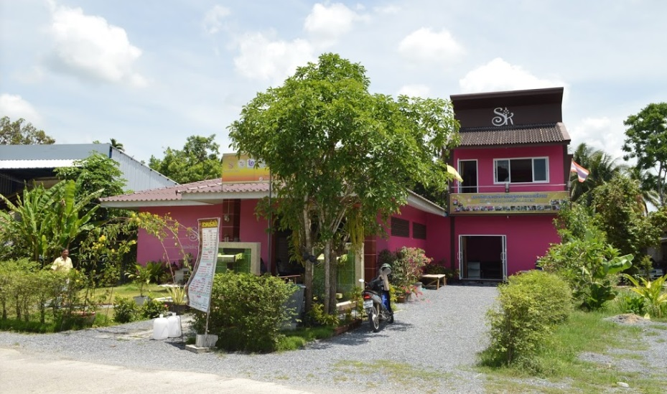

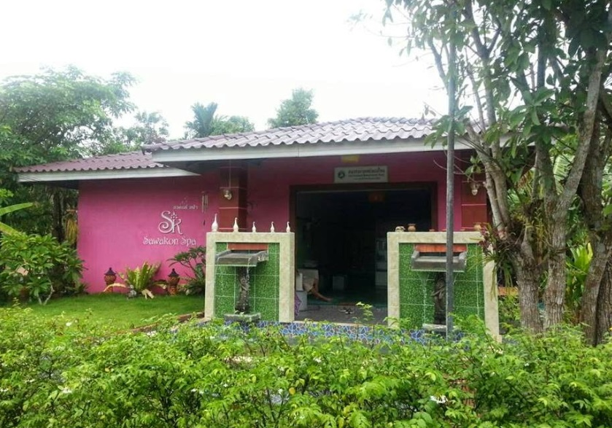

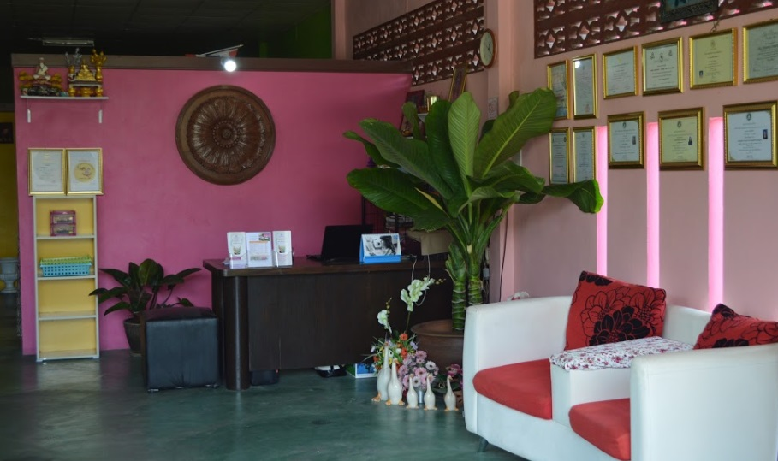

**ร้านภัทรลดา นวดแผนไทย&สปา**

[**ที่อยู่**](https://www.google.com/search?rlz=1C1SQJL_thTH824TH824&q=%E0%B8%A3%E0%B9%89%E0%B8%B2%E0%B8%99%E0%B8%A0%E0%B8%B1%E0%B8%97%E0%B8%A3%E0%B8%A5%E0%B8%94%E0%B8%B2+%E0%B8%99%E0%B8%A7%E0%B8%94%E0%B9%81%E0%B8%9C%E0%B8%99%E0%B9%84%E0%B8%97%E0%B8%A2%26%E0%B8%AA%E0%B8%9B%E0%B8%B2+%E0%B8%AD%E0%B8%B3%E0%B9%80%E0%B8%A0%E0%B8%AD%E0%B9%80%E0%B8%A1%E0%B8%B7%E0%B8%AD%E0%B8%87%E0%B8%99%E0%B8%84%E0%B8%A3%E0%B8%A8%E0%B8%A3%E0%B8%B5%E0%B8%98%E0%B8%A3%E0%B8%A3%E0%B8%A1%E0%B8%A3%E0%B8%B2%E0%B8%8A+%E0%B8%97%E0%B8%B5%E0%B9%88%E0%B8%AD%E0%B8%A2%E0%B8%B9%E0%B9%88&stick=H4sIAAAAAAAAAOPgE-LVT9c3NEwzy8soio-v0JLNTrbSz8lPTizJzM-DM6wSU1KKUouLF7EuZnywY_GDnZ0Pdmx6sGPmgx0LHuzY-GDHdJDgjqUPdkwBiiuAJZaDODsbH-yYA-LubAErWqT2YMeqBztmQ1StfbBj84OdDWBD1oIZCx_s2A4Wbweb0QI2dgWY3PpgxwwwYzFY2WKwA7oUwMZufbCzA6xt0YMdO4FsAP6UwpDXAAAA&ludocid=5651224985595101637&sa=X&ved=2ahUKEwjfppb-0-bjAhWKMY8KHUfrCecQ6BMwA3oECAEQIQ)**:**6 ด้านหน้าโรงแรมทวิลโลตัส 12 ถนน พัฒนาการคูขวาง ตำบล ในเมือง อำเภอเมืองนครศรีธรรมราช นครศรีธรรมราช 80000

[**ชั่วโมง**](https://www.google.com/search?rlz=1C1SQJL_thTH824TH824&q=%E0%B8%A3%E0%B9%89%E0%B8%B2%E0%B8%99%E0%B8%A0%E0%B8%B1%E0%B8%97%E0%B8%A3%E0%B8%A5%E0%B8%94%E0%B8%B2+%E0%B8%99%E0%B8%A7%E0%B8%94%E0%B9%81%E0%B8%9C%E0%B8%99%E0%B9%84%E0%B8%97%E0%B8%A2%26%E0%B8%AA%E0%B8%9B%E0%B8%B2+%E0%B8%AD%E0%B8%B3%E0%B9%80%E0%B8%A0%E0%B8%AD%E0%B9%80%E0%B8%A1%E0%B8%B7%E0%B8%AD%E0%B8%87%E0%B8%99%E0%B8%84%E0%B8%A3%E0%B8%A8%E0%B8%A3%E0%B8%B5%E0%B8%98%E0%B8%A3%E0%B8%A3%E0%B8%A1%E0%B8%A3%E0%B8%B2%E0%B8%8A+%E0%B8%8A%E0%B8%B1%E0%B9%88%E0%B8%A7%E0%B9%82%E0%B8%A1%E0%B8%87&ludocid=5651224985595101637&sa=X&ved=2ahUKEwjfppb-0-bjAhWKMY8KHUfrCecQ6BMwBXoECAEQNQ)**: เปิด** ⋅ ปิด 22:00

|  |  |
| --- | --- |
|  |  |
|  |  |
|  |  |
|  |  |
|  |  |
|  |  |
|  |  |

[**โทรศัพท์**](https://www.google.com/search?rlz=1C1SQJL_thTH824TH824&q=%E0%B8%A3%E0%B9%89%E0%B8%B2%E0%B8%99%E0%B8%A0%E0%B8%B1%E0%B8%97%E0%B8%A3%E0%B8%A5%E0%B8%94%E0%B8%B2+%E0%B8%99%E0%B8%A7%E0%B8%94%E0%B9%81%E0%B8%9C%E0%B8%99%E0%B9%84%E0%B8%97%E0%B8%A2%26%E0%B8%AA%E0%B8%9B%E0%B8%B2+%E0%B8%AD%E0%B8%B3%E0%B9%80%E0%B8%A0%E0%B8%AD%E0%B9%80%E0%B8%A1%E0%B8%B7%E0%B8%AD%E0%B8%87%E0%B8%99%E0%B8%84%E0%B8%A3%E0%B8%A8%E0%B8%A3%E0%B8%B5%E0%B8%98%E0%B8%A3%E0%B8%A3%E0%B8%A1%E0%B8%A3%E0%B8%B2%E0%B8%8A+%E0%B9%82%E0%B8%97%E0%B8%A3%E0%B8%A8%E0%B8%B1%E0%B8%9E%E0%B8%97%E0%B9%8C&ludocid=5651224985595101637&sa=X&ved=2ahUKEwjfppb-0-bjAhWKMY8KHUfrCecQ6BMwBnoECAEQPQ)**:**075 841 099

**ภาพประกอบ**



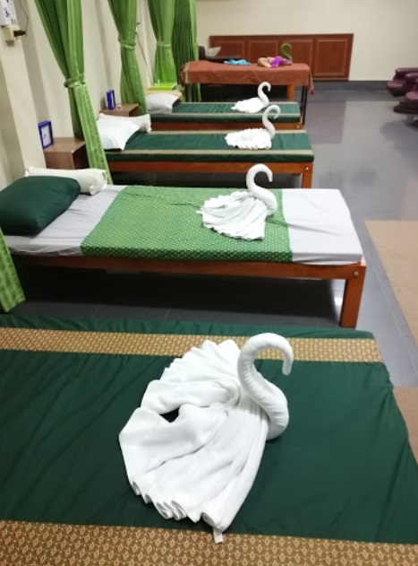

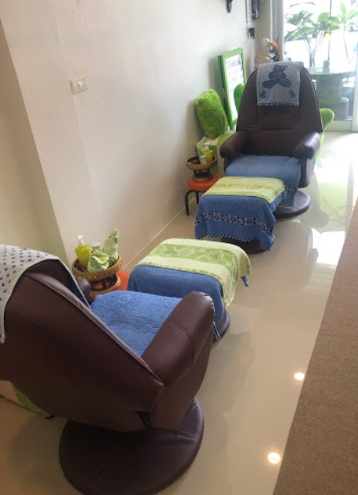

**มะลิ Thaimassage&Spa**

[**ที่อยู่**](https://www.google.com/search?rlz=1C1SQJL_thTH824TH824&q=%E0%B8%A1%E0%B8%B0%E0%B8%A5%E0%B8%B4+thaimassage%26spa+%E0%B8%AD%E0%B8%B3%E0%B9%80%E0%B8%A0%E0%B8%AD+%E0%B9%80%E0%B8%A1%E0%B8%B7%E0%B8%AD%E0%B8%87%E0%B8%99%E0%B8%84%E0%B8%A3%E0%B8%A8%E0%B8%A3%E0%B8%B5%E0%B8%98%E0%B8%A3%E0%B8%A3%E0%B8%A1%E0%B8%A3%E0%B8%B2%E0%B8%8A+%E0%B8%97%E0%B8%B5%E0%B9%88%E0%B8%AD%E0%B8%A2%E0%B8%B9%E0%B9%88&stick=H4sIAAAAAAAAAOPgE-LVT9c3NExPriqwzDVI0ZLNTrbSz8lPTizJzM-DM6wSU1KKUouLF7FWPtix8MGODQ92LH2wY4tCSUZiZm5icXFieqpacUGiwoMdax_s2PxgZ8ODHQuAbAUwC6h-O1ii_cGOmQ92tDzYsfjBjhVgcuuDHTPAjMVgZUBy04MdXUBjpoPkdnaAtS16sGMnkA0A8exWGqwAAAA&ludocid=2652067682459832022&sa=X&ved=2ahUKEwiIv_2x1ebjAhUMKY8KHZtfCJYQ6BMwA3oECAEQIg)**:**โรบินสัน โอเชี่ยน นครศรีธรรมราช 89/201 ถนน พัฒนาการคูขวาง ตำบล คลัง อำเภอ เมืองนครศรีธรรมราช นครศรีธรรมราช 80000

[**ชั่วโมง**](https://www.google.com/search?rlz=1C1SQJL_thTH824TH824&q=%E0%B8%A1%E0%B8%B0%E0%B8%A5%E0%B8%B4+thaimassage%26spa+%E0%B8%AD%E0%B8%B3%E0%B9%80%E0%B8%A0%E0%B8%AD+%E0%B9%80%E0%B8%A1%E0%B8%B7%E0%B8%AD%E0%B8%87%E0%B8%99%E0%B8%84%E0%B8%A3%E0%B8%A8%E0%B8%A3%E0%B8%B5%E0%B8%98%E0%B8%A3%E0%B8%A3%E0%B8%A1%E0%B8%A3%E0%B8%B2%E0%B8%8A+%E0%B8%8A%E0%B8%B1%E0%B9%88%E0%B8%A7%E0%B9%82%E0%B8%A1%E0%B8%87&ludocid=2652067682459832022&sa=X&ved=2ahUKEwiIv_2x1ebjAhUMKY8KHZtfCJYQ6BMwBXoECAEQNg)**: เปิด** ⋅ ปิด 21:00

|  |  |
| --- | --- |
|  |  |
|  |  |
|  |  |
|  |  |
|  |  |
|  |  |
|  |  |

[**โทรศัพท์**](https://www.google.com/search?rlz=1C1SQJL_thTH824TH824&q=%E0%B8%A1%E0%B8%B0%E0%B8%A5%E0%B8%B4+thaimassage%26spa+%E0%B8%AD%E0%B8%B3%E0%B9%80%E0%B8%A0%E0%B8%AD+%E0%B9%80%E0%B8%A1%E0%B8%B7%E0%B8%AD%E0%B8%87%E0%B8%99%E0%B8%84%E0%B8%A3%E0%B8%A8%E0%B8%A3%E0%B8%B5%E0%B8%98%E0%B8%A3%E0%B8%A3%E0%B8%A1%E0%B8%A3%E0%B8%B2%E0%B8%8A+%E0%B9%82%E0%B8%97%E0%B8%A3%E0%B8%A8%E0%B8%B1%E0%B8%9E%E0%B8%97%E0%B9%8C&ludocid=2652067682459832022&sa=X&ved=2ahUKEwiIv_2x1ebjAhUMKY8KHZtfCJYQ6BMwBnoECAEQPg)**:**061 235 6364

**ภาพประกอบ**

