

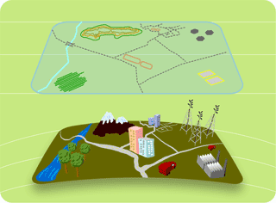

Spatial Operations Tutorial for uDig Framework
Reusing Existent Spatial Process
Integrating Sextante

Duration:60 minutes

Author | Details | Date
Aritz Davila | Initial version | 03/15/2010
Mauricio Pazos | General document review | 04/29/2010

Table of Contents
1 Introduction 4
2 Goal 5
3 Setting the Development Environment 6
3.1 Setting Eclipse 6
3.2 Adding the Spatial Operation Framework 8
3.3 Testing the Development Environment 9
4 Creating a New Plugin Project 12
5 Extension for Spatial Operations 14
6 Developing the LineToPolygon Spatial Operation 16
7 Writing the LineToPolygon Operation 18
7.1 SOLineToPolygonComposite class 22
7.2 LineToPolygonImages class 23
7.3 LineToPolygonCommand class 24
7.4 Adding Sextante 32
7.5 LineToPolygonTask class 33
8 Executing the LineToPolygon Spatial Operations 36
9 Contact 38

Introduction
This document is a description of how third parties can contribute to the Spatial Operations framework.
The Spatial Operations framework, promoted by Gipuzkoa Provincial Council - Mobility and Land Planning Department, provides a template where the spatial operations can be displayed and executed. It is integrated into uDig.
In this tutorial it is assumed that you know the uDig framework and your Eclipse environment is configured with uDig SDK. You can find good documents in the uDig Developers page.
The following figure presents the Spatial Operations view.
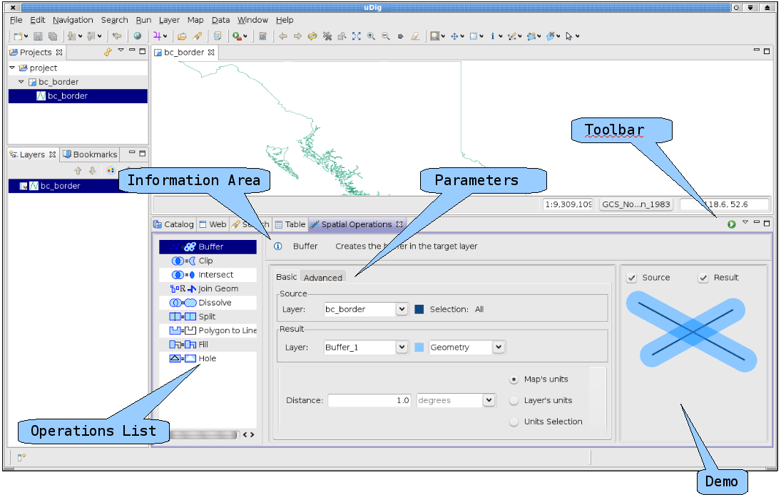
We can see the following panels:
- Operations List: shows a set of available spatial operations.
- Information Area: displays a message in order to guide in the spatial operation settings.
- Parameters: This panel presents the parameters required by the selected spatial operation in the Operations List.
- Demo: Provides feedback about the result of the selected spatial operation based in the parameters value.
- Tool Bar: Provides the actions that can be applied.

Goal
In this tutorial we will reuse the spatial operation LineToPolygon from www.sextantegis.com project. Sextante was developed under the auspices of the government of the Spanish autonomous region of Extremadura. We will use the default behavior implemented by SimplePresenter and SimpleCommand which are provided by the Spatial Operations framework.
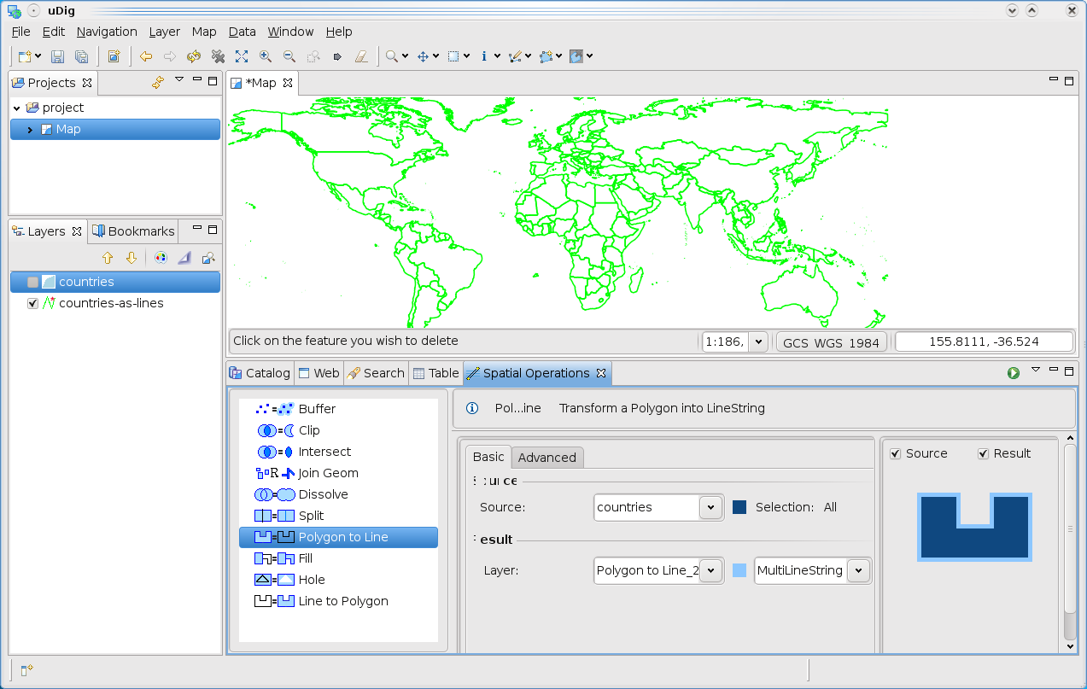
Suppose that you have the country boundaries as shown below:
We will include the LineToPolygon operation as shown in the following screenshot, which could be used to create a polygon layer based in the country boundaries.
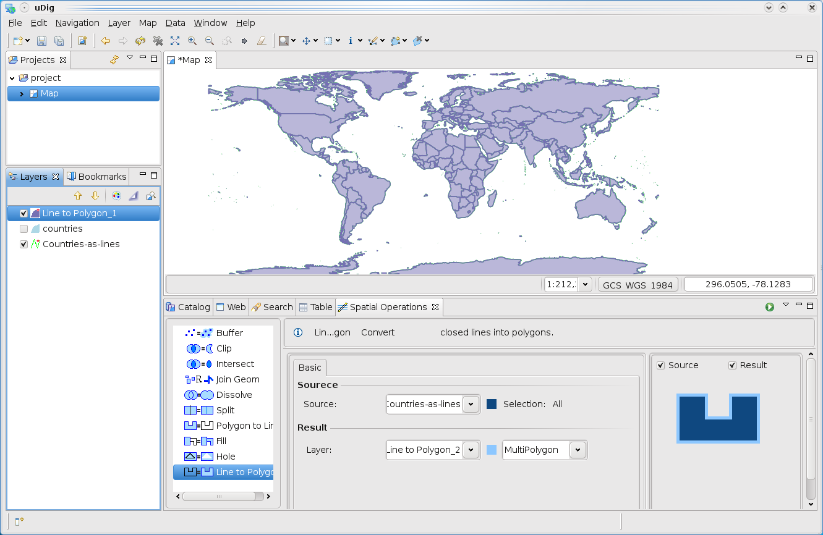

Setting the Development Environment
This tutorial was written for the following platform.
- uDig 1.2.x SDK
- Spatial Operations SDK 1.3.x
- Eclipse Platform 3.5.2

Setting Eclipse

- Include the uDig 1.2 SDK in your Eclipse environment as described in the uDig SDK Quick Start. It's a good idea to execute the uDig product (in net.refraction.udig) in order to test your environment.

- Download es.axios.udig.spatialoperations-1.3.x-sdk.zip from our download page in www.axios.es

- Create a new directory or folder like:
mkdir INSTALL_DIR/java/target/udig-spatialoperations-sdk
- Unpack the spatial operations SDK in that directory.
unzip es.axios.udig.spatialoperations-sdk-1.3.x.zip
You should have the following files:
INSTALL_DIR/java/target/udig-spatialoperations-sdk/features/
es.axios.udig.spatialoperations.sdk_1.3.0.m4.jar
es.axios.udig.spatialoperations.sdk.source_1.3.0.m4.jar

INSTALL_DIR/java/target/udig-spatialoperations-sdk/plugins/
es.axios.udig.extensions_1.3.0.m4.jar
es.axios.udig.extensions.source_1.3.0.m4.jar
es.axios.udig.ui.commons_1.3.0.m4.jar
es.axios.udig.ui.commons.source_1.3.0.m4.jar
es.axios.udig.ui.spatialoperations_1.3.0.m4.jar
es.axios.udig.ui.spatialoperations.source_1.3.0.m4.jar

- This document describes the most relevant function, but it does not provide details about some utility methods. Thus, the source code for this tutorial is provided to avoid you to write that code. To accomplish this tutorial without pains, you can download the axios-sextante plug-in sources from the mentioned download page.

Adding the Spatial Operation Framework

Open the Eclipse Preferences Dialog: Window > Preferences > Plug-in Development > Target Platform.
If you have followed the uDig SDK Quick Start document you should have uDig SDK as Target Platform, so select it and press the Edit button. In the Locations tab you should have the following target definition.
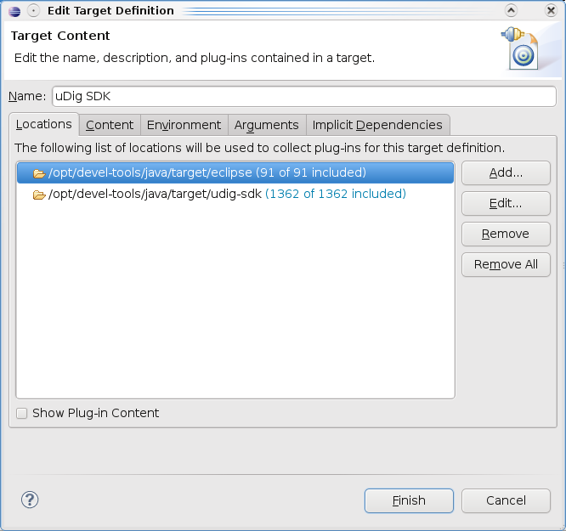
To add the Spatial Operations SDK, press the Add button, then select the directory, where it was installed. In this case:
INSTALL_DIR/java/target/udig-spatialoperations-sdk
Now, you will get the following target configuration:
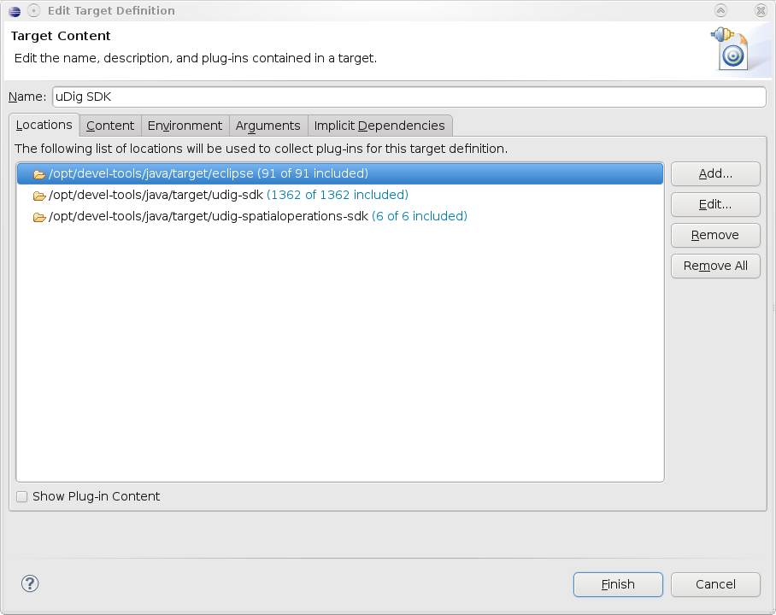

Testing the Development Environment
To test your environment you need to open the Eclipse Run Dialog, and create a run configuration in Eclipse Application. Be sure that the Run a Product radio button is checked and net.refractions.udig.product is selected.
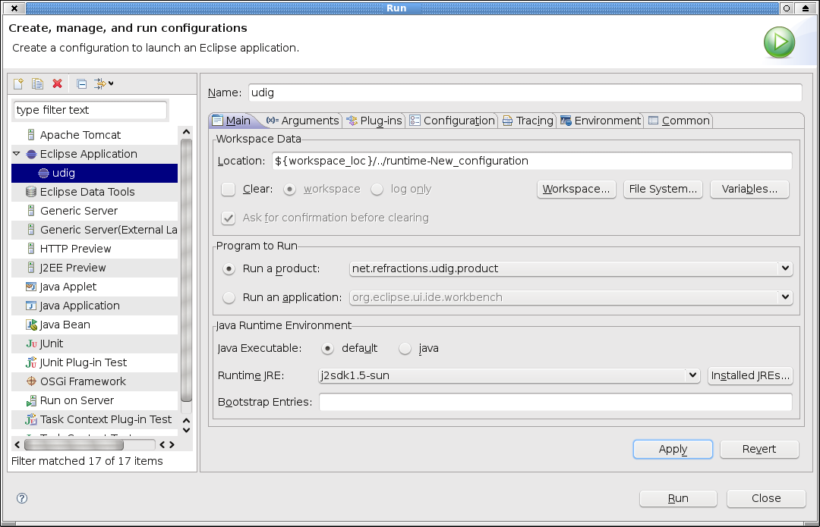

Be sure that the es.axios.udig.* plugins are checked in the Plug-ins tab in the uDig Run Configurations.

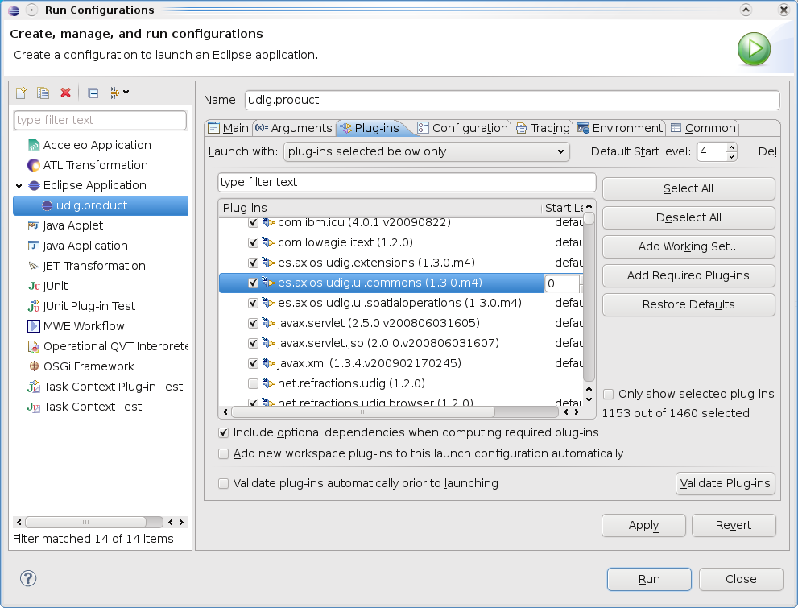
At this point everything is ready to test uDig with spatial operations.
- Press the Run button. The uDig main window should be shown.
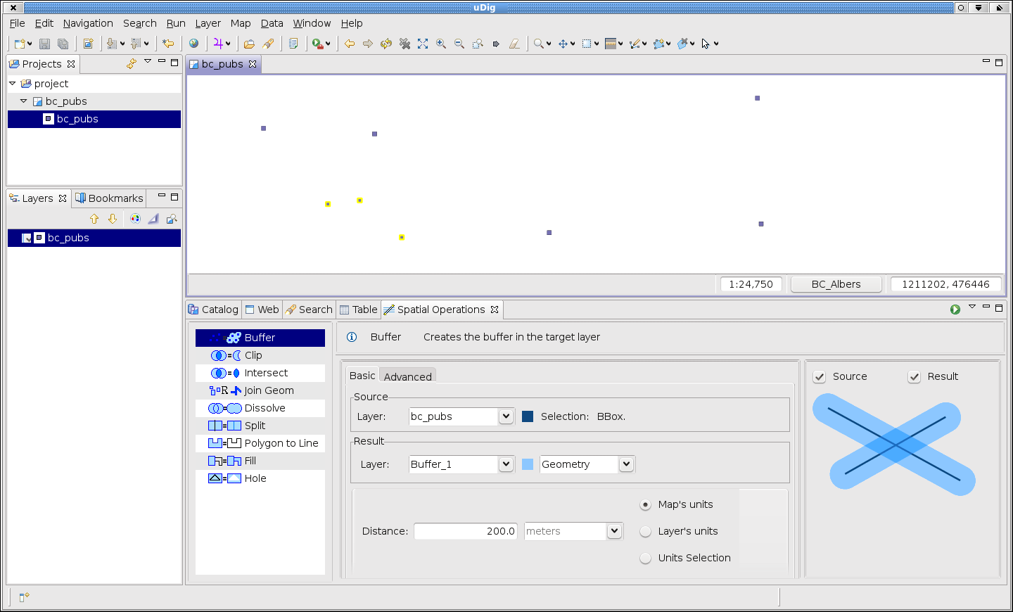
- Add some layers to test your development environment with the default spatial operations. By example: bc_pubs.shp.
- Select a layer.
- Open the pop up menu (right click on bc_pub layer).
- Select Operations> Spatial Operations to open the Spatial Operations View.
- Finally, three Pubs are selected to execute the buffer operation. The result is shown in the next screenshot.
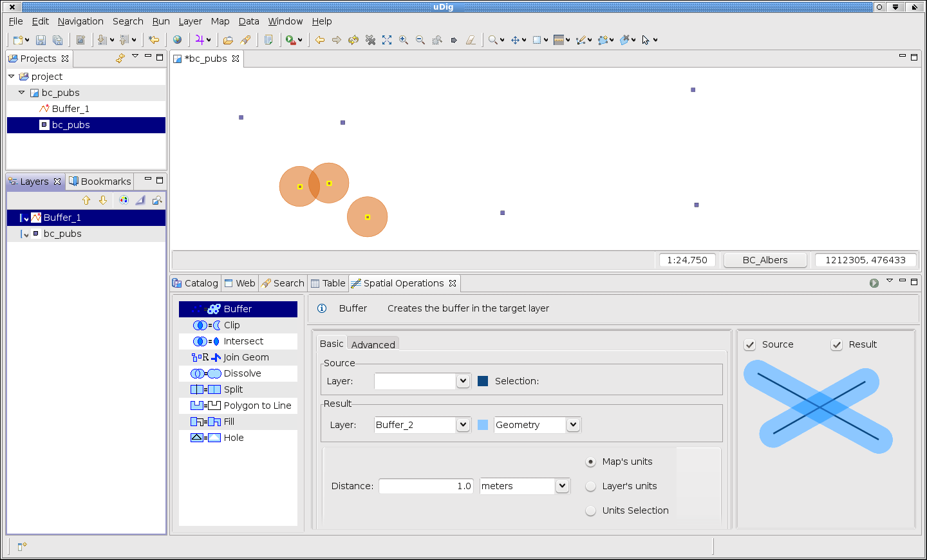

Creating a New Plugin Project
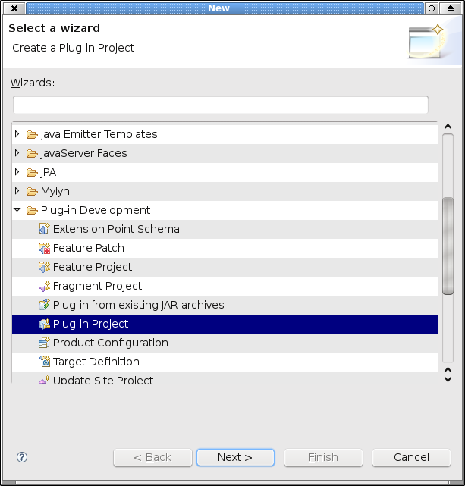
- Our first step will be to create a new plug-in project using the Eclipse wizard. File > New > Other > Plug in Project

- Write the project name: es.axios.udig.sextante in the next dialog.
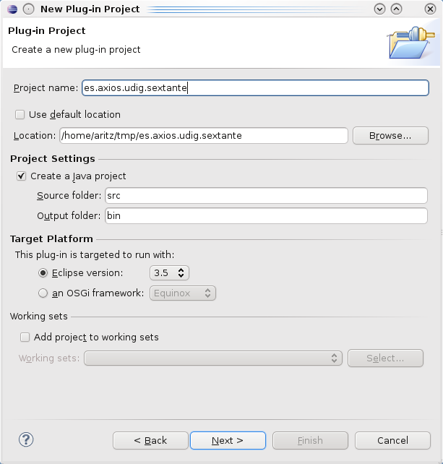

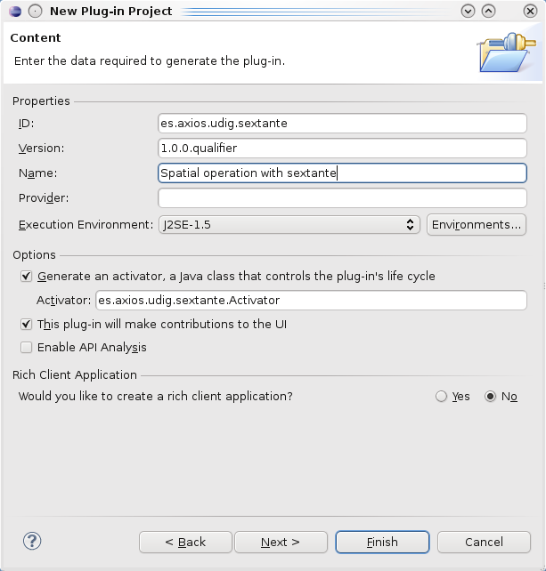
- In the next step it's important to select No in the Rich Client Application question.

- Now, press the Finish button, so the project template for the new plug-in can be created.

Extension for Spatial Operations
- In order to define the new extension you must declare it in the MANIFEST.MF.
- Switch to the Dependencies page and click on the Add button under Required Plug-ins panel.
- Select the es.axios.udig.ui.spatialoperations, es.axios.udig.ui.commons and net.refractions.udig.project.ui plug-ins, then save the manifest.
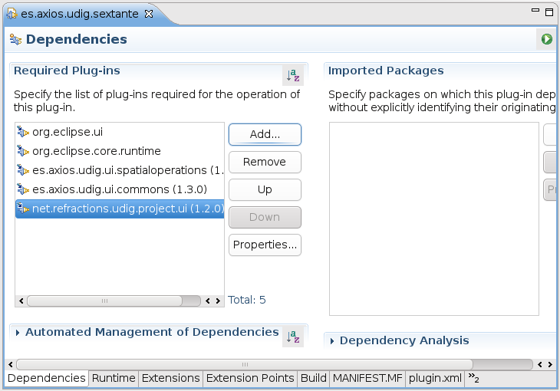
- Select the Extensions page.
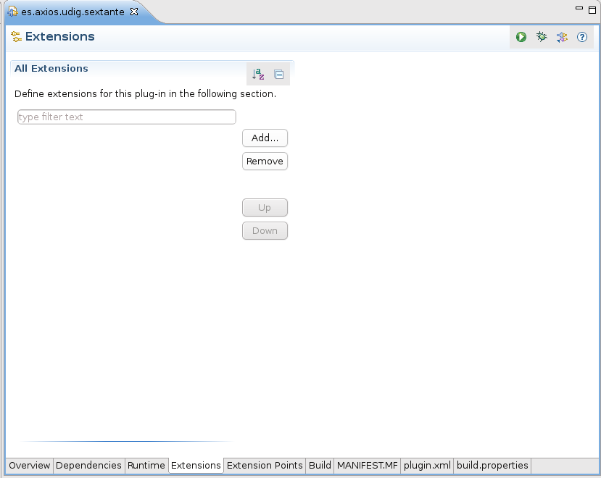
- Press the Add button, and select the extension point es.axios.udig.spatialoperations.ui.
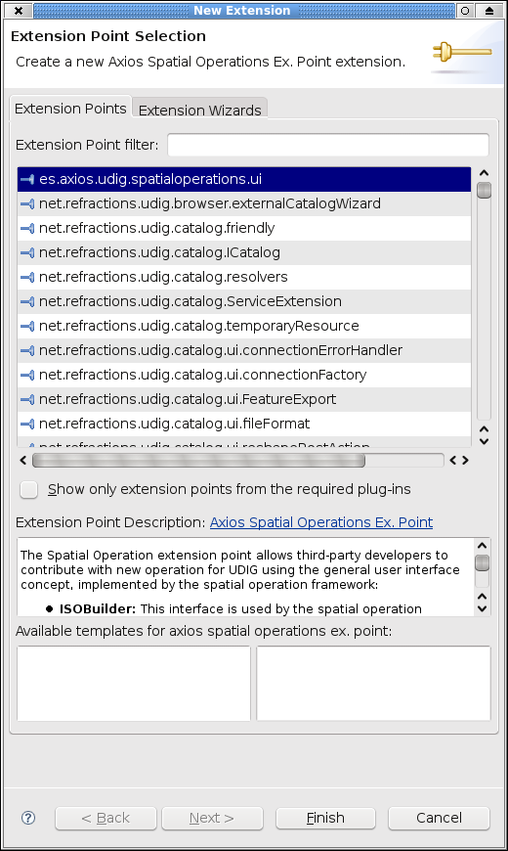

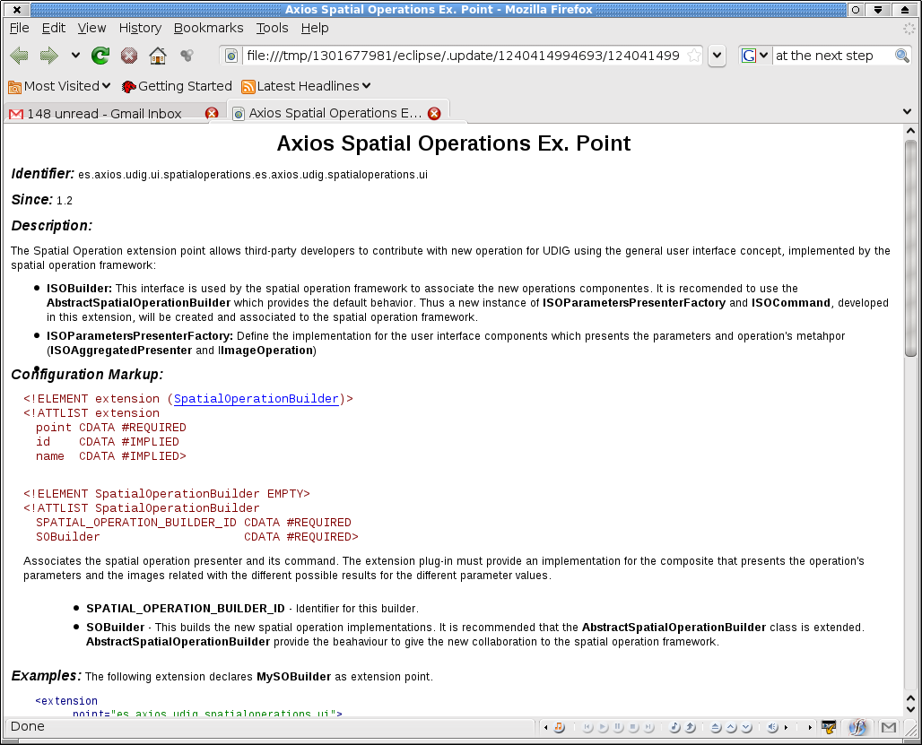
- Additional information about this extension point is available in the Extension Point Description link shown in the previous image.

- Finally, press the finish button and save the MANIFEST.MF

Developing the LineToPolygon Spatial Operation
Now, that the new extension was defined we are going to develop the new spatial operation presentation.
The framework requires an implementation for ISOBuilder. To add the implementation class follow these steps:
- Open the plugin.xml and select the extension es.axios.udig.spatialoperations.ui.
- Use the right button to open the pop up menu and select:
New > SpatialOperationBuilder
- Select the SpatialOperationBuilder and fill in the right panel with the ID and the name of the implementation class for this builder. We typed in the ID field:
es.axios.udig.sextante.VectorSpatialOperationBuilder
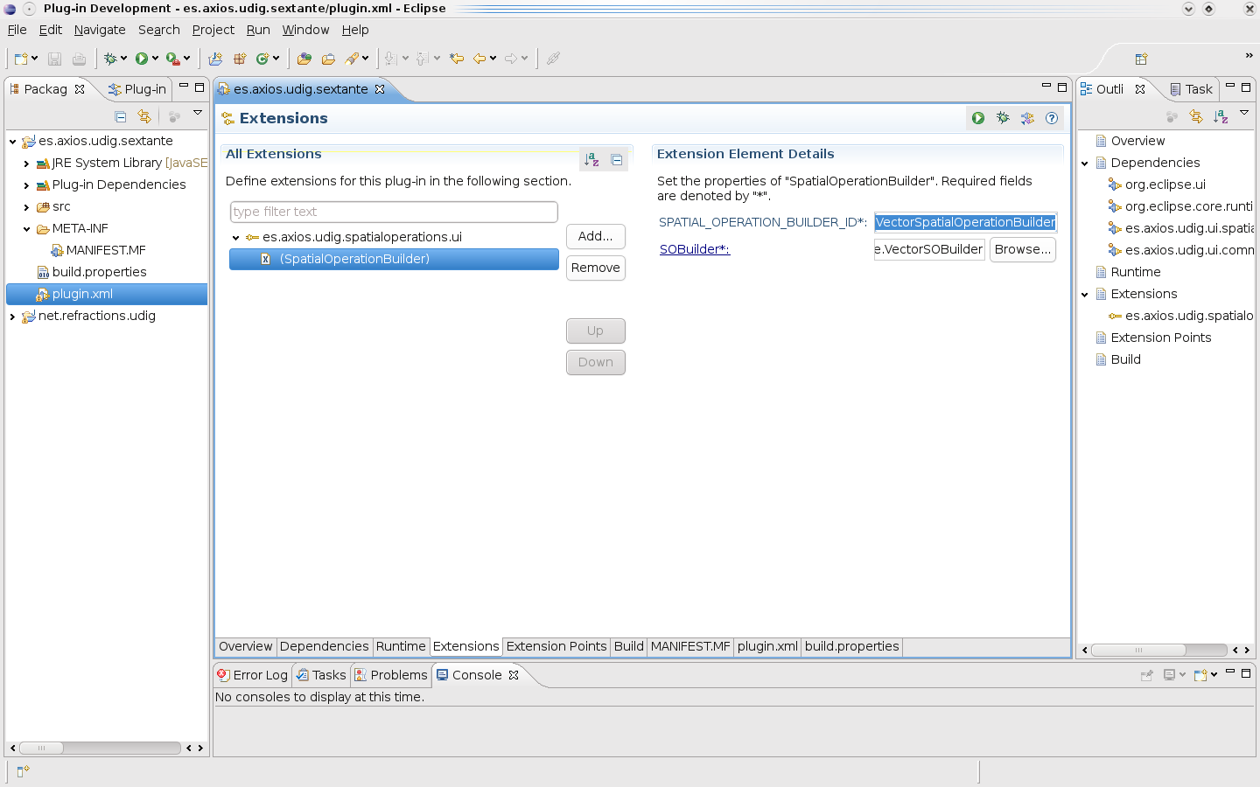

- To add the builder implementation class, click on SOBuilder* and fill the New Java Class dialog as it is shown in the next screen. We will take advantage of the AbstractSpatialOperationBuilder class declared as superclass of SextanteSOBuilder, that implements a common behavior for this sort of builders.
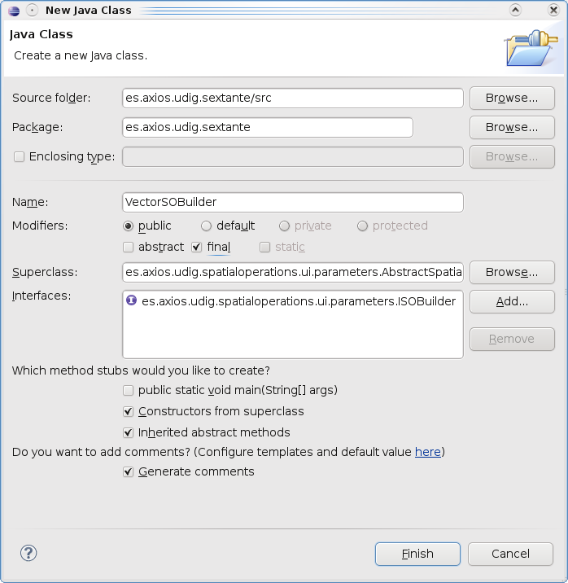
- The wizard will create the new Builder class, SextanteSOBuilder.
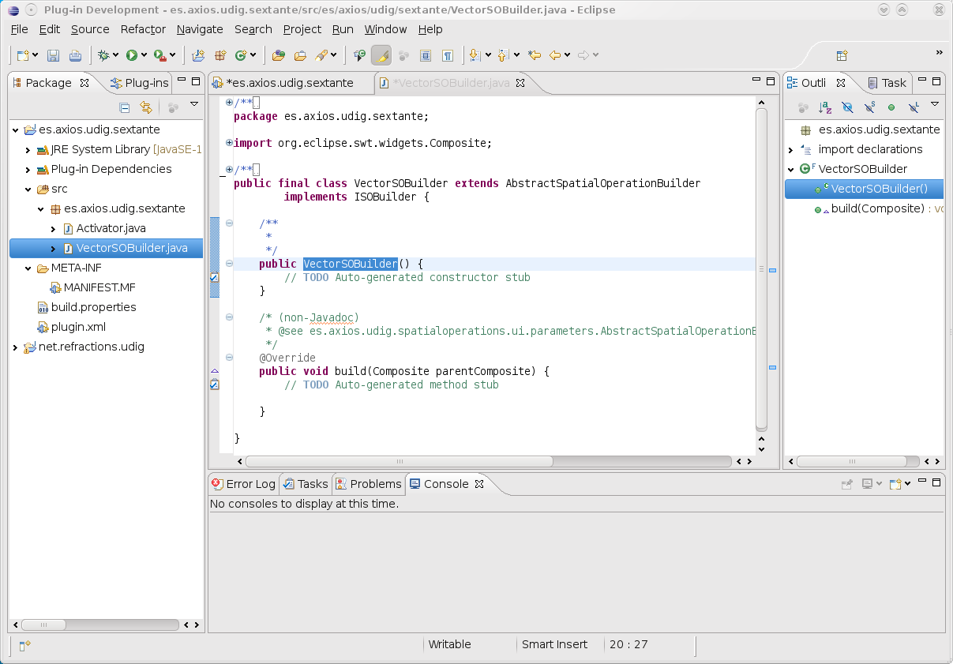

Writing the LineToPolygon Operation
In the previous section we have created the SextanteSOBuilder class which provides the user interface components required by the framework. In this section we are going to develop the user interface for the LineToPolygon operation with the help of SimplePresenter.
- In order to add the new spatial operation you should use the build method to create the component required by the spatial operations framework. The AbstractSpatialOperationBuilder provides the addCollaboration default method which can be used in the build() method to create one or more collaborations. We need to create only the LineToPolygon spatial operation.
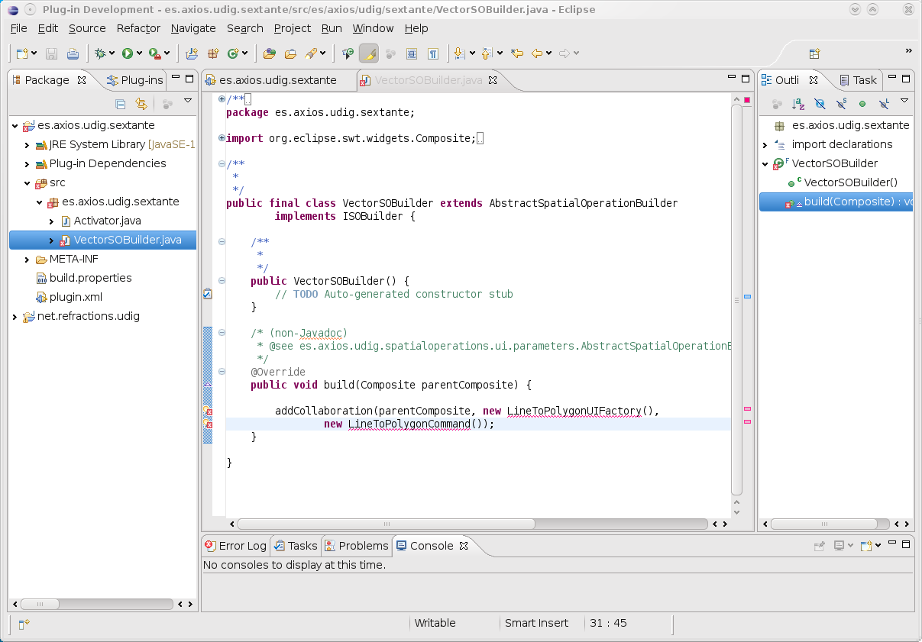
@Override
public void build(Composite parentComposite) {
addCollaboration(parentComposite, new LineToPolygonUIFactory(),
new LineToPolygonCommand());
}
- Create an implementation class called LineToPolygonUIFactory into the es.axios.udig.sextante.linetopolygon package, that implements the ISOParametersPresenterFactory interface.
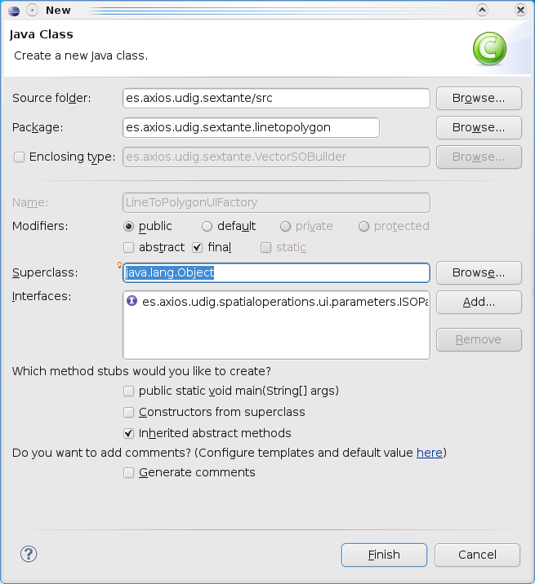
- The framework will get this implementation to compose the LineToPolygon spatial operation in the spatial operations view. The factory requires an implementation to get the spatial operation parameters (createDataComposite);
public ISOAggregatedPresenter createDataComposite(
ScrolledComposite dataParent, int style) {
return return new SOLineToPolygonComposite(dataParent, style, cmd);
}
the command used on the composite and its method;
private ISOCommand cmd = null;
public void setCommand(ISOCommand cmd) {
assert cmd != null : "Can't be null!"; //$NON-NLS-1$
this.cmd = cmd;
}
the demo images (createDemoImages);
public IImageOperation createDemoImages() {
return new LineToPolygonImages();
}
and the icon for the Centroid operation (createIcon).
public Image createIcon() {
final String file = "images/LineToPolygon.gif"; //$NON-NLS-1$
ImageDescriptor descriptor = ImageDescriptor.
createFromFile(SOLineToPolygonComposite.class, file);
Image image = descriptor.createImage();
return image;
}
Finally add this imports:
import org.eclipse.jface.resource.ImageDescriptor;
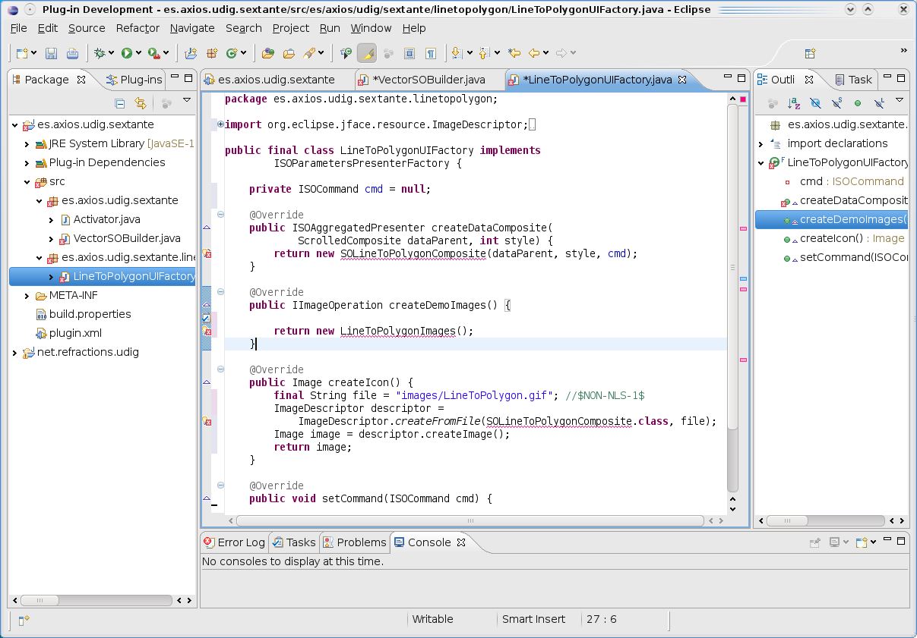

- We have to create the SOLineToPolygonComposite (as subclass of SimplePresenter) and LineToPolygonImages (as subclass of SimpleImages) classes into the same package.
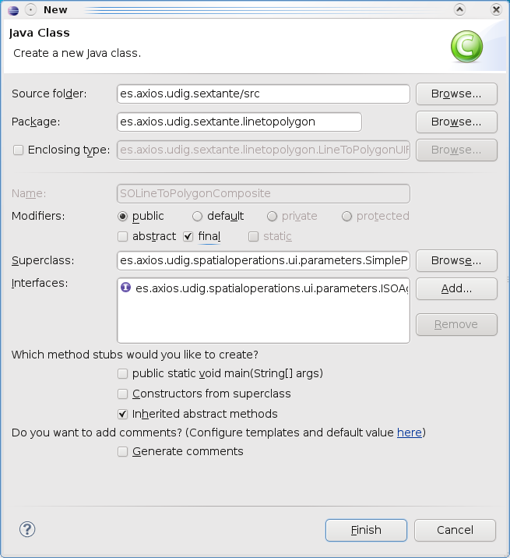
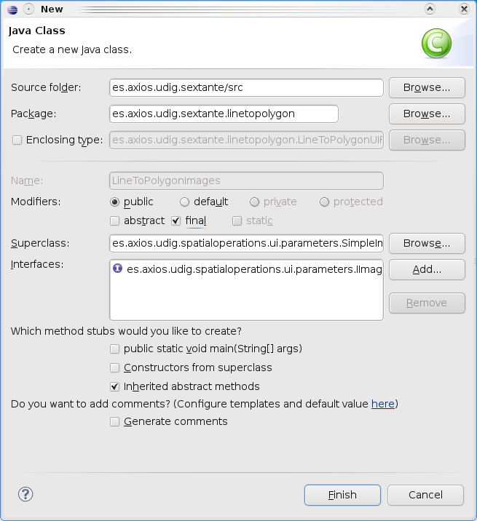

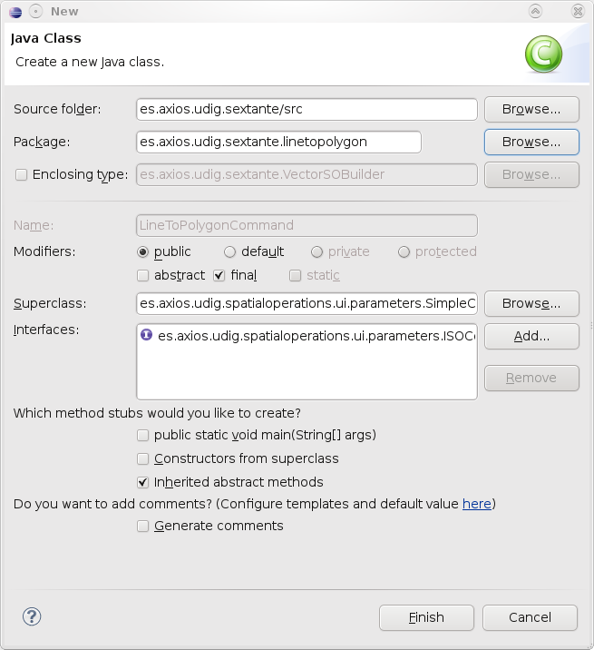
- Then we will create the LineToPolygonCommand class, which is a subclass of SimpleCommand. The SimpleCommand class is a default implementation for common spatial operation cases, it will help saving programming time.

- Fill the fields and press Finish. In the class editor you can add the method required by the interface. We are going to program this class later.

- Let's check that you have the following package structure:
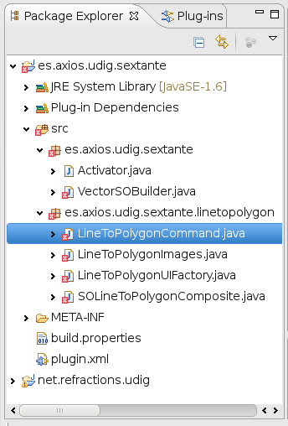
In the next sections we will write the code for the created classes.

SOLineToPolygonComposite class
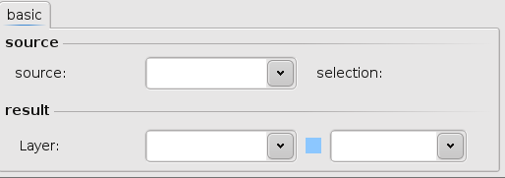
This class is responsible of presenting the widgets that will be used to provide the parameter values for the operation. The following image shows the idea.

The constructor must call the initialize() method defined in AbstractParamsPresenter class. Thus the framework will execute the operations to create the composite widgets, populate with the initial parameter values, and add some common listeners for spatial operations (map listener and layer listener).
But, we will take the advantage of the SimplePresenter, SimpleCommand, etc superclasses. It's only needed to define the constructor.

public SOLineToPolygonComposite(Composite parent, int style, ISOCommand cmd) {
super(parent, style, cmd);
}
The SimplePresenter is responsible of the presentation, its methods can be redefined and its fields are protected so it could be used by the developers.

LineToPolygonImages class
This presentation is very simple, it is responsible of displaying the demo images. To take advantage of framework abstract implementation this class will extend from SimpleImages. The most important methods are getDefaultImage(), which is called when the default demo image is presented, and the getImage(...), that is invoked when the user requires the source image, the result image or the LineToPolygon operation final image. Those methods are implemented on the superclass, so the developers only have to define the name of the images and call the superconstructor.
The code is shown below.
private static final String IMAGE_SOURCE = "source"; //$NON-NLS-1$
private static final String IMAGE_RESULT = "result"; //$NON-NLS-1$
private static final String IMAGE_FINAL = "final"; //$NON-NLS-1$

public LineToPolygonImages() {

super(LineToPolygonImages.class, IMAGE_SOURCE, IMAGE_RESULT,
IMAGE_FINAL);
}
Finally, it's necessary to provide the images to display. You can copy all images required for this tutorial from
es.axios.udig.sextante/src/es/axios/udig/sextante/linetopolygon/images
provided in the sources file. These files should be in the
es.axios.udig.sextante.linetopolygon.images package, so you will need to create it.

LineToPolygonCommand class
The LineToPolygonCommand class extends the SimpleCommand abstract class. This SimpleCommand is responsible of executing the task, store the parameters and verify them. Also, it has the methods to populate the SimplePresenter but we will see this later.
The developers will define on this command the “polygon to line” description shown on the information panel and the method to execute the Sextante task. Moreover, they could redefine some methods, for example, to validate additional parameters, to restrict the geometry types of the layers, etc.
First, we will create the constructor and call the superclass constructor. We need to declare an initial message describing the operation, as is done below:

protected static InfoMessage INITIAL_MESSAGE = new InfoMessage("Convert closed lines into polygons.",InfoMessage.Type.IMPORTANT_INFO);
public LineToPolygonCommand() {
super(INITIAL_MESSAGE);
}

The abstract methods from the SimpleCommand forces the developers to set the values which will be presented on the SOLineToPolygonComposite that defines this command. Use the fields hosted by the SimpleCommand to fill that methods.

@Override
public void setGroupSourceText() {
this.groupSourceText = "Source";
}

@Override
public void setGroupTargetInputsText() {
this.groupTargetInputsText = "Result";
}

@Override
public void setLabelSourceLayerText() {
this.labelSourceLayerText = "Source";
}

@Override
public void setTabItemAdvancedText() {
this.tabItemAdvancedText = "Advanced";
}

@Override
public void setTabItemBasicText() {
this.tabItemBasicText = "Basic";
}

@Override
public void setTargetLabelText() {
this.targetLabelText = "Layer";
}

@Override
public void setTargetLabelToolTipText() {
this.targetLabelToolTipText = "The layer where the result will go. Select an existent layer or write a new one.";
}

The framework requires an ID, Name and tooltip text for each spatial operation, this is the purpose of the following methods:
@Override
public void setOperationID() {
this.operationID = "LineToPolygon";
}

@Override
public void setOperationName() {
this.operationName = "LineToPolygon";
}
@Override
public void setToolTipText() {
this.toolTipText = "Convert lines to polygon.";
}

The valid geometries for the LineToPolygon result layer are Polygon or MultiPolygon, they should be provided by the getResultLayerGeometry method. Redefine it:
@Override
protected Object[] getResultLayerGeometry() {
Object[] obj;
if (sourceLayer != null) {
obj = new Object[1];
Class<? extends Geometry> sourceGeom = LayerUtil.getGeometryClass(this.sourceLayer);
// is a geometry collection
if (sourceGeom.getSuperclass().equals(GeometryCollection.class)) {
obj[0] = MultiPolygon.class;
} else {
obj[0] = Polygon.class;
}
} else {
obj = new Object[2];
obj[0] = Polygon.class;
obj[1] = MultiPolygon.class;
}
return obj;
}

The required geometries for the source layer are: line or multiLine. The getSourceGeometryClass() is responsible of providing this information to the user interface.
@Override
protected Object[] getSourceGeomertyClass() {
Object[] obj = new Object[] {
LineString.class,
MultiLineString.class };
return obj;
}

The framework will call the validateParameters method in order to check if the parameter values are OK before executing the spatial operation. The SimpleCommand has a validateParameters which is designed for validate the parameters from the SimplePresenter, if the developers wish to validate more information, they just need to override the method.
Note: you can see the details of each private method in the source code provided with this tutorial.

When the validateParameters() predicate returns true, the framework enables the execute button which allows executing the operation. We will override the executeOperation() to create and execute the LineToPolygon task.
@Override
public void executeOperation() throws SOCommandException {
final NullProgressMonitor progress = new NullProgressMonitor();
this.map = sourceLayer.getMap();
final FeatureStore<SimpleFeatureType, SimpleFeature> source = getFeatureStore(sourceLayer);
try {
progress.setTaskName("LinesToPolygon Spatial Operation");
String msg = MessageFormat.format("Doing lines to polygon of {0}", sourceLayer.getName());
progress.beginTask(msg, IProgressMonitor.UNKNOWN);
IRunnableWithProgress runner = new IRunnableWithProgress() {
public void run(IProgressMonitor monitor) throws InvocationTargetException,
InterruptedException {
final FeatureStore<SimpleFeatureType, SimpleFeature> resultStore;
LineToPolygonTask task = new LineToPolygonTask(source);
try {
task.run();
resultStore = task.getResult();
addFeaturesToTargetStore(resultStore);
} catch (GeoAlgorithmExecutionException e){
// TODO Auto-generated catch block
e.printStackTrace();
} catch (IOException ioe){
// TODO Auto-generated catch block
e.printStackTrace();
} catch (SOCommandException soe){
// TODO Auto-generated catch block
e.printStackTrace();
} finally {
this.map.getRenderManager().refresh(
this.targetLayer, this.map.getBounds(progress progress.done();
}
}
};
DialogUtil.runInProgressDialog("Executing LinesToPolygon Operation", true, runner, true, true);
} catch (Exception e) {
throw new SOCommandException(e.getMessage());
}
}

private final FeatureStore<SimpleFeatureType, SimpleFeature> getFeatureStore(final ILayer layer) throws SOCommandException {

assert layer != null;
IGeoResource resource = layer.getGeoResource();
if (resource == null) {
throw new SOCommandException("The layer does not have GeoResource");
}
FeatureStore<SimpleFeatureType, SimpleFeature> store;
try {
store = resource.resolve(FeatureStore.class, new NullProgressMonitor());
return store;
} catch (IOException e) {
throw new SOCommandException(e.getMessage());
}
}
private final void addFeaturesToTargetStore(FeatureStore<SimpleFeatureType, SimpleFeature> resultStore)
throws SOCommandException, IOException {
FeatureStore<SimpleFeatureType, SimpleFeature> emptyTargetStore = null;
if (this.targetLayer != null) {
emptyTargetStore = this.getFeatureStore(this.targetLayer);
} else { // create a new layer
this.targetLayer = createNewLayer();
IGeoResource targetGeoResource = targetLayer.getGeoResource();
try {
emptyTargetStore = targetGeoResource.resolve(FeatureStore.class, null);
} catch (IOException e) {
throw new SOCommandException(e.getMessage());
}
}
Transaction transactionOld =
((net.refractions.udig.project.internal.Map) this.map)
.getEditManagerInternal().getTransaction();
SOFeatureStore soStore = new SOFeatureStore(emptyTargetStore, transactionOld);
// add to target store.
addToStore(soStore, resultStore);
}

private void addToStore(SOFeatureStore soStore, FeatureStore<SimpleFeatureType, SimpleFeature> resultStore)
throws IOException {
FeatureCollection<SimpleFeatureType, SimpleFeature> collection = resultStore.getFeatures();
FeatureIterator<SimpleFeature> iter = collection.features();
SimpleFeatureType newFeatureType = soStore.getSchema();
Transaction transaction = soStore.getTransaction();
try {
while (iter.hasNext()) {
SimpleFeature sextanteFeature = iter.next();
SimpleFeature featureToAdd =
FeatureUtil.createFeatureUsing(
sextanteFeature, newFeatureType,
(Geometry) sextanteFeature.getDefaultGeometry());
soStore.addFeatures(
DataUtilities.collection(
new SimpleFeature[] { featureToAdd }));
transaction.commit();
}
} catch (Exception ex) {
transaction.rollback();
throw new IOException(ex.getMessage());
} finally {
collection.close(iter);
transaction.close();
}
}
private final CoordinateReferenceSystem getTargetCRS() {
if (this.targetLayer != null) {
return this.targetLayer.getCRS();
} else {
return getMapCRS();
}
}
private CoordinateReferenceSystem getMapCRS() {
return MapUtil.getCRS(map);
}

private final ILayer createNewLayer()
throws SOCommandException {

FeatureStore<SimpleFeatureType, SimpleFeature> targetStore;
try {
SimpleFeatureType type = FeatureUtil.createFeatureType(
this.sourceLayer.getSchema(), targetLayerName,
getTargetCRS(), this.targetGeometryClass);
IGeoResource targetGeoResource =
AppGISMediator.createTempGeoResource(type);
assert targetGeoResource != null;
targetStore = targetGeoResource.resolve(FeatureStore.class, null);
assert targetStore != null;
ILayer newLayer = MapUtil.addLayerToMap(
(IMap) this.map, targetGeoResource);
return newLayer;
} catch (Exception e) {
e.printStackTrace();
throw new SOCommandException(e);
}
}

To solve the compilation errors, write the following import declarations:(Note: not all the errors will be corrected yet)
import java.io.IOException;
import java.lang.reflect.InvocationTargetException;
import java.text.MessageFormat;

import net.refractions.udig.catalog.IGeoResource;
import net.refractions.udig.project.ILayer;
import net.refractions.udig.project.IMap;

import org.eclipse.core.runtime.IProgressMonitor;
import org.eclipse.core.runtime.NullProgressMonitor;
import org.eclipse.jface.operation.IRunnableWithProgress;
import org.geotools.data.DataUtilities;
import org.geotools.data.FeatureStore;
import org.geotools.data.Transaction;
import org.geotools.feature.FeatureCollection;
import org.geotools.feature.FeatureIterator;
import org.opengis.feature.simple.SimpleFeature;
import org.opengis.feature.simple.SimpleFeatureType;
import org.opengis.referencing.crs.CoordinateReferenceSystem;

import com.vividsolutions.jts.geom.Geometry;
import com.vividsolutions.jts.geom.GeometryCollection;
import com.vividsolutions.jts.geom.LineString;
import com.vividsolutions.jts.geom.MultiLineString;
import com.vividsolutions.jts.geom.MultiPolygon;
import com.vividsolutions.jts.geom.Polygon;

import es.axios.udig.sextante.task.LineToPolygonTask;
import es.axios.udig.spatialoperations.ui.parameters.SOCommandException;
import es.axios.udig.spatialoperations.ui.parameters.SimpleCommand;
import es.axios.udig.spatialoperations.ui.taskmanager.SOFeatureStore;
import es.axios.udig.ui.commons.mediator.AppGISMediator;
import es.axios.udig.ui.commons.message.InfoMessage;
import es.axios.udig.ui.commons.util.DialogUtil;
import es.axios.udig.ui.commons.util.FeatureUtil;
import es.axios.udig.ui.commons.util.LayerUtil;
import es.axios.udig.ui.commons.util.MapUtil;
import es.unex.sextante.exceptions.GeoAlgorithmExecutionException;

It could be a good idea to try the LineToPolygon user interface before writing the LineToPolygonTask. Thus, you should comment imports that aren't compiled and the previous code from the executeOperation and put this instead:
System.out.println("LineToPolygon Task should be implemented");
Before executing the uDig product, have a look in the Run Dialog to be sure that the es.axios.udig.sextante plug-in is checked to launch.
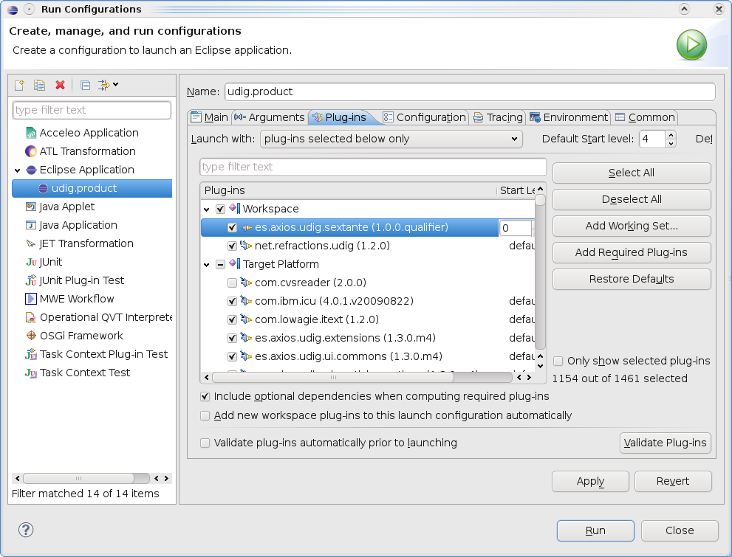
After opening the spatial operations view you should see the new LineToPolygon operation.

Note: don't forget to revert this hack before continuing this tutorial.

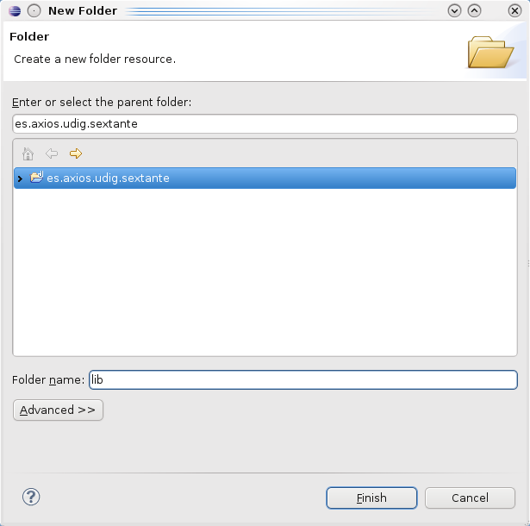
Adding Sextante
Before starting with the LineToPolygonTask, we are going to configure the plugin.xml. First we create a folder called “lib” where the .jars will be stored.
Right click on es.axios.udig.sextante > New > Folder.
After creating the folder, we will put in the next .jars:
- sextante-0.5.jar
- sextante_gt25_bindings.jar
- sextante_vectorTools-0.5.jar

These jars are provided with the source code in the folder:
es.axios.udig.sextante/lib

After refreshing the workspace, we are going to add the jars to the project. Right click on es.axios.udig.sextante > Properties > Java Build Path > Libraries tab > Add Jars... And then select these 3 jars.
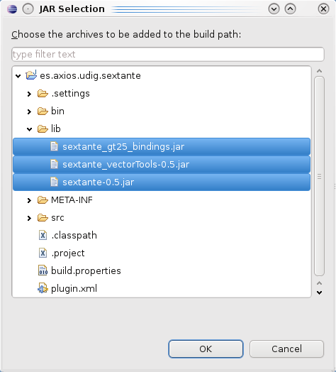
Go to the plugin.xml “Runtime” tab and add these jars and save it.
Also, don't forget to add the “.” as it's shown on the image. For adding the “.”, click on New... and write it.
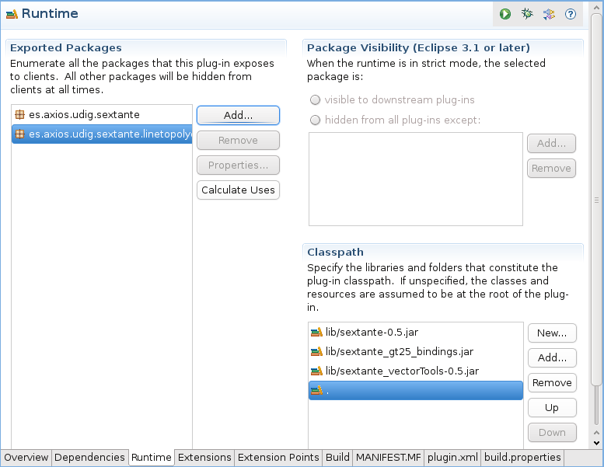

LineToPolygonTask class
Finally, it's time to provide the LineToPolygonTask. This task will call Sextante algorithm PolylinesToPolygonsAlgorithm. To simplify this tutorial we will create a simple class. Interested people could have a look at the default spatial operation model (buffer, intersect, clip, etc).
First, create the package where the LineToPolygonTask will be:
es.axios.udig.sextante.task
After that, you can start to develop the LineToPolygonTask.
public final class LineToPolygonTask {

private final FeatureStore<SimpleFeatureType, SimpleFeature> sourceStore;
private FeatureStore<SimpleFeatureType, SimpleFeature> targetStore = null;

public LineToPolygonTask(
final FeatureStore<SimpleFeatureType, SimpleFeature> sourceStore) {
assert sourceStore != null :
"Illegal argument. Expects sourceStore != null";
this.sourceStore = sourceStore;
}

public void run() throws GeoAlgorithmExecutionException, IOException {
PolylinesToPolygonsAlgorithm alg = new PolylinesToPolygonsAlgorithm();
// set the inputs.
DataStore ds = (DataStore) sourceStore.getDataStore();
GTVectorLayer layer = GTVectorLayer.createLayer(ds, ds.getNames()
.get(0).getLocalPart());
ParametersSet params = alg.getParameters();
params.getParameter(PolylinesToPolygonsAlgorithm.LAYER)
.setParameterValue(layer);
// set the outputs.
OutputFactory outputFactory = new GTOutputFactory();
OutputObjectsSet outputs = alg.getOutputObjects();
Output contours = outputs
.getOutput(PolylinesToPolygonsAlgorithm.RESULT);
alg.execute(null, outputFactory);
IVectorLayer result = (IVectorLayer) contours.getOutputObject();
targetStore = (FeatureStore) result.getBaseDataObject();
}

public FeatureStore<SimpleFeatureType, SimpleFeature> getResult() {
return this.targetStore;
}
}

To solve the compilation errors, write the following import declarations
import java.io.IOException;

import org.geotools.data.DataStore;
import org.geotools.data.FeatureStore;
import org.opengis.feature.simple.SimpleFeature;
import org.opengis.feature.simple.SimpleFeatureType;

import es.unex.sextante.core.OutputFactory;
import es.unex.sextante.core.OutputObjectsSet;
import es.unex.sextante.core.ParametersSet;
import es.unex.sextante.dataObjects.IVectorLayer;
import es.unex.sextante.exceptions.GeoAlgorithmExecutionException;
import es.unex.sextante.geotools.GTOutputFactory;
import es.unex.sextante.geotools.GTVectorLayer;
import es.unex.sextante.outputs.Output;
import es.unex.sextante.vectorTools.polylinesToPolygons.PolylinesToPolygonsAlgorithm;

Executing the LineToPolygon Spatial Operations
At this point, you should not have any compilation errors. If all is OK, you can execute the uDig product, and you should see the newest LineToPolygon operation in the spatial operations list. To test it, you need a LineString layer with some rings. We are going to generate a LineString layer using the country layer applying the PolygonToLine operation, as you can see in below:
  - Load the shapefile countries.shp.
  - Execute the operation PolygonToLine using as source layer countries.shp, and as result layer Countries-as-lines. The result is shown in the following screenshot.
  - Now, we have the required input for LineToPolygon. So, execute the operation LineToPolygon using as source layer Countries-as-lines and result layer LineToPolygon_1.

Contact
For any suggestions or doubts about this tutorial, please don't hesitate to contact us:
www.axios.es
info@axios.es
or
Mauricio Pazos
Axios Director
mauricio.pazos@axios.es

