
Adding a Distance Tool

Tool Plugin Tutorial
13 January 2011


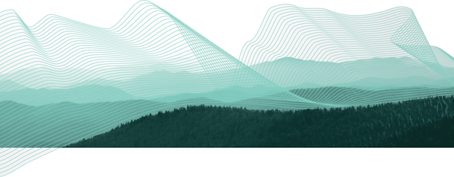

Table of Contents
1 Introduction 3
2 Create a New Plug-in 4
3 Manifest 7
4 Import Icons and Pointers 9
5 Extensions 11
6 Tool Definition 14
7 Tool Implementation 16
8 Testing the Plugin 20
9 Question and Answer 22
10 What to do Next 23

Introduction
The uDig application is built on the “Eclipse Rich Client Platform” that offers an alternative to traditional application framework design. The RCP Platform is customized through extensions that contribute to extensions points. The good news is that everything is consistent, everything from adding a tool to creating an application is done in the same manner.
After completing this tutorial, you will have gained the skills to:
- Create a new Plugin
- Define a new Extension
- Implement a new Tool Extension
- Update the map from within a tool
We are going to create a tool that returns the distance between the point the mouse is clicked and the point the mouse is released.
Click
Release
Drag
X Meters

Create a New Plug-in
In this section we are going to create a new plug-in. Eclipse plug-ins are managed bundles of code (often packaged up as a jar or folder).
Our focus in this section is on creating a plug-in and getting the name and version information correct. We will also provide a list of uDig plug-ins we need in order to make a good tool.
An Eclipse class called Platform is responsible for loading up our plug-in when it is needed. The Platform class will use the information we provide to make sure all our requirements are met. Plug-ins are loaded up into separate class loaders; and Java class loader restrictions are in place so you really can only talk to plug-ins you depend on!
- Open up Eclipse using the workspace configured for uDig SDK development.
- Select Window > Open Perspective > Other and choose the Plug-in Development perspective from the list.
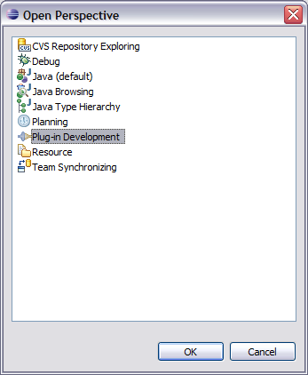
The Plug-in Perspective will contain a few Views and Editors you may not be familiar with from day to day Java programming.
- Choose File > New > Project... from the menu bar.
- Select Plug-in Project and press Next.
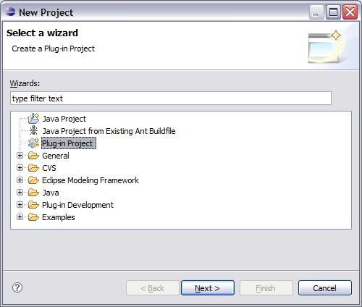
- Create a name for the plug-in by entering
Project Name: net.refractions.udig.tutorials.distancetool
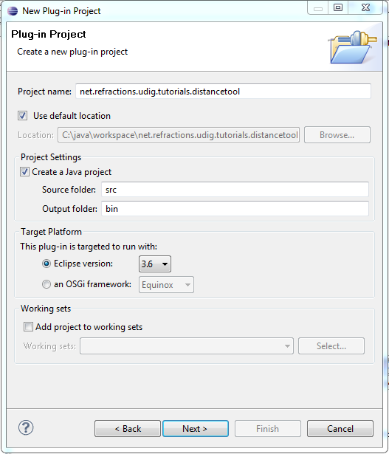
- Press the Next Button
- Accept the default values for Plug-in Content.
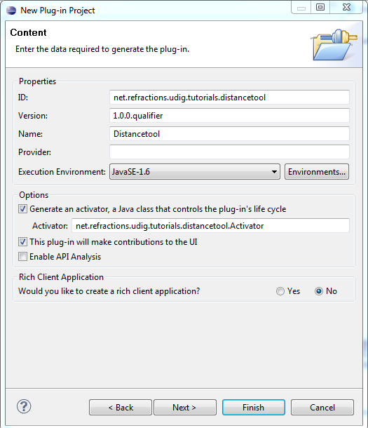
- Press Finish to create your new project.

Manifest
Your new project is both: a plug-in project (with a MANIFEST.MF file for the Eclipse Platform class to read); and a Java project with .classpath file for the eclipse compiler to read.
Lets have a look at what information is MANIFEST.MF:
- In the Package Explorer navigate to the plug-in created in the previous section. Find the file META-INF/MANIFEST.MF and double click to open the plug-in manifest editor.
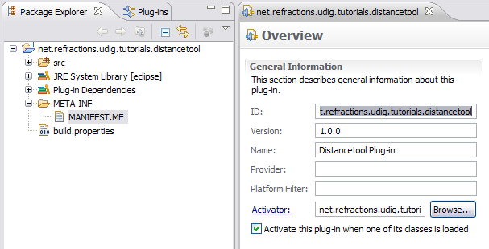
- The overview tab shows much of the information you entered when you created the plug-in project.
- Switch to the Dependencies tab.
(the tabs are located at the bottom of the editor area)
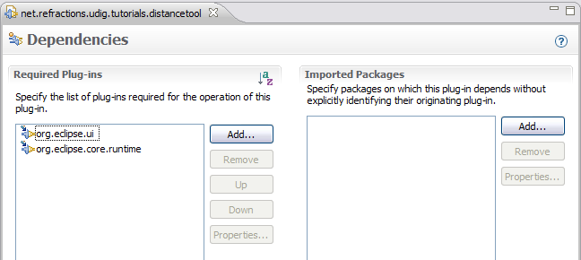
- Click on the Add button under Required Plug-ins.
- Select the net.refractions.udig.project.ui plug-in from the list.
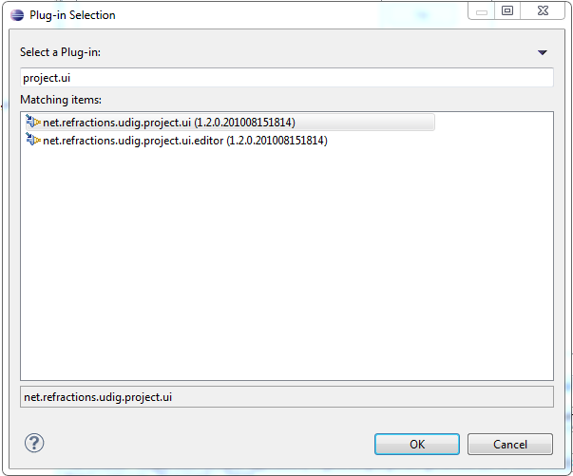
You can use the field at the top of the dialog to filter the plug-in list.
Use “*project.ui” to quickly find the needed plug-in.
- At this point you need to save your work (using File > Save ).
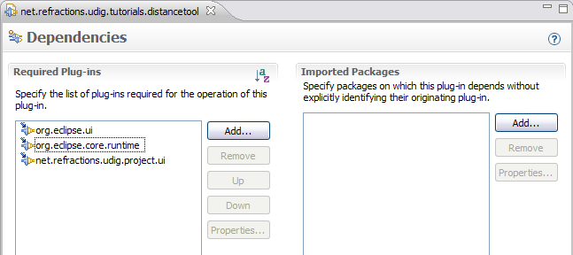
- Changes to the plug-in project (ie MANIFEST.MF file) are used to update the Java project (ie .classpath file). If you do not save your work you will not be able find the tool classes used later in the tutorial.

Import Icons and Pointers
You can use normal image files to define tool bar icons, and cool pointers.
By convention icons are organized into the following directories:
icons/etool16 | Enabled icon used in application tool bar.  (16x16 left and top clear)
icons/pointers | Used to define a cursor  (32x32)
Lets download the images used for this tutorial:
- Download the following file:
http://udig.refractions.net/files/tutorials/distance_icons.zip
If you are using this work book in a lab setting you will find the file on your DVD.
- Select File > Import to open up the Import wizard
- Choose General > Archive File and press Next
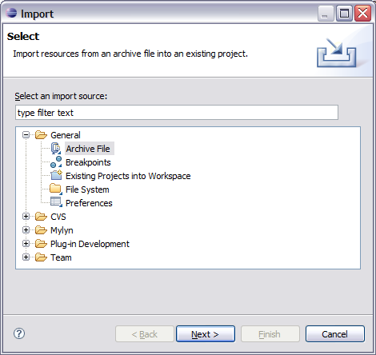
- Fill in the following details on the Archive File page:
From archive file: distance_icons.zip
Into folder: net.refractions.udig.tutorials.distancetool
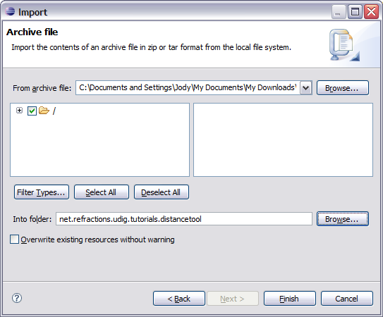
- Press Finish
- An icons directory will be created.
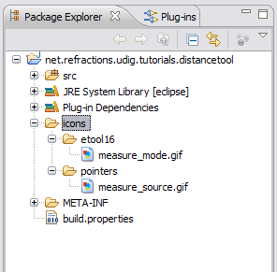

Extensions
Programming with extensions is accomplished in two parts; filling in a bit of information (letting the Eclipse Platform class know what you are up to); and then implementing a Java class to do the work.
The Platform class acts as a mediator; hooking up the distance tool we define here to the uDig application that will display it on the tool bar and make use of the tool when the user asks.
This is becoming a popular approach; web applications made with the Spring framework often use a single xml file to wire everything together.
The information we provide is stored in a file called plugin.xml; the Platform class reads in all the plugin.xml files when the application is started it and wires up everything.
- Return to your plug-in MANIFEST.MF editor, and switch the the Extentions tab.
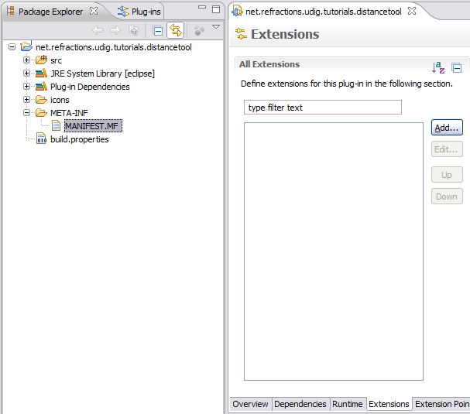
- Press the Add button
- Select net.refractions.udig.project.ui.tool from the list of extension points.
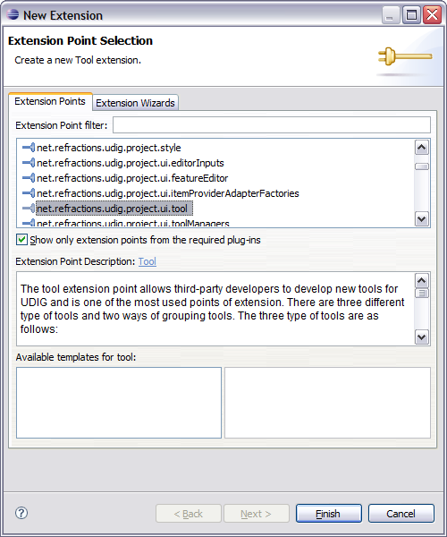
- Click Finish
- Enter the following Extention Details:
ID: <Make it Empty>
Name: Distance Tool Example
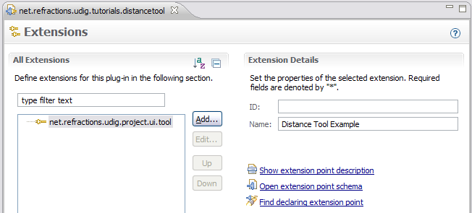
The id and name provided here is used by the Platform class to log errors associated with your tool.
There is a bug with icon lookup which is why we made the id empty.
- Change to the build tab of your MANIFEST.MF editor. Make sure your icons folder and plugin.xml is checked as part of the Binary Build.
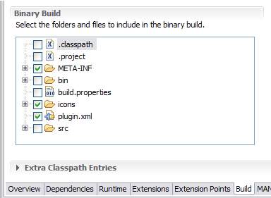
- This step will ensure that the icons are included when the plug-in is bundled up into a jar. Proceed to the next section and we will define our distance tool.

Tool Definition
We can now use the extensions tab to define our distance tool. A single plug-in may define multiple tools, and indeed provide contributions to several extension points.
To create a new tool:
- Right click on newly added net.refractions.udig.project.ui.tool in the Extensions tab,
and select New > modalTool
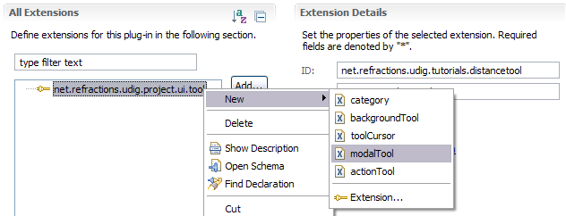
- Fill in the following value for id: net.refractions.udig.tutorials.distancetool.
- Enter a tool tip message into tooltip:
Measure the surface distance between two points
- For icon, click on the browse button and select: icons/etool16/measure_mode.gif
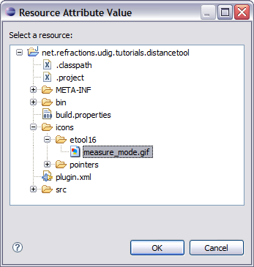
- Fill in the following for name: Distance
- For onToolbar: select true from the list
- For the tool categoryId: net.refractions.udig.tool.category.info
- Save your work.
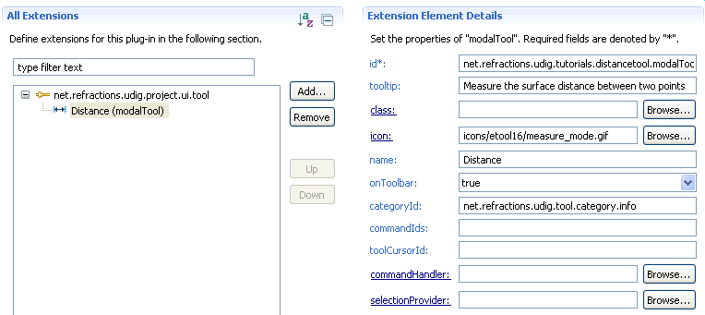
- We are going to add a child element that specifies the cursor.
- Right click on Distance and select New > cursor.
- For the image: use the browse button to select: icons/pointers/measure_source.gif
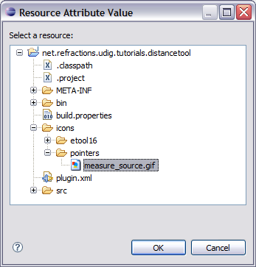
- Fill in the location of the hot spot where the user clicks:
hotSpotX: 10
hotSpotY: 10
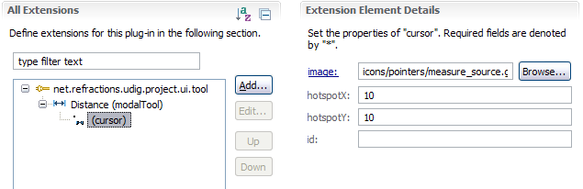
- Save your work before continuing to the next section.

Tool Implementation
Now that all the description is out of the way we can implement the DistanceTool class.
- Return to the Distance (modalTool) element
(it is child of net.refractions.udig.project.ui.tool)
- Enter in the following for class: net.refractions.udig.tutorials.distancetool.DistanceTool
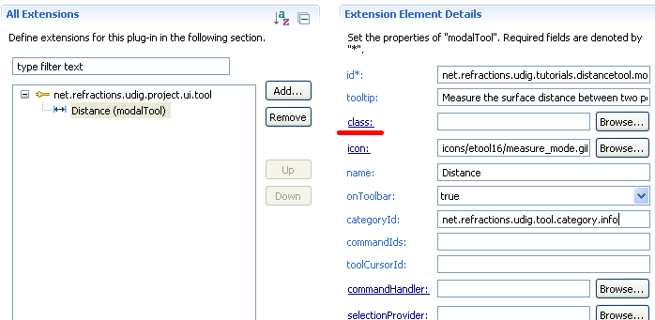
- Click the class link shown above.
- A New Java Class wizard is opened, the needed details should have be already filled in for you.
Constructors from superclass: uncheck
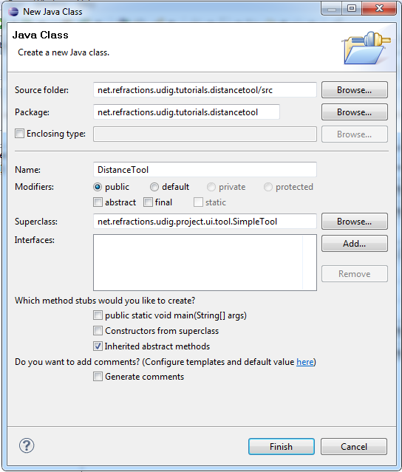
- Press Finish
- The following file will be created for you.
package net.refractions.udig.tutorial.distancetool;

import net.refractions.udig.project.ui.tool.SimpleTool;

public class DistanceTool extends SimpleTool {

}
- Add the following field, to jot down where the user clicked.
import com.vividsolutions.jts.geom.Coordinate;
public class DistanceTool extends SimpleTool {
/** records where in the world the user clicked */
Coordinate start;
}
- Right click on the editor and select Source > Override/Implement Methods
- Expand SimpleTool node and check the following:
- Check onMousePressed(MapMouseEvent)
- Check onMouseReleased(MapMouseEvent)
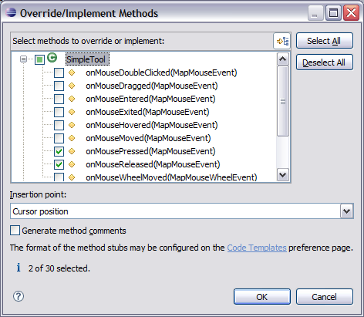
- Click on the OK button to create these methods.
- Implement the onMousePressed(MapMouseEvent) method
@Override
protected void onMousePressed(MapMouseEvent e) {
start=getContext().pixelToWorld(e.x, e.y);
}
- Implement the onMouseReleased(MapMouseEvent) method.
We are using the utility JTS class to calculate the distance between two coordiantes.
@Override
protected void onMouseReleased(MapMouseEvent e) {
Coordinate end=getContext().pixelToWorld(e.x, e.y);
try {
double distance=JTS.orthodromicDistance(
start, end,
getContext().getCRS() );
displayOnStatusBar(distance);
} catch (Exception e1) {
displayError();
}
}
- Implement the displayOnStatusBar(double) method.
We need to
private void displayOnStatusBar(double distance) {
final IStatusLineManager statusBar =
getContext().getActionBars().getStatusLineManager();

if( statusBar==null ){
return; // shouldn't happen if the tool is being used.
}
int totalmeters=(int)distance;
final int km=totalmeters/1000;
final int meters=totalmeters-(km*1000);
float cm = (float) (distance-totalmeters)*10000;
cm = Math.round(cm);
final float finalcm=cm/100;

getContext().updateUI(new Runnable(){
public void run() {
statusBar.setMessage(
"Distance = "+km+"km "+meters+"m "+finalcm+"cm"
);
}
});
}
- Implement the displayError () method
private void displayError() {
final IStatusLineManager statusBar =
getContext().getActionBars().getStatusLineManager ();

if( statusBar==null )
return; // shouldn't happen if the tool is being used.

getContext().updateUI(new Runnable() {
public void run() {
statusBar.setErrorMessage("Unable to calculate the distance");
}
});
}
- The file will not compile as we have a few imports to sort out.
- Press Ctrl-Shift-o to import any needed classes. You will have one conflict to sort out, please choose: org.geotools.geometry.jts.JTS
- Save your file, this should refresh the project and clean up any remaining error message.

Testing the Plugin
We can now run uDig and try out your new plug-in:
- Select Run > Run Configurations... from the menu bar and choose the configuration you set-up in the previous tutorial
- Go to the Plug-ins tab and check that “Launch With” is set to “plug-ins selected below only”. The actual plugins selected were defined by the udig.product – we are going to add our new plugin to this list next.
- Select your new plugin, listed at the top under “Workspace”
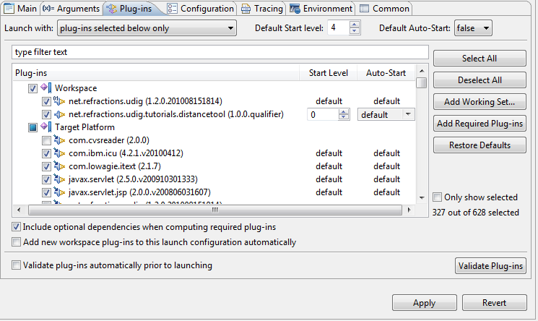
- Click Run.
- After the application has started up we can put together a map to try out the distance tool.
- Select File > New > New Map
- Change to the Web view and choose WMS: jpl nasa on the page.
Select the Blue Marble Next Generation layer and press Finish.
- Select the Distance Tool ( ) from the toolbar and drag from one point to another on the Map.
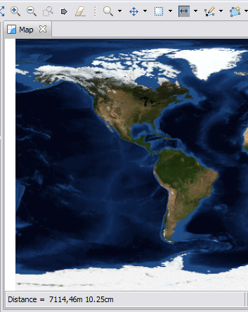
You can find your distance tool “under the i” since you placed it in the information tool category.
- The distance will be displayed in the Map status bar.

Question and Answer
Here are some common questions:
Q: My distance tool does not show up
A: Did you open the information tool menu and look in the drop down list?
A: Check your plugin.xml file; make sure the “id” is unique; check that it does not conflict with the extension point id that contains it.
Q: Unable to calculate the distance!
A: The projection of your data must be defined, you may see this if you are working with a shapefile that does not have a ".prj" file defined.
Q: Connection error has occurred
A: Sounds like the data you were looking for is unavailable, try a different WMS.
Q: How can I look at the source code examples
A: It is included in the SDK:
- Make sure you have the Plug-in Development Perspective open
- Open the Plugins tab and scroll down the the code examples
- Right click and Import As a Binary Project
- The project will be copied into your workspace.

What to do Next
Here are some additional challenges for you to try:
- Tools are organized into "Categories" each with their own keyboard short-cut, the Distance Tool is in the category "Information".
Create your own Category
- Plug-ins have a life cycle (controlled by the Platform class); the start method is used to provide your Activator with a BundleContext (used to access resources like Icons).
The ID for your Plugin is used so often that it is worth making a constant in your activator for others to refer to. This may already be done by the wizard.
public static final String PLUGIN_ID =
"net.refractions.udig.tutorials.distancetool";
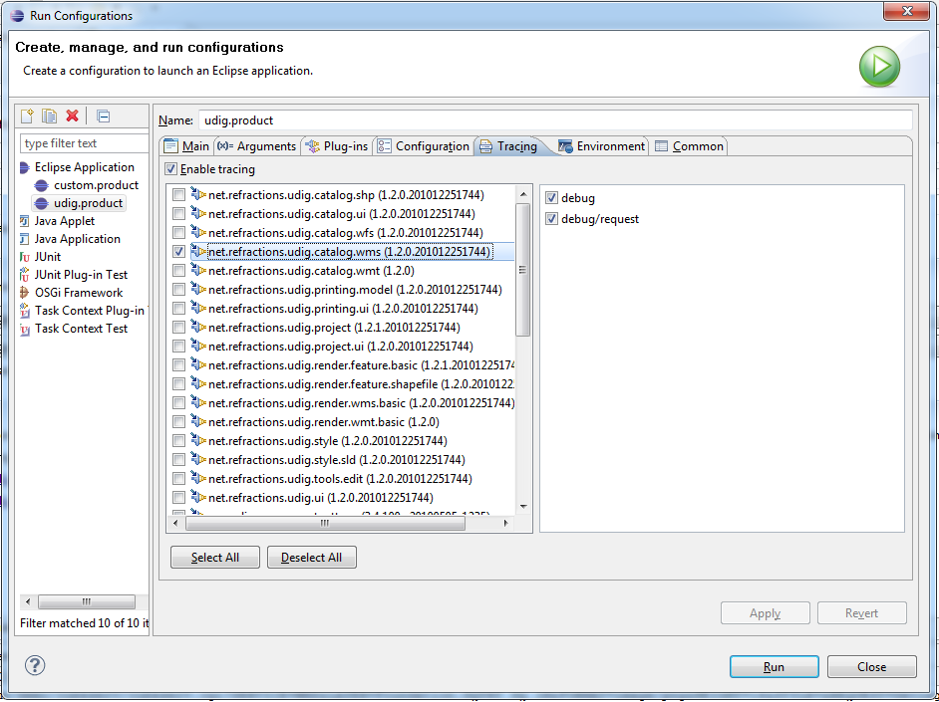
- Your activator can also be used to send log messages; and check debug options (from the TRACING page)
To enable this, add a “.options” file to your plug-in next to plugin.xml. The presense of a “.options” file tells the system that you have trace options available.
net.refractions.udig.tutorials.distancetool/debug=true
net.refractions.udig.tutorials.distancetool/debug/distance=true
At runtime use your Activator to check if tracing is turned on, put the following in the start method:
if( isDebugging() &&
"true".equalsIgnoreCase(Platform.getDebugOption(PLUGIN_ID + "/debug"))){
Status status = new Status(IStatus.INFO,PLUGIN_ID,"Distance Tool Started");
getLog().log(status);
}
Now, output your distance results to the console log. This information is currently being displayed in the status bar (eg. 3420 km)
- Advanced: You can select the "Information" category by pressing "i".
Hook up your category to a keyboard binding.

