





UDig Walkthrough 3
Working with Images
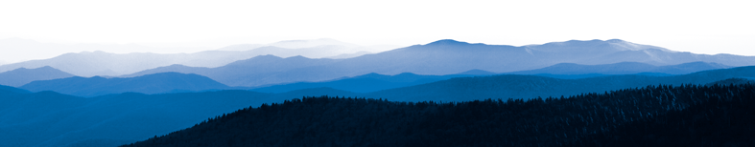
Table of Contents
1 Introduction 3
2 Georeferencing 4
3 What to Do Next 8

Introduction
TODO

Writing Tip: When writing the introduction try and cover the same material as presented in the slides; you can use diagrams and so on as needed. The goal here is to have very clear step by step instructions. If you would like to communicate ideas and concepts or background information please use this introduction section, or the intro paragraph of each section, or the fly out text.

Georeferencing
In this section we will use uDig to georeference an image in a map. The georeferencing tools are shown in the following menu:
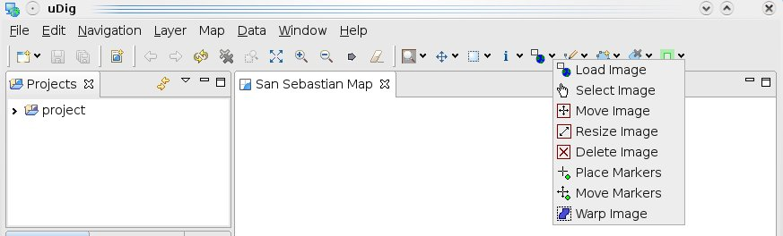
We will explore these tools in a real georeferencing case.
- Click on the “data download” link and save the zip file to your local computer.
At the time of writing the file was:
http://udig.refractions.net/files/data/data_1_2.zip
- After starting uDig, please choose the File menu and select New > New Map to create a new map. Rename this new map as San Sebastian Map.
- Load a base map layer with a proper projection. For this example we will use the gipuzkoa-roads.shp file which includes a proper projection. Add this file in the map.
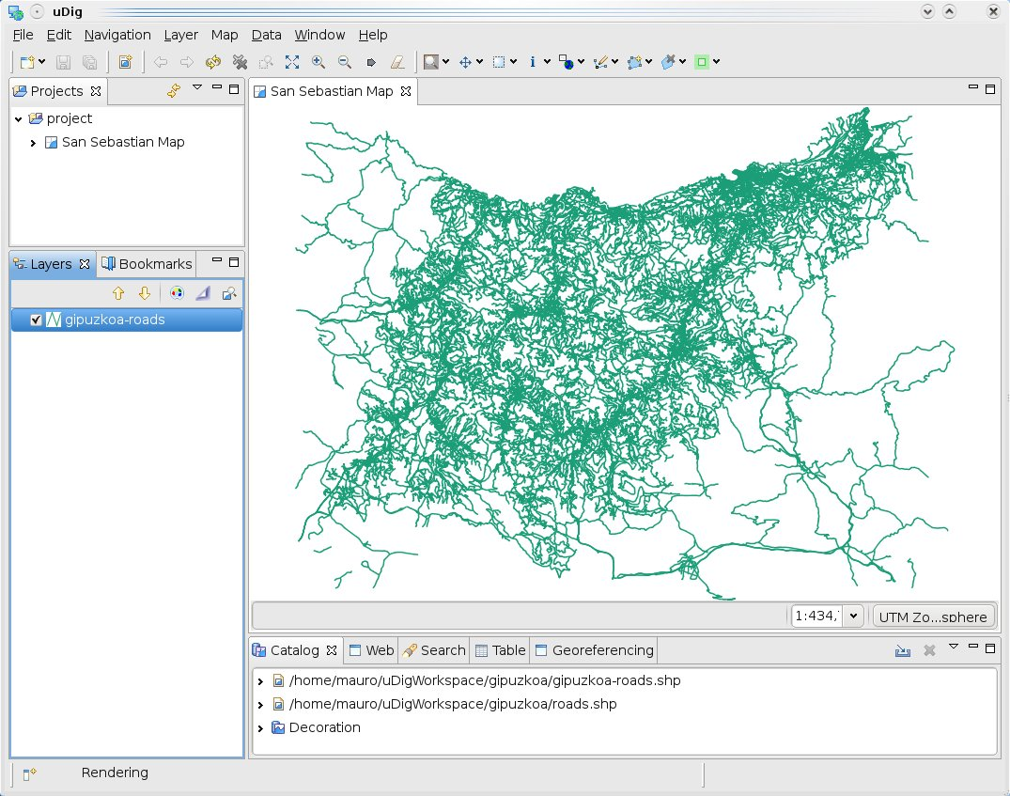
- Use the Zoom tool to display the San Sebastian, La Concha Beach, it is near the coordinate x=580403 and y =4797593.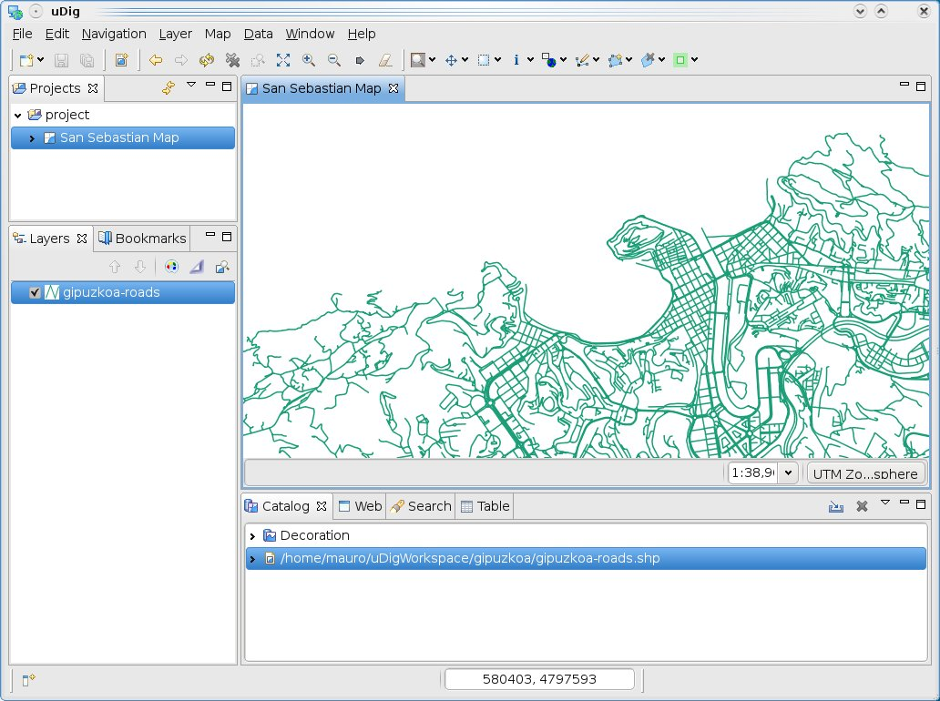
- Now, that the base map layer is loaded, we need to load an image over the map. Click the and browse to the la-concha-beach.jpg image which we want to georeference.
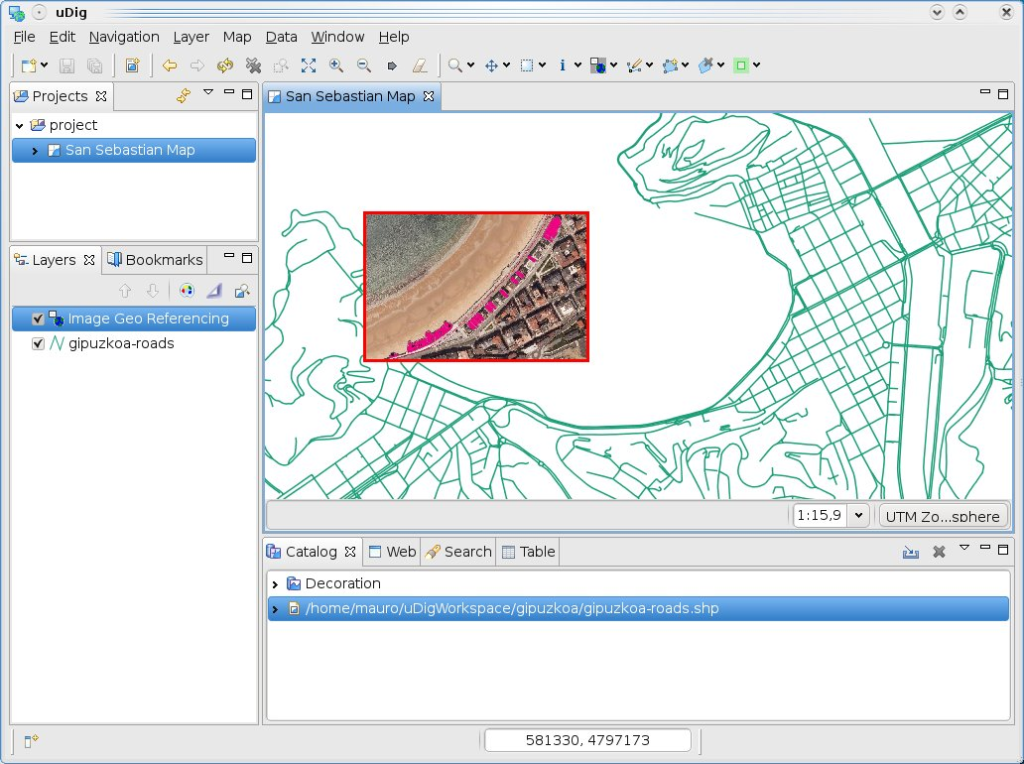
The image could be manipulated using the following tools:

- Now, we need to place a minimum of 6 markers on both the image and the base map that line up with each other. Select the tool to mark the references as shown in the following screenshot.
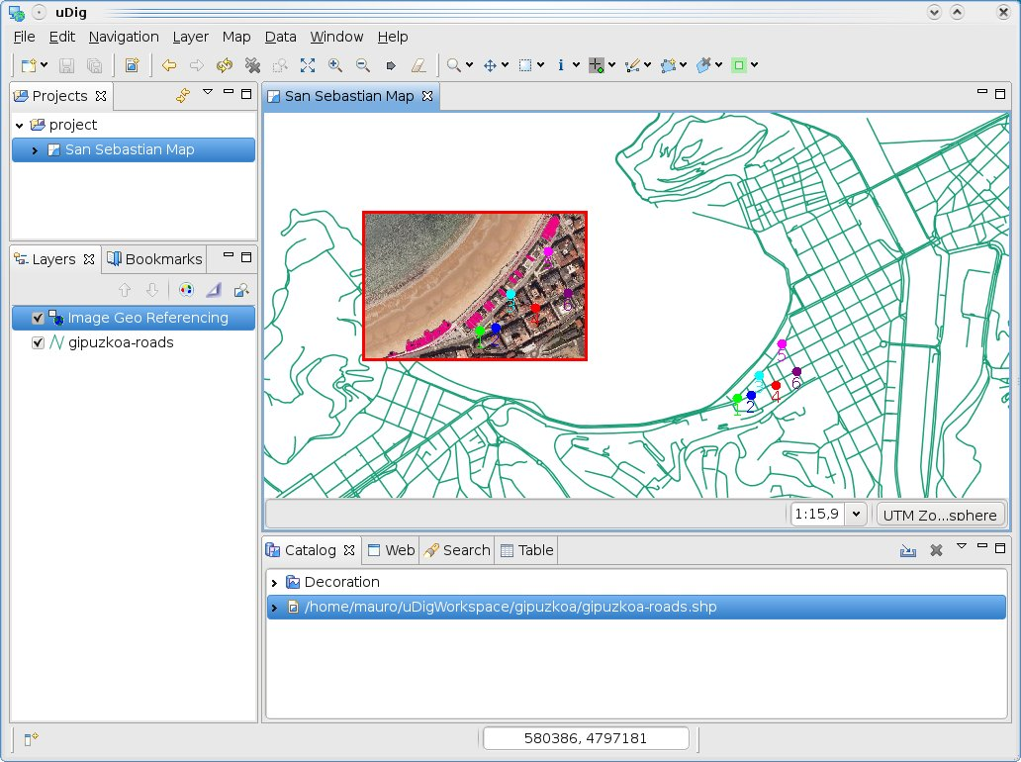
- If it is necessary you could move a mark using . Finally, we have a set of related marks that will be used as input in the georeferencing process. So, we will select in order to get the georeferencing image. This tool opens a dialog to select the place where you want to put the georeferencing image, then we write the file name: la-concha-beach.tif

- The result is presented in the following image.
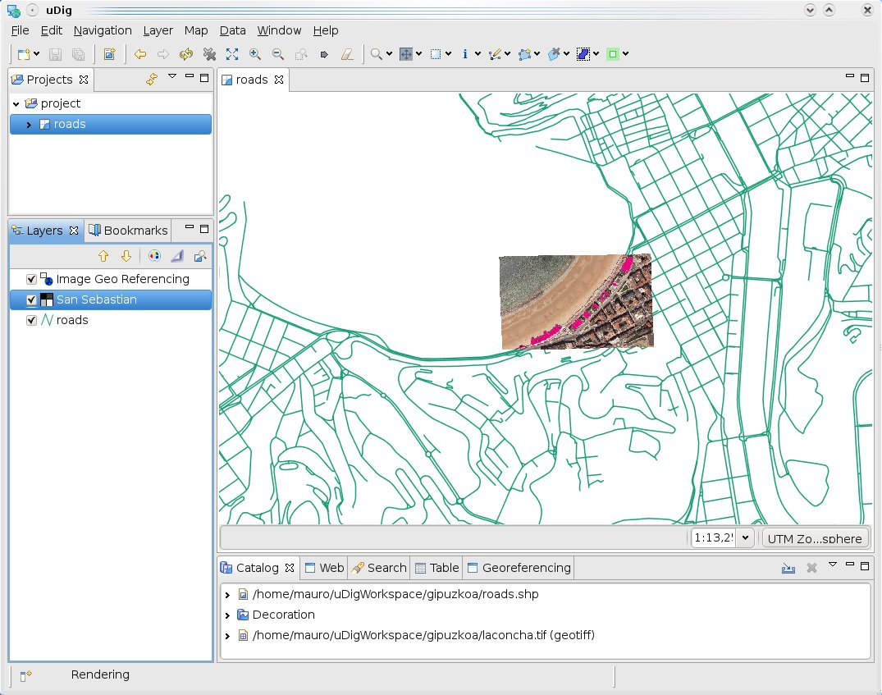

What to Do Next
Here are some additional challenges for you to try:
- Present a list of ideas for people to try out. Start off very specific with something most people can do based on the materials as presented.
- Continue on with a challenge that involves a small bit of research (it is recommended that the research be limited to something that can be found in the eclipse online help – in case the course is being presented behind a firewall)
- Finish up with an actual challenge for which you do not know the answer. As classes accomplish these goals you will both learn more.

