





SDK Quickstart
Set Eclpse for uDig Plug-in Development

Table of Contents
1 Introduction 3
2 Downloads 4
3 Eclipse SDK Installation 5
4 Eclipse Workspace 7
5 Eclipse Preferences 8
6 uDIG SDK 9
7 Running uDig 12
8 What to Do Next 15

Introduction
This workbook is aimed at those doing plug-in development against the uDig platform. Follow these instructions to quickly set up a development environment for working on your own plug-ins.
If you would like to work on uDig itself please visit the project Policies and Procedures.
Eclipse is familiar to most developers as a Java Integrated Development Environment (IDE). The Eclipse IDE can be extended with additional “capabilities” to work with alternate programming languages (like C++ or Ruby), or additional subject matter such as Java Enterprise Edition or in this case Eclipse Plug-in development.
In this Quickstart we are going to use the the Eclipse Plug-in Development capability; with the uDIG SDK as the target platform. This workbook covers setting up a development environment for working on your own plug-ins.
If you have an existing Eclipse installation please do not skip this tutorial – we are going to very carefully set up a copy of Eclipse with a few more additional tools then you are perhaps used to.
The Eclipse developers themselves make use of the Plug-in Development Environment (PDE) day in and day out – so it has gotten a lot of polish over the years. In some respects it is more polished then the Java development environment (with custom editors for all kinds of little files).
Some of the terminology used when working with the PDE:
- Everything is a Plug-in
- A plug-in can implement an extension
- A plug-in can provide an extension-point for others
Please keep these ideas in mind – even an “Application” is considered an extension when working with the Eclipse Platform.

Downloads
We are going to start by downloading all the software we need; we will be able to proceed with installation as we wait for some of the larger downloads.
If you are using this work book in a lab setting you will find these downloads available on your course DVD.
- For uDig 1.2 we are going going to download the latest SDK from here:
http://udig.refractions.net/download/
Normally you would grab the latest stable SDK from the public uDig download page.
At the time of writing the latest uDig SDK was:
udig-1.2.1-sdk.zip
- Visit http://www.eclipse.org/downloads and click on the link for “Eclipse Modeling Tools” and download the appropriate
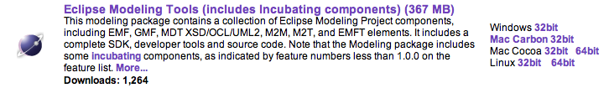
Tested with Eclipse 3.6.1 Helios Packages:
eclipse-modeling-helios-SR1-incubation-win32.zip
- We have prepared an “dropins” download in the following folder:
http://udig.refractions.net/files/downloads/extras/
This download includes a developers guide for udig, platform language packs, and a resource bundle editor.
At the time of writing: dropins-3.6.1.zip
- Download a Java Runtime Environment from this folder:
http://udig.refractions.net/files/downloads/jre/
This is a special JRE that has been extended with Java Advanced Imaging and Image IO and GDAL for spatial image formats.
At the time of writing: jre1.6.0_17.win32_gdal_ecw.zip
GDAL support is provided by the imageio-ext project started by GeoTools alumni.
- Download Eclipse RCP Delta Pack
Download the RCP-Delta Pack from http://download.eclipse.org/eclipse/downloads/ you will need to choose the "Latest Release" build; and the scroll down to the "Delta Pack" link to download.
Eclipse-3.6.1-delta-pack.zip at the time of writing

Eclipse SDK Installation
Hopefully by now your eclipse download has finished and we can begin to installation.
- Create a folder: C:\java
- Unzip the downloaded eclipse-modeling-helios-SR1-incubation-win32.zip file to your C:\java directory – the folder C:\java\eclipse will be created
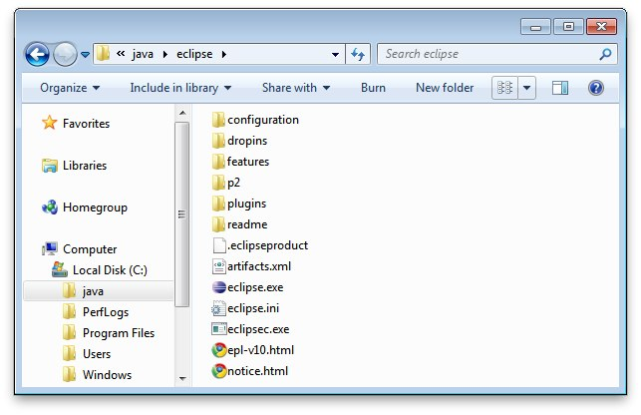
If you need a good program to unzip archive files try:
www.7-zip.org
- Open up the jre zip file Drag from the 7zip window.
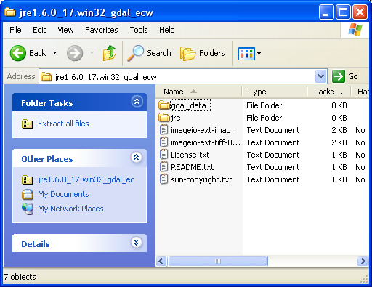
The folder must be called “jre” for the eclipse.exe to recognize it
- Drop into your C:\java\eclipse
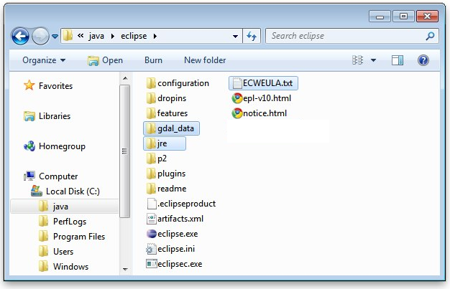
- Unzip the dropins-3.6.1.zip file to your eclipse/dropins folder. The download will add additional plug-ins and features to to your eclipse installation without getting mixed up with the bare-bones eclipse.
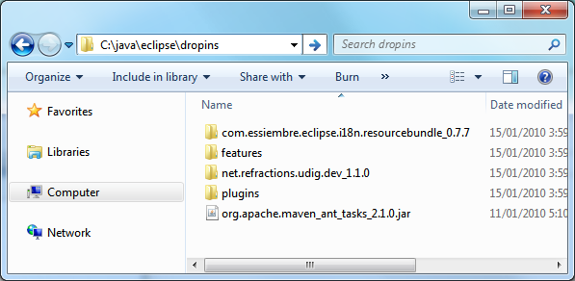
Be careful when extracting this zip not to get something silly like dropins/dropins
- Navigate to C:\java\eclipse and right-click on the eclipse.exe file and select Send To->Desktop (create shortcut).
You may want to modify the “eclipse.ini” file to specify additional command line options such as more memory.

Eclipse Workspace
The Eclipse IDE keeps track of what you are doing in a workspace. You can have several workspaces (often for different projects) each with its own configuration.
- Double click on your desktop short cut to start up eclipse. When you start up eclipse for the first time it prompt you for a workspace.
- Choose a workspace for your sdk development:
C:\java\workspace
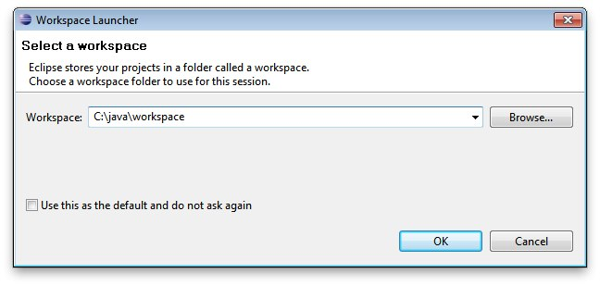
- Wait a few moments while eclipse starts up.
- On the Welcome view press the Workbench button along the right hand side.
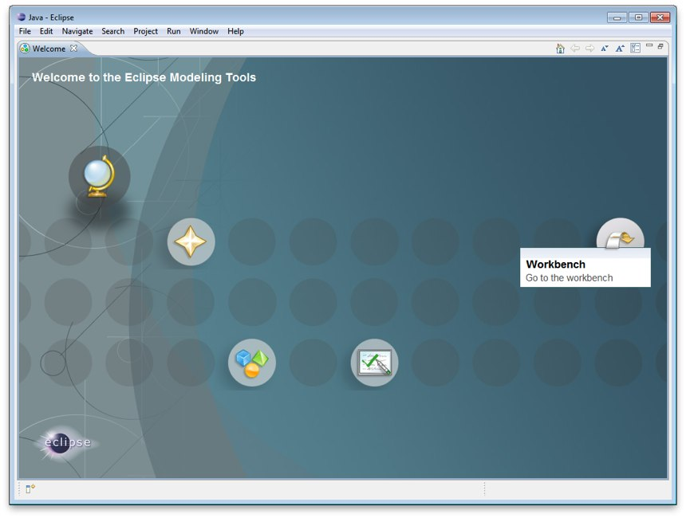

Eclipse Preferences
We have a few global settings to configure before we can proceed.
- Open up Window > Preferences from the menu bar.
We are waiting for a Mac OSX JRE to be available before using Java 6.
- Navigate to the Java > Compiler page and change:
- Compiler compliance level: 1.5
- Check the Java > Installed JREs page:
- Should have Location: C:\java\eclipse
If the setting is not correct you can use the Add.. button and create a JRE entry for C:\java\eclipse
- You can press Edit to look at the installed JRE.
Regardless of platform we are interested in making sure jai_core.jar, jai_imageio.jar and jai_codec.jar are available.
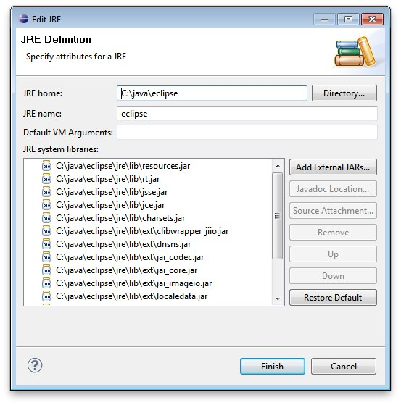
On OSX we are not able to provide a JRE for you to download – uDig will install JAI and ImageIO when run for the first time.
- As a result of these changes, Eclipse may prompt you to perform a clean build. Simply accept this request; it won't take long since we don't yet have any source code.

uDIG SDK
We are now going to unpack the udig sdk and use it as our plug-in target platform.
- Extract the udig sdk download into C:\java\target
- Extract the eclipse-delta-pack download into C:\java\target
- You will be left with the following directory structure:
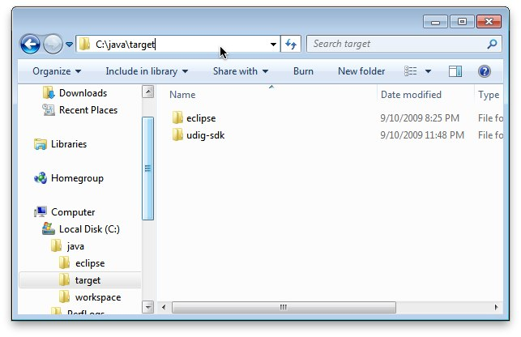
- Go back to eclipse and open Window>Preferences.
- Select the Plugin Development > Target Platform page.
- Press the Add button to start a new target definition
- Choose Nothing as we are going to define a target from scratch
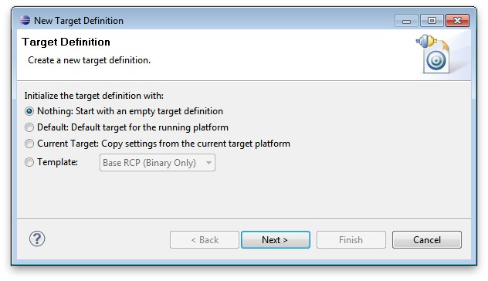
- Fill in the name “uDig SDK” for this target
- Press the Add button and add a Directory. Choose the C:\java\target\eclipse directory where you unpacked the eclipse-delta-pack
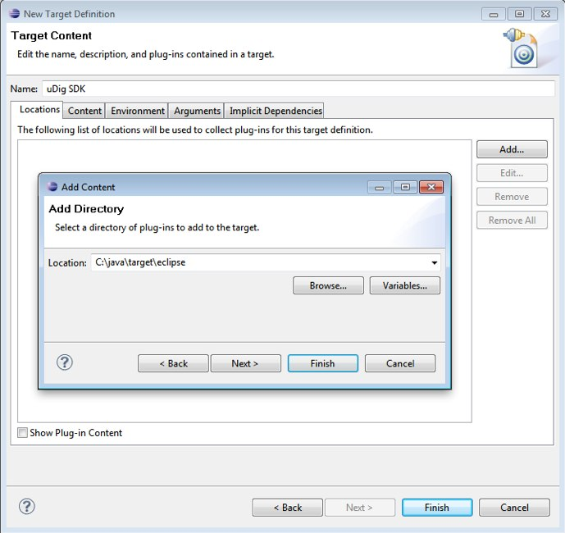
- Press Add again and add the C:\java\target\udig-sdk directory.
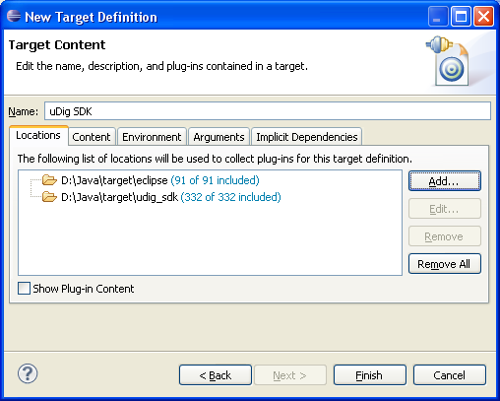
- Press Finish to complete the “uDig SDK” target platform. Please tick the checkbox next to the “uDig SDK” so it will be the Active target platform.
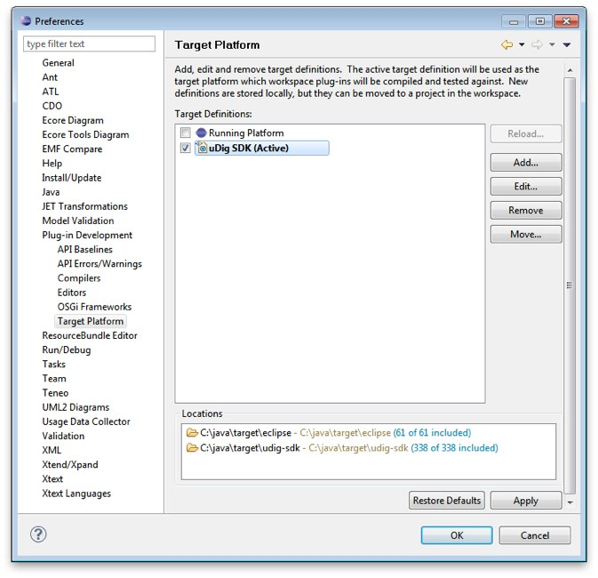
- Press OK
At this point all the source code for the Eclipse and uDig plug-ins are available. We can now start working on uDig plug-ins, but before we do that lets try running the application.

Running uDig
With all this in place we can now run the uDig application from your development environment. This is a good way to test that everything is installed correctly.
- To start out with we will switch to the Plug-in Development perspective; in the top right of the toolbar you can choose Other to open the Open Perspective dialog
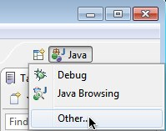
- Chose Plugin-Development from the list and press OK
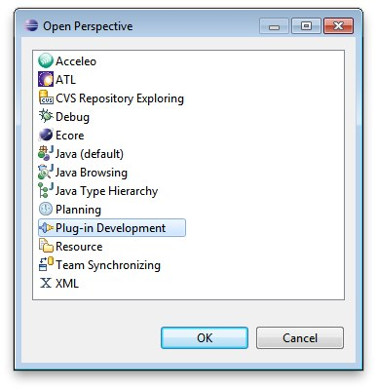
- Click on the Plugins view and right click on net.refractions.udig plug-in the list.
Select Import As > Source Project to copy the plugin into your workspace.
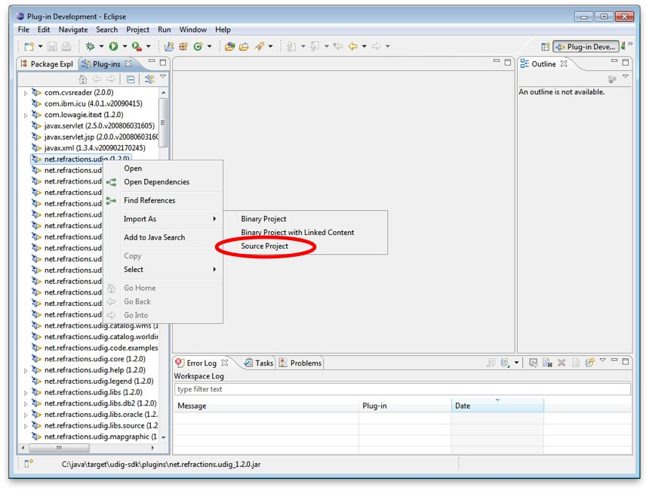
- Change to the Package Explorer view and open up the net.refractions.udig plugin and double click to open udig.product.
- From the overview tab of udig.product click on the Launch Eclipse Application link
(it is located under testing as shown below).
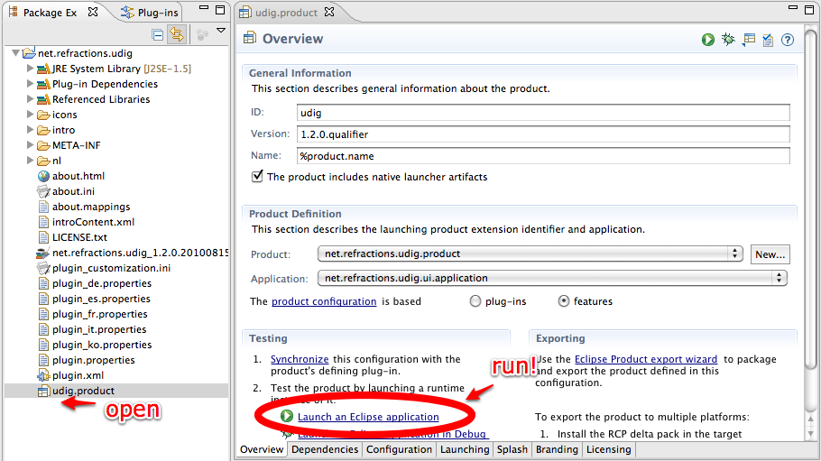
- The application will now start!
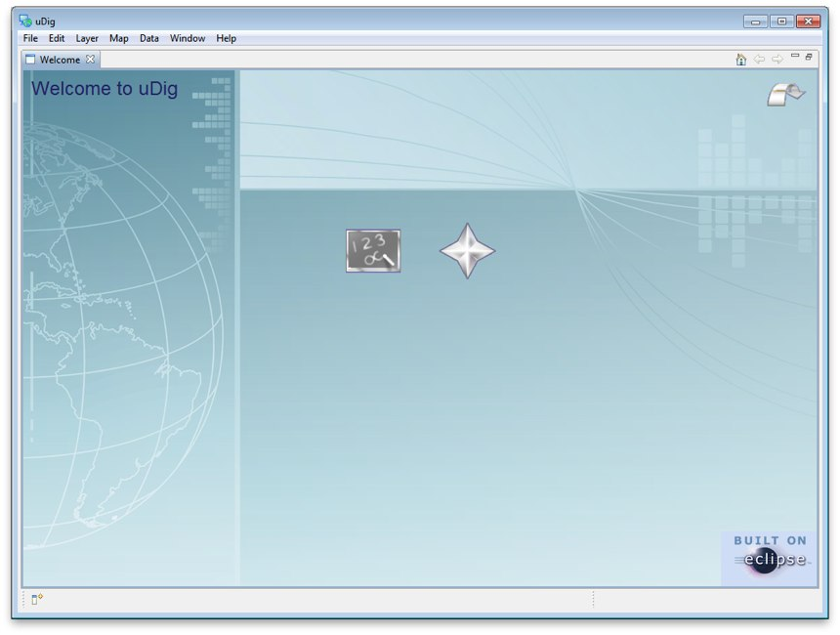

What to Do Next
Here are some additional things to try when running uDig.
- From Eclipse open up Run > Run Configurations to examine or customize configuration of uDig you are running. Many of these fields were filled in for you by the udig.product.
- The number one tip is to go to the Arguments tab and enable console logging. To send log information to the console as udig runs add -consolelog to your “program arguments”.
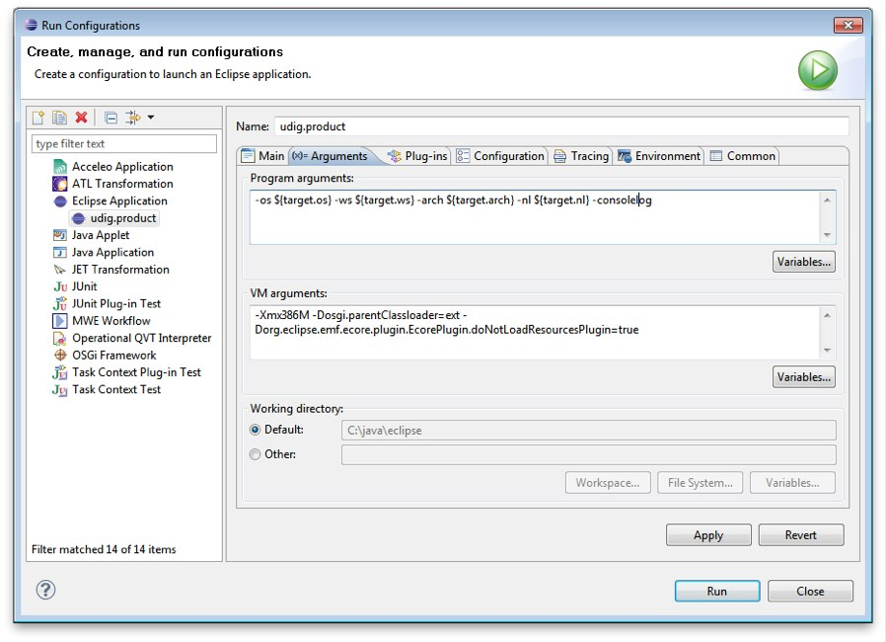
You can also review the VM arguments; including changing the amount of memory available to your uDig application -Xmx512m may be useful when working with large images?
The -Dosgi.parentClassload=ext setting allows uDig to find JRE extensions such as Java Advanced Imaging and ImageIO.
For documentation on these command line parameters check the eclipse help menu.
- The running uDig application makes use of the “Workspace Data” folder defined in the Run dialog. Try checking clear and workspace in order to simulate starting uDig from a fresh install.
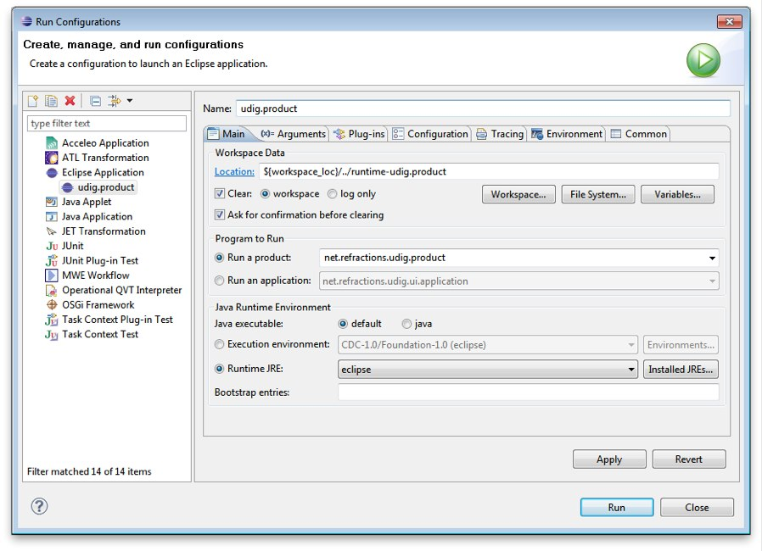
- Have a look on the Tracing tab of the Run dialog; you can control the amount of logging information produced (for example WMS logging is turned on below).
Tracing is especially useful when the -consolelog program argument is used.
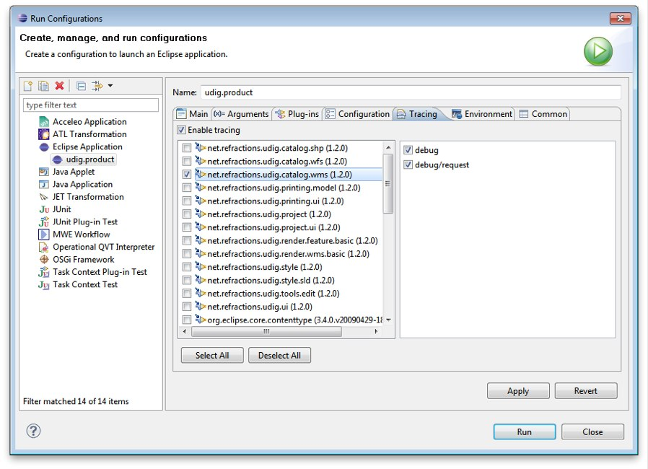
- Have a look at the plug-ins tab and see if you can turn off: printing support.
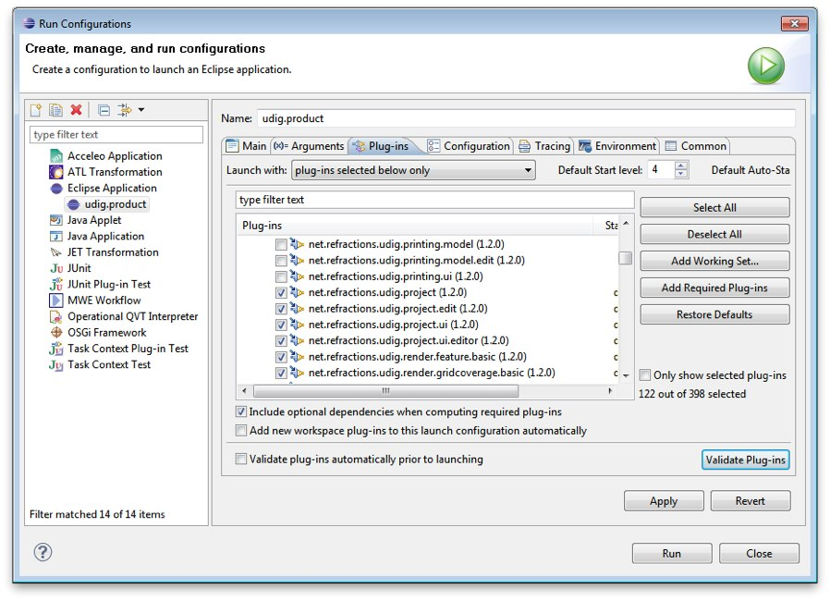
Normally the plugins included by an application are organized into features – we will cover how to do this in the custom application tutorial.
- Advanced: When working on the uDig project itself we use the FindBugz tool to check for obvious mistakes prior to committing. You can add FindBugz to your environment using the following update site:
http://findbugs.cs.umd.edu/eclipse
