





Title Property
Subject Property

Table of Contents
1 Introduction 3
2 WMS and WFS Integration 4
3 What to Do Next 5

Introduction
In this workbook we are going to cover two major topics. The first is a tour of Web Feature Server functionality using a local GeoServer installation. We will use a WFS to edit both feature geometry and feature attributes. We will also show how to export information out of a WFS using both a local shape file and the system clip board.
The rest of the workbook is devoted to working with information. We will create a new feature type by hand, and work with a range of feature creation and editing tools. Finally we will save the result to a new file.
For more instruction see:
- http://geoserver.org/
Writing Tip: When writing the introduction try and cover the same material as presented in the slides; you can use diagrams and so on as needed. The goal here is to have very clear step by step instructions. If you would like to communicate ideas and concepts or background information please use this introduction section, or the intro paragraph of each section, or the fly out text.

Section Title
In this section we will use uDig to display contents from our local Web Feature Server. We will also make use of some of the more interesting selection features.
Fly out text is used to provide descriptions and background information without getting in the way of the instructions.
- After starting uDig, please choose the File menu and select New > New Map to create a new map. For instructions try and use “bold” to indicate actual names that appear on the screen
- Select the Layer > Add menu to open up the Add Data wizard.
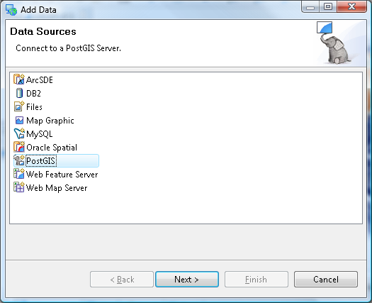
For pictures use 70% scale and make sure to use a “soft return” (ie Shift-Enter) so that the picture is considered part of the paragraph – this will keep the picture from being orphaned. You will need to make sure the picture is Anchored as a Character for this trick to work.
- Navigate to that GeoServer Welcome page:
http://localhost:8080/geoserver/
- Properties file
# Example properties file
foo=bar
# Code Blocks are "out dented" and make use of 8 point courier new
# So that we do not run out of room when working with Java code.
# (With these settings you can have 120 columns on the screen)

What to Do Next
Here are some additional challenges for you to try:
- Present a list of ideas for people to try out. Start off very specific with something most people can do based on the materials as presented.
- Continue on with a challenge that involves a small bit of research (it is recommended that the research be limited to something that can be found in the eclipse online help – in case the course is being presented behind a firewall)
- Finish up with an actual challenge for which you do not know the answer. As classes accomplish these goals you will both learn more.

