


GeoServer Install
Installation and Configuration of GeoServer

Table of Contents
1 Introduction 3
2 Java Runtime Environment 4
3 GeoServer install 6
4 Starting up GeoServer 11
5 OpenLayers Tasmania Preview 14
6 What to do Next 16

Introduction
GeoServer is Java Enterprise Edition application used to publish spatial information. It supports a number of Industry Standard protocols and also offers a REST API for configuration.
In this workbook we are going to install GeoServer and go over a couple of configuration options.
After completing this workbook, you will have:
- Installed a Java Runtime Environment onto your computer
- Installed GeoServer using the Windows installer
- Started up and Customize GeoServer
- Started the Open Layers Tasmania Preview

Java Runtime Environment
GeoServer is a Java application – if you do not already have Java on your system please go ahead and install it now. Any version of Java 5 or newer will do fine.
Previous versions of GeoServer required a full Java Development Kit in order to run JSP pages. GeoServer 2.0 makes use of the Wicket toolkit and no longer has this requirement.
- Download the latest Java SE Runtime Environment from sun:
http://java.sun.com/javase/downloads/
At the time of writing jre_6u18-windows-i586.exe had just been released.
GeoServer 2.0 has been rewritten to use the Wicket toolkit and is able to run with just a JRE.
- Double-click the installer (jre_6u18-windows-i586.exe is used in this example) and accept the license agreement.
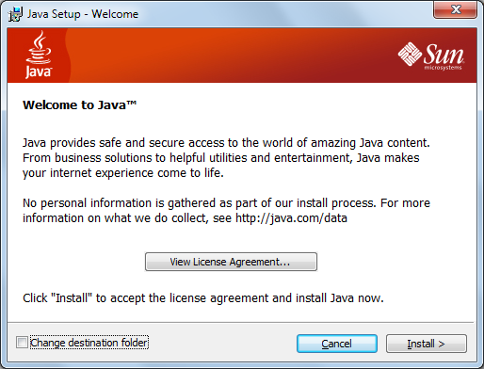
- Press the Install but to get going.
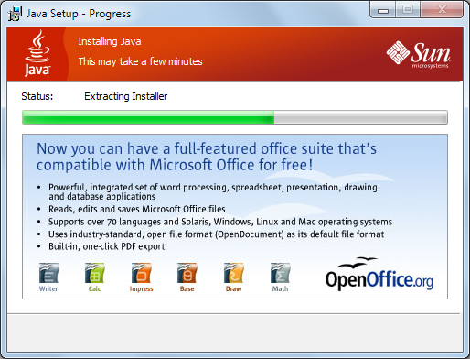
- Congratulations Java is now installed.
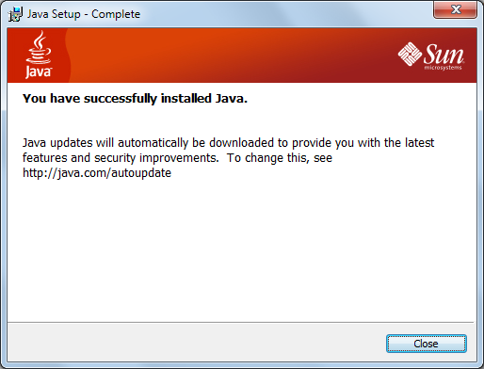

GeoServer install
GeoServer 2.0.1 has an installer that allows you to set things up as a windows service or as a normal application that you need to run manually. Since we are only installing GeoServer for today, we are going to use the manual option.
- Downloaded the latest GeoServer release:
http://geoserver.org/display/GEOS/Stable
As this workbook went to press we got a hold of geoserver-2.0.1.exe
- Double-click the geoserver-2.0.1.exe installer.
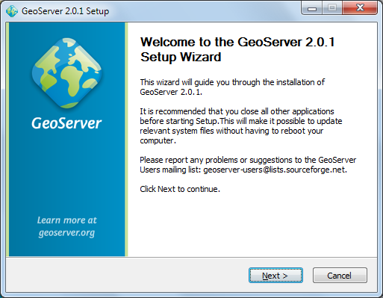
- GeoServer is released under the GPL license, press “I Agree” to contunue.
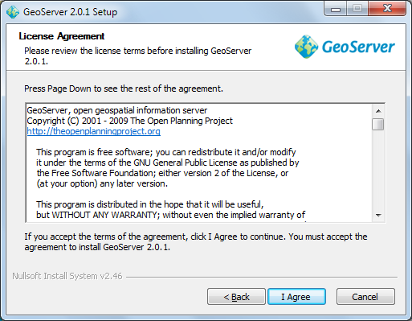
GeoServer uses the same LGPL GeoTools and ImageIO-Ext projects as uDig.
- GeoServer will install into the Programmers Files directory, press Next to continue.
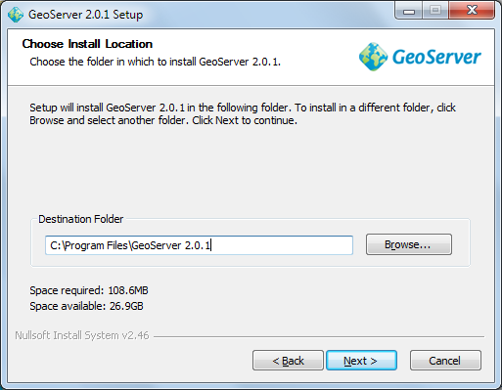
- Press Next to create the default start menu folder
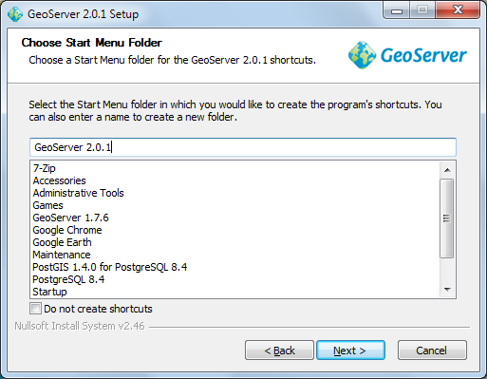
- GeoServer select your current Java Runtime Environment. Press Next to continue.
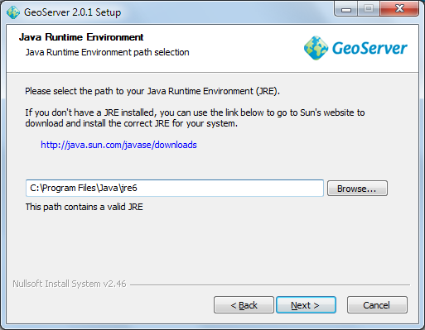
- GeoServer will store your configuration in a “data directory”, the default location will work fine. Press Next to continue.
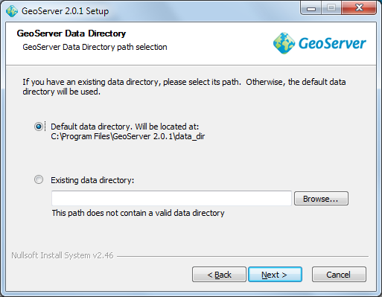
- GeoServer provides a web based configuration system allowing you to administer the application remotely. Please accept the default credentials (admin and geoserver) for the purpose of this tutorial.
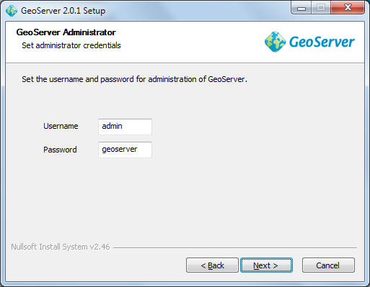
- You can also choose the port for the service, 8080 will be fine for this tutorial.
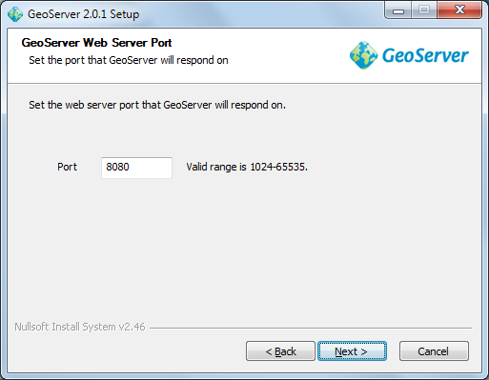
The GeoServer installer uses the Jetty application container. GeoServer is also available as a war if you would like to use Tomcat.
- We now get to choose “Run Manually” (as we are just interested in evaluating GeoServer at this time).
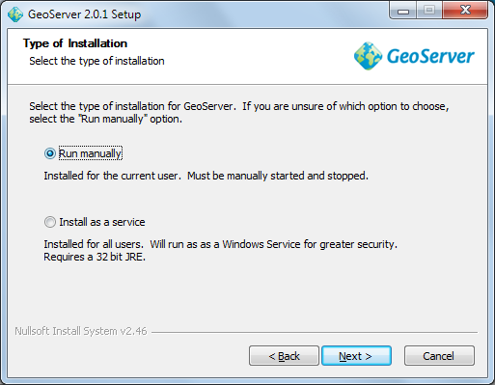
- You can review your settings and then press Finish to install GeoServer. Please wait while GeoServer installs.
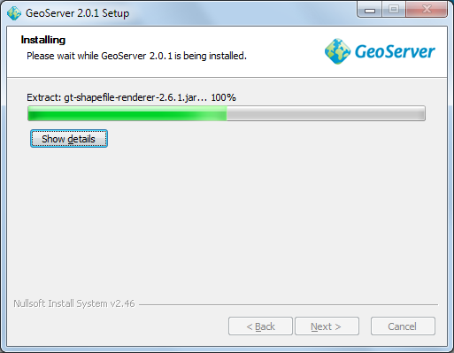
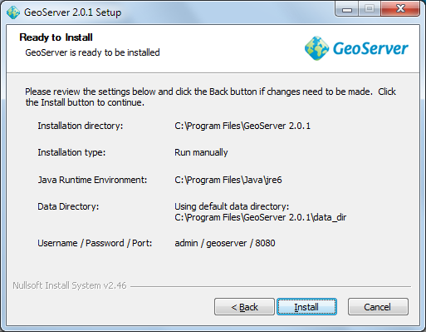

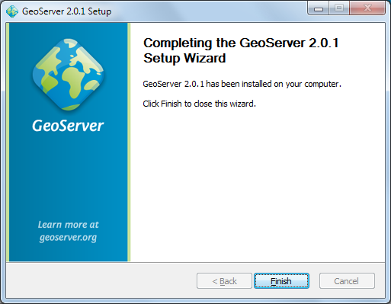

Starting up GeoServer
In this section you will learn how to start GeoServer, and explore its editing abilities.
- Click Start->Programs >GeoServer 2.0.1 >Start GeoServer
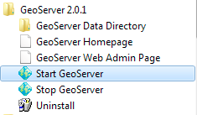
- When starting for the first time you will need to grant the Firewall permission for GeoServer to open a port.
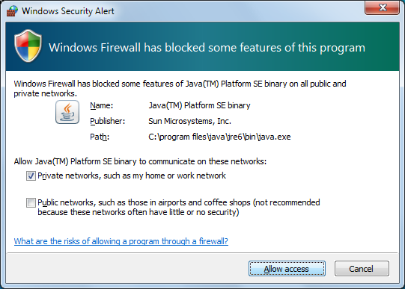
- GeoServer will open up a console running the Jetty Application Server; please wait until Jetty indicates it is listening on port 8080 as shown below.
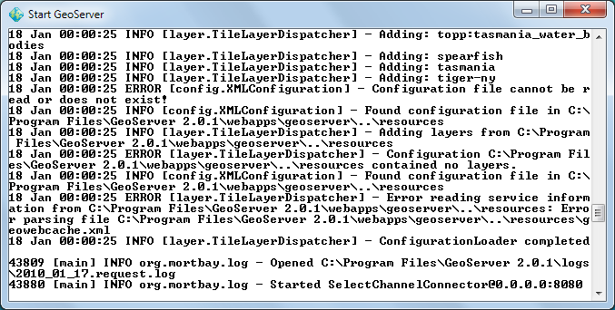
If you already jave a web server running on 8080 you can modify the jetty xml file by hand.
- You can use the start menu to open the “GeoServer Web Admin Page”.
The web browser will open: http://localhost:8080/geoserver/web/
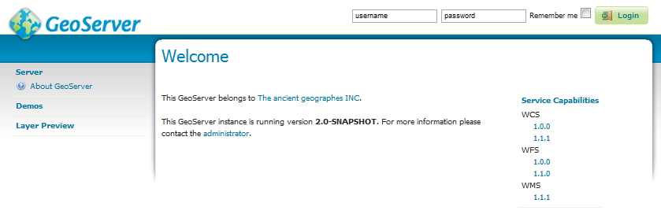
- We need to login before we can use the configuration screen. Fill in “admin” and “geoserver” along the top of the screen and press “Login”.
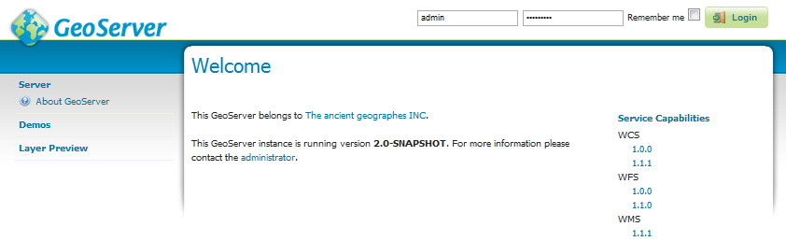
- The welcome screen now has a great many more options than in previous versions.
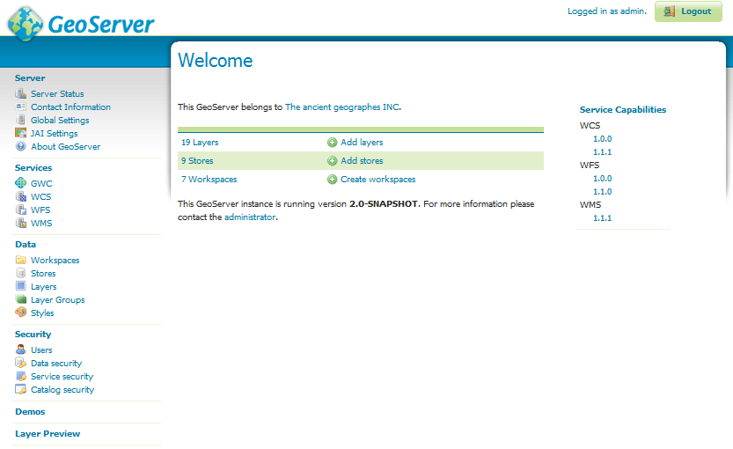
- You may notice that this GeoServer belongs to “The ancient geographes INC”. Let us go in and fix that up.
- Click on “Contact Information” and fill in the details for your organisation.
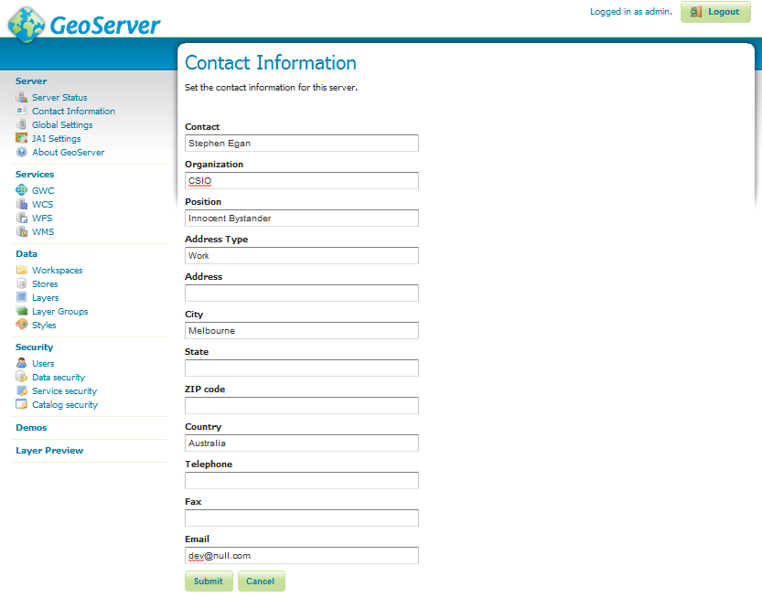
- Press the Submit button, you will be returned to the Welcome screen and you can see the contact organization has been changed.
- In a similar fashion change the title of the WMS to “Local Web Map Server”.
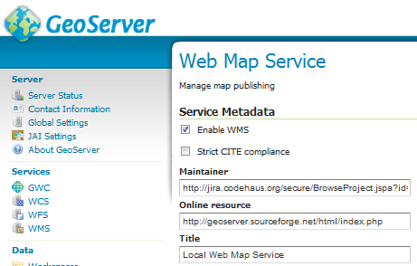

OpenLayers Tasmania Preview
GeoServer provides a layer preview implemented with the OpenLayers AJAX library.
- From the Welcome screen select Layer Preview (the bottom of the list on the left).
- From the Layers Preview page type “Tasmania” into the search box and press enter.
- In the tasmania row click on the “OpenLayers” link.
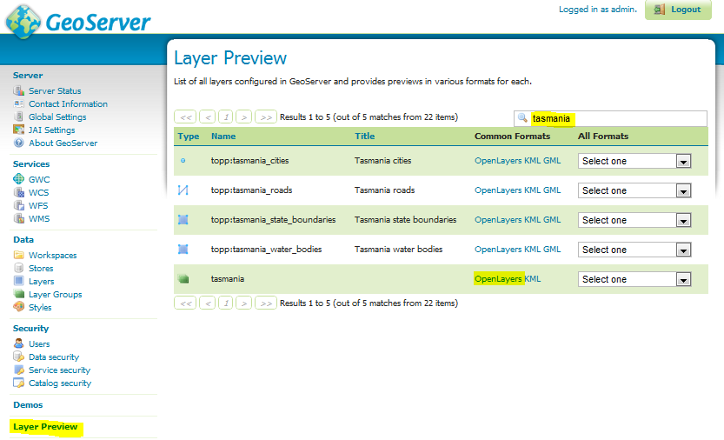
- Click on the highlighted OpenLayers link at the bottom to open a new tab. As this Open Layers application is started up you can watch the GeoServer console respond to queries.
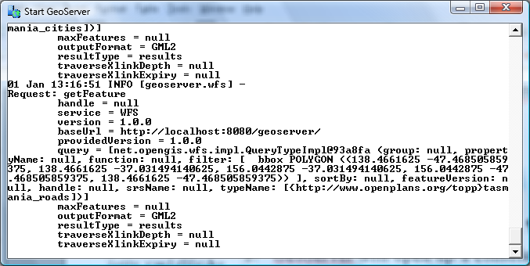
- This will bring up a web application put together with “Open Layers”.
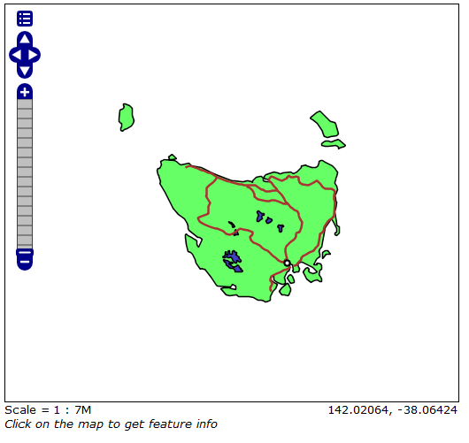
This is the same map used as a reference point for the uDig “Walkthrough 2” tutorial.

What to do Next
If you finish early here are some challenges.
- The “Sample Requests” demo lets you try out requests one at a time by selecting them from a List and hitting Submit.
Try out a GetFeature request by hand.
Try out WMS GetCapabilities and confirm the title is as you defined it.
- Turn down the amount of logging to let GeoServer run faster
- Advanced: Have a look at the “open layers” link for the Tasmania layer preview. Can you explain what trick Geoserver is doing.
How can you use GeoServer in your organisation?

