RestWell – Comprehensive System Design Specification
Version: 1.0 | Date: June 2026 | New Brand: RestWell
Prepared by: Systems Analyst, Business Analyst, Software Engineer & Project Manager Team

Executive Summary
RestWell is a modern, multi-tenant SaaS/PaaS platform for end-of-life and legacy services.
It supports funeral parlors, policy underwriters, cemetery operators, and future integration with government bodies (DHA).
Key capabilities include multi-branch operations, custom funeral policy management with multiple underwriters,
a dedicated mortuary module, geolocation for pickups/drop-offs, and flexible monetization through core features and paid add-ons.

1. Project Overview & Business Case
Business Need: End-of-life service providers in South Africa and beyond need a scalable, compliant,
and future-proof platform. RestWell digitizes operations while enabling expansion into cemetery management,
insurance underwriting, government integration, and family legacy tools.

2. Architecture & Multi-Tenancy Design
Multi-Tenancy: Implemented from the ground up using tenant_id on all tables.
Each tenant (funeral company, underwriter, cemetery operator, etc.) has isolated data.
Multi-Branch Operations: Full support for branches across provinces, regions, or countries with localization.

3. Core Modules (All Included)
- Client & Family Management (CRM/Case)
- Service Booking & Scheduling
- Inventory & Resource Management
- Financial Management & Billing
- Document & Compliance Management
- Operations & Staff Management
- Marketing, Memorials & Community
- Funeral Policy Management (with multiple underwriters)
- Mortuary Management (paid add-on)
- Geolocation Capability (core + advanced paid)

4. SaaS/PaaS Monetization Model
Base Platform + Paid Add-ons: Mortuary, Advanced Geolocation, Premium Notifications, In-App Calls, Advanced Analytics.

5. Cross-Platform Delivery
Frontend: Flutter (Android, iOS, Huawei, Windows .exe, Web PWA)
Backend: Django REST with Docker support.

6. Application Screenshots (Mockups)

Main Dashboard (Mobile)
Active cases, calendar, and revenue overview.
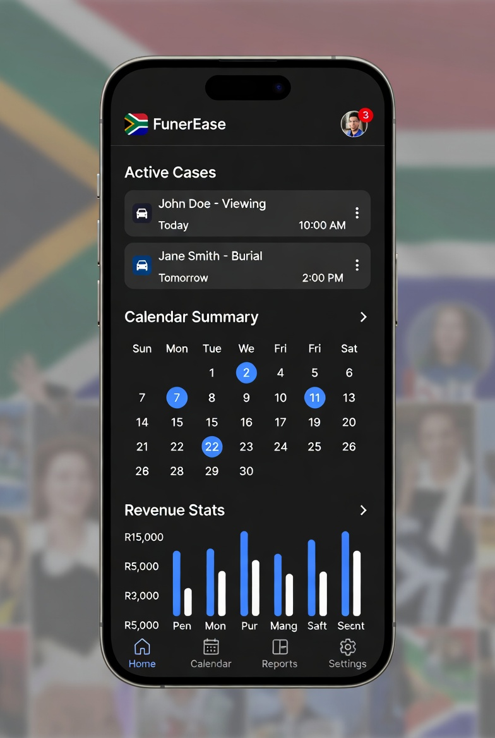

New Case Creation (Tablet)
Step-by-step case wizard with family and policy selection.
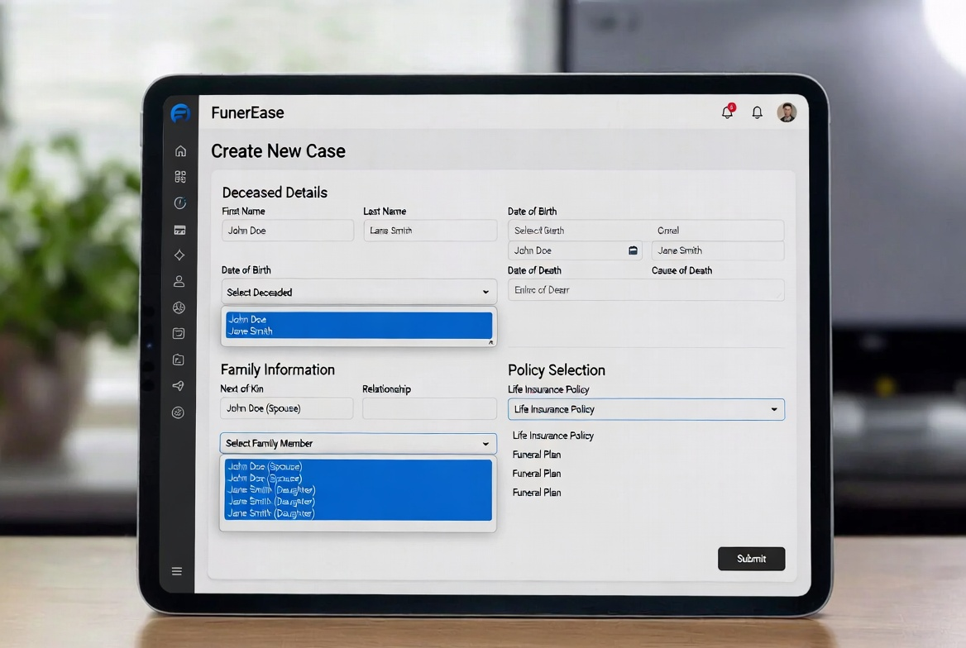

Policy Enrollment (Mobile)
Custom plan, premium, and underwriter selection.
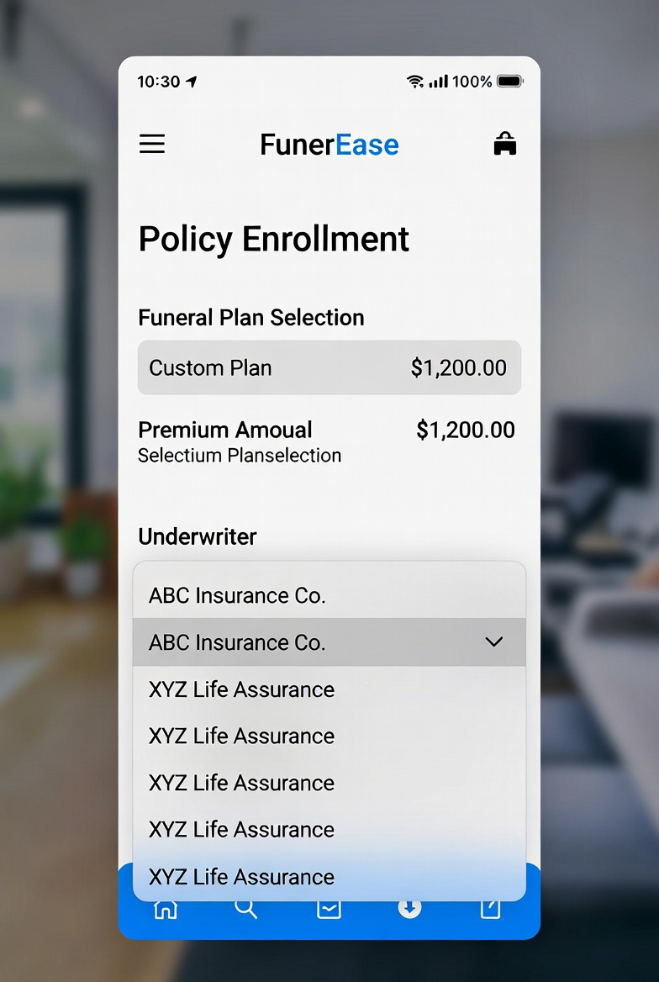

Multi-Branch Dashboard (Desktop)
Branch overview and monetization toggles.
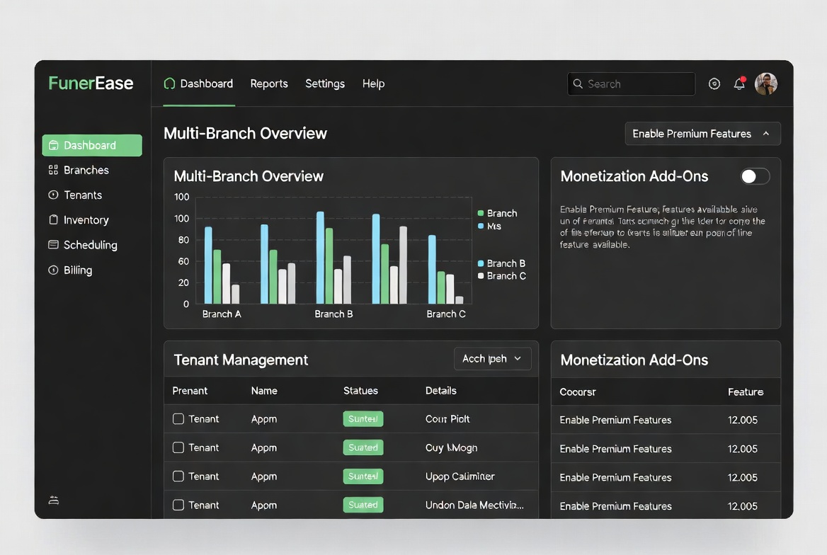

Mortuary Management (Mobile)
Body intake, storage, and preparation tracking.
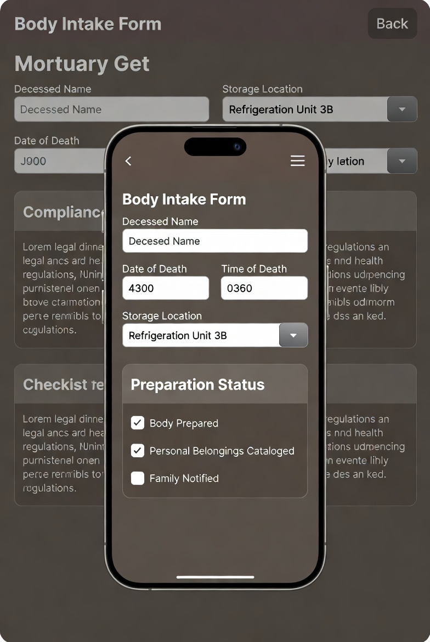

Geolocation Map (Mobile)
Live pickup and drop-off route tracking.
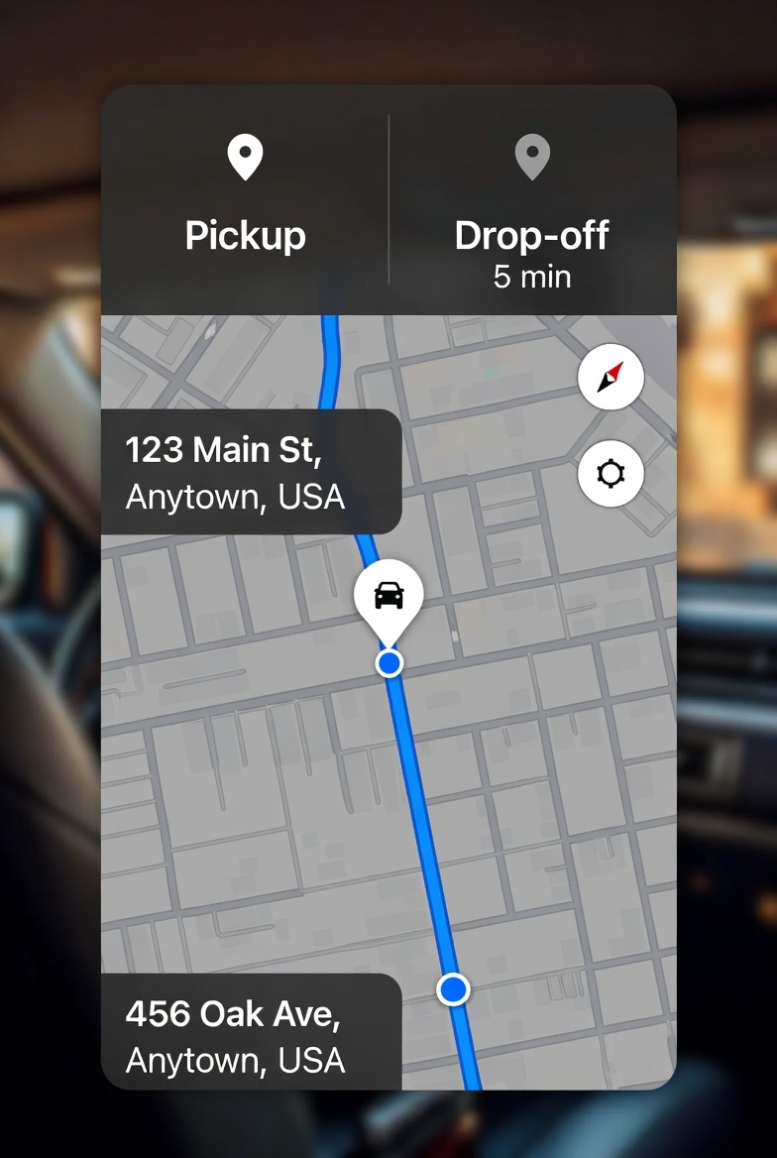

Claims Processing Flow
End-to-end claims submission, verification, and approval workflow.
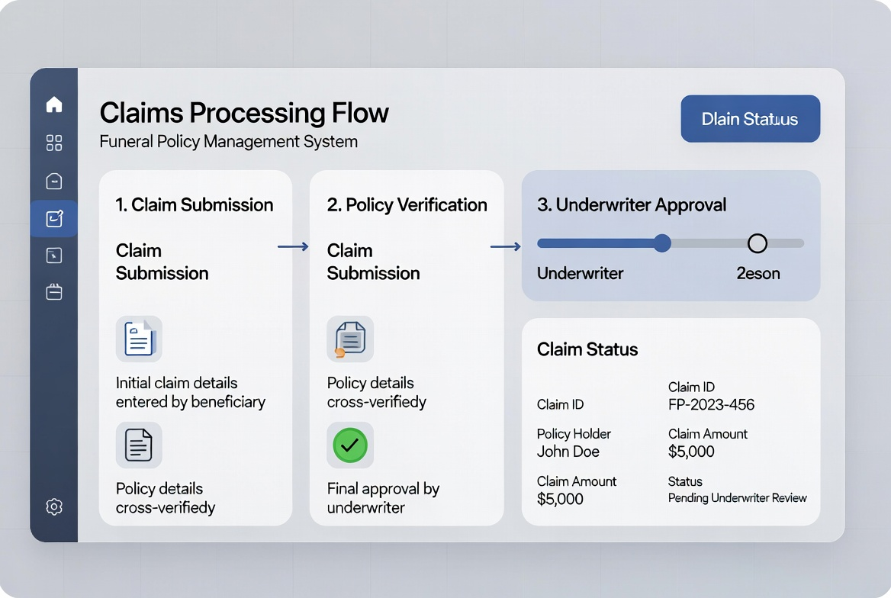

7. Implementation Roadmap
Phase 1 (MVP): Core modules + multi-tenancy + basic policy + geolocation.
Phase 2: Mortuary module, advanced add-ons, cemetery features.
Phase 3: DHA integration, legacy tools, marketplace expansion.

