SHOPPA
Shopping Intelligence Platform
API Specification
REST endpoints, conventions, and real-time channels
Document | API Specification
Project | Shoppa — Shopping Intelligence Platform
Version | 1.0 (API v1)
Status | Draft for review
Prepared by | Backend Engineering
Date | June 2026

Contents

1. Introduction
This document specifies the Shoppa REST API: conventions, authentication, error handling, and the primary resource endpoints. It is the contract between the backend and the mobile/web clients, and the reference for integration testing.
The API is built on Django REST Framework, is versioned, and returns JSON. Real-time features are delivered separately over WebSockets (Django Channels) and are summarized in Section 9.

2. Conventions
Aspect | Convention
Base URL | https://api.shoppa.app/v1
Format | JSON request and response bodies (UTF-8)
Versioning | URI-based (/v1); breaking changes increment the version
Naming | snake_case fields; plural resource collections
IDs | UUIDs for all resources
Timestamps | ISO 8601, UTC
Money | Integer minor units + currency_code (e.g. 1599, "ZAR")
Pagination | Cursor-based; page_size with next/previous cursors

3. Request Lifecycle
Each request passes through gateway, authentication, region scoping, validation, business logic, and persistence, with cross-cutting concerns applied throughout.
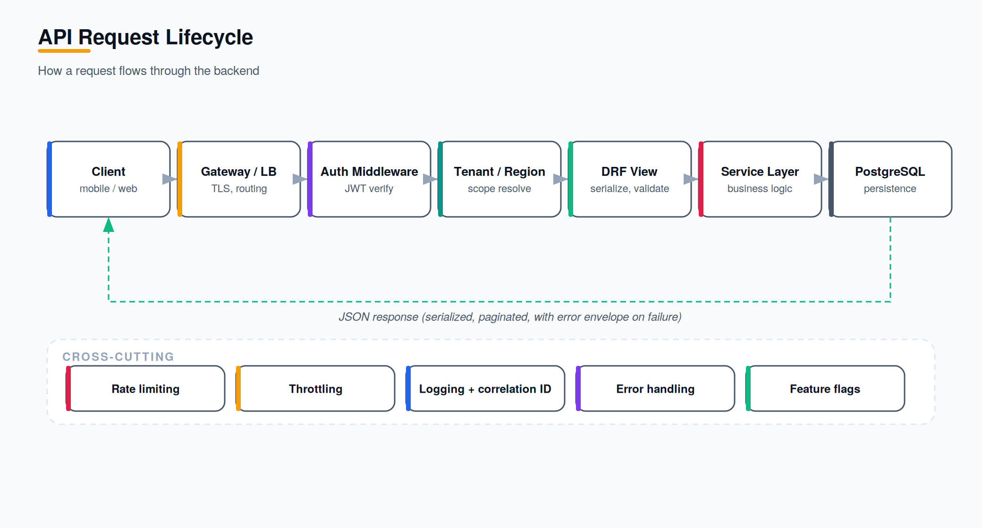
Figure 1 — API request lifecycle.

4. Authentication
Authentication uses JWT bearer tokens. Clients obtain an access/refresh pair at login and send the access token on each request. The access token is short-lived; the refresh token mints new access tokens.
POST /auth/register
POST /v1/auth/register
{
"email": "user@example.com",
"password": "••••••••",
"account_type": "personal",
"region": "ZA"
}
POST /auth/login
200 OK
{
"access": "<jwt>",
"refresh": "<jwt>",
"user": { "id": "uuid", "email": "...", "account_type": "personal" }
}
POST /auth/refresh
Header for authenticated requests:
Authorization: Bearer <access_token>

5. Error Handling
Errors return a consistent envelope with an HTTP status, a machine-readable code, and a human-readable message. Validation errors include per-field detail.
422 Unprocessable Entity
{
"error": {
"code": "validation_error",
"message": "One or more fields are invalid.",
"fields": { "email": ["This email is already registered."] }
}
}
Status | Meaning
200 / 201 | Success / resource created
400 | Malformed request
401 | Missing or invalid authentication
403 | Authenticated but not permitted (permission/tier)
404 | Resource not found or out of region scope
409 | Conflict (e.g. sync conflict)
422 | Validation error
429 | Rate limit exceeded

6. Core Resources

6.1 Lists
GET /lists
Returns the authenticated user's lists (owned and shared), paginated.
POST /lists
POST /v1/lists
{
"title": "Monthly Groceries",
"category": "groceries",
"is_recurring": true,
"recurrence": "monthly"
}
GET /lists/{id}
PATCH /lists/{id}
DELETE /lists/{id}
POST /lists/{id}/duplicate
POST /lists/{id}/scale
Scales all item quantities (professional). Body: { "factor": 5 } or { "guests": 50 }.

6.2 List Items
GET /lists/{id}/items
POST /lists/{id}/items
POST /v1/lists/{id}/items
{
"product_id": "uuid", // optional; or free-text name
"name": "Full cream milk 2L",
"quantity": 2,
"unit": "ea",
"note": "any brand on promo"
}
PATCH /lists/{id}/items/{item_id}
Used to check off an item and record the paid price:
PATCH /v1/lists/{id}/items/{item_id}
{
"checked": true,
"paid_price": 2599, // minor units
"store_id": "uuid"
}
DELETE /lists/{id}/items/{item_id}

6.3 Collaboration
POST /lists/{id}/collaborators
POST /v1/lists/{id}/collaborators
{
"email": "friend@example.com",
"permission": "edit" // "view" | "edit"
}
GET /lists/{id}/collaborators
DELETE /lists/{id}/collaborators/{user_id}
GET /lists/{id}/activity

6.4 Price Intelligence
GET /lists/{id}/comparison
Returns per-store totals and suggested savings for the list in the user's region.
200 OK
{
"currency_code": "ZAR",
"stores": [
{ "store_id": "uuid", "name": "Store A", "total": 48750, "confidence": "high" },
{ "store_id": "uuid", "name": "Store B", "total": 50990, "confidence": "medium" }
],
"best": { "store_id": "uuid", "saves": 2240 }
}
POST /prices/observations
Submit a crowd-sourced price observation (also created implicitly on item check-off).
POST /v1/prices/observations
{
"product_id": "uuid",
"store_id": "uuid",
"price": 2599,
"observed_at": "2026-06-27T09:15:00Z"
}
GET /products/{id}/price-history

6.5 Delivery
GET /lists/{id}/delivery-quotes
Returns availability, price, and ETA per delivery platform, plus affiliate order links.
200 OK
{
"quotes": [
{ "platform": "checkers_6060", "total": 49900, "eta_minutes": 60,
"available_items": 18, "order_url": "https://...?aff=shoppa" },
{ "platform": "pnp_asap", "total": 51200, "eta_minutes": 75, ... }
]
}

6.6 Promotions
GET /promotions
Returns promotions matched to the user's active list contents and opt-in settings.
POST /promotions/opt-out

6.7 Subscriptions
GET /subscriptions/plans
POST /subscriptions/checkout
Creates a Stripe checkout session for the selected tier; returns a session URL.
GET /subscriptions/me
POST /webhooks/stripe
Server-to-server endpoint; verifies Stripe signature and reconciles subscription state.

6.8 Advertising
GET /ads/placements
Returns eligible house ad creative(s) for a surface (query params: surface = home|list|checkout, ad_format = banner|native|interstitial|rewarded, optional). Returns an empty list if the user’s active subscription has the ads_free feature flag enabled.
POST /ads/impressions
Records an ad impression (placement id, surface, format, timestamp) for frequency capping and reporting. No-op if the requesting user is ads_free.
POST /ads/clicks
Records a click-through on a house ad; used for house-ad performance reporting (no external ad-network callback).

7. Pagination
Collections use cursor-based pagination for stable ordering under concurrent writes.
GET /v1/lists?page_size=20&cursor=eyJpZCI6...
{
"results": [ ... ],
"next": "eyJpZCI6...",
"previous": null
}

8. Rate Limiting
Endpoints are throttled per user and per IP. Contribution and comparison endpoints have stricter limits to deter abuse. Exceeding a limit returns 429 with a Retry-After header.
Endpoint Group | Indicative Limit
Authentication | 10 requests / minute / IP
Reads (lists, items) | 120 requests / minute / user
Price observations | 60 requests / minute / user
Comparison / delivery quotes | 30 requests / minute / user

9. Real-Time (WebSocket) Channels
Real-time features connect over WebSockets after authenticating with the access token. Each concern subscribes to a channel group.
Channel | Purpose / Events
ws /lists/{id} | item.added, item.updated, item.checked, collaborator.joined
ws /lists/{id}/chat | message.created, message.read
ws /lists/{id}/delivery | quote.updated, availability.changed
ws /users/me/notifications | price.drop, promotion.matched, list.shared

10. Webhooks (Outbound)
Store/partner accounts may register webhooks to receive events such as promotion performance and aggregate (anonymized) match counts. Payloads are signed for verification.

