SHOPPA
Shopping Intelligence Platform
Business Requirements Document
Vision, objectives, scope, and stakeholder needs
Document | Business Requirements Document (BRD)
Project | Shoppa — Shopping Intelligence Platform
Version | 1.0
Status | Draft for review
Prepared by | Business Analysis Team
Date | June 2026

Contents

1. Executive Summary
Shoppa is a mobile-first shopping intelligence platform that helps individuals, families, and shopping professionals plan, collaborate on, and execute their shopping — smarter, together, and for less. The platform began as a grocery list tool and is expanding into a comprehensive shopping companion spanning lists of every kind, real-time collaboration, crowd-sourced price intelligence, and integration with South African on-demand delivery services.
This document defines the business rationale, objectives, scope, stakeholders, and high-level requirements that govern the project. It is the reference point against which functional and technical specifications are derived.

2. Business Context & Problem Statement
Shoppers today juggle fragmented tools: notes apps for lists, separate retailer apps for prices and delivery, and group chats for coordinating household or event shopping. There is no single place to plan a shop, see who has the best price nearby, coordinate with others in real time, and act on it — whether by walking the aisles or ordering for same-day delivery.
For professionals — caterers, chefs, and event organizers — the gap is sharper. They manage large, repeatable ingredient and supply lists that must scale by guest count and be shared with teams and clients, yet they rely on spreadsheets and manual recalculation.
Shoppa addresses these gaps with one platform that unifies list management, collaboration, price intelligence, and delivery — localized for South Africa first, and architected to expand internationally.

3. Business Objectives
# | Objective | Success Indicator
O1 | Become the default shopping list and planning app for SA households | Monthly active users and lists created per user
O2 | Deliver trustworthy price comparison across stores and delivery platforms | Price coverage %, contribution accuracy score
O3 | Enable real-time collaboration for families, teams, and professionals | Shared lists, concurrent editing sessions
O4 | Establish multiple revenue streams (subscriptions, affiliate, promotions, in-app advertising) | Conversion to paid tiers, affiliate click-through revenue
O5 | Build a defensible data asset from crowd-sourced real-time pricing | Volume and freshness of price observations

4. Project Scope

4.1 In Scope
- Shopping list creation across categories: groceries, clothing, wishlists, event supplies, ingredient lists, and user-defined types
- Real-time collaborative editing, sharing with permissions, in-app chat and calls
- In-store shopping mode with offline support and price capture at check-off
- Price intelligence via crowd-sourcing, web scraping, and (where available) store data
- Delivery platform comparison for Checkers 60/60, Pick n Pay ASAP, Spar 2u, and Woolies Dash
- Targeted store promotions matched to list contents
- Professional tooling: quantity scaling, event lists, public list publishing
- Subscription-ready feature gating across all account types
- Admin web console for moderation, partner management, and analytics
- House-sold in-app advertising (banner, native/sponsored, interstitial/rewarded) with ad-free as a paid-tier benefit

4.2 Out of Scope (Initial Release)
- Official delivery-platform API partnerships (initial release relies on scraping and crowd-sourced data)
- In-app payment for groceries (orders hand off to the delivery platform)
- International regions at launch (architecture provisions for multi-region, SA ships first)
- Third-party ad network integration (e.g. AdMob, Meta Audience Network) — initial release is house ads only, sold and served directly
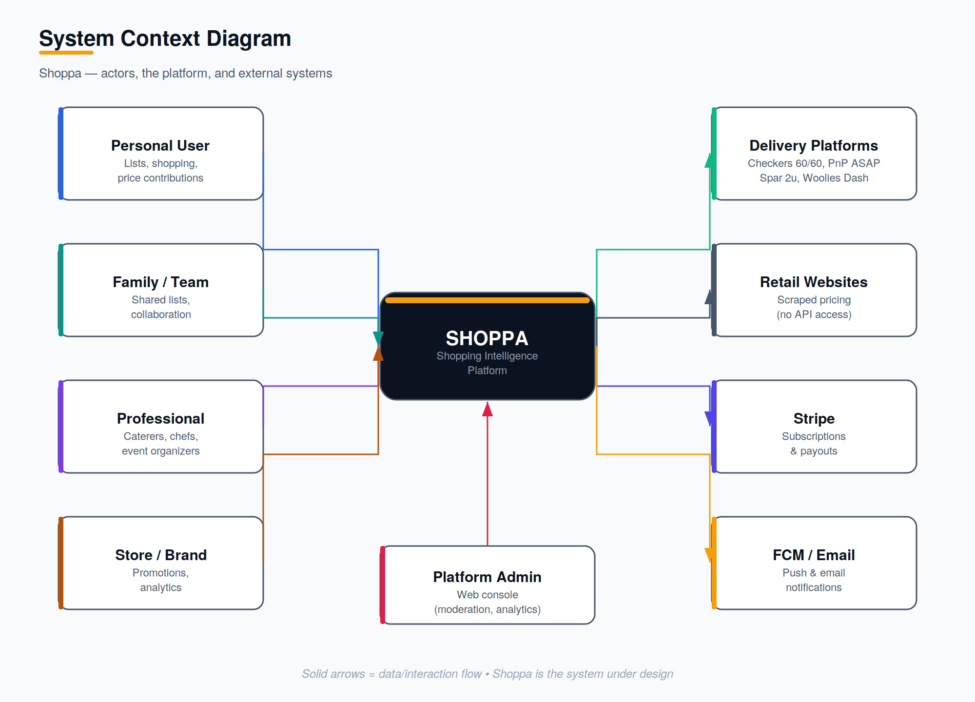
Figure 1 — System context: actors, the Shoppa platform, and external systems.

5. Stakeholders
Stakeholder | Interest | Influence
Personal users | Save time and money on everyday shopping | High — primary adoption driver
Professional users | Scale and share ingredient/supply lists | Medium — high-value segment
Retail & delivery partners | Reach in-market shoppers, promote products | Medium — revenue partner
Platform owner / business | Growth, monetization, data asset | High — sponsor
Product & engineering team | Deliver a reliable, scalable platform | High — execution
Platform admins | Moderate content, manage partners | Medium — operations

6. Account Types
Account Type | Description | Channel
Personal | Standard consumer — lists, shopping, contributions | Mobile
Professional | Caterers, chefs, organizers — scaling, publishing | Mobile
Store / Brand | Promotions and aggregate analytics | Mobile + Web
Admin | Platform administration and moderation | Web only

7. High-Level Requirements
The following capabilities are required at a business level; detailed functional requirements appear in the Software Requirements Specification.
ID | Requirement
BR-1 | Users can create, categorize, share, and reuse shopping lists.
BR-2 | Multiple users can edit a shared list simultaneously with changes reflected in real time.
BR-3 | The platform compares prices for list items across stores and delivery platforms.
BR-4 | Users contribute prices while shopping; contributions are validated and reconciled.
BR-5 | Lists remain usable offline and synchronize when connectivity returns.
BR-6 | Professional users can scale lists by guest count and publish lists publicly.
BR-7 | Stores can target promotions to users whose lists contain relevant products.
BR-8 | All features are gateable by subscription tier without code changes.
BR-9 | The platform is localized for South Africa and architected for multi-region expansion.
BR-10 | The platform serves house-sold in-app advertising (banner, native, interstitial/rewarded); display is suppressed for users on an ad-free subscription tier.

8. Monetization Model
Revenue Stream | Description
Subscriptions | Monthly/annual plans across Free, Personal Premium, Family/Team, Professional, and Store Partner tiers
Affiliate commissions | Revenue share on delivery-platform click-throughs that lead to orders
Store promotion fees | Stores pay to push targeted deals to matched users
Data insights | Aggregated, anonymized shopping trend reports for retail partners
In-app advertising | Direct-sold house ads (banner, native/sponsored, interstitial/rewarded) shown to Free-tier users; ad-free is a paid-tier benefit

9. Assumptions & Constraints

9.1 Assumptions
- Sufficient active users will contribute in-store prices to build a useful data set.
- Delivery platforms' public catalogues remain accessible for scraping in the initial phase.
- Stripe is available for subscription billing in the launch market.

9.2 Constraints
- No official delivery-platform API access at launch — reliance on scraping and crowd-sourced data.
- South Africa is the launch market; data residency and currency default to ZA.
- Mobile-first delivery; the web build is limited to the admin console initially.

10. Risks (Business)
Risk | Impact | Mitigation
Insufficient price contributions | Weak comparison value early on | Seed with scraping; incentivize contributions
Scraping disruption / blocking | Gaps in delivery price data | Adapter abstraction; pursue official partnerships
Low conversion to paid tiers | Revenue shortfall | Tier value clearly; gate premium features
Data accuracy disputes | Trust erosion | Trust scoring, recency weighting, reporting
Ads perceived as intrusive | Reduced engagement, lower conversion to paid tiers | Frequency capping; non-intrusive placements; clear ad-free upgrade path

