SHOPPA
Shopping Intelligence Platform
Project Management Plan
Approach, roadmap, team, and governance
Document | Project Management Plan (PMP)
Project | Shoppa — Shopping Intelligence Platform
Version | 1.0
Status | Draft for review
Prepared by | Project Management Office
Date | June 2026

Contents

1. Project Overview
This Project Management Plan defines how Shoppa will be delivered: approach, phases, team, governance, risks, and quality. It complements the BRD (why), the SRS (what), and the Solution Architecture (how technically), and governs execution.
Attribute | Value
Project | Shoppa — Shopping Intelligence Platform
Delivery approach | Agile, two-week sprints within phased rollout
Launch market | South Africa (multi-region ready)
Primary platform | Mobile (Flutter); web admin console (Flutter Web)
Estimated duration | Approximately 13 months across five phases

2. Delivery Approach
Delivery follows an agile cadence of two-week sprints, organized into five sequential-but-overlapping phases. Each phase ends with a demonstrable increment. The team works backend and frontend in parallel, with a design-system-first approach on the client and contract-first APIs to unblock both sides.

3. Roadmap & Phases
The roadmap sequences foundational capabilities first, then collaboration, then the data-heavy price intelligence layer, then delivery and monetization, and finally professional and growth features.
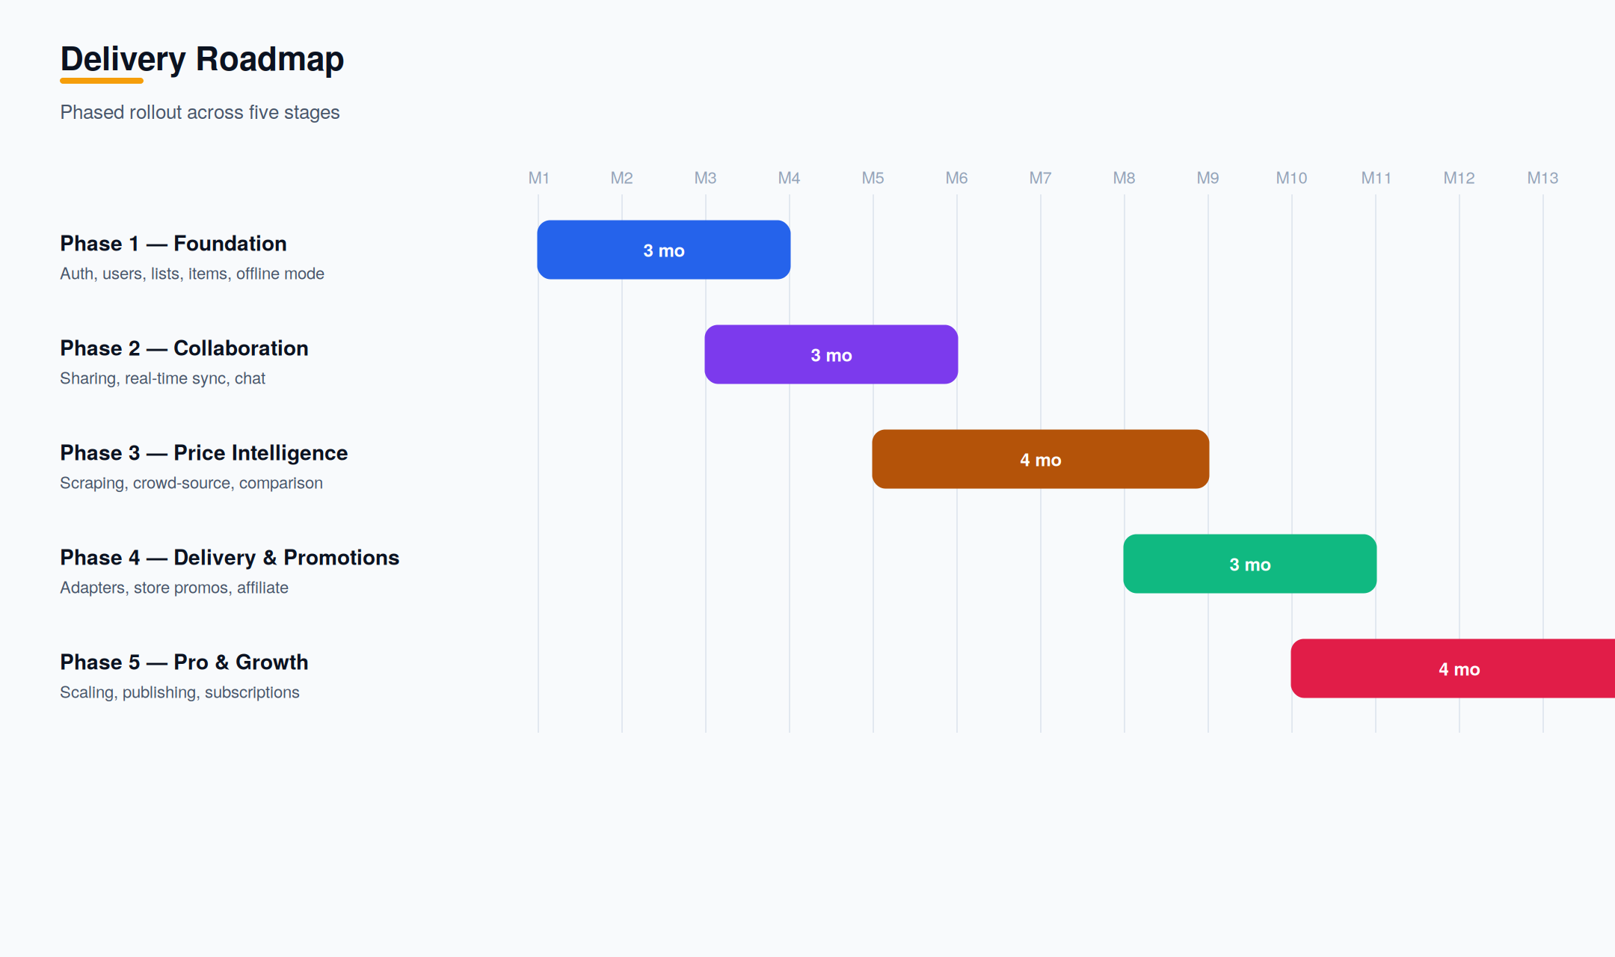
Figure 1 — Phased delivery roadmap.

3.1 Phase Detail
Phase | Key Work | Exit Criteria
Phase 1 — Foundation | Auth & accounts, list/item CRUD, categories, offline mode, mobile shell, CI/CD, base API. | Working list app with offline check-off
Phase 2 — Collaboration | Sharing & permissions, real-time sync (Channels), activity feed, in-app chat. | Multiple users editing a shared list live
Phase 3 — Price Intelligence | Scraper service, crowd-sourced capture, reconciliation engine, comparison & alerts. | Per-list savings suggestions
Phase 4 — Delivery & Promotions | Delivery adapters (60/60, ASAP, 2u, Dash), comparison, affiliate links, store promotions. | Compare & order via delivery
Phase 5 — Pro & Growth | Quantity scaling, public publishing, event lists, subscriptions & feature gating. | Paid tiers live; professional tools

4. Team & Responsibilities
Role | Responsibility
Project Manager | Planning, cadence, risk, stakeholder communication
Business Analyst | Requirements, acceptance criteria, traceability
Systems Analyst | Process modeling, data and use-case definition
Solutions Architect | Architecture, integration strategy, technical decisions
Backend Developer | Django apps, APIs, workers, data model
Frontend Developer | Flutter Web admin console, shared widget/component library
Mobile Developer | Flutter app, offline/sync, device integration
QA Engineer | Test strategy, automation, release verification

5. Governance & Ceremonies
- Sprint planning at the start of each two-week sprint.
- Daily stand-up for coordination and blocker removal.
- Sprint review/demo of the increment to stakeholders.
- Retrospective to improve process each sprint.
- Phase gate review before committing to the next phase.

6. Milestones
Milestone | Description | Target
M1 | Foundation complete — offline list app | End of Month 3
M2 | Real-time collaboration live | End of Month 5
M3 | Price comparison available | End of Month 8
M4 | Delivery comparison & promotions | End of Month 10
M5 | Subscriptions & professional tools — GA | End of Month 13

7. Risk Register
Risk | Likelihood | Impact | Mitigation
Scraping blocked by platforms | Medium | High | Adapter abstraction; crowd-source fallback; pursue partnerships
Low early contribution volume | Medium | High | Seed via scraping; incentives and gamification
Real-time scaling complexity | Medium | Medium | Load test Channels; Redis tuning; backpressure
Offline sync conflicts | Medium | Medium | Field-level LWW; clear conflict rules; tests
Scope creep across phases | High | Medium | Phase gates; MoSCoW prioritization
Payment/billing edge cases | Low | Medium | Use Stripe primitives; webhook reconciliation

8. Quality Management
- Definition of Done includes tests, code review, and documentation.
- Automated unit and integration tests gate merges via CI.
- Each functional requirement maps to acceptance criteria and test cases.
- Performance and offline scenarios are tested before each phase gate.

9. Communication Plan
Audience | Channel | Cadence
Core team | Stand-up, sprint board | Daily / per sprint
Stakeholders | Sprint demo, status report | Every two weeks
Sponsor | Phase gate review | End of each phase

10. Dependencies
- Stripe account and approval for the launch market.
- Firebase project for push notifications.
- Hosting and managed PostgreSQL/Redis in the SA region.
- Access to delivery-platform catalogues for the scraper service.

