SHOPPA
Shopping Intelligence Platform
Software Requirements Specification
Functional and non-functional requirements
Document | Software Requirements Specification (SRS)
Project | Shoppa — Shopping Intelligence Platform
Version | 1.0
Status | Draft for review
Prepared by | Systems Analysis & Engineering
Date | June 2026

Contents

1. Introduction

1.1 Purpose
This Software Requirements Specification (SRS) defines the functional and non-functional requirements for Shoppa, a mobile-first shopping intelligence platform. It is intended for the engineering, QA, design, and product teams responsible for building and verifying the system.

1.2 Scope
Shoppa enables users to create and collaborate on shopping lists of all kinds, compare prices across stores and delivery platforms, shop in-store with offline support, and — for professional users — scale and publish lists. The platform launches in South Africa and is architected for multi-region expansion.

1.3 Definitions
Term | Definition
List | A named collection of items belonging to a user, optionally shared.
Price observation | A single recorded price for a product at a store, from any source.
Delivery adapter | A pluggable integration with an on-demand delivery platform.
Trust score | A per-user rating reflecting reliability of contributed data.
Tier | A subscription level that gates feature access.

2. Overall Description

2.1 Product Perspective
Shoppa is a new, self-contained platform comprising a mobile application, an admin web console, a backend API, real-time services, asynchronous workers, and integrations with external delivery platforms and payment services.
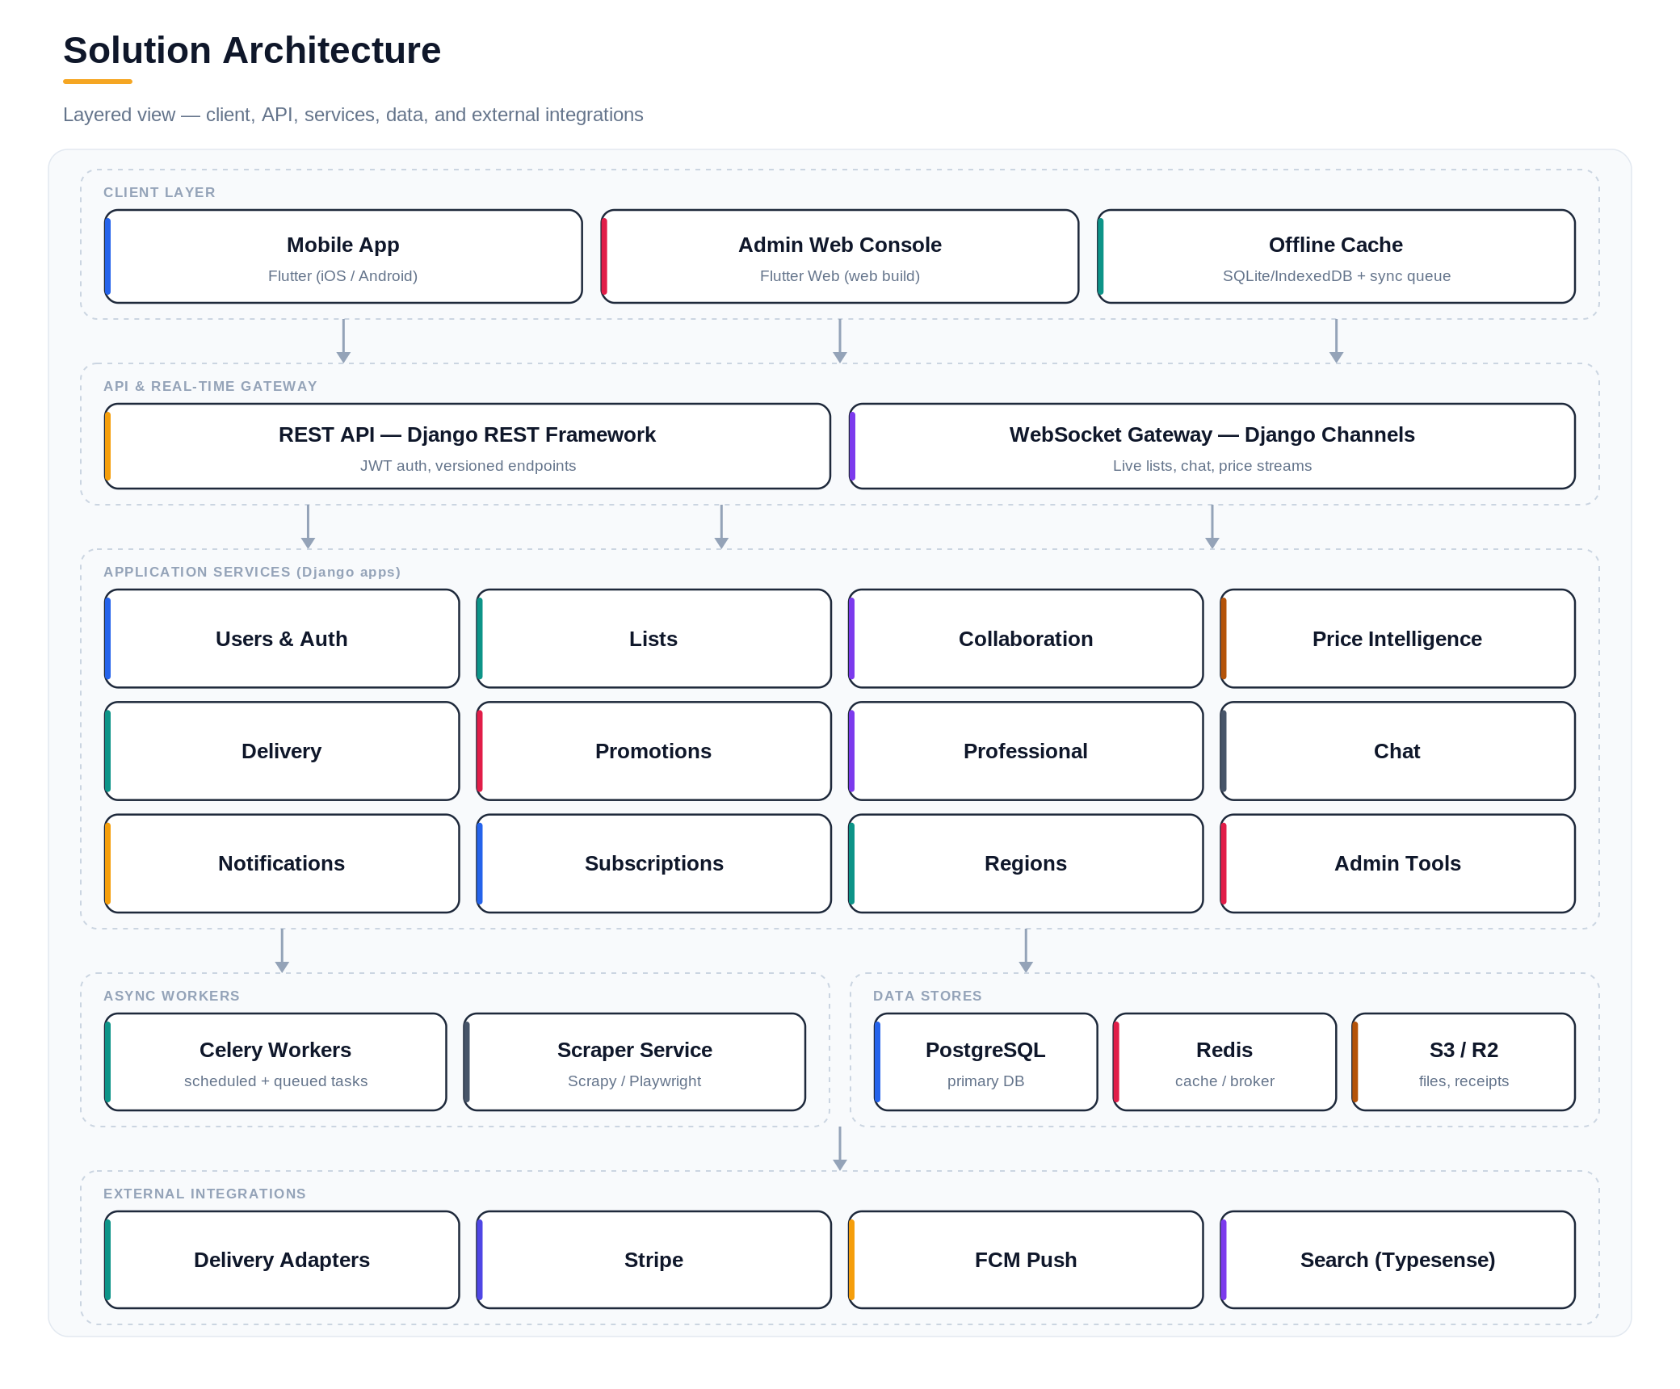
Figure 1 — Layered solution architecture.

2.2 User Classes
- Personal user — Creates and manages personal/household lists, contributes prices, shops in-store or orders delivery.
- Professional user — Manages large, repeatable lists; scales by guest count; publishes lists publicly.
- Store / brand — Configures targeted promotions; views aggregate analytics.
- Admin — Moderates content, manages partners, monitors platform health (web only).

2.3 Operating Environment
- Mobile: iOS and Android via Flutter, with offline storage and background sync.
- Web: Flutter Web admin console (modern browsers).
- Backend: Django + Django REST Framework, Django Channels, PostgreSQL, Redis, Celery — containerized with Docker.

3. Functional Requirements

3.1 Accounts & Authentication
ID | Requirement | Priority
FR-1.1 | The system shall allow registration with email and password. | Must
FR-1.2 | The system shall support four account types: Personal, Professional, Store, Admin. | Must
FR-1.3 | The system shall issue JWT access and refresh tokens and refresh them transparently. | Must
FR-1.4 | The system shall associate each user with a region and locale. | Must
FR-1.5 | The system shall allow upgrade from Personal to Professional. | Should

3.2 Shopping Lists
ID | Requirement | Priority
FR-2.1 | Users shall create lists with a category (groceries, clothing, wishlist, event, ingredients, custom). | Must
FR-2.2 | Users shall add, edit, remove, and reorder items with quantity, unit, and notes. | Must
FR-2.3 | Users shall mark lists as recurring with carry-over of unchecked items. | Should
FR-2.4 | Users shall save lists as reusable templates. | Should
FR-2.5 | The system shall sort items by aisle/category for in-store efficiency. | Could
FR-2.6 | The system shall retain version history and allow rollback. | Could

3.3 Collaboration
ID | Requirement | Priority
FR-3.1 | Users shall share lists with others at view or edit permission. | Must
FR-3.2 | The system shall reflect edits to a shared list in real time across collaborators. | Must
FR-3.3 | The system shall record an activity feed of changes per list. | Should
FR-3.4 | Collaborators shall exchange messages in a per-list chat thread. | Should
FR-3.5 | Collaborators shall initiate in-app voice/video calls. | Could

3.4 In-Store Shopping Mode
ID | Requirement | Priority
FR-4.1 | The system shall provide a check-off view optimized for one-handed use. | Must
FR-4.2 | Lists shall be fully usable offline and sync when connectivity returns. | Must
FR-4.3 | Users shall confirm or enter the actual price when checking off an item. | Must
FR-4.4 | The system shall present a session summary of spend and savings on completion. | Should
FR-4.5 | Users shall add or check items by voice. | Could

3.5 Price Intelligence
ID | Requirement | Priority
FR-5.1 | The system shall ingest prices from crowd-sourcing, scraping, and store data. | Must
FR-5.2 | The system shall reconcile conflicting prices by recency and user trust score. | Must
FR-5.3 | The system shall compare prices for a list across stores and suggest savings. | Must
FR-5.4 | The system shall alert users to price drops on saved items. | Should
FR-5.5 | Users shall scan receipts to verify and contribute prices. | Could

3.6 Delivery Integration
ID | Requirement | Priority
FR-6.1 | The system shall check item availability across delivery platforms via adapters. | Must
FR-6.2 | The system shall compare delivery prices and ETAs for a list. | Must
FR-6.3 | The system shall generate affiliate-tracked links for orders. | Should
FR-6.4 | New delivery platforms shall be addable without changes to core services. | Must

3.7 Promotions
ID | Requirement | Priority
FR-7.1 | Stores shall target users whose lists contain matching products. | Must
FR-7.2 | Promoted items shall be flagged non-intrusively in list views. | Should
FR-7.3 | Users shall opt out of promotions per store or category. | Must

3.8 Professional Tools
ID | Requirement | Priority
FR-8.1 | Professional users shall scale a list by a multiplier or guest count. | Must
FR-8.2 | Professional users shall publish lists publicly for others to clone. | Should
FR-8.3 | Professional users shall attach lists to named events with dates. | Should
FR-8.4 | The system shall export lists to PDF and CSV. | Could

3.9 Subscriptions
ID | Requirement | Priority
FR-9.1 | The system shall gate features by subscription tier via feature flags. | Must
FR-9.2 | The system shall process subscription billing through Stripe. | Must
FR-9.3 | Free-tier limits shall be enforced (e.g. maximum active lists). | Should

3.10 In-App Advertising
ID | Requirement | Priority
FR-10.1 | The system shall display house-sold banner advertisements on home and list screens to Free-tier users. | Must
FR-10.2 | The system shall support house-sold native/sponsored listings interleaved with price comparison and store results. | Should
FR-10.3 | The system shall support house-sold interstitial and rewarded ad placements at natural app transition points (e.g. end of a shopping session). | Should
FR-10.4 | The system shall suppress all ad display for users whose active subscription has the ads_free feature flag enabled. | Must
FR-10.5 | The system shall enforce frequency capping on interstitial/rewarded placements to limit impressions per user per session. | Should
FR-10.6 | The system shall serve only house-sold advertising; no third-party ad network SDK shall be integrated in the initial release. | Must

4. Use Cases
The diagram below summarizes primary interactions by actor; detailed flows follow.
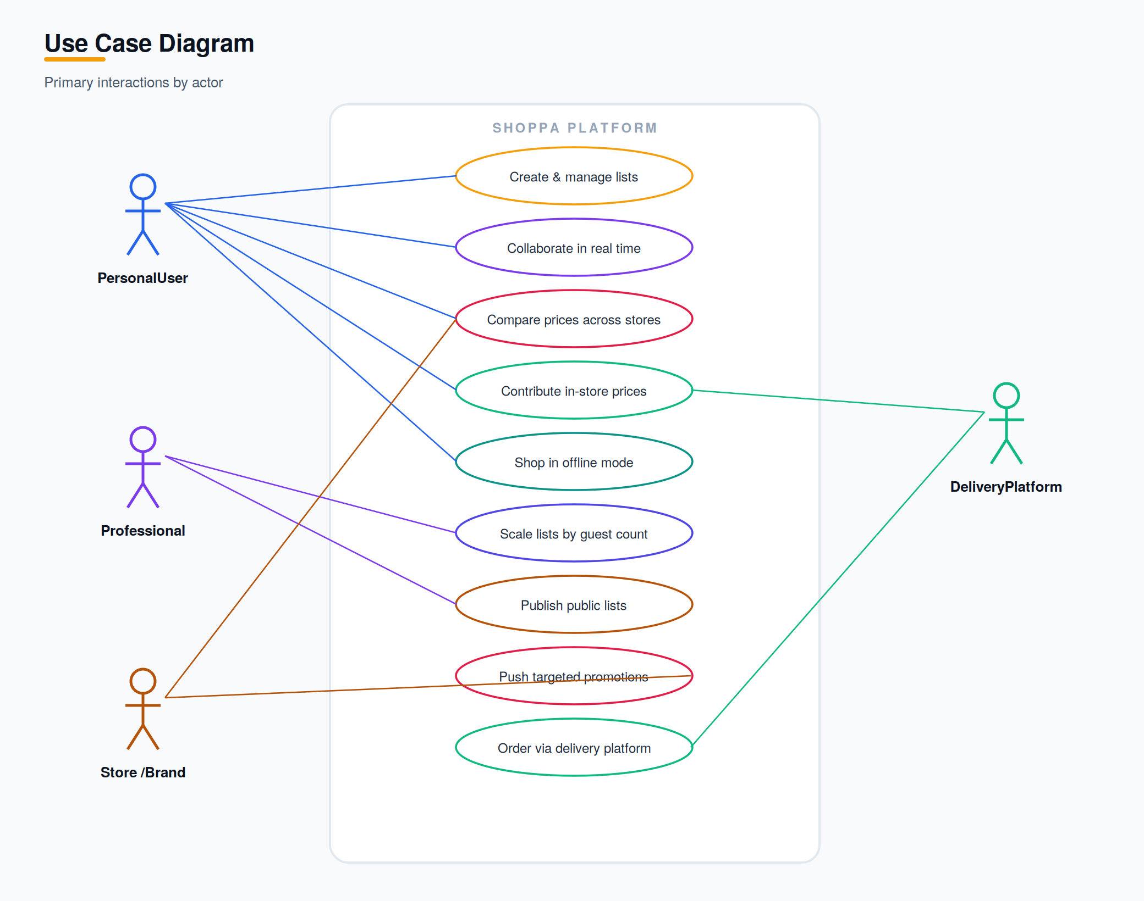
Figure 2 — Use case overview by actor.

4.1 Use Case: Compare Prices for a List
Field | Detail
Actor | Personal / Professional user
Precondition | User has a list with one or more items in their region.
Main flow | User opens a list, requests comparison; system gathers prices per store and delivery platform, reconciles, and returns ranked totals with suggested savings.
Alternate | If data is sparse, system shows best-available estimates and flags low confidence.
Postcondition | User sees savings suggestions and may switch store or order delivery.

4.2 Use Case: Order via Delivery Platform
The sequence below shows how Shoppa assembles a delivery comparison and hands off an order to the chosen platform.
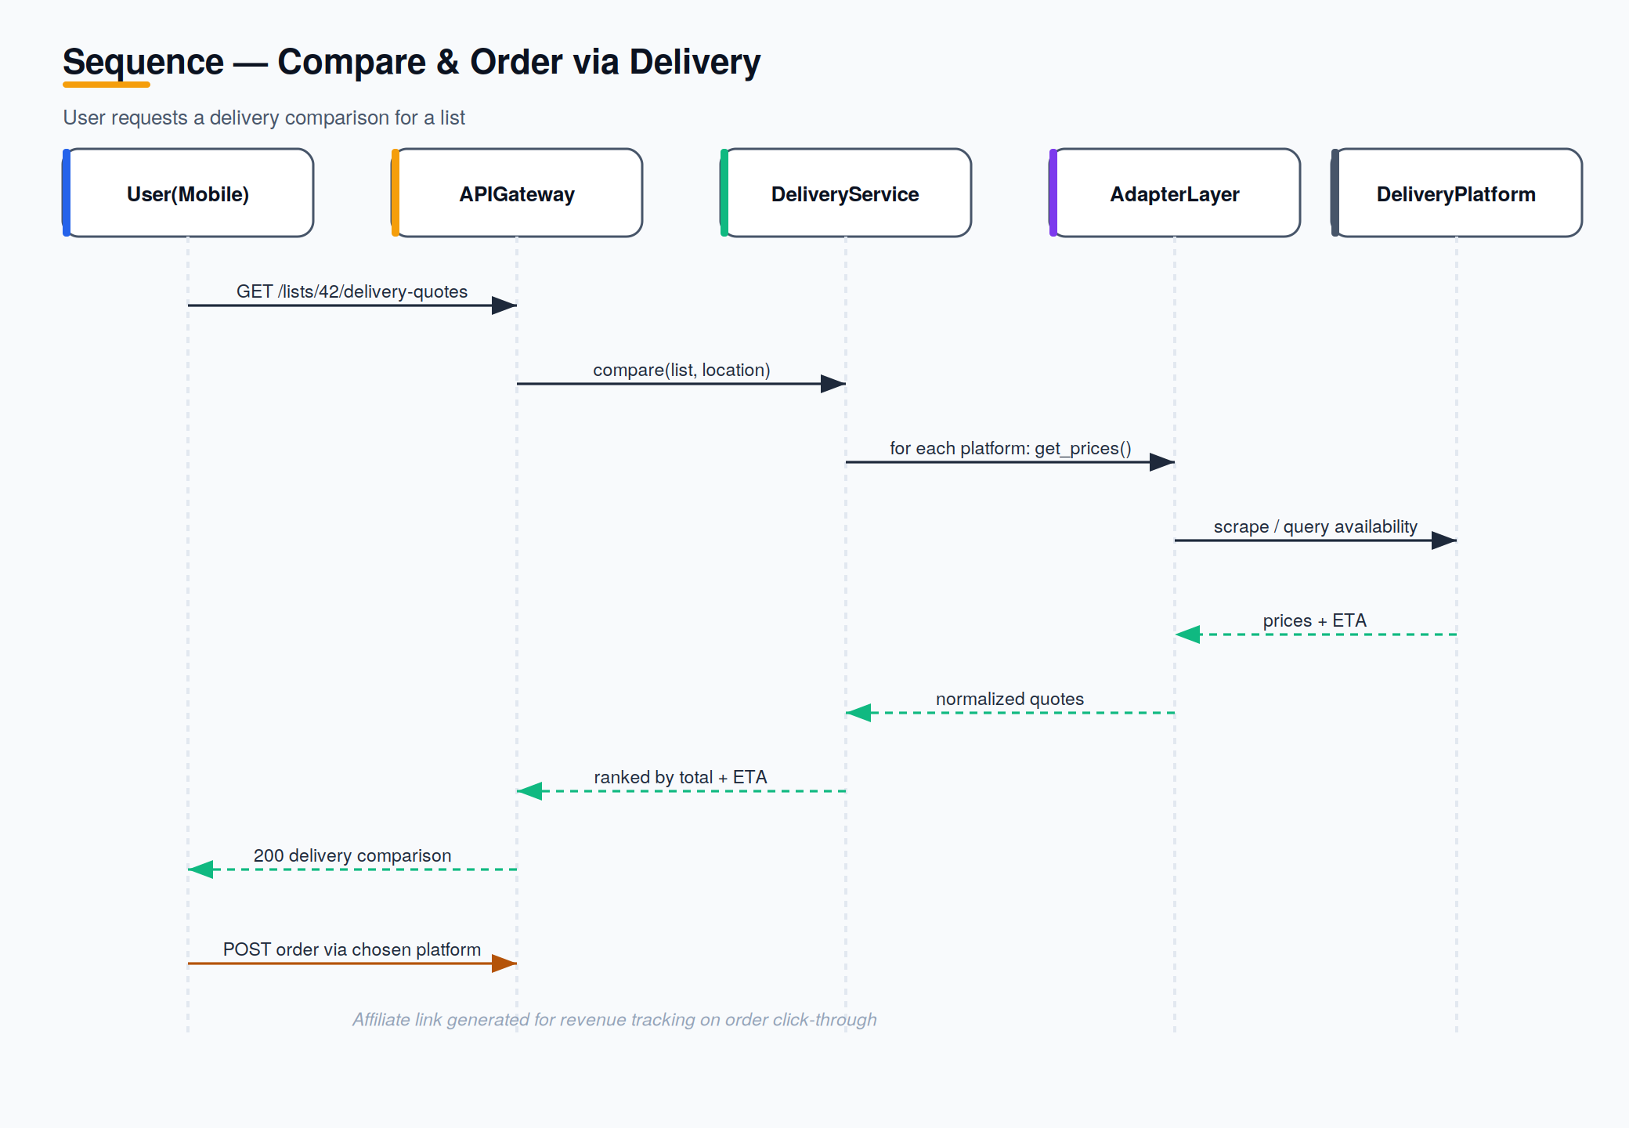
Figure 3 — Sequence: compare and order via delivery.

5. Data Requirements
The core domain model is shown below. Monetary values are stored in minor units with a currency code; users, lists, and stores are region-scoped.
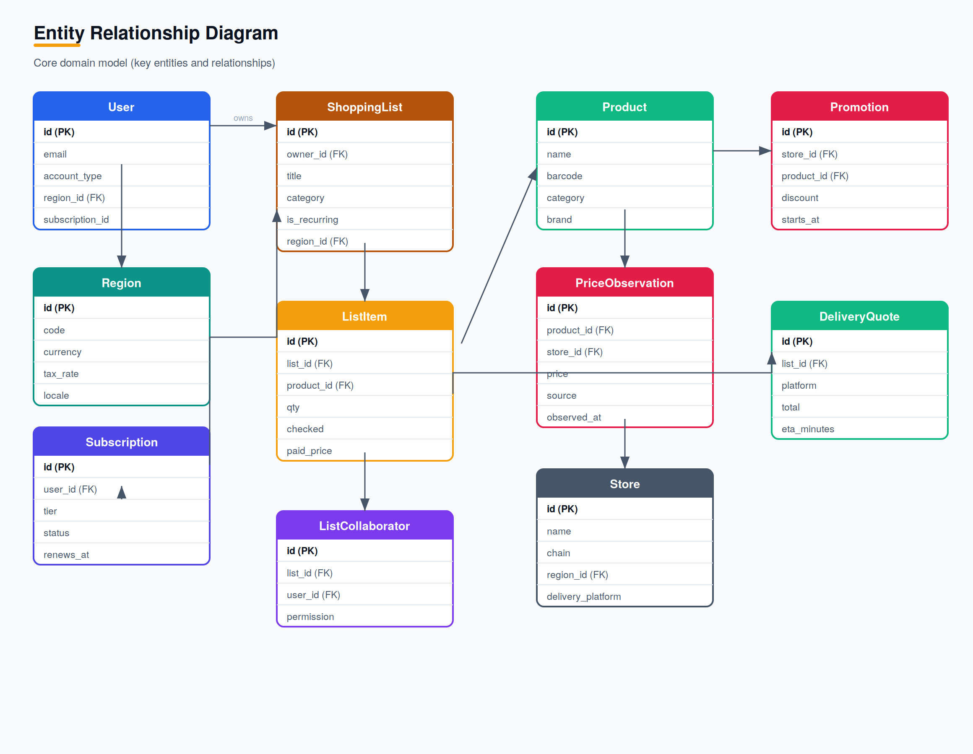
Figure 4 — Entity relationship diagram (core entities).

6. Non-Functional Requirements
Category | Requirement | Target
Performance | API p95 response time under nominal load | < 400 ms
Real-time | List edit propagation to collaborators | < 1 s
Availability | Monthly platform uptime | 99.5%
Offline | Full list view and check-off without connectivity | 100% of list ops
Scalability | Horizontal scaling of API and worker tiers | Stateless pods
Security | Encryption in transit and at rest; JWT auth | TLS 1.2+ / AES-256
Privacy | Contributed data anonymized for analytics | PII-free exports
Localization | Currency, tax, language per region | i18n-ready
Accessibility | Mobile UI meets contrast and focus standards | WCAG 2.1 AA

7. Assumptions & Dependencies
- Stripe is the billing provider for subscriptions in the launch market.
- Delivery platform catalogues remain scrape-accessible in the initial phase.
- Firebase Cloud Messaging is used for push notifications.
- A critical mass of contributing users is required for high-confidence comparisons.

8. Traceability
Each functional requirement traces to a business requirement (BRD) and will map to test cases in the QA test plan. Priorities follow MoSCoW: Must, Should, Could.

