SHOPPA
Shopping Intelligence Platform
Solution Architecture
Technical design, integrations, and deployment
Document | Solution Architecture & Technical Design
Project | Shoppa — Shopping Intelligence Platform
Version | 1.0
Status | Draft for review
Prepared by | Solutions Architecture
Date | June 2026

Contents

1. Architecture Overview
This document describes the technical architecture for Shoppa: its layers, services, data model, integration strategy, real-time infrastructure, and deployment topology. It is the reference for the engineering team and the basis for technical decision records.
Shoppa follows a layered, service-oriented architecture within a Django monolith-of-apps backend, complemented by asynchronous workers and a dedicated scraping service. The mobile client is offline-capable; real-time features are delivered over WebSockets.
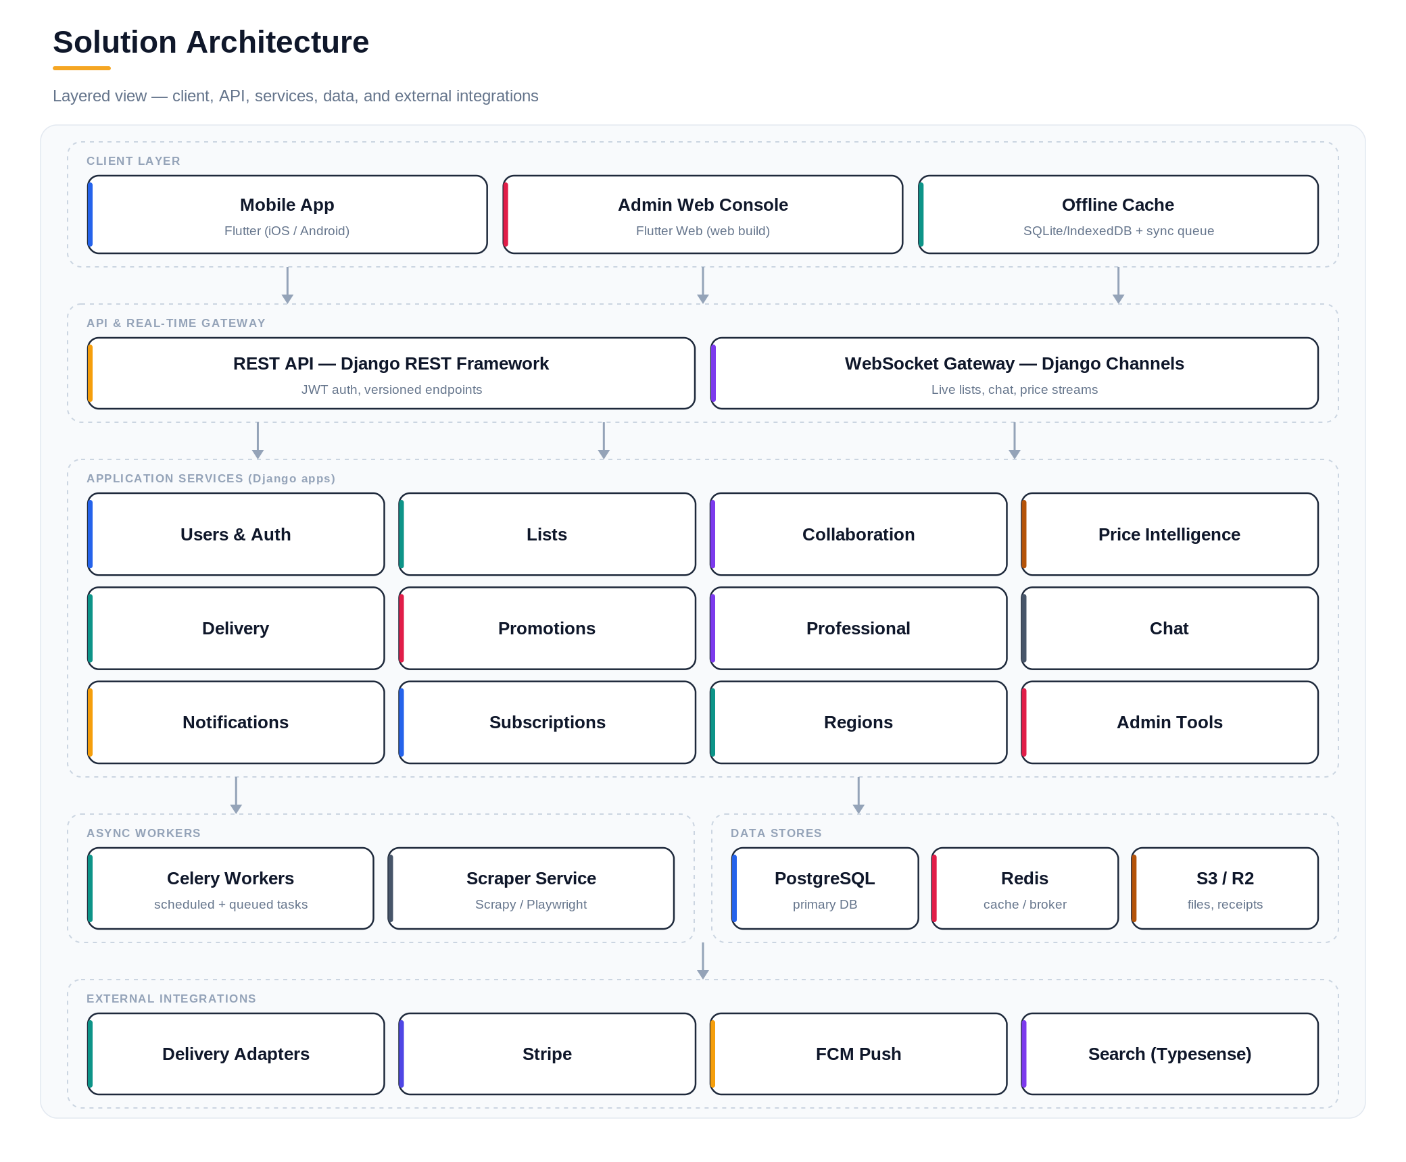
Figure 1 — Layered solution architecture.

2. Architectural Principles
- Region-first data model — every user, store, and price is region-scoped; money is stored in minor units with a currency code.
- Pluggable integrations — delivery platforms sit behind a common adapter interface so new platforms require no core changes.
- Offline-first mobile — the client owns a local store and a sync queue; the server is the source of truth on reconciliation.
- Feature-flag everything — capabilities are gated by subscription tier without code changes.
- Stateless services — API and worker tiers scale horizontally; state lives in PostgreSQL and Redis.

3. Technology Stack
Layer | Technology | Rationale
Mobile app | Flutter | Single codebase, iOS/Android, native rendering performance, offline support
Admin web | Flutter Web | Shares widgets/design tokens with mobile build via Flutter's web target
API | Django REST Framework | Mature, batteries-included, rapid delivery
Real-time | Django Channels + Redis | WebSocket groups for lists and chat
Async | Celery + Celery Beat | Scheduled and queued background work
Scraping | Scrapy / Playwright | Catalogue and price extraction
Primary DB | PostgreSQL | Relational integrity, JSON where needed
Cache / broker | Redis | Cache, channel layer, Celery broker
Search | Typesense | Fast product/item search
Payments | Stripe | Subscriptions and payouts
Push | Firebase Cloud Messaging | Cross-platform notifications
Storage | S3 / Cloudflare R2 | Receipts, exports, images
Containerization | Docker | Consistent build/runtime packaging across all environments

4. Backend Service Decomposition
The backend is organized into focused Django apps with clear ownership:
App | Responsibility
users | Auth, profiles, account types, region/locale, subscription status
lists | List and item CRUD, categories, templates, recurring logic, versioning
collaboration | Sharing, permissions, real-time sync, activity feed
price_intelligence | Ingestion, reconciliation, comparison, alerts, receipts
delivery | Adapter layer, availability, ETA, affiliate links
promotions | Targeting engine, campaigns, coupons
professional | Quantity scaling, event lists, public publishing, inventory
chat | Messaging and call signaling
notifications | Push, in-app, and email delivery
subscriptions | Plans, feature flags, Stripe billing
regions | Region/locale config, currency, tax
admin_tools | Analytics, partner management, moderation
ads | House ad placement selection, impression/click tracking, frequency capping

5. Data Architecture
PostgreSQL is the system of record. The core entities and their relationships are shown below. Time-series price history supports trend analysis and drop alerts; Redis caches hot comparison results.
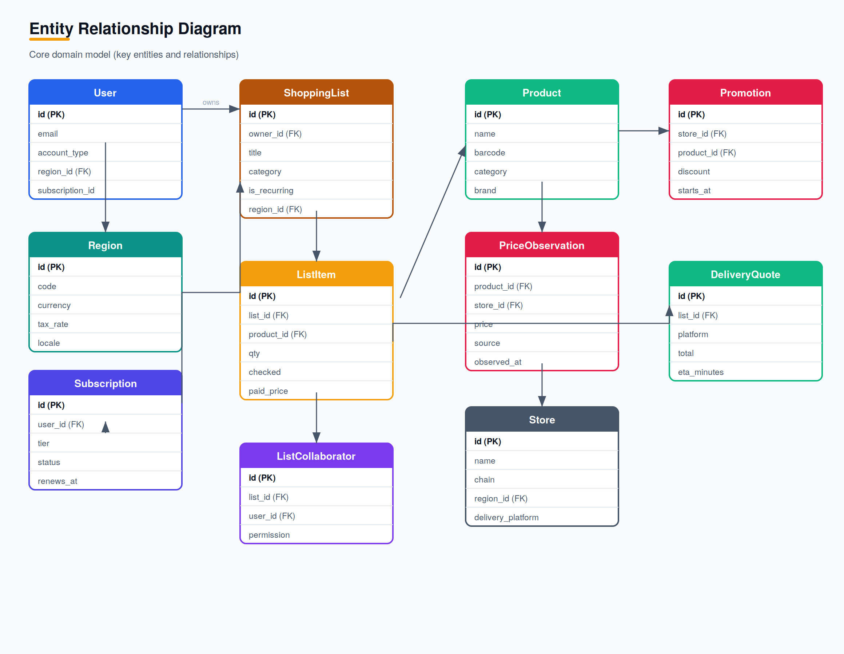
Figure 2 — Core domain model.

5.1 Multi-Tenancy & Regions
Shoppa uses a shared database with region-scoped rows rather than schema-per-region, keeping operations simple at launch scale. A region column on users, stores, and price observations partitions data logically; queries are always region-filtered. Data residency hooks allow routing storage and processing per region as Shoppa expands.

6. Price Intelligence Pipeline
Prices arrive from three sources, are validated and normalized, then reconciled into authoritative observations with confidence weighting.
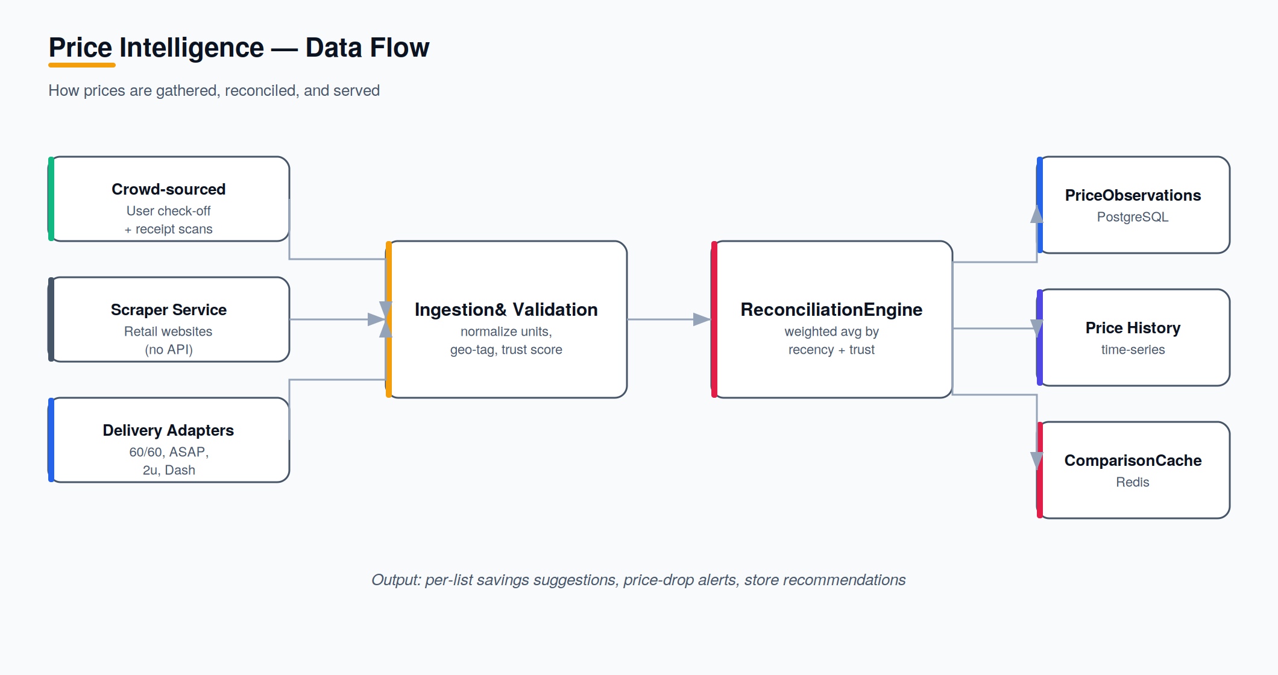
Figure 3 — Price intelligence data flow.

6.1 Reconciliation Strategy
- Crowd-sourced prices are weighted by contributor trust score and recency.
- Scraped prices establish a baseline where user data is sparse.
- Outliers beyond a configurable band are quarantined for review.
- Each product/store pair resolves to a current price plus a confidence indicator.

7. Delivery Integration Architecture
All delivery platforms implement a common adapter interface. The service layer is unaware of platform specifics; it requests availability, prices, ETAs, and affiliate links through the interface.
Adapter Method | Returns
check_availability(items, location) | Per-item availability for the platform
get_prices(items, location) | Per-item prices for the platform
get_delivery_eta(location) | Estimated delivery time
get_affiliate_link(item, platform) | Tracked URL for revenue attribution
Launch adapters: Checkers 60/60, Pick n Pay ASAP, Spar 2u, Woolies Dash. Each is toggled per region by feature flag. Future adapters (e.g. Instacart, Ocado) plug in without core changes.
Because official APIs are unavailable at launch, adapters initially wrap scraping and crowd-sourced data behind the same interface — so a later switch to official APIs is internal to the adapter.

8. Real-Time Infrastructure
Django Channels provides WebSocket groups backed by Redis. Each concern maps to a channel group:
Feature | Channel Group
Live list collaboration | Per-list group
In-app chat | Per-conversation group
Price update broadcasts | Per-item subscription
Delivery availability updates | Per-list delivery status
Notification stream | Per-user channel

9. Offline & Synchronization
The mobile client maintains a local database and an outbound change queue. While offline, all list reads and check-offs operate locally. On reconnect, queued mutations replay to the server; conflicts resolve last-write-wins at the field level, with the server as the authority. Price contributions captured offline are timestamped at capture time to preserve recency weighting.

10. Security Architecture
- Authentication via JWT access/refresh tokens with transparent refresh on the client.
- Authorization enforced at the API and object level (list permissions, account type, tier).
- TLS for all traffic; encryption at rest for the database and object storage.
- Secrets managed outside source control; least-privilege service credentials.
- Rate limiting and abuse detection on contribution and scraping endpoints.

11. Deployment Topology
Services run as Docker containers, orchestrated for horizontal scaling, with managed data services pinned to the South African region at launch.
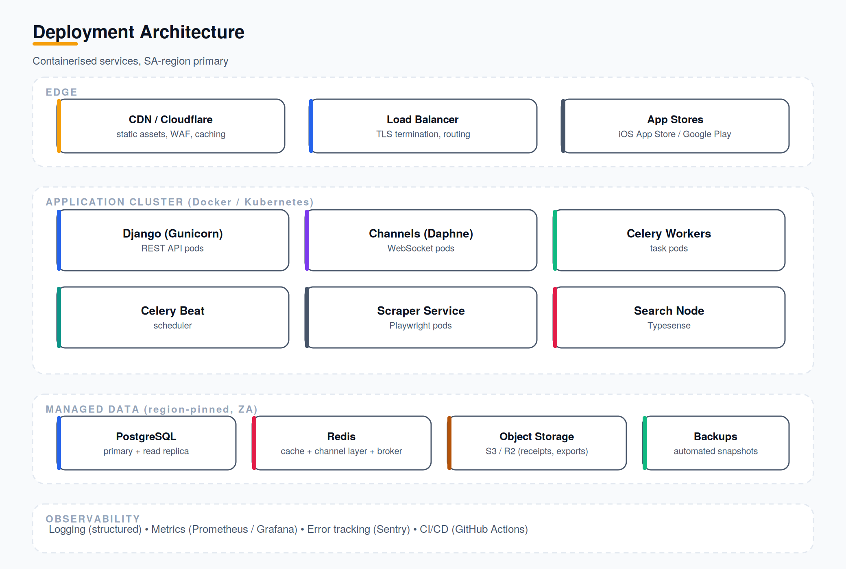
Figure 4 — Deployment architecture.

12. Observability & CI/CD
- Structured logging across services with correlation IDs.
- Metrics via Prometheus/Grafana; error tracking via Sentry.
- CI/CD through GitHub Actions: test, build Docker images, deploy on merge.
- Automated database backups with point-in-time recovery.

13. Key Architectural Decisions
ID | Decision | Rationale
AD-1 | Shared DB with region-scoping | Operationally simple at launch; supports multi-region later
AD-2 | Adapter pattern for delivery | Isolates platform churn; enables API switch without core change
AD-3 | Django Channels for real-time | Keeps stack unified; avoids third-party real-time vendor
AD-4 | Offline-first mobile | In-store usability without connectivity is core to the product
AD-5 | Feature flags for tiers | Monetization flexibility without redeploys
AD-6 | Flutter for mobile & admin web | Native rendering performance for an animation-heavy consumer UI; single codebase and shared widgets across mobile and admin surfaces
AD-7 | Docker for service packaging | Consistent, portable build and deployment across all environments and CI/CD stages
AD-8 | House-only ad serving (no third-party SDK) | Avoids ad-network SDK bloat, privacy/consent overhead, and revenue-share loss; reuses the existing subscriptions feature-flag mechanism (AD-5) for ads_free suppression

14. Advertising Serving Architecture
The ads app owns house-ad creative, placement selection, and delivery. Ad creative and campaigns are stored and managed directly by Shoppa; no third-party ad-network SDK is integrated (AD-8), so there is no external mediation layer or client-side ad SDK to maintain.
On each placement request, the service checks the requesting user’s active subscription for the ads_free feature flag (reusing the tier/feature-flag mechanism from AD-5). If ads_free is enabled, no creative is returned and the surface renders no ad. Otherwise, an eligible banner, native/sponsored, or interstitial/rewarded creative is selected for the requested surface.
Frequency capping (FR-10.5) is enforced by tracking recent impressions per user in Redis, keyed by placement format and a rolling session window; requests beyond the cap are served no creative rather than a repeat impression. Impression and click events are written asynchronously to apps.ads for reporting, independent of the request path.

