SHOPPA
Shopping Intelligence Platform
QA & Test Plan
Test strategy, traceability, and cases
Document | Quality Assurance & Test Plan
Project | Shoppa — Shopping Intelligence Platform
Version | 1.0
Status | Draft for review
Prepared by | QA Engineering
Date | June 2026

Contents

1. Introduction

1.1 Purpose
This Test Plan defines the quality strategy, scope, approach, and test cases for Shoppa. It maps each functional requirement from the SRS to verifiable test cases and establishes the gates a build must pass before release.

1.2 Scope
Testing covers the mobile application, admin web console, backend API, real-time services, offline synchronization, and external integrations (delivery adapters, payments, push). Non-functional testing covers performance, security, offline resilience, and localization.

2. Test Strategy
Shoppa follows a test-pyramid approach: a broad base of fast unit tests, a substantial layer of integration and API contract tests, focused component tests on the client, and a thin top of end-to-end journeys. Quality gates run automatically at each stage of the pipeline.
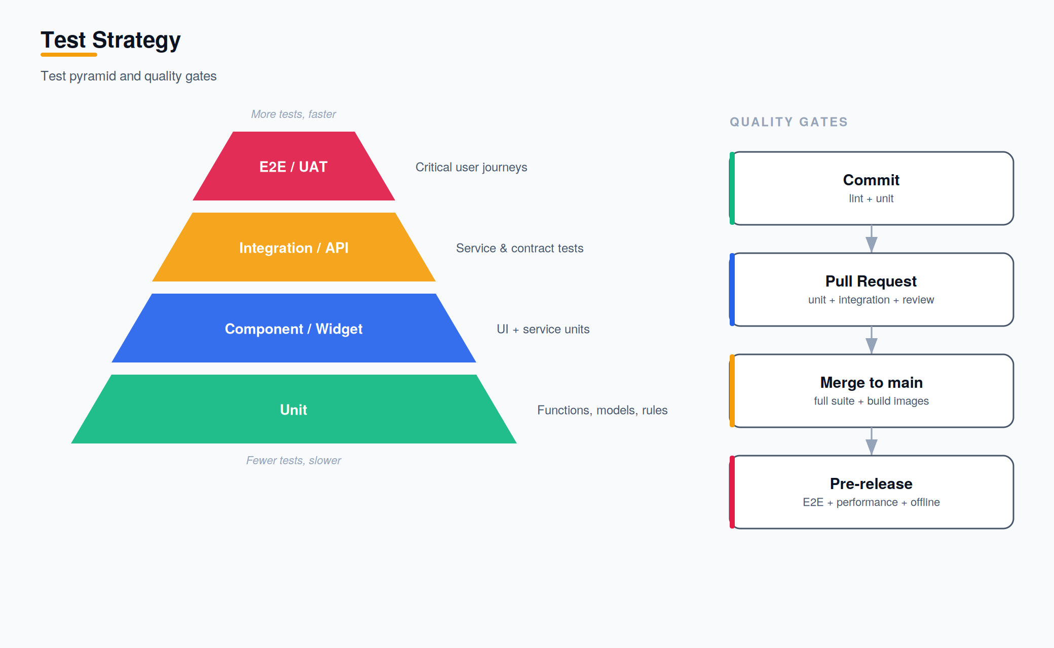
Figure 1 — Test pyramid and pipeline quality gates.

3. Test Levels
Level | Focus | Tooling (indicative)
Unit | Functions, models, commission/reconciliation rules | pytest, Jasmine/Karma
Integration | API endpoints, DB, Celery tasks, webhooks | pytest + DRF test client
Contract | Adapter and API contracts between services/clients | schema/contract tests
Component | Angular/Ionic components and services | Karma, Testing Library
End-to-end | Critical user journeys across the stack | Cypress / Playwright
Non-functional | Performance, security, offline, localization | k6, OWASP ZAP, manual

4. Test Types
- Functional testing — verifies each requirement behaves as specified.
- Regression testing — automated suite guards against reintroduced defects.
- Offline & sync testing — list operations offline, conflict resolution on reconnect.
- Performance testing — API latency and real-time propagation under load.
- Security testing — auth, authorization, input validation, rate limiting.
- Localization testing — currency, tax, and language correctness per region.
- User acceptance testing (UAT) — stakeholder validation of key journeys.

5. Requirement Traceability & Test Cases
Each test case traces to a functional requirement (FR) from the SRS. Priority mirrors the requirement's MoSCoW level.

5.1 Accounts & Authentication
Test ID | FR | Test Case | Type
TC-1.1 | FR-1.1 | Register with valid email/password creates a Personal account. | Functional
TC-1.2 | FR-1.1 | Register with an existing email is rejected with a clear error. | Negative
TC-1.3 | FR-1.3 | Expired access token is refreshed transparently without re-login. | Integration
TC-1.4 | FR-1.4 | New user is assigned the correct region and locale. | Functional
TC-1.5 | FR-1.5 | Personal account can upgrade to Professional and gains pro features. | Functional

5.2 Shopping Lists
Test ID | FR | Test Case | Type
TC-2.1 | FR-2.1 | Create lists in each category; category persists. | Functional
TC-2.2 | FR-2.2 | Add, edit, remove, reorder items with quantity, unit, notes. | Functional
TC-2.3 | FR-2.3 | Recurring list carries over unchecked items on reset. | Functional
TC-2.4 | FR-2.4 | Save a list as a template and instantiate a new list from it. | Functional
TC-2.5 | FR-2.6 | Roll back a list to a previous version restores prior state. | Functional

5.3 Collaboration
Test ID | FR | Test Case | Type
TC-3.1 | FR-3.1 | Share a list at view permission; collaborator cannot edit. | Functional
TC-3.2 | FR-3.2 | Edit by one collaborator appears for another within one second. | Performance
TC-3.3 | FR-3.3 | Activity feed records add/remove with author and timestamp. | Functional
TC-3.4 | FR-3.4 | Messages in a list chat thread deliver to all collaborators. | Integration
TC-3.5 | FR-3.2 | Concurrent edits to the same item resolve deterministically. | Edge case

5.4 In-Store Shopping Mode
Test ID | FR | Test Case | Type
TC-4.1 | FR-4.2 | With network disabled, list opens and items can be checked off. | Offline
TC-4.2 | FR-4.2 | Queued offline changes sync correctly on reconnect. | Offline
TC-4.3 | FR-4.3 | Checking off an item prompts for and stores the actual price. | Functional
TC-4.4 | FR-4.4 | Session summary totals spend and savings accurately. | Functional
TC-4.5 | FR-4.2 | Conflicting offline edits resolve last-write-wins by field. | Edge case

5.5 Price Intelligence
Test ID | FR | Test Case | Type
TC-5.1 | FR-5.1 | Crowd-sourced, scraped, and store prices are ingested. | Integration
TC-5.2 | FR-5.2 | Conflicting prices reconcile by recency and trust score. | Functional
TC-5.3 | FR-5.2 | Outlier price beyond band is quarantined, not surfaced. | Edge case
TC-5.4 | FR-5.3 | List comparison ranks stores and shows savings. | Functional
TC-5.5 | FR-5.4 | Price drop on a saved item triggers a notification. | Integration

5.6 Delivery Integration
Test ID | FR | Test Case | Type
TC-6.1 | FR-6.1 | Availability is checked across all configured adapters. | Integration
TC-6.2 | FR-6.2 | Delivery comparison returns prices and ETAs per platform. | Functional
TC-6.3 | FR-6.3 | Order link carries affiliate tracking parameters. | Functional
TC-6.4 | FR-6.4 | Adding a new adapter requires no change to core services. | Architecture
TC-6.5 | FR-6.1 | Adapter failure degrades gracefully with partial results. | Resilience

5.7 Promotions
Test ID | FR | Test Case | Type
TC-7.1 | FR-7.1 | Promotion targets only users whose lists contain the product. | Functional
TC-7.2 | FR-7.3 | Opting out of a store suppresses its promotions. | Functional

5.8 Professional Tools
Test ID | FR | Test Case | Type
TC-8.1 | FR-8.1 | Scaling a list by guest count adjusts all quantities correctly. | Functional
TC-8.2 | FR-8.2 | Published list is discoverable and can be cloned by another user. | Functional
TC-8.3 | FR-8.4 | Export produces valid PDF and CSV of the list. | Functional

5.9 Subscriptions
Test ID | FR | Test Case | Type
TC-9.1 | FR-9.1 | A gated feature is hidden on Free and visible on the paid tier. | Functional
TC-9.2 | FR-9.2 | Successful Stripe payment activates the subscription. | Integration
TC-9.3 | FR-9.3 | Free-tier list limit is enforced at the boundary. | Edge case
TC-9.4 | FR-9.2 | Failed or expired payment downgrades access appropriately. | Negative

5.10 In-App Advertising
Test ID | FR | Test Case | Type
TC-10.1 | FR-10.1 | Free-tier user sees a banner ad on home and list screens. | Functional
TC-10.2 | FR-10.2 | Native/sponsored listing appears interleaved with price comparison results. | Functional
TC-10.3 | FR-10.3 | Interstitial/rewarded ad is offered at end of a shopping session. | Functional
TC-10.4 | FR-10.4 | User on an ads_free subscription tier sees no ad placements anywhere in the app. | Functional
TC-10.5 | FR-10.5 | Impressions beyond the frequency cap in a session are suppressed. | Edge case

6. Non-Functional Test Targets
Area | Scenario | Target
Performance | API p95 under nominal load | < 400 ms
Real-time | Edit propagation to collaborators | < 1 s
Load | Concurrent active collaboration sessions | Meets capacity plan
Offline | All list ops available without network | 100%
Security | Auth, injection, access control checks | No high/critical findings
Localization | Currency/tax/language per region | Correct for all locales

7. Defect Management
Defects are logged with severity, steps to reproduce, and environment, then moved through a defined lifecycle. Failed verification reopens the defect.
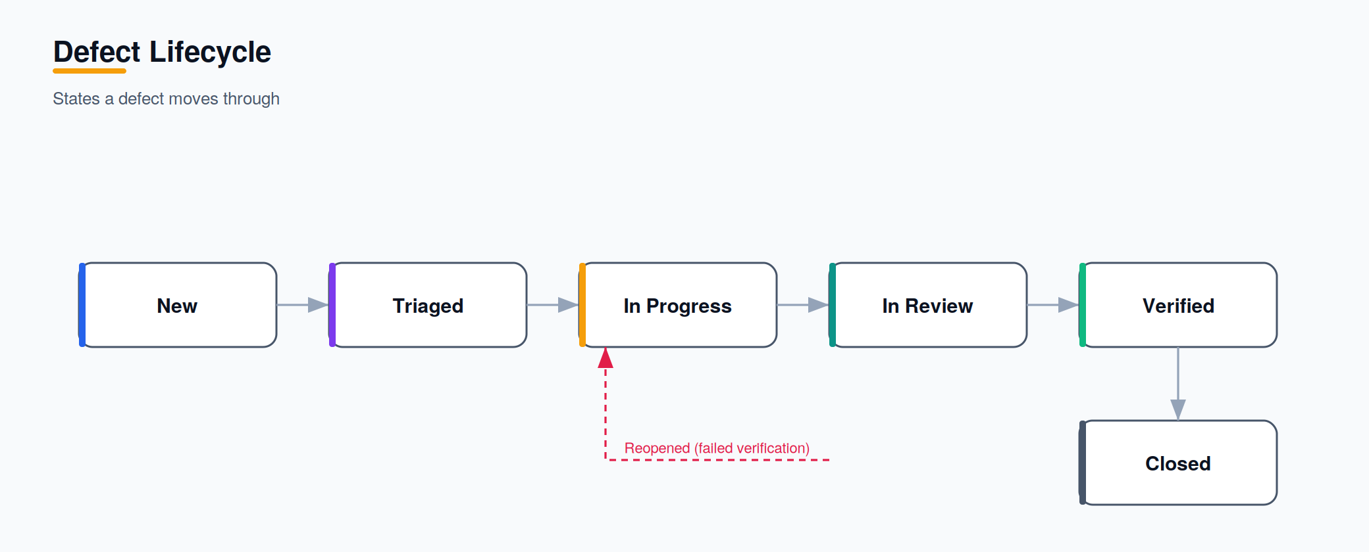
Figure 2 — Defect lifecycle.

7.1 Severity Definitions
Severity | Definition
Critical | Blocks core journey; no workaround (e.g. cannot sync offline changes).
High | Major feature impaired; workaround exists.
Medium | Limited impact or non-core feature.
Low | Cosmetic or minor inconvenience.

8. Entry & Exit Criteria

8.1 Entry Criteria
- Requirements for the feature are approved and testable.
- Build is deployed to the test environment and smoke-tests pass.
- Test data and adapter sandboxes are available.

8.2 Exit Criteria
- All Must-priority test cases pass.
- No open Critical or High defects.
- Non-functional targets met for the phase.
- UAT sign-off obtained for the increment.

9. Test Environments
Environment | Purpose
Local | Developer testing and unit suites
CI | Automated unit/integration on every push and PR
Staging | Integration, E2E, performance, UAT; adapter sandboxes
Production | Smoke tests and monitored canary releases

