

Lab 4: Basic Computer Organization

CEG 2136 - Computer Architecture I

Fall 2018

School of Electrical Engineering and Computer Science University of Ottawa

Group Number: 3

Mathew George Binu (8248470) Christy Olotu (783710)

Experiment Date: November 6th, 2018

# OBJECTIVE

Analyze the structure of a basic computer, design its control unit, and use opcodes to write simple programs in machine code using Quartus II as a development tool and the Altera DE2-115 board as an experimental platform.

# EQUIPMENT & COMPONENTS

* Quartus II 13.0 Service-Pack 1
* Altera DE2-115 circuit board with:
  + USB Blaster cable
  + Power supply 12 VDC, 2A.

# PART I - HARDWARE

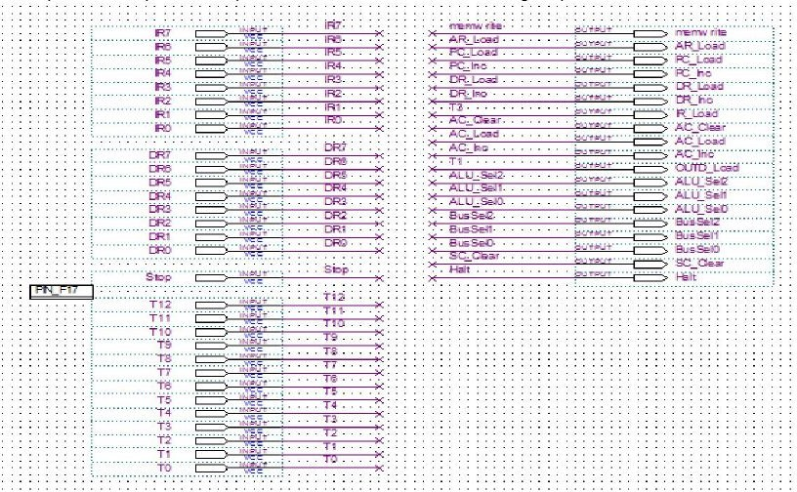

**Procedure:** As described in the lab manual (CEG2136 Lab 4 – Basic Computer Organization, p.10-p.12)

In this part of the lab, we were instructed to implement the Boolean expressions for the control signals (derived in the hardware prelab) using AND, OR, and NOT gates. We used virtual connections when designing the circuits as to avoid any confusion caused by multiple crossing wires. To ensure that the control unit would run in under 20 ns, we reduced the number of logic gates that the signals passed through.

The inputs and outputs are represented in Quartus II in the following way:

# Figure 1: Block Diagram of the Control Unit’s Input/Outputs

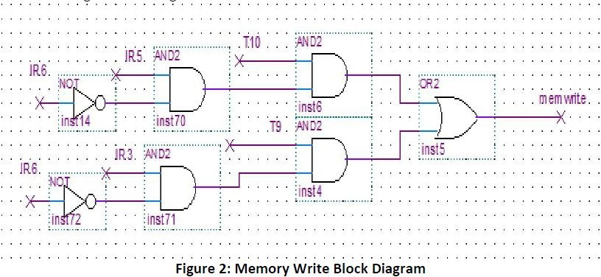

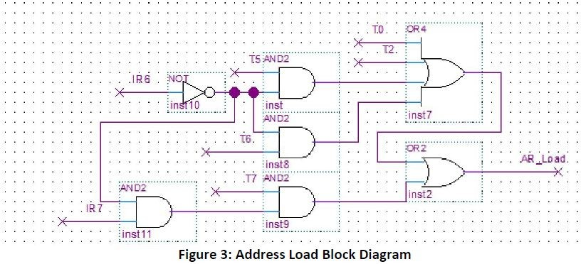

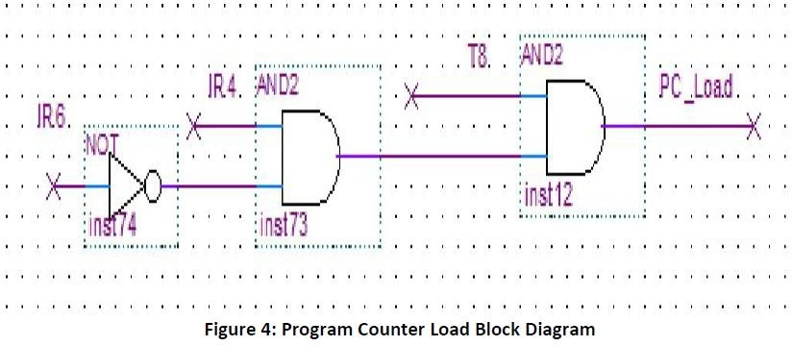

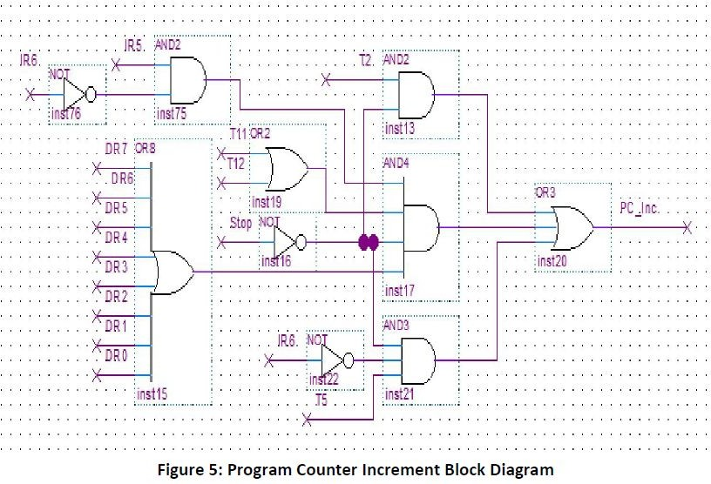

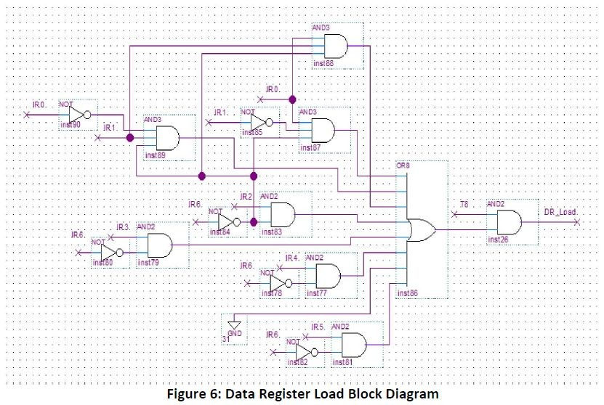

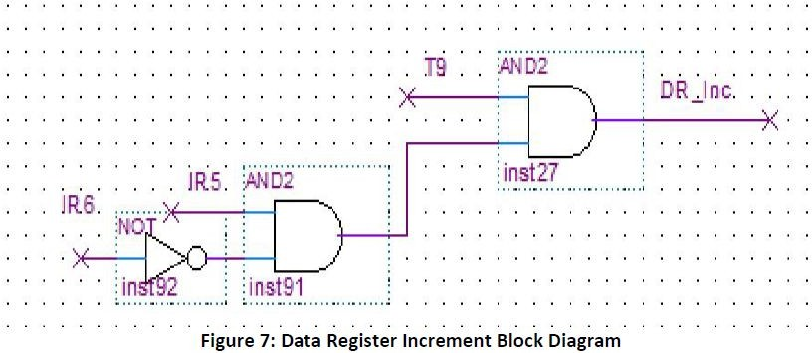

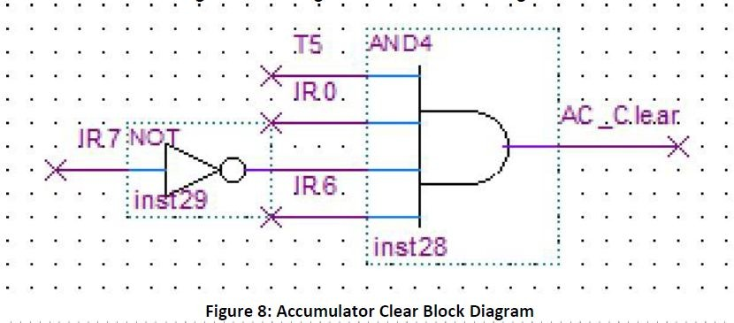

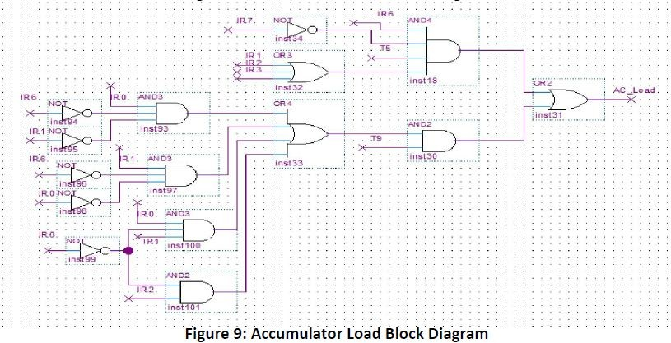

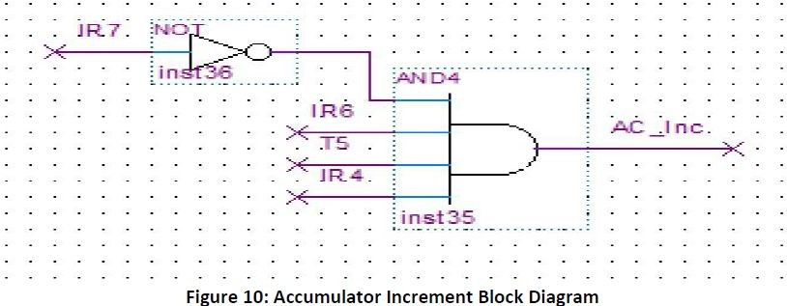

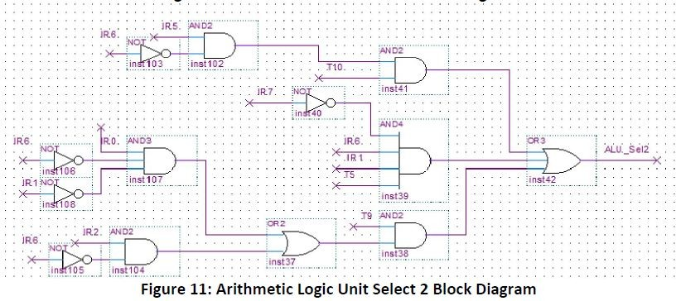

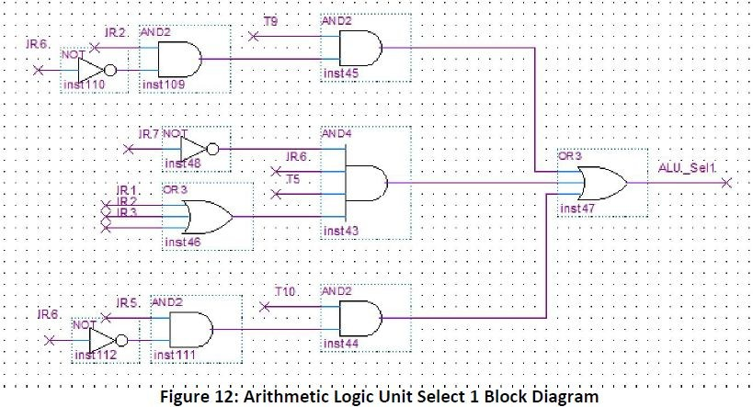

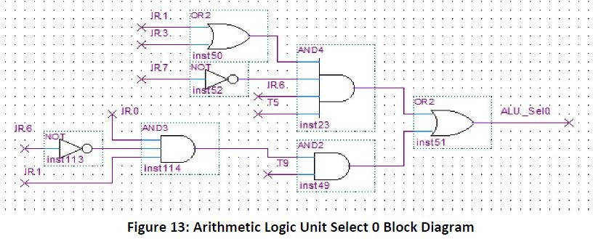

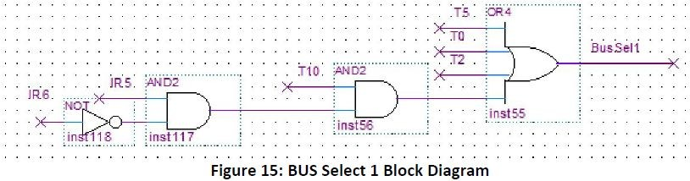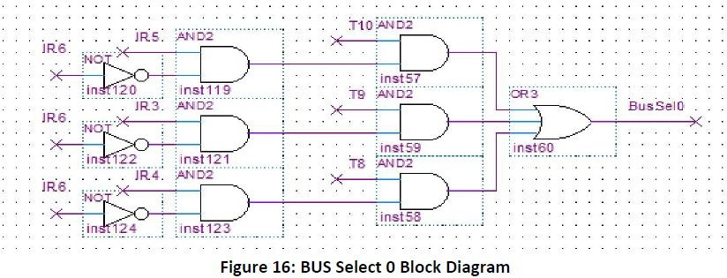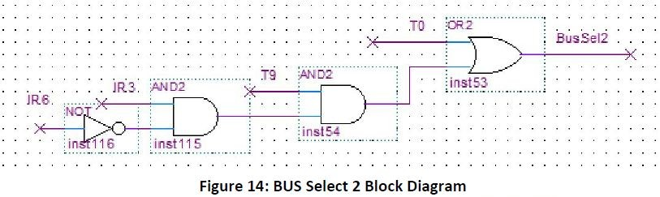

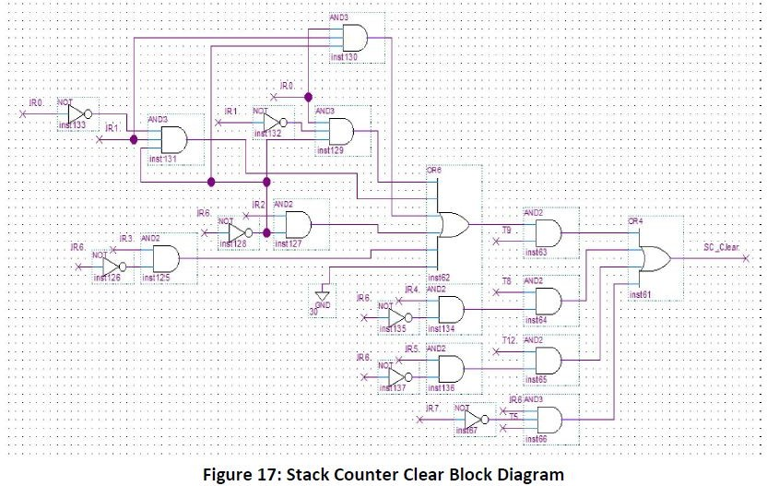

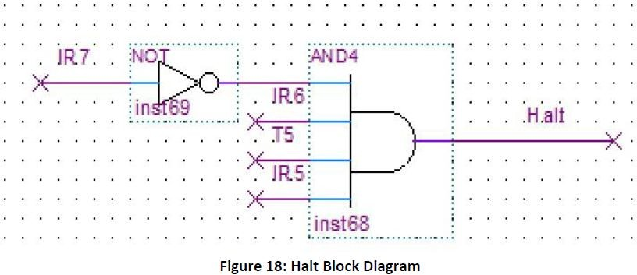

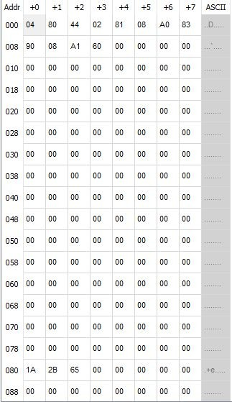

**Figure 19: Machine code for testing the Control Unit**

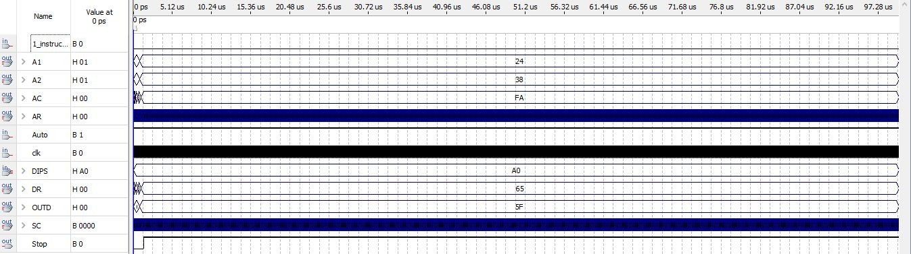

# Figure 20: Waveform pointing to the A0 register

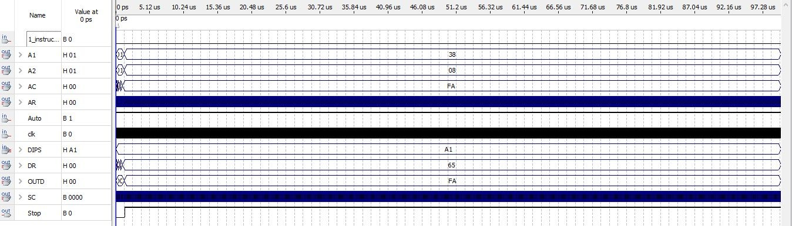

**Figure 21: Waveform pointing to the A1 register**

# 7.2 PROGRAM DESIGN

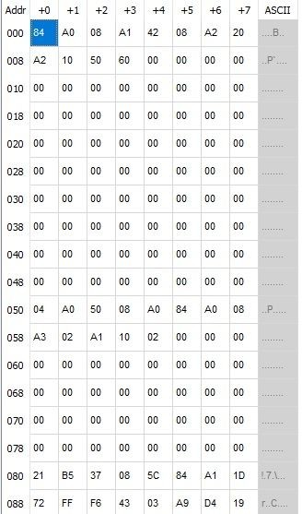

**Figure 22: Machine code for the adder**

# SIMULATION OF THE PROGRAM

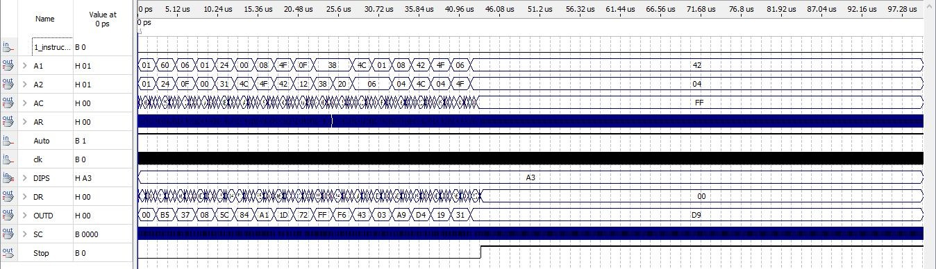

**Figure 23: Waveform output of the adder**

# PRELAB

